mmmmmmm333333邮件格式规范

发件说明
收件人：邮件内容主要告知人和负责人

抄送：所有的上级负责人、相关干系人(如：质量检查员等)

主题：
- 项目邮件：[项目名称缩写]要求本邮件内容的主题思想，要言简意赅。如果不是项目相关邮件，项目名称题头可省略。
- 组长周报：[组名][YYYY.MM.DD-YYYY.MM.DD]-周报
- 日常通知：通知主题，通知主题必须简单扼要，如：会议通知，放假通知等

内容：要把问题描述清楚，不要含糊其辞。
正文内容统一使用 中文/宋体 10号；英文/Arial 10号

签名：必须提供，这是你在公司的职位象征。

下面是一个模板（Foxmail）(字体：Arial，大小：10px)
HTML格式的：
Hi

Regards,
-Your Name
Team Leader/ Senior Software Engineer/Software Engineer/QA Engineer/Senior QA Engineer
Ufinity/QA department/your team name
Email: yourname@cn.ufinity.com | Web: www.ufinity.com
Tel/Fax:(+86)0551-5368557,5368559
Address: 605 #316,#317,#318,#319 HuangShan Road,HeFei City,An Hui Province

QA Engineer
Ufinity/QA department/Traiblazer team
Email: sflu@cn.ufinity.com | Web: www.ufinity.com
Tel/Fax:(+86)0551-5368557,5368559
Address: 605 #316,#317,#318,#319 HuangShan Road,HeFei City,An Hui Province

文本格式的：

Hi %CURSOR

Regards,
-Your Name
---------------------------------------------------------------------------------------------
Team Leader/ Senior Software Engineer/Software Engineer/QA Engineer/Senior QA Engineer
Ufinity/QA department/your team name
Email: yourname@cn.ufinity.com | Web: www.ufinity.com
Tel/Fax:(+86)0551-5368557,5368559
Address: 605 #316,#317,#318,#319 HuangShan Road,HeFei City,An Hui Province

回复说明

收件人：所收邮件的发件人

抄送：所收邮件的所有接收人和抄送人以及上级负责人、相关干系人

主题：Re:原邮件主题

内容：回复时请不要删除所收邮件的原有内容

签名：必须提供，这是你在公司的职位象征。

回复HTML格式：
Hi

Regards,
-Your name

Test Team Leader/Senior Test Engineer/Automation Test Engineer/Test Development Engineer/Test Engineer
Ufinity/QA department/your team name
Email: yourname@cn.ufinity.com | Web: www.ufinity.com
Tel/Fax:(+86)0551-5368557,5368559
Address: 605 #316,#317,#318,#319 HuangShan Road,HeFei City,An Hui Province
<> wrote:

回复文本邮件格式：
Hi %CURSOR

Regards
Your name

%ODATE %OTIME %OFROMNAME <%OFROMADDR> wrote:
%QUOTES

---------------------------------------------------------------------------------------------
Test Team Leader/Senior Test Engineer/Automation Test Engineer/Test Development Engineer/Test Engineer
Ufinity/QA department/your team name
Email: yourname@cn.ufinity.com| Web: www.ufinity.com
Tel/Fax:(+86)0551-5368557,5368559
Address: 605 #316,#317,#318,#319 HuangShan Road,HeFei City,An Hui Province

邮件附件
- 邮件附件总大小请不要超过10M,超过10M的附件请不要通过EMAIL发送，可以向网管申请FTP存贮空间；超过1M的附件请压缩后发送。

- 当邮件有附件同时发送时，请在邮件的内容中向收件人进行提醒。如：Please check attachment.

签名设置
- Foxmail进入[工具]—>[签名管理]，点击[新建]按钮，输入[名称]，点击[下一步]
- 在邮件签名输入文本框中输入如下:
Test Team Leader/Senior Test Engineer/Automation Test Engineer/Test Development Engineer/Test Engineer
Ufinity/QA department/your team name
Email: yourname@cn.ufinity.com | Web: www.ufinity.com
Tel/Fax:(+86)0551-5368557,5368559
Address: 605 #316,#317,#318,#319 HuangShan Road,HeFei City,An Hui Province
点击[确定]
- 选择邮箱列表树的根节点，点击鼠标右键，点击[属性]进入邮箱输入设置页面
- 依次选择[信纸]—>[签名]，进入选中签名页面
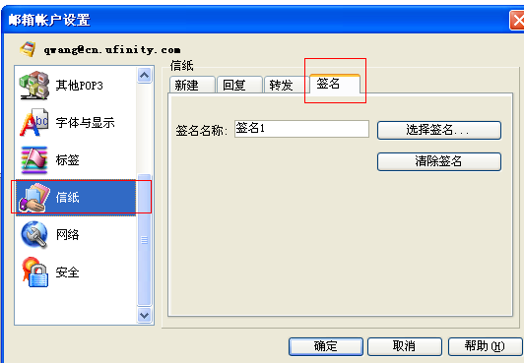
- 选择使用的签名，并点击[确定]保存，完成邮件签名设置及引用

