在主网激活情况下，即就是由投票出来的节点出块的情况下，账户间以租借和赠送方式抵押CPU+NET资源的总结；

账户A以租借方式为账户B抵押资源，A赎回；

账户A以赠送方式为账户B抵押资源，B赎回；（如果B本来没有抵押的资源，则不能全部赎回）

用test1创建了helloworld55账户，没有抵押资源

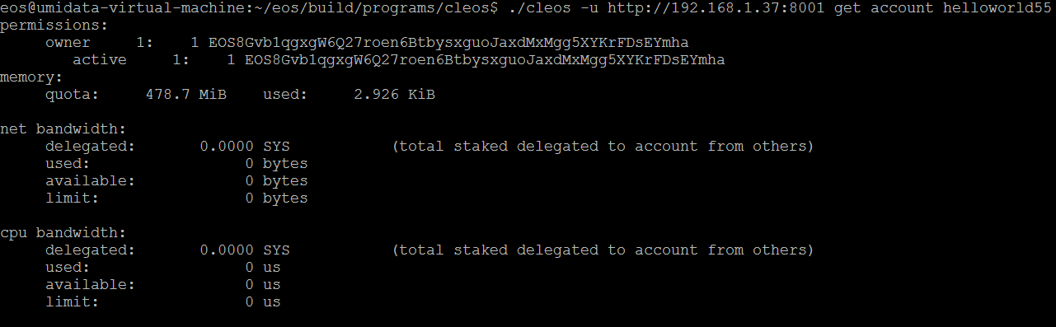

**test1以租借的方式给helloworld抵押资源，CPU 100SYS + NET 100SYS**

eos.transaction(tr => {

tr.delegatebw({

from: "test1",

receiver: "helloworld55",

stake_net_quantity: "100.0000 SYS",

stake_cpu_quantity: "100.0000 SYS",

transfer: 0

})

}).then(result => console.log(result))

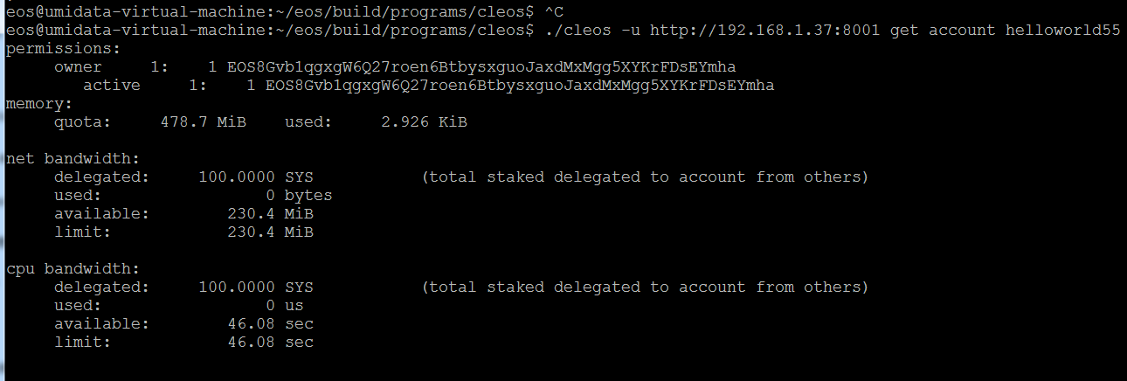

由helloworld55账户自己赎回由test1租借给他的资源

eos.transaction(tr => {

tr.undelegatebw({

from: "helloworld55",

receiver: "helloworld55",

unstake_net_quantity: "10.0000 SYS"

unstake_cpu_quantity: "10.0000 SYS"

})

}).then(result => console.log(result))

失败：资源不足

clipboard.png

由test1赎回租借给helloworld55的资源

eos.transaction(tr => {

tr.undelegatebw({

from: "test1",

receiver: "helloworld55",

unstake_net_quantity: "100.0000 SYS",

unstake_cpu_quantity: "100.0000 SYS"

})

}).then(result => console.log(result))

查看helloworld55账户资源，已经没有了

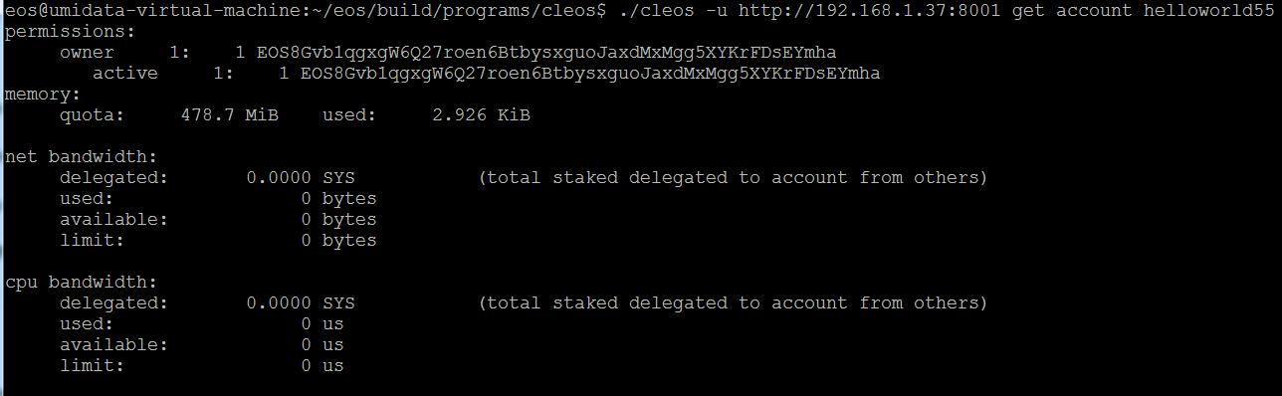

查看test1账户资源，赎回的资源将在72小时到账

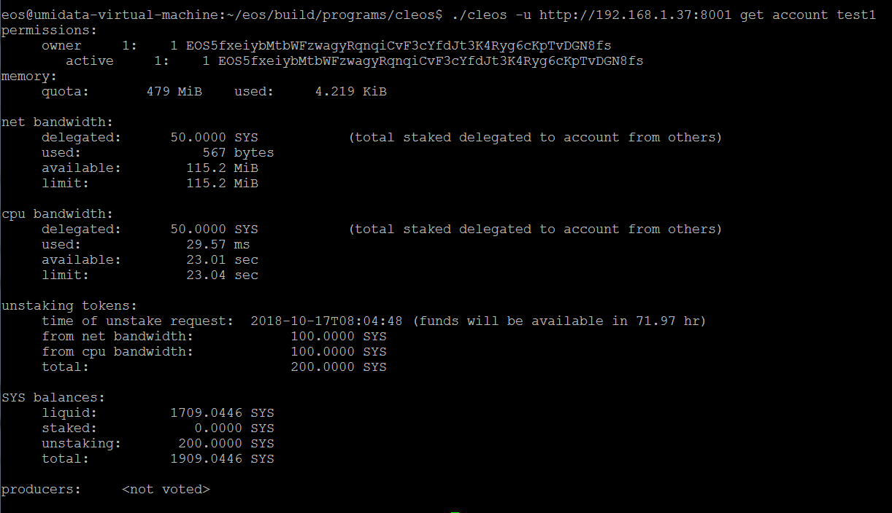

test1以赠送的方式给helloworld55抵押资源，CPU 100SYS + NET 100SYS

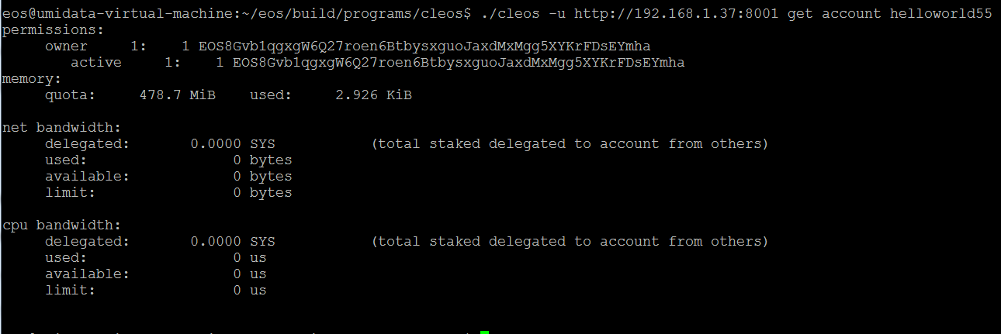

eos.transaction(tr => {

tr.delegatebw({

from: "test1",

receiver: "helloworld55",

stake_net_quantity: "100.0000 SYS",

stake_cpu_quantity: "100.0000 SYS",

transfer: 1

})

}).then(result => console.log(result))

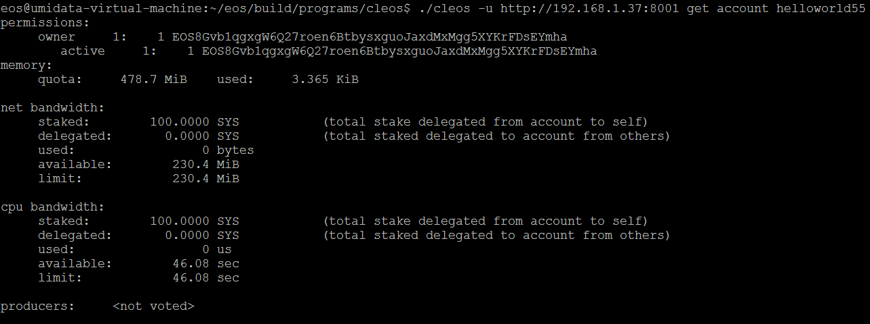

**test1自己赎回由他以赠送方式抵押给helloworld55的资源**

eos.transaction(tr => {

tr.undelegatebw({

from: "test1",

receiver: "helloworld55",

unstake_net_quantity: "100.0000 SYS",

unstake_cpu_quantity: "100.0000 SYS"

})

}).then(result => console.log(result))

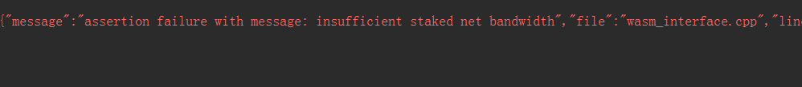

helloworld55自己赎回由test1以赠送的方式抵押的资源

eos.transaction(tr => {

tr.undelegatebw({

from: "helloworld55",

receiver: "helloworld55",

unstake_net_quantity: "100.0000 SYS",

unstake_cpu_quantity: "100.0000 SYS"

})

}).then(result => console.log(result))

如果全部赎回回出现以下错误，因为本次赎回交易会占用资源



现在分别赎回CPU、NET 90SYS的资源

eos.transaction(tr => {

tr.undelegatebw({

from: "helloworld55",

receiver: "helloworld55",

unstake_net_quantity: "90.0000 SYS",

unstake_cpu_quantity: "90.0000 SYS"

})

}).then(result => console.log(result))

查看helloworld55账户资源赎回情况如下：

