I Built 4 AI-Powered Applications in 6 Weeks
With an Agentic AI Coding Partner
Here's What I Learned.
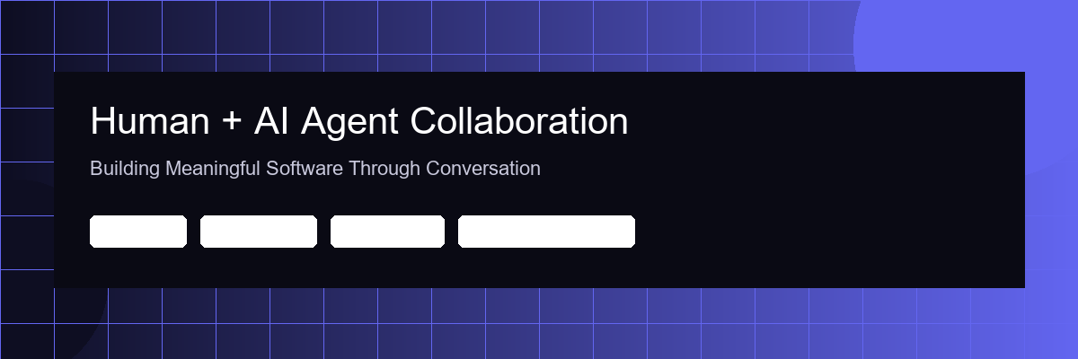

Six weeks ago, I set out to test a hypothesis: can a single person with domain expertise and an agentic AI collaborator build meaningful software — the kind that would normally require a cross-functional team?
Not prototypes. Not demos. Functional applications across trade finance, capital markets, regulatory compliance, and computational linguistics — each one built through natural language conversation with an autonomous AI coding agent.
Here's what happened.

The Builds


1. LC Compliance Checker — Agentic Document Intelligence for Trade Finance
In trade finance, operations teams spend hours doing field-by-field comparison of Letter of Credit documents against UCP600 rules. I built an AI agent that autonomously orchestrates a multi-step reasoning chain: PDF ingestion → OCR extraction (Tesseract fallback for scanned documents) → entity recognition → fuzzy matching using Levenshtein distance and token-set ratio → severity-graded compliance output with confidence scoring.
The agent doesn't just flag mismatches — it classifies discrepancies by severity (critical, major, minor) using a rule engine that mirrors how experienced trade ops analysts actually think. The entire document review loop runs without human-in-the-loop intervention.
Stack: FastAPI, React, Python OCR pipeline, structured JSON output.


2. Trading Opportunity Scanner — Autonomous Market Intelligence Agent
An always-on AI agent that performs autonomous market surveillance across US equities, India NSE, options, and FX. It executes a tool-use pipeline: data ingestion → technical indicator computation (SMA/EMA crossovers, MACD divergence, RSI momentum detection, Bollinger Band squeeze patterns) → multi-factor weighted scoring → strategy backtesting against historical time-series data.
The agent operates in a continuous observe-orient-decide loop, surfacing opportunities only after validating them through a NumPy-powered backtesting engine. Think of it as a digital analyst with no sleep requirement and no recency bias.
Stack: FastAPI, React dashboard, NumPy/Pandas for quantitative analysis, WebSocket feeds.


3. KYC Partner Verification — Multi-Jurisdiction Compliance Agent
An agentic system that autonomously executes an 8-step KYC verification workflow spanning UK (Companies House), Singapore (ACRA), and India (MCA). The agent chains together API calls for entity verification, UBO (Ultimate Beneficial Owner) resolution, sanctions and PEP screening via OpenSanctions, and adverse media analysis.
Risk scoring uses a 6-factor weighted model — jurisdiction risk, entity structure complexity, sanctions proximity, adverse media signals, document completeness, and historical compliance patterns. The agent makes a graded determination (low/medium/high/critical) and generates an audit-ready report, replacing what would typically require a compliance analyst and several days of manual due diligence.
Stack: Expo React Native (cross-platform), Supabase (PostgreSQL + RLS), REST API orchestration.


4. Kavya — Classical Poetry Translation With Retrieval-Augmented Context
This one is close to my heart. I built a cross-platform mobile application that translates and interprets Tamil, Hindi, and Sanskrit classical poetry using Claude as the reasoning engine. Users input via keyboard, camera (base64 image pipeline with vision model inference), voice (speech-to-text), or clipboard.
The AI agent returns richly structured JSON: line-by-line literal translation, poetic interpretation in English literary prose, modern Tamil rendering in Unicode, Hindi translation in Devanagari script, and scholarly metadata (raga, tala, historical period, literary tradition).
The system prompt functions as a domain-specific instruction set — 65 lines defining the output schema, handling for agglutinative Tamil morphology, Sanskrit sandhi compound decomposition, and the distinction between Sangam-era secular poetry, Bhakti devotional literature, and Vedantic philosophical verse.
Stack: Expo Router, TypeScript strict mode, Claude API, expo-secure-store, Supabase analytics, GitHub Actions CI/CD.

What the Agentic Workflow Actually Looked Like
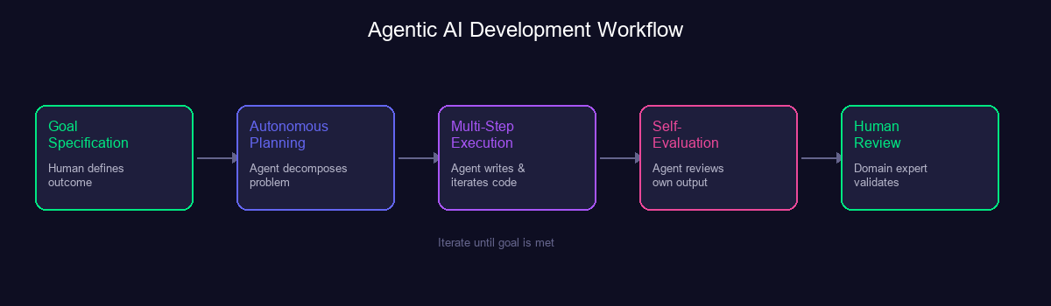
I want to move past the buzzwords and describe what agentic AI development actually feels like in practice.
When building the LC checker, I didn't write pseudocode or draw architecture diagrams. I described the problem domain in natural language — how UCP600 works, what document discrepancies look like, where banks currently waste the most analyst hours. The AI agent performed multi-step reasoning: it decomposed the problem, proposed a pipeline architecture, implemented the fuzzy matching engine, and structured the error handling — all within a single autonomous planning-and-execution loop.
This is what distinguishes agentic AI from conversational AI. I wasn't asking questions and getting answers. The agent was planning, executing, self-evaluating, and iterating — with me providing goal specification and quality judgment.
For Kavya, the agent's reasoning chain was different. The technical implementation was straightforward, but the evaluation function was culturally complex. I tested with actual verses from the Divya Prabandham and Thirukkural, assessing whether the agent correctly handled Tamil agglutinative morphology and the layered meanings in Bhakti poetry. The AI built the system. The human defined what "correct" means in a domain where correctness is subjective.

Three Observations on Human-Agent Collaboration

1. Goal Specification Beats Task Specification
Early on, I made the mistake of giving the agent implementation instructions — "use this library," "structure the service this way." The output was mediocre. The breakthrough came when I switched to outcome-based prompting: "Build a compliance pipeline that a junior trade ops analyst could trust without escalating." The agent's autonomous planning consistently produced better architectures than my prescriptive instructions did.
The skill isn't prompt engineering. It's domain fluency — knowing the problem space well enough to specify what "done" looks like, and having enough technical depth to evaluate whether the agent's reasoning chain led to a sound solution.

2. Agents Excel at Cross-Domain Tool Use
Kavya alone required the agent to operate across React Native, TypeScript, Anthropic's SDK (with dangerouslyAllowBrowser: true for Expo compatibility), Supabase with Row Level Security policies, platform-conditional storage (SecureStore on native, localStorage on web), CI/CD with GitHub Actions, Gradle build configuration, and classical Indian literary analysis.
No single developer I know spans all of that. The agent moved fluidly across every layer. It wasn't an expert in any one domain, but it demonstrated competent tool use across all of them. In software, most projects fail at the integration boundaries between specialties — an agent that can bridge those seams is more valuable than one that goes deep in a single area.

3. Context Window Is the Real Moat
My most productive sessions were long, iterative collaborations where the agent accumulated deep context — the design tokens, the data models, the deployment constraints, my conventions and preferences. By hour two, I could give sparse instructions and the agent would infer the rest from accumulated context.
This is why I believe the future of human-agent collaboration isn't about single prompts. It's about sustained working relationships with persistent memory and growing shared understanding — much like onboarding a senior engineer who gets better every day.

The Honest Assessment
Agentic AI didn't make me a better coder. It made my 20 years of experience in financial services, commodity trading, and technology dramatically more leveraged.
Every application used my domain knowledge for problem framing and solution evaluation. The agent handled the execution layer — the boilerplate, the API integrations, the cross-platform edge cases, the deployment orchestration. The work that used to consume 80% of development time and require coordinating multiple specialists.
But the agent also made confident mistakes. It referenced CSS classes that didn't exist in the codebase. It occasionally hallucinated API parameters. It proposed architectures that were technically sound but didn't account for real-world operational constraints I knew from experience.
The human-in-the-loop isn't a safety net. It's a requirement. The agent accelerates execution. The human ensures the execution is pointed in the right direction.

What I Believe This Means
We're in the early innings of a fundamental shift in how software gets built. The unit of production is moving from "team of specialists" to "domain expert + AI agent."
This doesn't eliminate the need for deep technical expertise. It restructures it. The value moves from implementation to orchestration — from writing code to directing autonomous systems that write code.
The professionals who will define this next era aren't the fastest coders or the most prolific prompt writers. They're the ones with enough domain depth to specify the right goals, enough technical fluency to evaluate the agent's reasoning, and enough judgment to know when to trust the agent and when to override it.
That's not a lower bar. It's a different one.

I'm exploring opportunities where I can apply this human-agent collaboration model — combining domain expertise in financial services with AI-augmented development.
Open to connecting with teams building at this intersection.

