From Temple Verses to Trade Finance
How a Personal Project Led Me Down the Agentic AI Rabbit Hole



This story doesn't start with a grand plan to explore agentic AI. It doesn't start with a business case or a technology thesis. It starts with something far simpler.
It starts with a prayer.

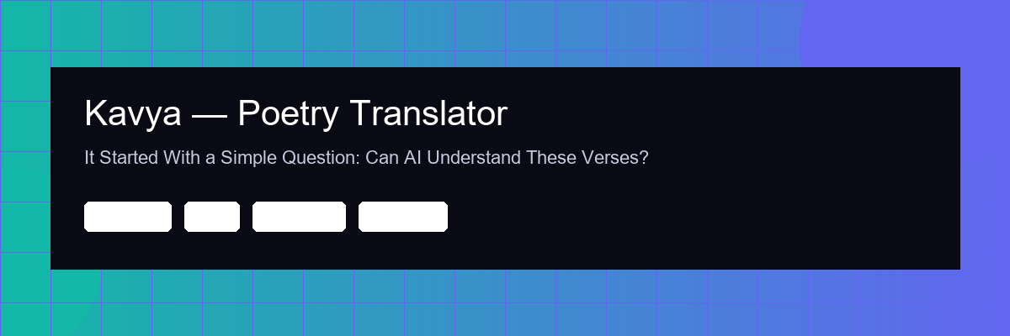

Chapter 1: The Verses That Started Everything
I grew up listening to my grandmother recite Tamil devotional poetry — the Divya Prabandham, Thirukkural, verses from the 108 Divyadesam temples. Beautiful, ancient words that I could hear but never fully understand. The classical Tamil in these poems is dense — agglutinative morphology, layered meanings, centuries of literary tradition compressed into a few lines.
I'd always wanted a way to truly understand what each verse meant. Not just a rough translation — the literal meaning of each line, the poetic interpretation, the historical context, the scholarly significance. The kind of explanation you'd get from a patient Tamil literature professor, not Google Translate.
So I tried something. I opened Claude Code — an agentic AI coding tool — and described what I wanted: a mobile app where I could type, photograph, or speak a Tamil verse, and get back a rich, structured translation with line-by-line breakdown, poetic interpretation in English, modern Tamil rendering, Hindi translation, and scholarly metadata.
I expected to spend weeks building it. The agent had a working prototype in a single session.
It scaffolded an Expo React Native project with file-based routing. It set up a Claude API integration with a 65-line system prompt I refined to handle the nuances of Sangam-era secular poetry differently from Bhakti devotional literature. It built four input methods — keyboard, camera with base64 image pipeline for vision model inference, speech-to-text, and clipboard. It configured expo-secure-store for API key management on native and localStorage fallback on web. It wired up Supabase for analytics and AsyncStorage with a 100-entry LIFO buffer for translation history.
I didn't write a single line of code. I described what I wanted, tested it with real verses from the Divya Prabandham, told the agent where the translations felt wrong, and watched it iterate. The cultural knowledge — knowing that a particular verse uses a specific raga reference, or that the sandhi compound in a Sanskrit shloka carries a double meaning — that was mine. The implementation was the agent's.
I named the app Kavya. It works. I use it regularly. And it changed how I thought about what's possible.
Stack: Expo Router, TypeScript strict mode, Claude API (claude-haiku-4-5-20251001), Supabase, GitHub Actions CI/CD.



Chapter 2: What If It Could Watch Markets While I Sleep?
Kavya planted a seed. If an AI agent could navigate the complexity of classical Tamil poetry — morphology, literary traditions, multi-script output — what could it do with structured numerical data?
I've traded markets for years. The tedious part was never the decision-making — it was the scanning. Watching charts across US equities, India NSE, options chains, and FX pairs. Running the same technical checks over and over. SMA/EMA crossovers. MACD divergence. RSI momentum shifts. Bollinger Band squeezes. It's repetitive, time-consuming, and the moment you look away, you miss something.
So I described the problem to the agent: build me a digital analyst that monitors multi-asset markets autonomously, runs technical analysis across a configurable set of indicators, scores opportunities using a weighted model, and — critically — backtests every signal against historical data before surfacing it.
The agent designed an observe-orient-decide pipeline. Data ingestion through WebSocket feeds. A NumPy and Pandas-powered computation layer for time-series analysis. A multi-factor scoring engine that weights signals by reliability and market regime. A backtesting module that validates strategies before they reach the dashboard.
What struck me wasn't just that it worked. It was how the agent reasoned about the architecture. When I said "I don't want false signals," it didn't just add a threshold filter. It proposed a confirmation mechanism — requiring convergence across multiple independent indicators before scoring an opportunity as actionable. That's the kind of thinking I'd expect from a quantitative analyst, not a coding tool.
The agent was operating as an autonomous reasoning system — decomposing my goal into sub-problems, proposing solutions for each, self-evaluating its own architecture, and iterating. This wasn't autocomplete. This was agentic AI in action: multi-step planning with tool use, goal-directed execution, and self-correction.
Now I was genuinely impressed. And I started thinking about a much harder problem.
Stack: FastAPI, React dashboard, NumPy/Pandas for quantitative analysis, WebSocket feeds.



Chapter 3: The Real Test — A Problem I Spent Years Solving Manually
In my years in commodity trading and trade finance, I've sat through countless Letter of Credit reviews. If you've worked in trade ops, you know the pain. A bank issues an LC. Documents come in — invoices, bills of lading, certificates of origin, inspection reports. Every single field has to be checked against UCP600 rules and the LC terms. Is the beneficiary name exactly right? Does the shipping date fall within the validity period? Does the goods description match letter-for-letter?
One missed discrepancy can delay payment by weeks. One overlooked clause can cost real money. Experienced trade ops analysts spend hours on a single set of documents, and they still miss things when they're fatigued.
This was the problem I knew better than any other. And if the agent could handle Tamil poetry and market analysis, I wanted to see if it could handle this.
I described the domain in detail. UCP600 articles. The types of discrepancies that matter — and the ones that don't. How banks actually review documents in practice. The difference between a critical discrepancy that stops payment and a minor one that gets waived.
The agent built something that genuinely surprised me.
It designed a multi-step agentic pipeline: PDF ingestion with a dual-path extraction system — native text extraction for digital documents, Tesseract OCR fallback for scanned copies. An entity recognition layer that identifies and extracts key fields (beneficiary, applicant, amounts, dates, goods description, shipping terms). A fuzzy matching engine using Levenshtein distance and token-set ratio for field comparison — because in trade documents, a slight variation in company name spelling shouldn't trigger a false discrepancy. And a severity classification system that grades findings as critical, major, or minor, with confidence scores.
The architecture wasn't what I would have designed. It was better. The agent proposed a confidence scoring mechanism I hadn't considered — assigning a reliability score to each extracted field based on OCR quality, then adjusting the compliance verdict accordingly. A scanned document with poor image quality gets flagged for human review on uncertain fields, while a clean digital PDF runs fully autonomously.
That's the moment I understood what agentic AI really means. It's not about generating code faster. It's about an autonomous system that can reason through a complex problem, propose a solution architecture, execute it, evaluate its own output, and refine — all within a goal-directed loop that I'm guiding but not micromanaging.
Stack: FastAPI, React, Python OCR pipeline, fuzzy matching engine, structured JSON output with confidence scoring.

What I Actually Learned About Human-Agent Collaboration
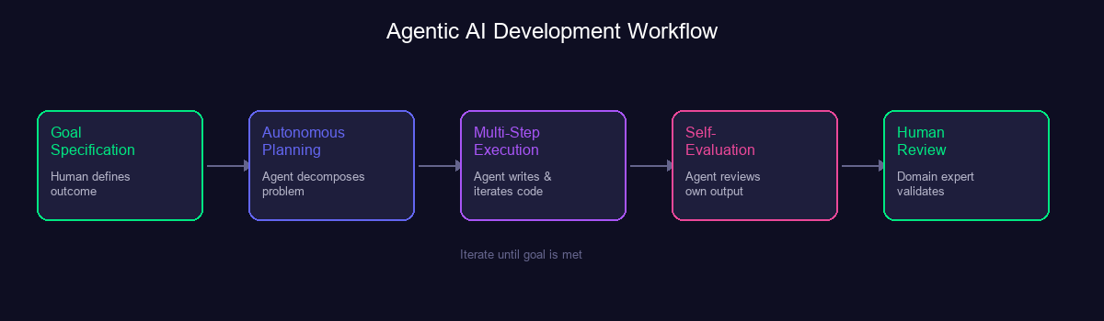

The agent gets better when you describe problems, not solutions.
My early instinct was to over-specify. "Use this library. Structure the API this way." The output was mediocre — I was constraining the agent's reasoning chain. The breakthrough came when I switched to outcome-based goal specification: "Build a compliance pipeline that a junior trade ops analyst could trust without escalating." The agent's autonomous planning produced better architectures than my prescriptive instructions every single time.

Context accumulation is the real multiplier.
The magic wasn't in any single prompt. It was in the accumulated context over a long session. By hour two of building Kavya, I could say "add camera input with the same error handling pattern" and the agent knew exactly which service layer, which error boundary, and which UI component to update. It had built a mental model of my project — design tokens, data flow, deployment pipeline, my preferences.
This is why "prompt engineering" is a misleading term. What actually matters is session engineering — the ability to build a productive, context-rich working relationship with an AI agent over an extended collaboration. The value compounds with shared context, exactly like working with a colleague who's been on the project for months.

The agent makes confident mistakes. That's where you earn your keep.
The agent once referenced a CSS class that didn't exist in the codebase. It occasionally hallucinated API parameters. On the LC checker, it initially proposed a string-matching approach for goods descriptions that anyone with trade finance experience would know doesn't work — because real documents use abbreviations, alternate spellings, and formatting variations that defeat exact matching.
I caught it. I corrected it. And the agent immediately adapted — that's when it proposed the fuzzy matching approach that ended up being far more robust.
The human-in-the-loop isn't a safety net. It's the evaluation function. The agent handles the execution chain. The human provides the judgment that the agent can't learn from training data alone — the kind that comes from years of actually doing the work.

Where This Leaves Me
I started this journey trying to understand my grandmother's prayers. I ended up rethinking how software gets built.
These three projects taught me that agentic AI doesn't replace domain expertise. It amplifies it. My 20 years in financial services and trading didn't become less valuable — they became dramatically more leveraged. The problems I can now tackle as a single person with an AI agent would have required a cross-functional team and months of development time just two years ago.
The shift isn't from human to machine. It's from implementation to orchestration. From writing code to directing autonomous reasoning systems that write code. From being a specialist who executes to being a generalist who guides.
The professionals who will thrive in this era aren't the fastest coders. They're the ones with enough domain depth to specify the right goals, enough technical fluency to evaluate an agent's reasoning chain, and enough real-world experience to catch the confident mistakes that only a human would notice.
And sometimes, the most important thing a human brings is knowing which question to ask in the first place — even when that question is as simple as "what does this verse actually mean?"

I'm exploring opportunities where I can apply this human-agent collaboration approach — combining deep domain expertise in financial services and trading with AI-augmented development.
If that resonates with what you're building, I'd love to connect.

What's been your experience with agentic AI? I'd love to hear your story in the comments.

