LINKEDIN ARTICLE — Publish from JSK AI Company Page
Copy the text below into LinkedIn's article editor. Upload the banner images separately.

————————————————————————————————————————

Stop Worrying About LLMs and RAG
Here's What AI Automation Actually Looks Like for Small Businesses

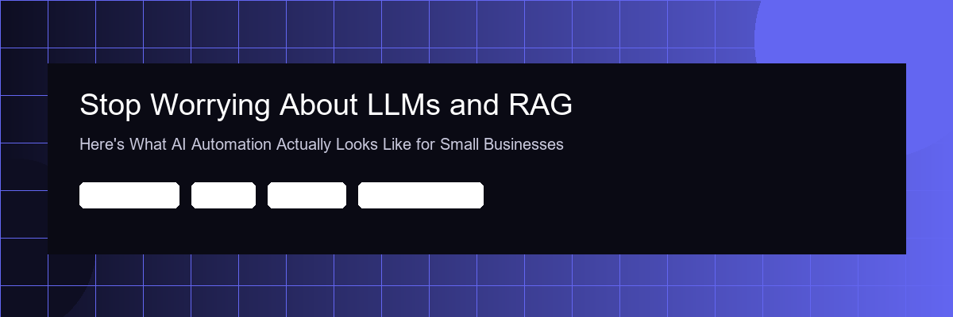

Every week, a new AI acronym trends on LinkedIn. LLMs. RAG. SLMs. Fine-tuning. Agentic frameworks.
If you're running a small business, this noise doesn't help you. It confuses you. And that confusion is costing you money — not because you're missing out on AI, but because the hype is stopping you from seeing what's already possible.
Let's cut through it.

What AI Automation Actually Looks Like for an MSME
Forget the buzzwords. Here's what AI automation means in practice for a business doing $500K–$5M in revenue:

1. Your invoices process themselves.
A document comes in — PDF, email, WhatsApp photo. AI reads it, extracts the data, matches it to your records, and flags exceptions. You approve. Done. What used to take 2 hours now takes 30 seconds.
2. Your customers get answers at 2am.
Not a "we'll get back to you" message. Actual answers — product details, order status, pricing — from an AI assistant trained on your business. No overtime. No missed enquiries.
3. Your leads don't go cold.
When someone enquires on WhatsApp, they get an instant, personalised response. Not a template. A real conversation that qualifies them and books a call. Response time drops from 24 hours to instant.
4. Your reports write themselves.
Daily sales summaries, inventory alerts, outstanding payment reminders — generated and sent to you before your morning coffee. No one sits there compiling spreadsheets anymore.
5. Your compliance checks run on autopilot.
Document verification, regulatory checklists, data validation — tasks that follow rules are perfect for AI. It checks everything, every time, without fatigue.
None of this requires you to understand what a "large language model" is. You just need the right setup.



The Real Question Isn't "Should I Use AI?" — It's "What Should I Automate First?"
Most small businesses have 3–5 workflows that eat up hours every week but follow predictable patterns. These are your automation goldmines:
- Data entry from documents, forms, or messages
- Customer enquiries that ask the same 20 questions
- Follow-ups that fall through the cracks
- Reporting that someone compiles manually
- Compliance checks against long checklists

If any of these sound familiar, you don't need a $50K digital transformation project. You need someone to sit with you for 30 minutes, map your workflows, and show you exactly what can be automated — and what the impact would be.

Why Most Small Businesses Haven't Automated Yet
It's not the cost. AI automation for MSMEs is more affordable than most people think — often less than the cost of one part-time hire.
It's the jargon barrier.
When every AI company leads with "we leverage cutting-edge LLMs with retrieval-augmented generation pipelines," most business owners (rightly) tune out. They don't want a technology lecture. They want to know:
Will this save me time?
Will this save me money?
How fast can it be set up?

The answers, for most MSME workflows, are: Yes. Yes. Days, not months.



A Simple Litmus Test
Ask yourself:
"Is there a task my team does every day that follows roughly the same steps, takes more than 30 minutes, and doesn't require creative judgment?"

If yes — that's automatable. Today. Without hiring a developer, without learning Python, and without understanding what GPT stands for.

————————————————————————————————————————

The businesses that win with AI aren't the ones with the biggest budgets. They're the ones that start with one workflow, see the result, and build from there.

Start small. Start now.

JSK AI helps small businesses automate their workflows — no jargon, no long contracts, just practical solutions delivered in days.
Book a free 30-minute discovery call: https://jskai.ai/#cta

#AIAutomation #SmallBusiness #MSME #DigitalTransformation #NoJargon

