QC and Annotation

# Quality Control

#### Density Plots of Beta Values

## [preprocessNoob] Applying R/G ratio flip to fix dye bias...

## [preprocessNoob] Applying R/G ratio flip to fix dye bias...

## [preprocessNoob] Applying R/G ratio flip to fix dye bias...

## [preprocessNoob] Applying R/G ratio flip to fix dye bias...

## [preprocessNoob] Applying R/G ratio flip to fix dye bias...

## [preprocessNoob] Applying R/G ratio flip to fix dye bias...

## [preprocessNoob] Applying R/G ratio flip to fix dye bias...

## [preprocessNoob] Applying R/G ratio flip to fix dye bias...

## [preprocessNoob] Applying R/G ratio flip to fix dye bias...

## [preprocessNoob] Applying R/G ratio flip to fix dye bias...

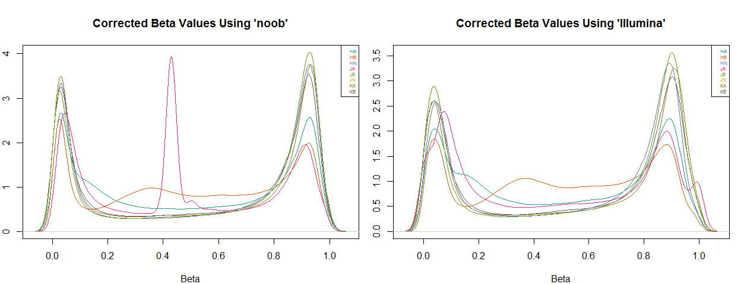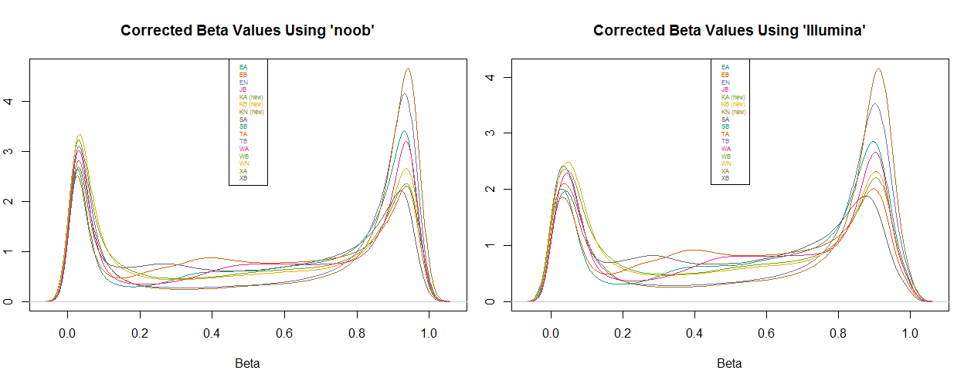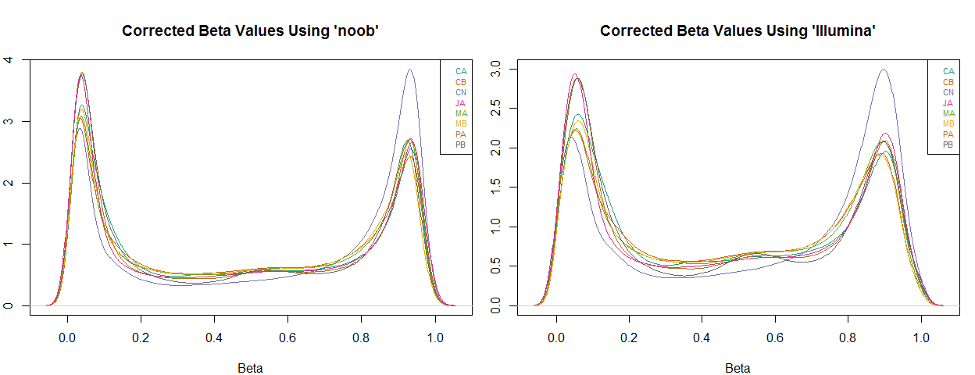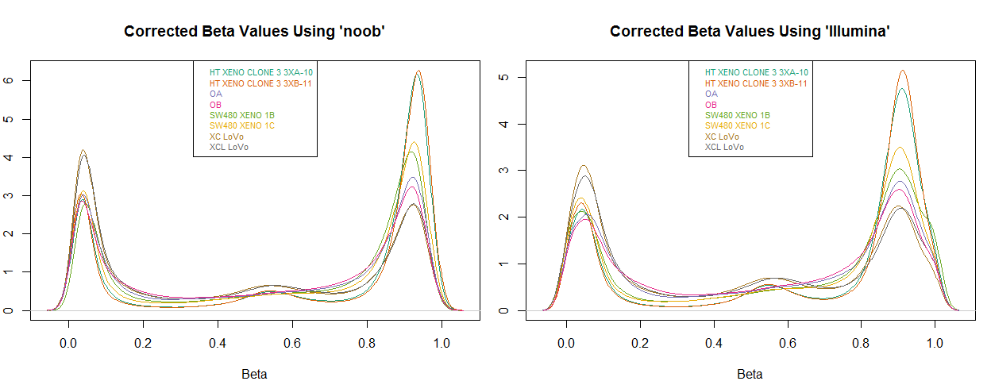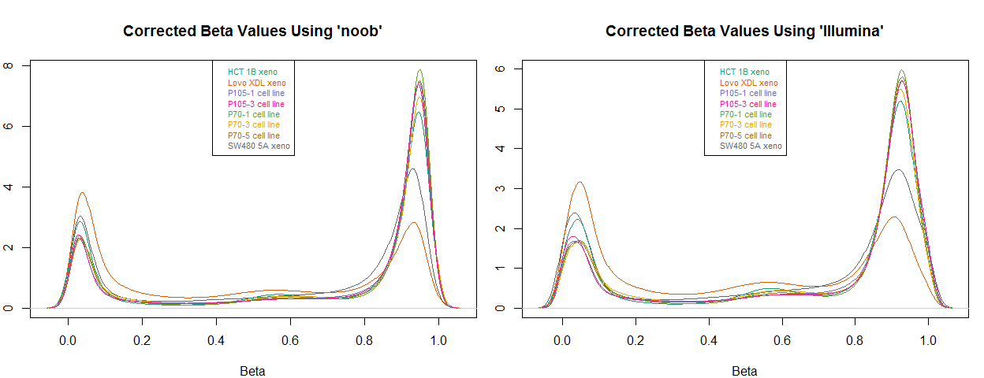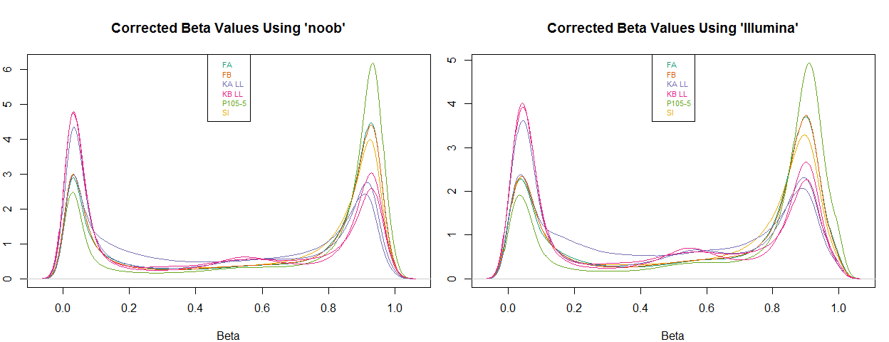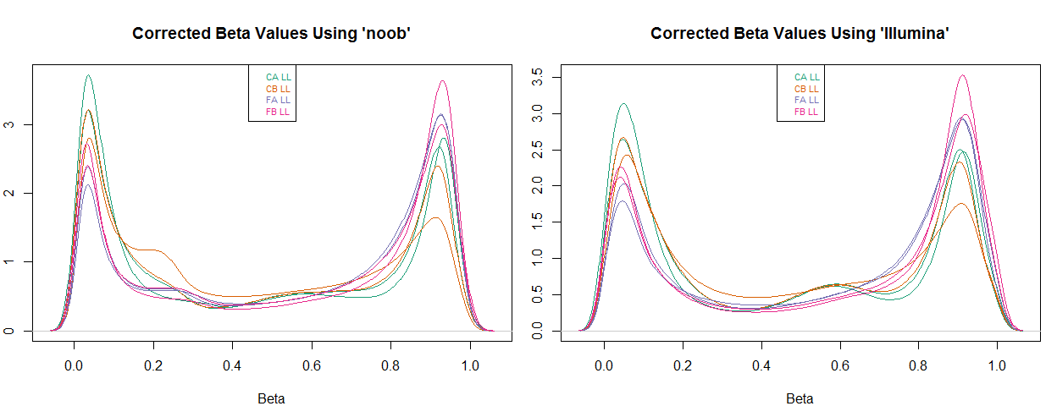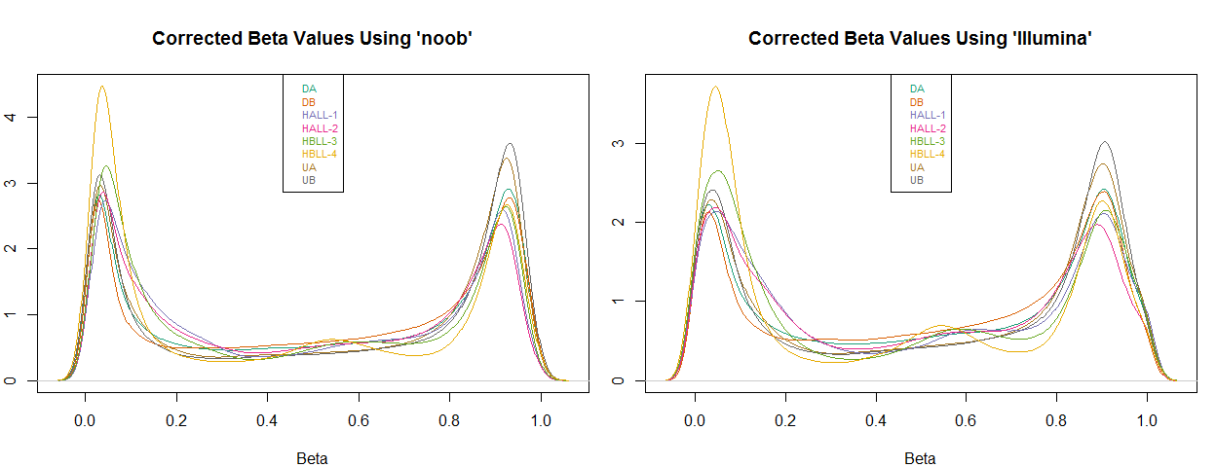

#### Scatterplots of Median Unmeth Signal versus Medain Meth Signal

* preprocessNoob *

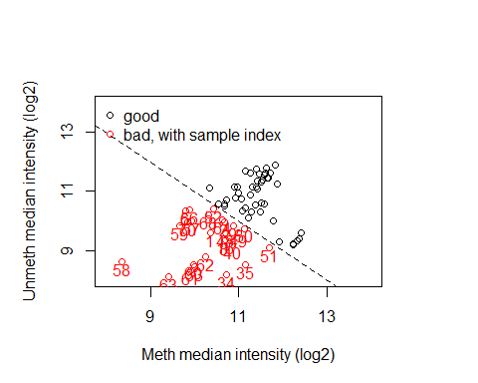

* preprocessIllumina *

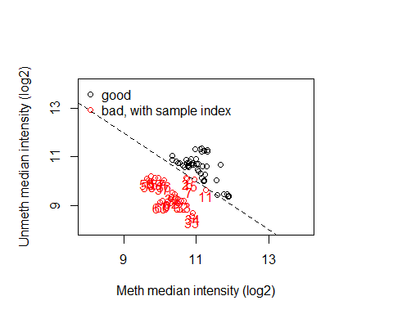

#### Multidimensional Scaling Plot

* preprocessNoob

## [1] 30000

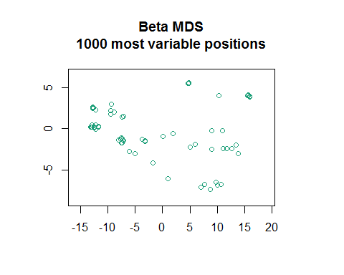

* preprocessIllumina

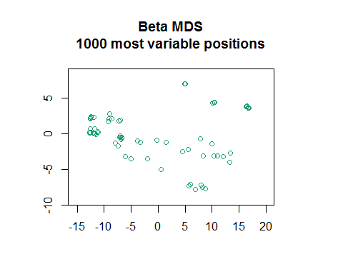

#### Predicting Sex

