This is an inline math formula:\(\sum_{i=0}^N\sqrt{2\pi\sigma^2}\exp(\frac{(x_i-\mu)^2}{\sigma^2})\) (should look as the picture above).

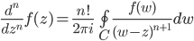
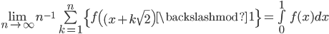
;
various cheating here(\langle/\rangle are pasted in, norm is double abs)
