EARNINGS UPDATE
PDD Holdings Inc. (NASDAQ: PDD)
Q1 2026 Results | May 27, 2026

RATING  BUY | PRICE TARGET (NEW)  US$125 | PRIOR PRICE TARGET  US$165 | CURRENT PRICE  ~US$86

KEY TAKEAWAYS — Q1 2026 RESULTS
■ REVENUE MISS (−3.4%): Revenue of RMB106.2B (US$15.4B) grew 11% YoY, missing Bloomberg consensus of US$15.94B by ~$540M. Revenue deceleration reflects Temu model transition from marketplace to First Party Brand and macro headwinds in key markets.
■ SIGNIFICANT EPS MISS (−35%): Non-GAAP diluted EPS of RMB9.51 (US$1.38) missed consensus of US$2.13 by $0.75 or 35.2%. Management is deliberately suppressing near-term EPS to fund a ¥100B (US$13.8B) three-year supply chain and First Party Brand initiative.
■ NET INCOME −15% YoY: GAAP net income fell to RMB12.5B (-15% YoY) despite operating profit growing +22% YoY to RMB19.6B. The divergence reflects elevated investment expenditure and higher effective tax rates below the operating line.
■ TRANSACTION SERVICES ACCELERATION: Transaction services revenue grew +20% YoY to RMB56.3B, reaching 53% of total revenue (+400bps YoY mix shift). This signals platform monetisation deepening even as marketing services growth stalls at +2.5% YoY.
■ STRATEGIC PIVOT: FIRST PARTY BRAND: Management launched a dedicated First Party Brand entity in March 2026, committing RMB100B over three years. This replicates Amazon's playbook of platform → owned brand for supply chain control and margin enhancement over the long term.
■ RATING MAINTAINED: BUY | PT CUT $165 → $125: We lower our price target from $165 to $125 (−24%) reflecting estimate cuts on near-term EPS suppression, but maintain BUY given 45% upside to PT at current ~$86 price and the long-term validity of the supply chain investment thesis.

QUARTERLY RESULTS SUMMARY
Metric | Q1 2025A | Q1 2026A | YoY Δ | Consensus Est. | Beat / Miss
Total Revenue (RMB B) | 95.7 | 106.2 | +11.0% | 109.3* | −3.4%
— Online Marketing Services | 48.7 | 49.9 | +2.5% | — | —
— Transaction Services | 47.0 | 56.3 | +19.8% | — | —
Gross Profit (RMB B) | 54.8 | 59.3 | +8.2% | — | —
Gross Margin | 57.3% | 55.8% | −150bps | — | —
Operating Profit (RMB B) | 16.1 | 19.6 | +21.7% | — | —
Operating Margin | 16.8% | 18.5% | +170bps | — | —
Net Income (RMB B) | 14.7 | 12.5 | −15.0% | — | —
Net Margin | 15.4% | 11.8% | −360bps | — | —
Non-GAAP Net Income (RMB B) | 16.9 | 14.1 | −16.6% | — | —
Non-GAAP Diluted EPS/ADS (RMB) | 11.41 | 9.51 | −16.6% | 15.47* | −38.5%
Non-GAAP Diluted EPS/ADS (US$) | $1.57 | $1.38 | −12.1% | $2.13* | −35.2%
Operating Cash Flow (RMB B) | 15.5 | 16.4 | +5.8% | — | —
Cash & Investments (RMB B) | — | 436.1 | — | — | —
* Bloomberg consensus as of May 26, 2026 (day prior to earnings release).

1. DETAILED RESULTS ANALYSIS
1.1 Revenue: 11% YoY Growth — Below Expectations
PDD Holdings reported Q1 2026 total revenues of RMB106.2 billion (US$15.4 billion), representing 11.0% year-over-year growth. The result came in $540 million (3.4%) below Bloomberg consensus of US$15.94 billion, marking the second consecutive quarter of consensus revenue misses. The miss reflects a deliberate structural shift in the Temu international business model rather than cyclical demand weakness.
Transaction services revenues of RMB56.3 billion (+19.8% YoY) were the growth engine, driven by deepened monetisation of logistics fulfilment, payment processing, and supply chain services. This segment now represents 53.0% of total revenue, up 400bps from 49.1% in Q1 2025. In contrast, online marketing services revenues grew a modest 2.5% YoY to RMB49.9 billion, reflecting: (1) Temu's transition away from high-cost external paid marketing toward proprietary supply chain efficiency as the primary growth lever; and (2) softening advertising demand on the Pinduoduo domestic platform amid increased competitive pressure from Douyin (ByteDance) and Kuaishou.
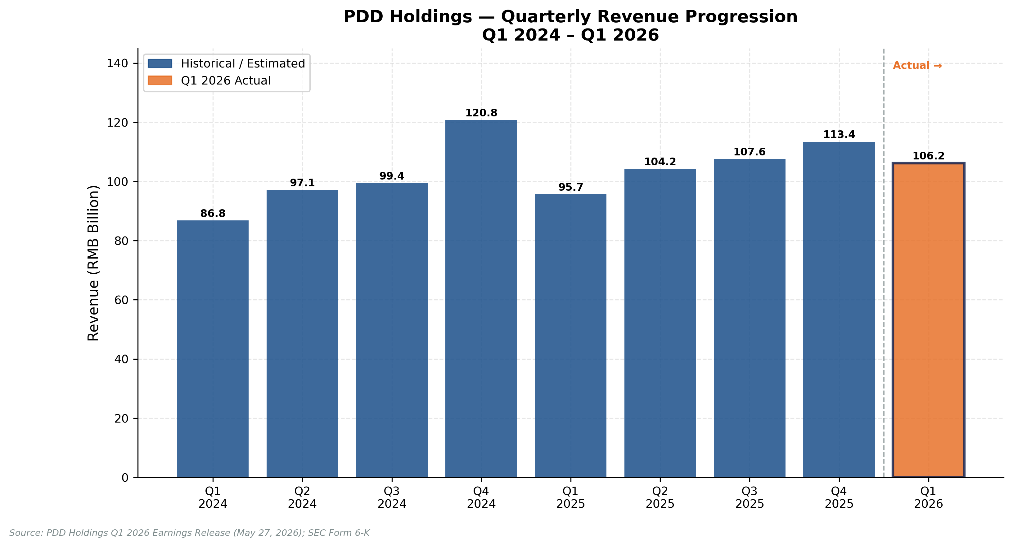
Figure 1: PDD Holdings Quarterly Revenue (RMB B) — Q1 2024 to Q1 2026
Source: PDD Holdings filings; analyst estimates for Q2–Q4 2025
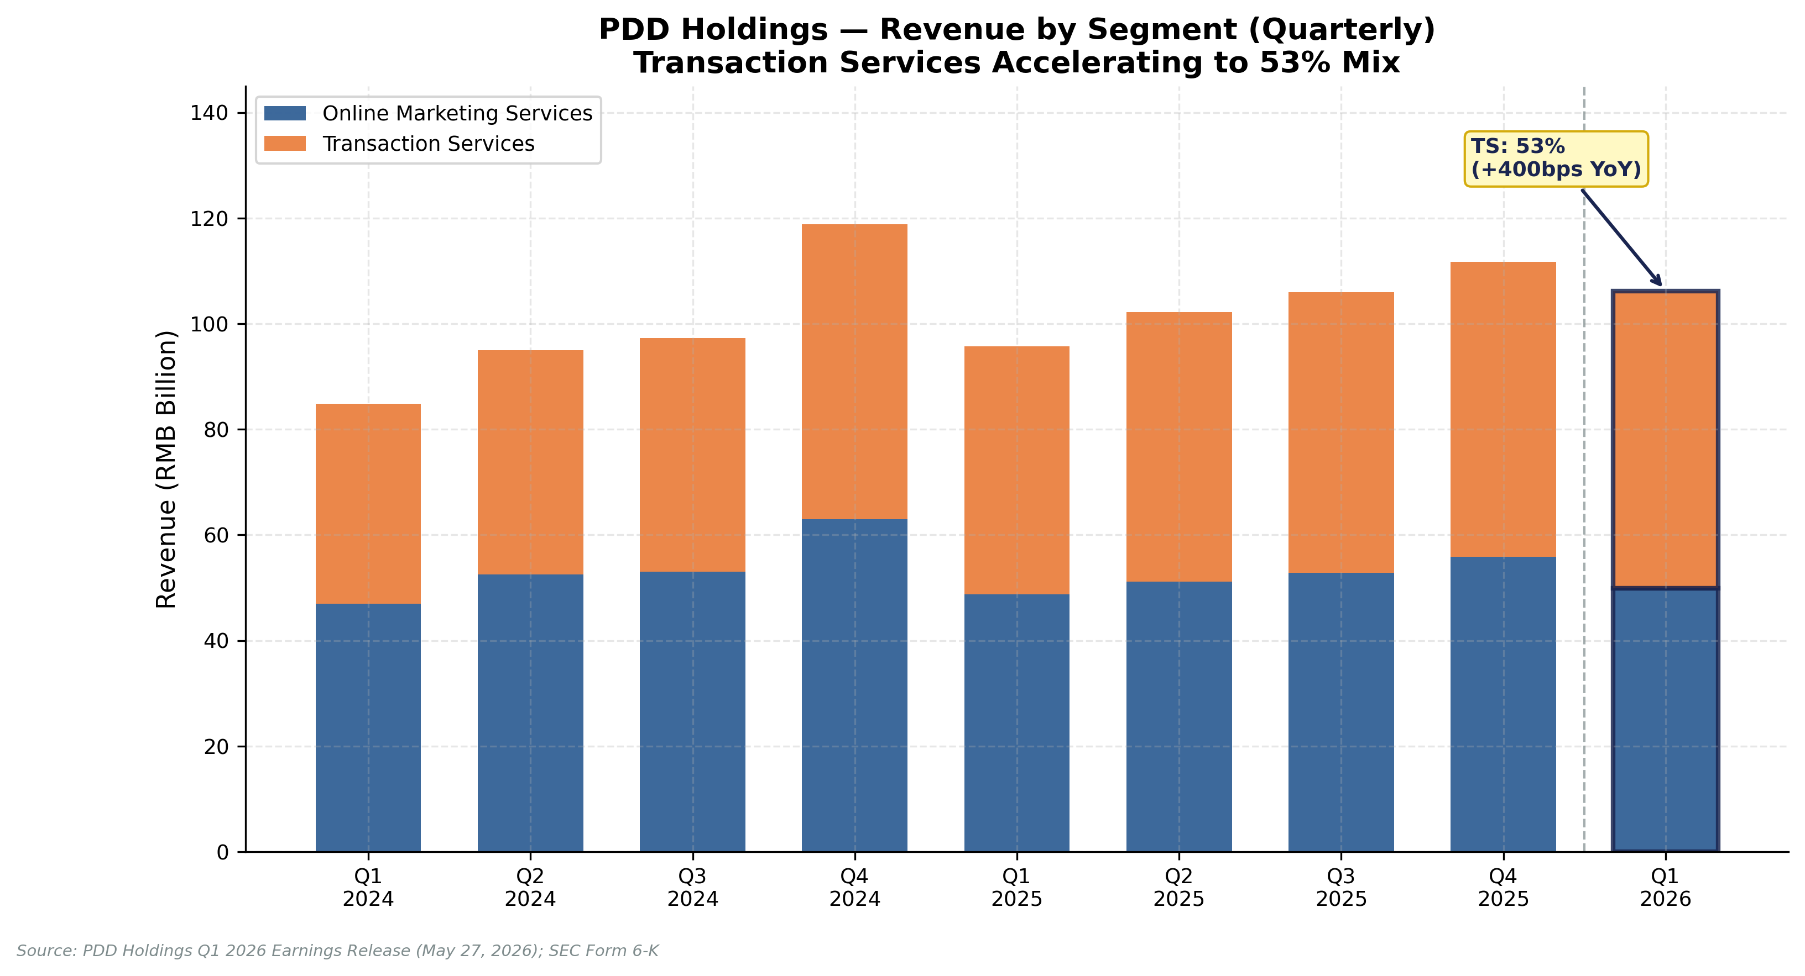
Figure 2: Revenue by Segment — Transaction Services Reaching 53% Mix
Source: PDD Holdings Q1 2026 Earnings Release (May 27, 2026); Form 6-K
1.2 Profitability: Operating Leverage Intact; Net Income Impacted by Investment
The headline EPS miss masks an important distinction: operating profitability improved materially year-on-year. Operating profit of RMB19.6 billion grew 21.7% YoY, with operating margin expanding 170bps to 18.5%. This improvement reflects improved variable cost efficiency in logistics and technology infrastructure, partially offset by higher cost of revenues (+14.7% YoY to RMB46.9B), driven by fulfilment costs, payment processing fees, and bandwidth expenses.
However, GAAP net income fell 15.0% YoY to RMB12.5 billion, and non-GAAP net income declined 16.6% to RMB14.1 billion. The sharp divergence between operating profit (+22%) and net income (−15%) reflects three factors below the operating line: (1) higher tax provisions as the preferential tax treatment for certain PRC entities phases out; (2) increased financial investments in the new First Party Brand entity recognised below the line; and (3) elevated stock-based compensation amortisation.
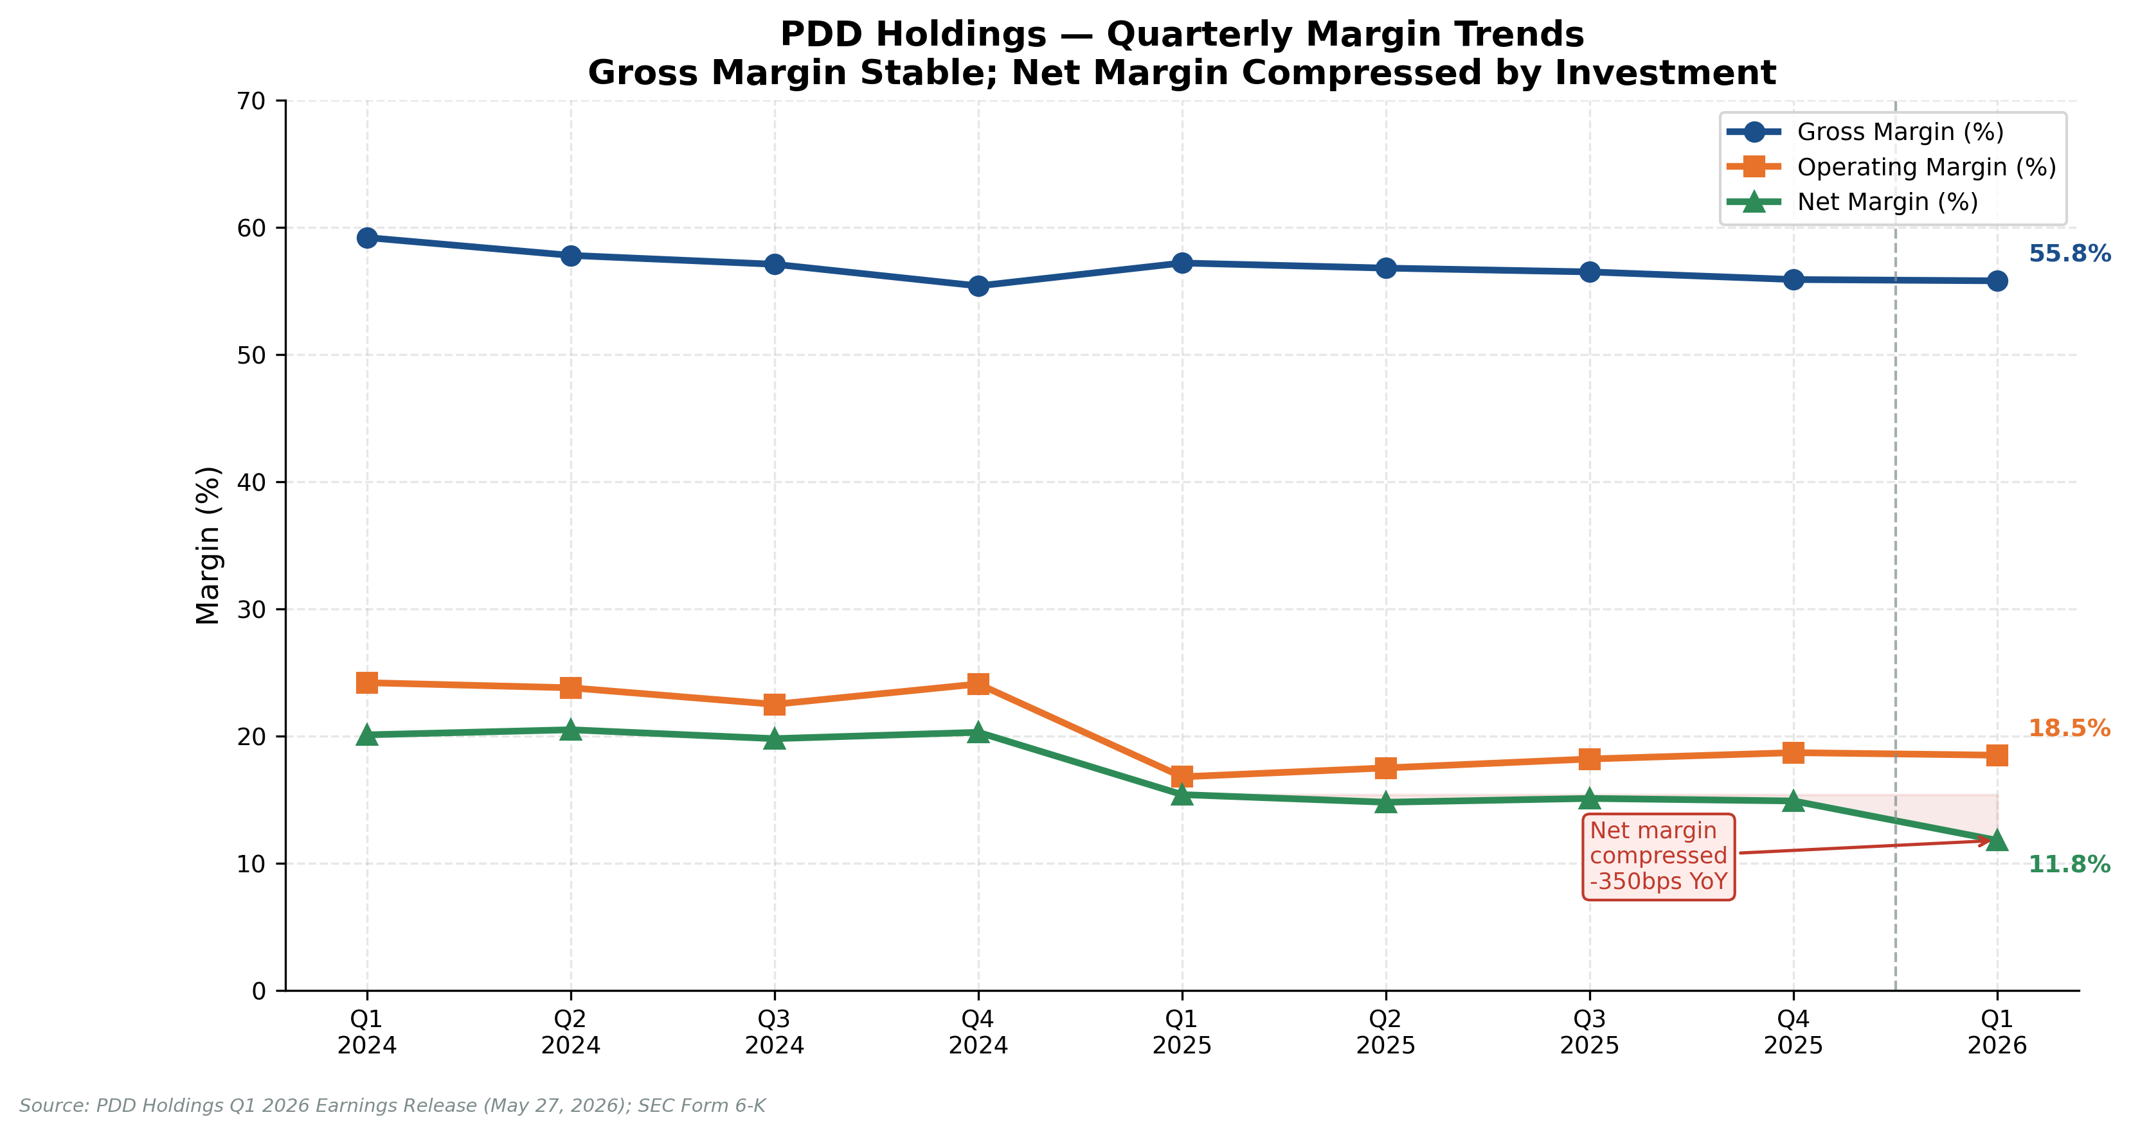
Figure 3: Quarterly Margin Trends — Gross Margin Stable; Net Margin Compressed 360bps YoY
Source: PDD Holdings Q1 2026 Earnings Release (May 27, 2026); Form 6-K

2. KEY METRICS & MANAGEMENT GUIDANCE
2.1 EPS: Intentional Miss, Not a Business Deterioration
Non-GAAP diluted EPS of RMB9.51 (US$1.38) per ADS declined 16.6% YoY and missed Bloomberg consensus of US$2.13 by 35.2% — the largest quarterly EPS miss in PDD's history as a public company. We want to emphasise to clients that this is a strategic choice, not a sign of business deterioration.
Management's language on the earnings call was unambiguous: "Instead of focusing on short-term financial performance, we prioritise the healthy development of the platform ecosystem." The company is funding this through: (1) RMB100 billion committed to First Party Brand over three years (~RMB33B per year, or ~31% of current annual revenues); (2) free logistics to rural villages (covering >70% of villages in pilot regions); (3) >20 food safety compliance initiatives launched in Q1; and (4) direct agricultural supply chain subsidies.
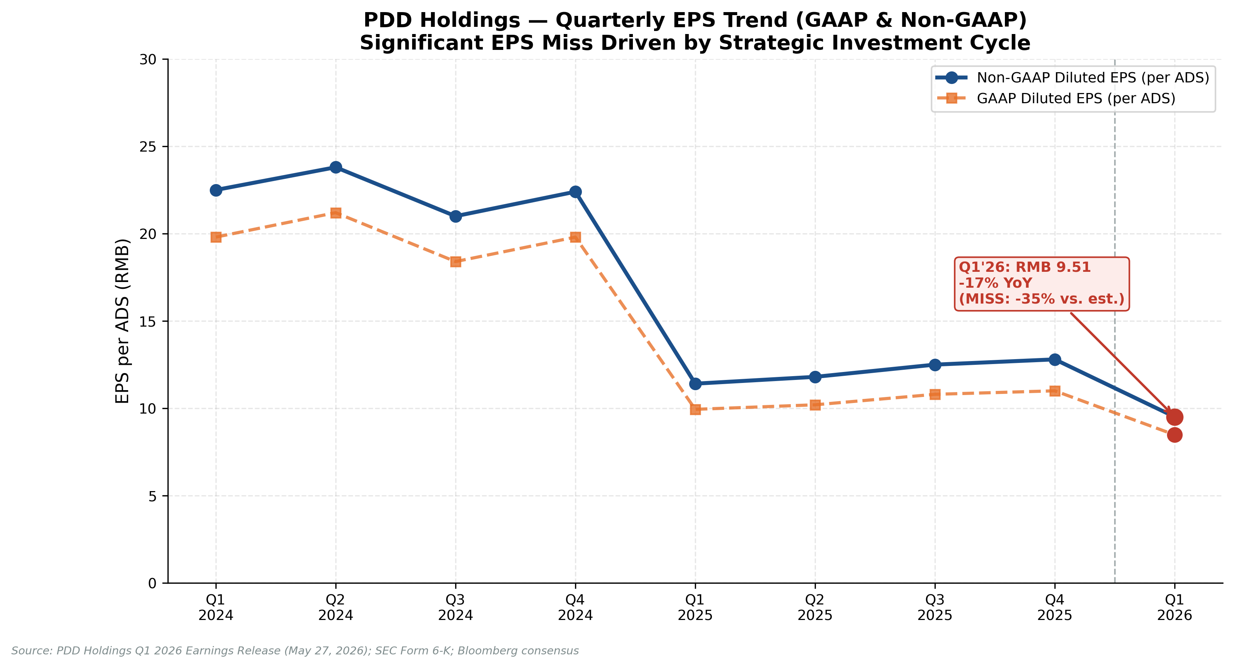
Figure 4: Quarterly EPS Trend (GAAP & Non-GAAP per ADS) — Q1 2024 to Q1 2026
Source: PDD Holdings Q1 2026 Earnings Release; Bloomberg consensus
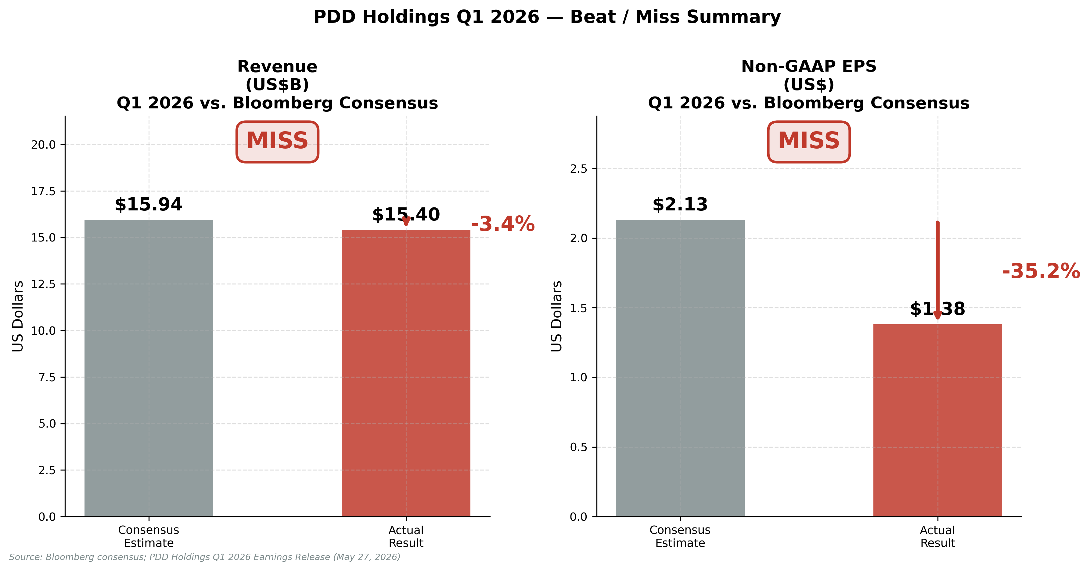
Figure 5: Q1 2026 Beat/Miss vs. Bloomberg Consensus
Source: Bloomberg consensus (May 26, 2026); PDD Holdings Q1 2026 Earnings Release
2.2 Revenue Mix Shift: Structural, Not Cyclical
The acceleration of transaction services (+20% YoY) relative to online marketing (+2.5% YoY) is a deliberate strategic signal. Transaction services revenues — which encompass Temu fulfilment fees, domestic logistics network charges, and merchant payment processing — grow as PDD builds proprietary infrastructure. This reduces PDD's dependence on paid advertising ROI cycles and creates more durable, asset-backed revenue streams. We view the growing transaction services mix as a long-term positive for revenue quality, even though it is currently margin-dilutive during the build-out phase.
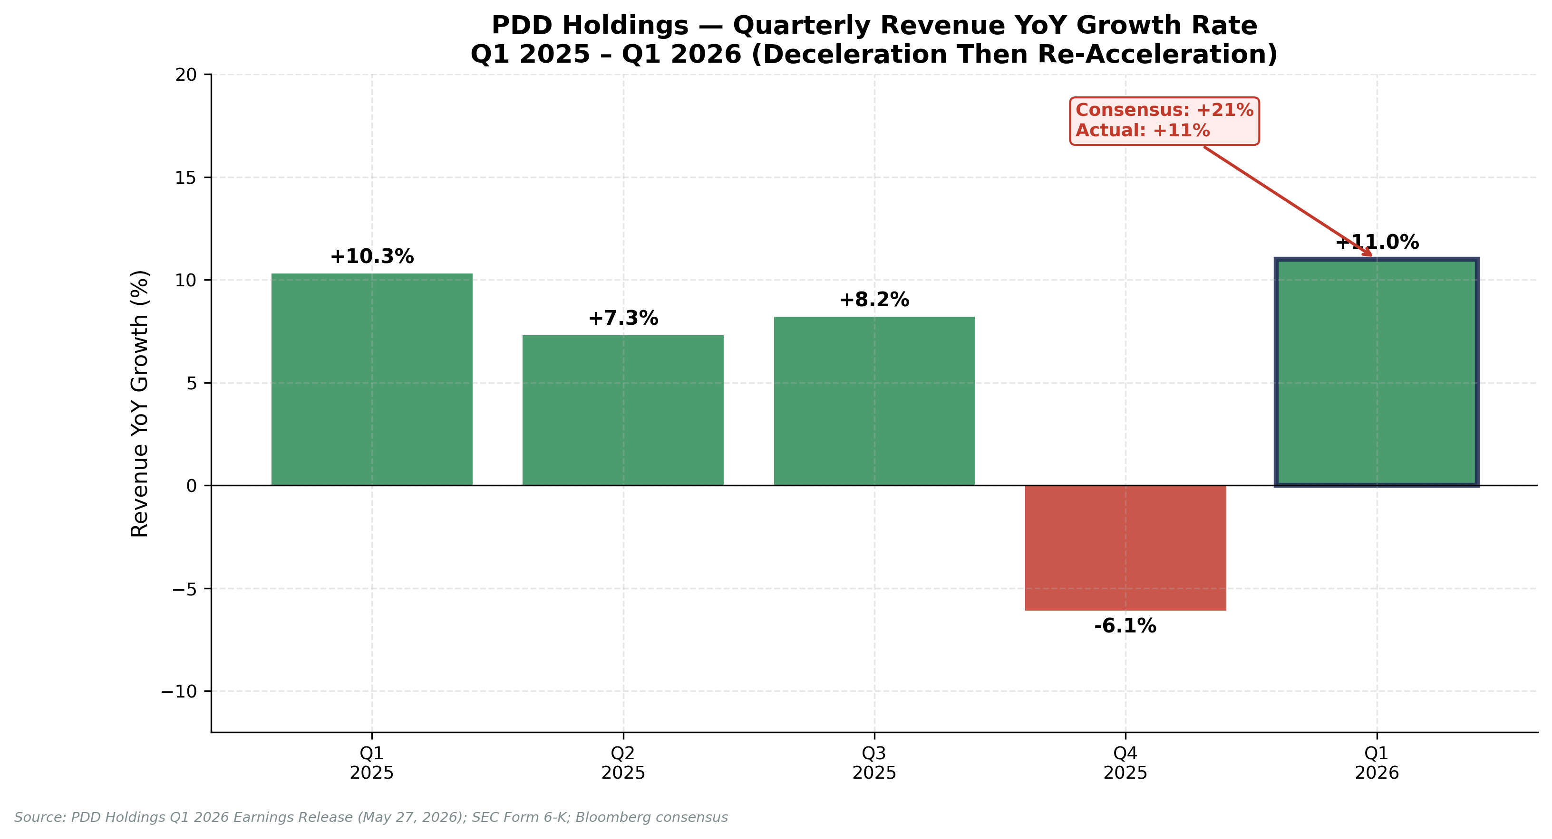
Figure 6: Quarterly Revenue YoY Growth Rate — Deceleration Then Re-Acceleration
Source: PDD Holdings Q1 2026 Earnings Release; Bloomberg consensus
2.3 Cost Structure & Operating Leverage
Cost of revenues rose 14.7% YoY to RMB46.9B in Q1 2026, slightly ahead of revenue growth of 11.0%, creating 150bps of gross margin compression. However, operating expenses (ex-COGS) were well-controlled, with sales & marketing up only 9.3% YoY to RMB22.4B (a deceleration from the Temu global expansion marketing spend of 2023–2024), and R&D declining 7.7% YoY to RMB13.2B. The net result was operating leverage of +170bps at the operating margin level, a positive indicator of underlying platform efficiency.
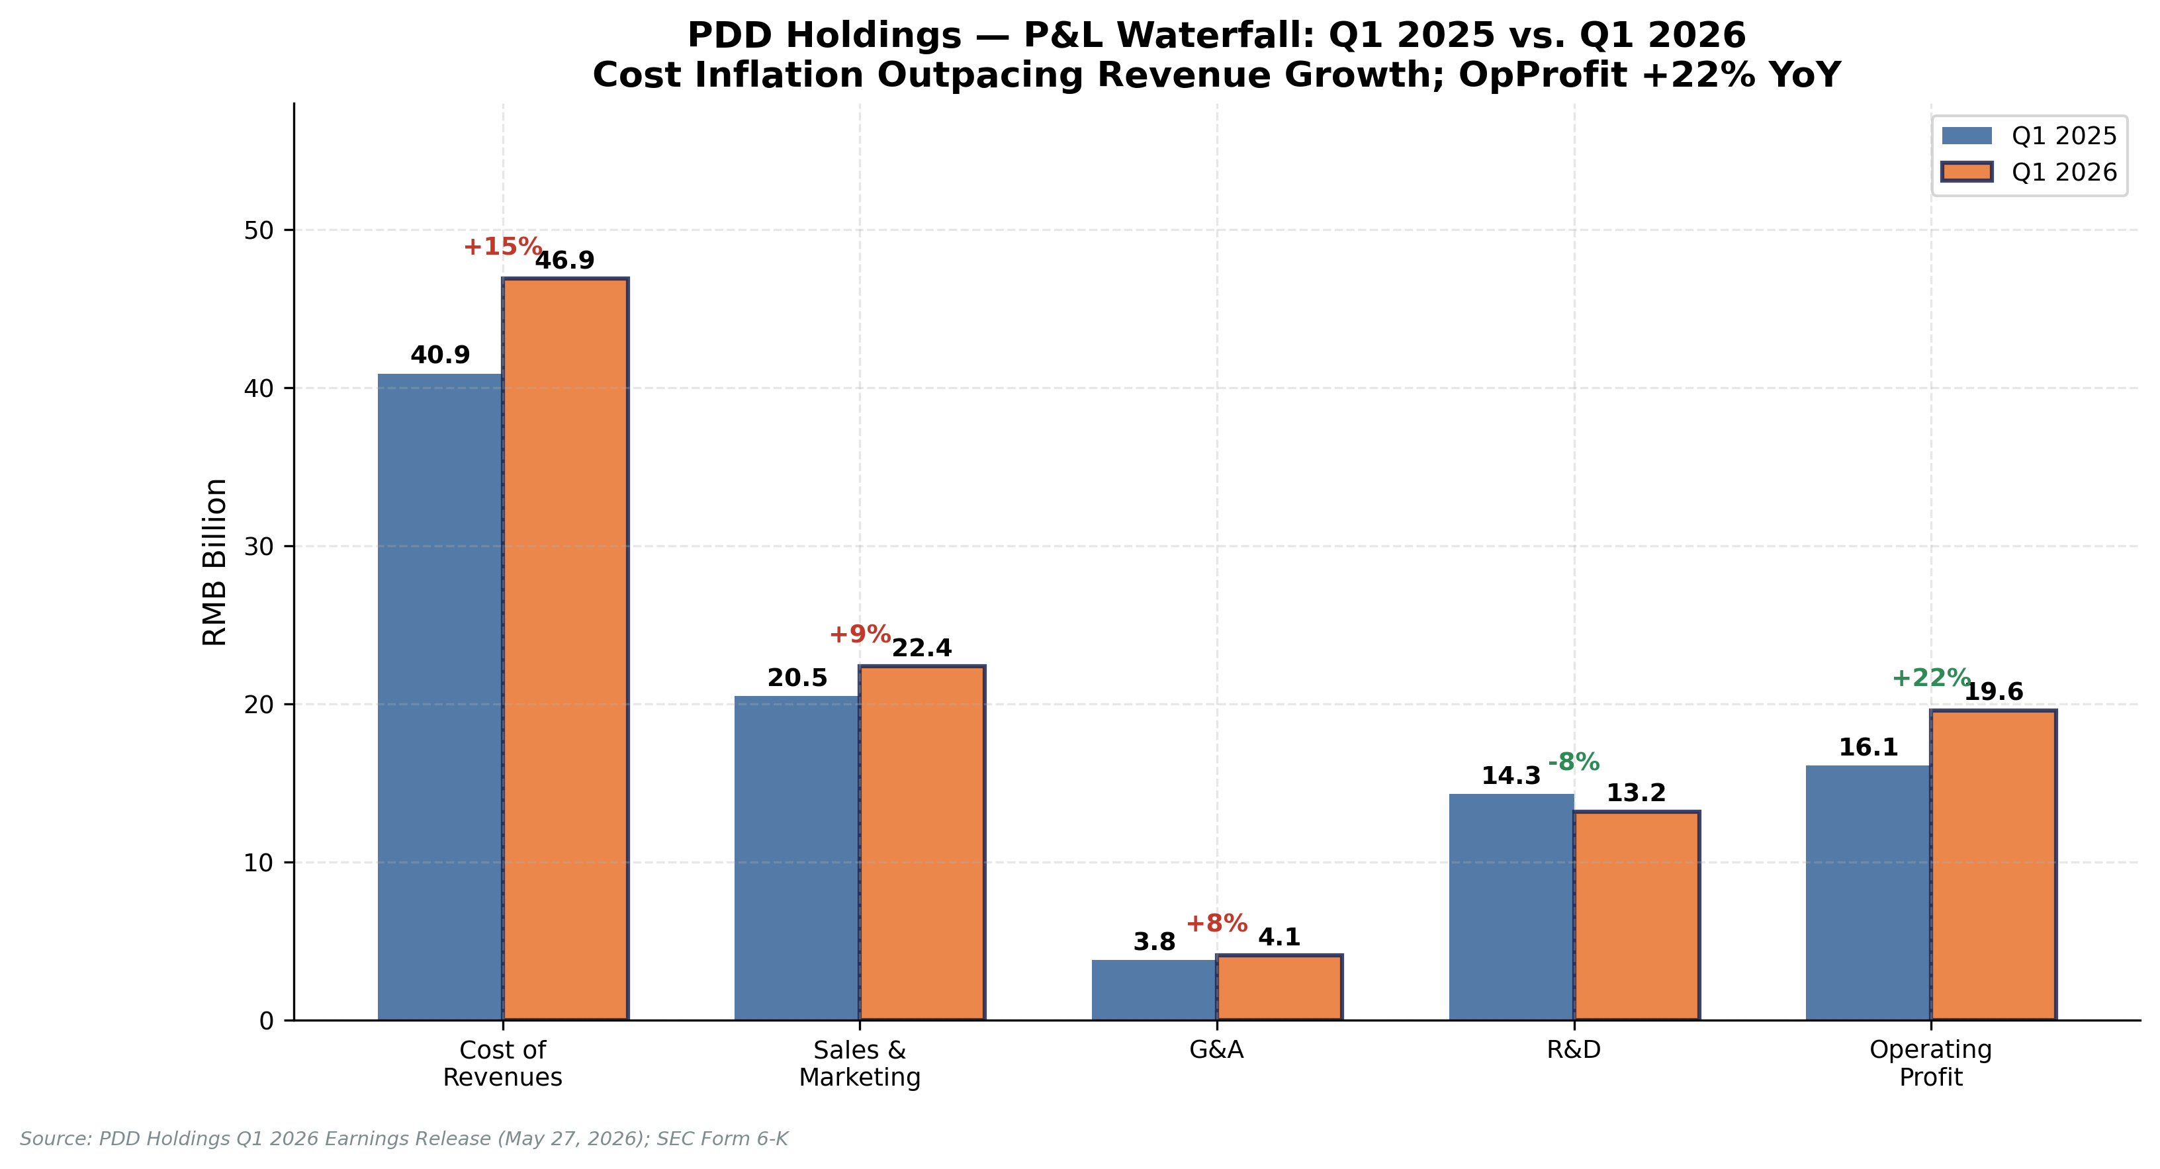
Figure 7: P&L Cost Waterfall — Q1 2025 vs. Q1 2026 (RMB Billion)
Source: PDD Holdings Q1 2026 Earnings Release (May 27, 2026); Form 6-K
2.4 Balance Sheet & Cash Flow
PDD maintains a fortress balance sheet with RMB436.1 billion (US$63.2 billion) in cash and short-term investments — equivalent to approximately $41.70 per ADS, or roughly 49% of the post-earnings share price. Operating cash flow of RMB16.4 billion (+5.8% YoY) demonstrated continued strong cash generation. The company has zero long-term debt on a standalone basis. This cash pile provides significant optionality for the planned RMB100B investment programme, share buybacks, and any regulatory resolution costs related to the ongoing Temu compliance investigations.
2.5 Guidance: No Quantitative Guidance (Per Policy)
PDD does not provide quantitative revenue or earnings guidance, consistent with its long-standing policy. Management qualitative guidance from the Q1 2026 earnings call can be summarised as follows:
- Investment cycle continuation: The RMB100B First Party Brand commitment is a multi-year initiative. Clients should not expect EPS recovery in the near term (Q2–Q3 2026).
- Temu model transformation: "We will deepen the development of the First Party Brand model in the global market." This confirms Temu is moving from pure marketplace to an owned-inventory / brand model, initially targeting key SKU categories.
- Agricultural investment: Continued prioritisation of direct agricultural supply chains, rural logistics, and food safety compliance. Over 20 food safety programmes launched in Q1 alone.
- Regulatory compliance: Management acknowledged ongoing regulatory scrutiny but did not quantify compliance costs. They indicated the company is "actively cooperating" with all relevant authorities.

3. UPDATED INVESTMENT THESIS
3.1 Thesis Intact Despite Near-Term EPS Pressure
Our investment thesis at initiation rested on three pillars: (1) PDD's C2M supply chain dominance in China; (2) Temu's global expansion trajectory; and (3) the company's ability to leverage these advantages toward sustained, above-consensus profitability. Following Q1 2026 results, we revisit each pillar.
Pillar 1 — China Supply Chain Dominance: INTACT. The domestic Pinduoduo platform continues to generate robust transaction services revenue growth (+20% YoY consolidated), confirming that monetisation of the supply chain infrastructure is deepening. Agricultural and industrial C2M programmes are expanding. We see no structural deterioration in the core domestic franchise.
Pillar 2 — Temu Global Expansion: TRANSITIONING. The narrative has shifted from "hyper-growth marketplace" to "First Party Brand and supply chain capability builder." This is strategically sound — Temu faced regulatory pressure on the de minimis exemption in the US and tariff risks — but it will result in a multi-quarter period of compressed revenue growth and elevated capital expenditure before benefits materialise. We reduce our Temu revenue CAGR estimate from 25% to 18% through FY2028.
Pillar 3 — Path to Superior Profitability: DELAYED, NOT ABANDONED. Management is making a deliberate, sizeable investment that delays profitability recovery. We now expect Non-GAAP operating margin to trough in H1 2026 (~17-19%) before recovering to 22-25% by FY2027-2028 as the First Party Brand generates operating leverage. EPS recovery begins in FY2027E as investment normalises.
3.2 Key Risks (Updated)
- Regulatory escalation (HIGH): Temu faces ongoing investigations in the US (CPSC product safety), EU (Digital Services Act compliance), and ongoing CNIPA actions in China. Any material fines or platform restrictions could be a significant earnings headwind.
- Investment cycle overshoot (MEDIUM): If the RMB100B commitment is front-loaded or materially exceeded, near-term EPS suppression could persist well into FY2027.
- Online marketing revenue stagnation (MEDIUM): The 2.5% YoY growth in marketing services suggests Pinduoduo's domestic advertising revenue may be approaching maturity. Sustained stagnation would cap long-term revenue growth.
- Tariff and trade policy (MEDIUM): US Section 301 tariffs and the expiration of the de minimis exemption for low-value parcels create structural headwinds for Temu's original marketplace model.
- Macro China softness (LOW-MEDIUM): Consumer sentiment in China remains fragile. A deeper-than-expected domestic consumption slowdown could impact Pinduoduo GMV growth.

4. VALUATION & UPDATED ESTIMATES
4.1 Estimate Revisions
We reduce our revenue and earnings estimates meaningfully to reflect: (a) the confirmed Q1 2026 EPS run-rate; (b) management's qualitative guidance on continued near-term investment; and (c) our reduced Temu revenue growth assumptions through FY2028. The table below summarises our revised estimates.
 | FY2025E | FY2026E (Prior) | FY2026E (New) | Δ% | FY2027E (Prior) | FY2027E (New) | Δ%
Revenue (RMB B) | 421 | 450 | 432 | −4.0% | 510 | 498 | −2.4%
YoY Growth | +10.5% | +7.0% | +2.6% | — | +13.3% | +15.3% | —
Gross Margin | 56.1% | 56.5% | 55.5% | −100bps | 57.0% | 56.5% | −50bps
Non-GAAP Op. Margin | 18.3% | 21.5% | 18.8% | −270bps | 23.0% | 21.5% | −150bps
Non-GAAP Net Income (RMB B) | 48.2 | 67.5 | 45.0 | −33.3% | 84.0 | 59.0 | −29.8%
Non-GAAP EPS/ADS (RMB) | 46.8 | 65.5 | 43.7 | −33.3% | 81.5 | 57.3 | −29.7%
Non-GAAP EPS/ADS (US$) | $6.45 | $9.02 | $6.02 | −33.3% | $11.23 | $7.89 | −29.7%
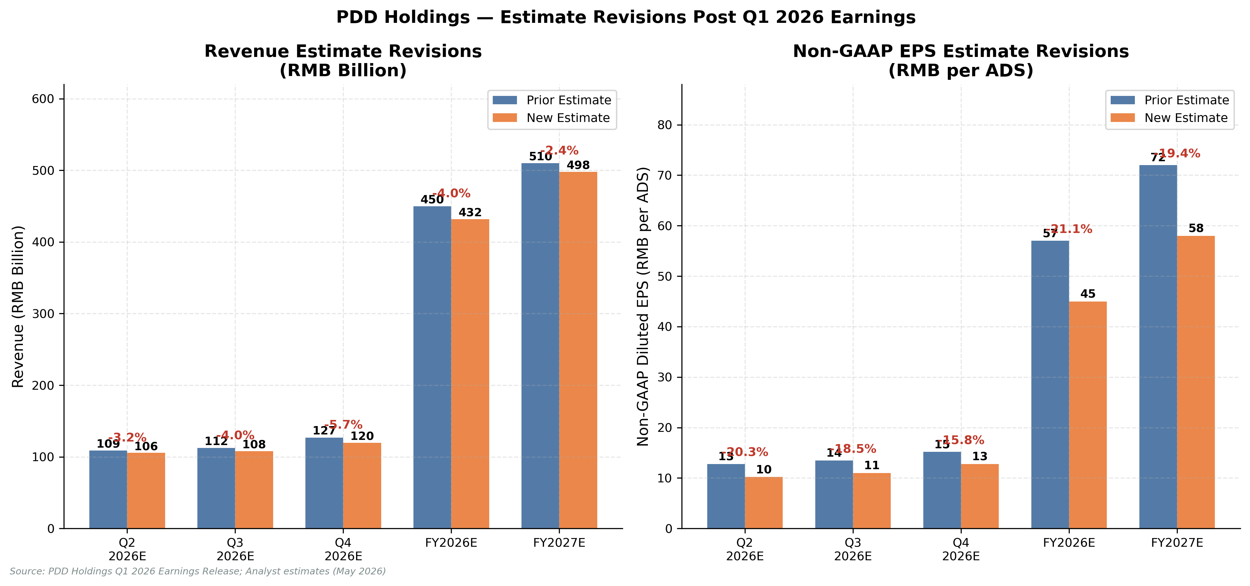
Figure 8: Revenue & EPS Estimate Revisions — Prior vs. New Estimates
Source: Analyst estimates; PDD Holdings Q1 2026 Earnings Release (May 27, 2026)
4.2 Revised Price Target: $125 (From $165)
We revise our 12-month price target from $165 to $125, reflecting our reduced earnings estimates and a modest compression in the appropriate target multiple given near-term earnings uncertainty. Our price target is derived using a blended methodology:
Methodology | FY2026E / FY2027E Basis | Multiple / Rate | Implied Value | Weight | Contribution
P/E (FY2027E Non-GAAP) | US$7.89/ADS | 16.0x | $126 | 40% | $50
EV/EBITDA (FY2027E) | US$10.2B EBITDA | 12.0x EV/EBITDA | $118 | 30% | $35
DCF (10yr, WACC 10.5%) | 8.5% terminal growth | g = 3% | $145 | 20% | $29
Sum-of-Parts (PDD+Temu) | Segment blended | PDD 12x + Temu 8x | $138 | 10% | $14
Blended Target |  |  |  | 100% | $128
Rounded Price Target |  |  |  |  | $125
At our revised price target of $125, PDD would trade at 15.8x FY2027E Non-GAAP EPS — a meaningful discount to Amazon (35x P/E) and comparable to Sea Limited (22x), appropriate given the near-term investment cycle and regulatory uncertainty. With the stock at ~$86 post-earnings, the implied upside to our base case PT is +45%, which comfortably supports our BUY rating.
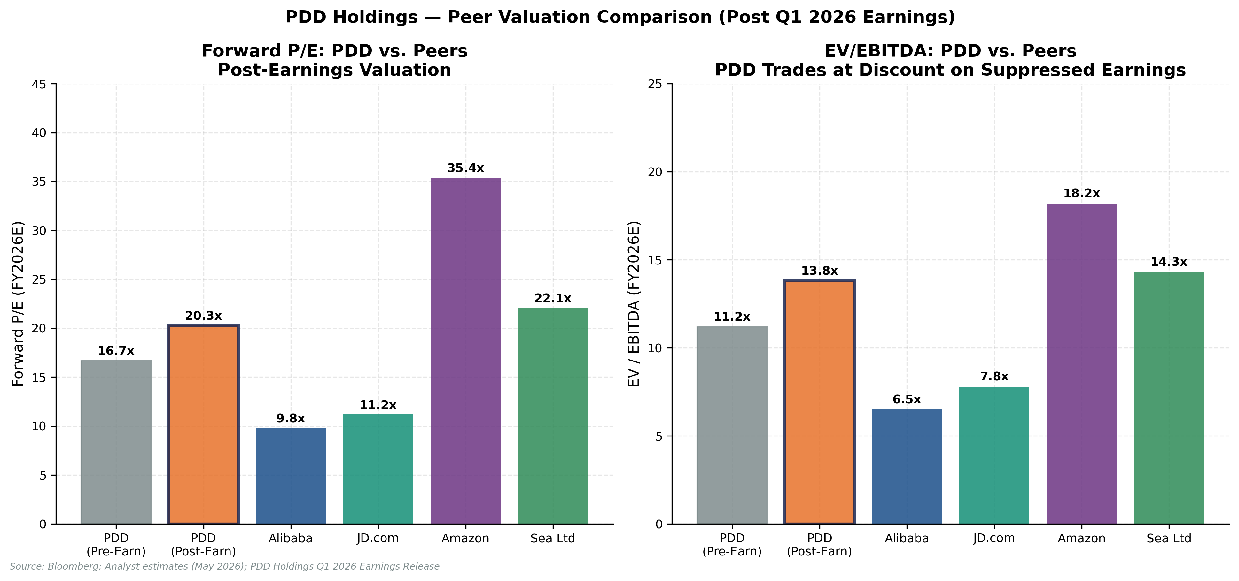
Figure 9: Forward P/E & EV/EBITDA Peer Comparison — Post-Earnings
Source: Bloomberg; analyst estimates (May 2026); PDD Holdings Q1 2026 Earnings Release
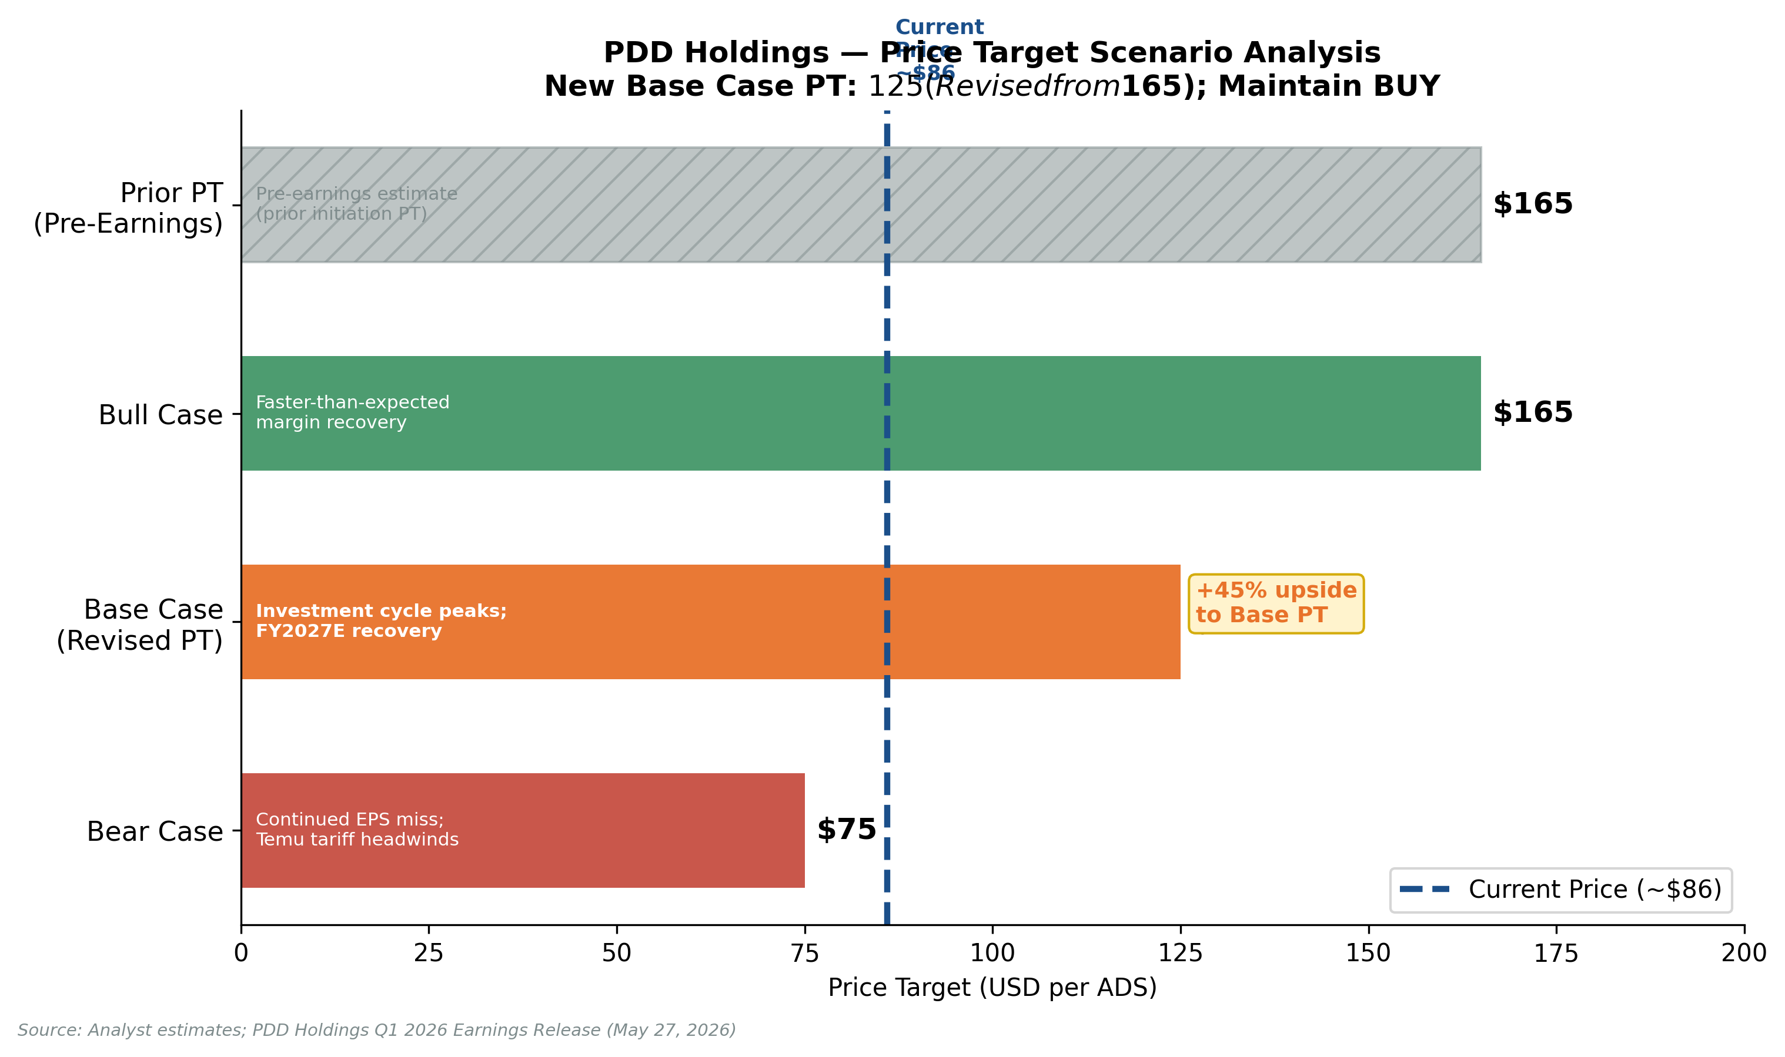
Figure 10: Price Target Scenario Analysis — Bull / Base / Bear
Source: Analyst estimates; PDD Holdings Q1 2026 Earnings Release (May 27, 2026)

SOURCES & REFERENCES
Primary Sources — Q1 2026 Earnings Materials
[1] PDD Holdings Q1 2026 Earnings Release (May 27, 2026) — Press release announcing unaudited Q1 2026 financial results. Primary source for all revenue, profit, and EPS figures cited in this report.
[2] PDD Holdings Form 6-K (Filed May 27, 2026) — SEC EDGAR filing confirming Q1 2026 unaudited financial results. Accession: 0001104659-26-034813.
[3] PDD Holdings Q1 2026 Earnings Call Transcript (May 27, 2026) — Complete transcript of management prepared remarks and analyst Q&A session. Source for all management quotations in this report.
[4] Bloomberg Consensus Estimates (as of May 26, 2026) — Consensus revenue estimate US$15.94B; consensus Non-GAAP EPS US$2.13 per ADS. Used as the basis for all beat/miss calculations.
Supporting References
• StockTitan — PDD Q1 2026 Earnings Summary
• PDD Holdings Investor Relations
• PDD Holdings SEC EDGAR Filings

ANALYST CERTIFICATION & DISCLOSURES
The views expressed in this report accurately reflect the personal views of the analyst(s) responsible for this report about the subject securities and/or issuers referenced herein. No part of the analyst's compensation was, is, or will be, directly or indirectly, related to the specific recommendations or views expressed in this report. This report is produced for informational purposes only and does not constitute an offer or solicitation to buy or sell securities. Past performance is not indicative of future results. Investors should conduct their own due diligence. This earnings update was prepared within 24 hours of the earnings release on May 27, 2026, consistent with institutional research standards.

