Class05

Liam Shweyk

January 24, 2019

# Lecture 5 R Graphics Intro  
  
x <- rnorm(1000,0)  
boxplot(x)

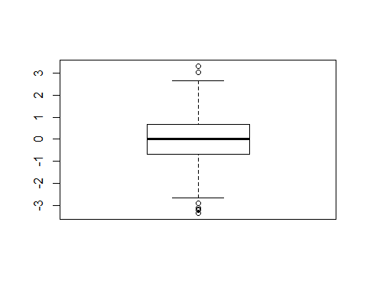

summary(x)

## Min. 1st Qu. Median Mean 3rd Qu. Max.   
## -3.344544 -0.670003 0.003366 -0.001449 0.688087 3.314512

hist(x)

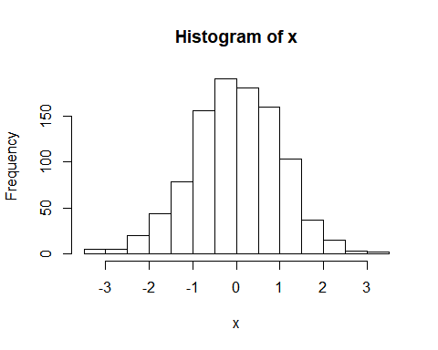

boxplot(x, horizontal = TRUE)

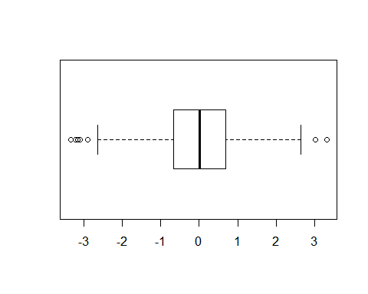

# Hands on Section 2  
weight <- read.table("bimm143_05_rstats/weight_chart.txt", header=TRUE)  
plot(weight$Age, weight$Weight, typ="o",   
 pch=15, cex=1.5, lwd=2, ylim=c(2,10),   
 xlab="Age (months)", ylab="Weight (kg)",   
 main="Baby weight with age")

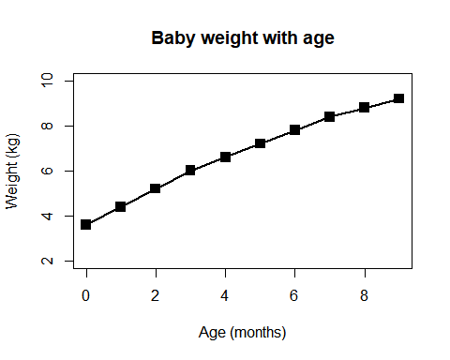

mouse <- read.table("bimm143_05_rstats/feature_counts.txt", sep="\t", header=TRUE)  
barplot(mouse$Count, horiz = TRUE)

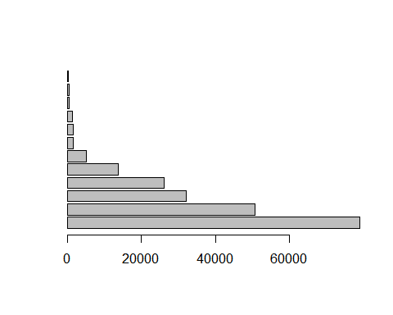

par(mar=c(3.1, 11.1, 4.1, 2))  
barplot(mouse$Count, names.arg=mouse$Feature,   
 horiz=TRUE, ylab="",   
 main="Number of features in the mouse GRCm38 genome",   
 las=1, xlim=c(0,80000))

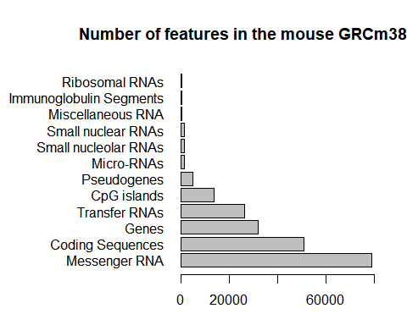

x <- c(rnorm(10000),rnorm(10000)+4)  
hist(x, breaks=80)

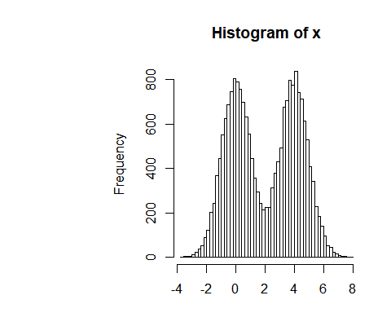

mf <- read.delim("bimm143_05_rstats/male_female_counts.txt")  
barplot(mf$Count, names.arg=mf$Sample, col=rainbow(nrow(mf)),   
 las=2, ylab="Counts")

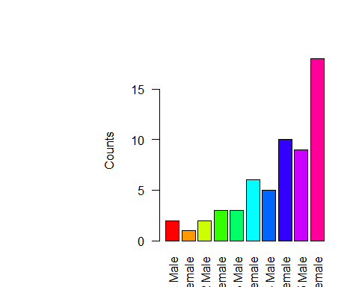

barplot(mf$Count, names.arg=mf$Sample, col=c("blue2","red2"),   
 las=2, ylab="Counts")

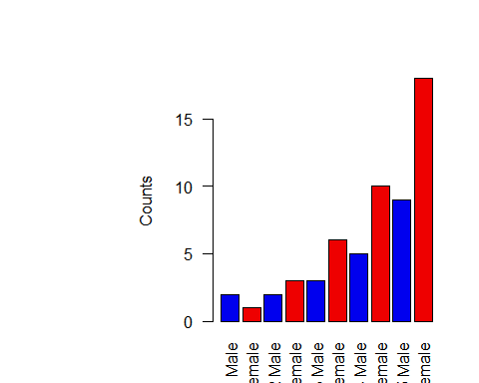

genes <- read.delim("bimm143_05_rstats/up_down_expression.txt")  
table(genes$State)

##   
## down unchanging up   
## 72 4997 127

plot(genes$Condition1, genes$Condition2, col=genes$State,  
 xlab = "Expression condition 1", ylab = "Expression condition 2")

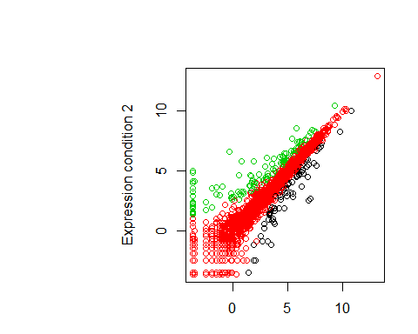

palette(c("blue","gray","red"))  
plot(genes$Condition1, genes$Condition2, col=genes$State, xlab="Expression condition 1", ylab="Expression condition 2")

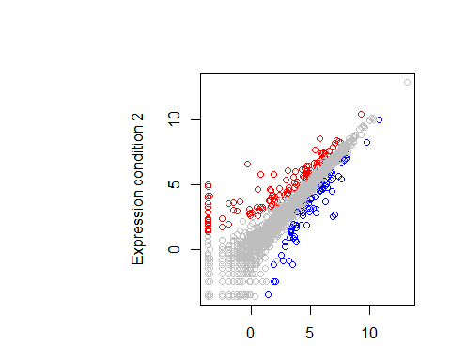

# Let's plot expression vs gene regulation  
meth <- read.delim("bimm143_05_rstats/expression_methylation.txt")  
dcols <- densCols(meth$gene.meth, meth$expression)  
plot(meth$gene.meth, meth$expression, col=dcols, pch=20)

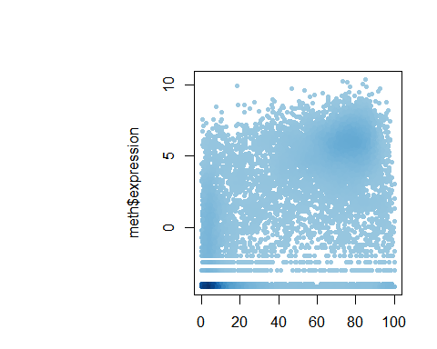

# Find the indices of genes with above 0 expresion  
inds <- meth$expression > 0  
  
# Plot just these genes  
plot(meth$gene.meth[inds], meth$expression[inds])

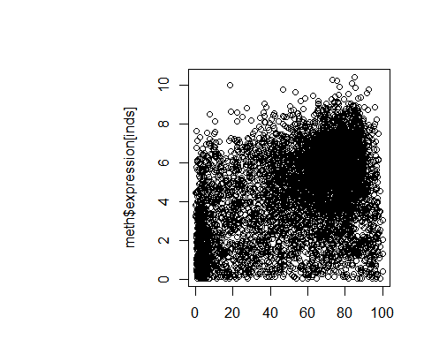

## Make a desnisty color vector for these genes and plot  
dcols <- densCols(meth$gene.meth[inds], meth$expression[inds])  
  
plot(meth$gene.meth[inds], meth$expression[inds], col = dcols, pch = 20)

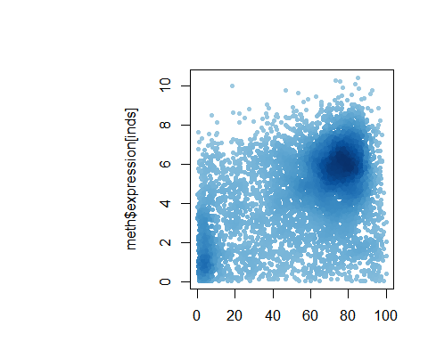

dcols.custom <- densCols(meth$gene.meth[inds], meth$expression[inds],  
 colramp = colorRampPalette(c("blue2",  
 "green2",  
 "red2",  
 "yellow")) )  
  
plot(meth$gene.meth[inds], meth$expression[inds],   
 col = dcols.custom, pch = 20)

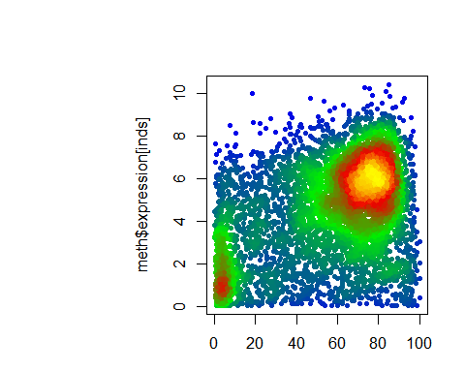

plot(meth$promoter.meth, meth$gene.meth, ylab="gene methylation", xlab="promoter methylation")

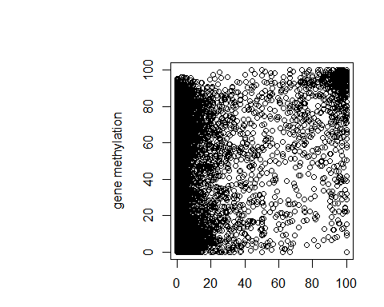

# source the provided function so we can use it  
source("bimm143_05_rstats/color_to_value_map.r")  
  
mycols=map.colors(meth$expression,   
 c(max(meth$expression), min(meth$expression)),   
 colorRampPalette(c("blue","red"))(100))  
  
plot(meth$promoter.meth, meth$gene.meth,   
 ylab="Gene Methylation",   
 xlab="Promoter Methylation",   
 col=mycols)

