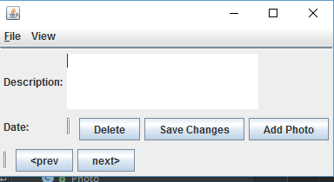

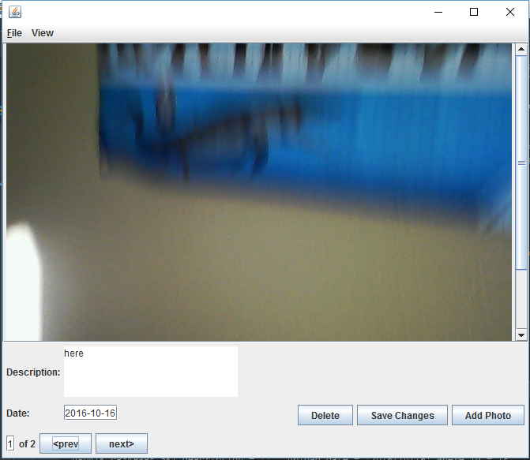

I decided when the next button is hit and the photo is at the end the photos will restart

I am also using the sql datetime for the date