I have a really bad computer. I had to lower the loop# significantly

Part 1

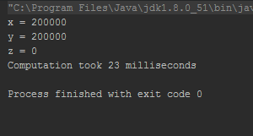

Part 2

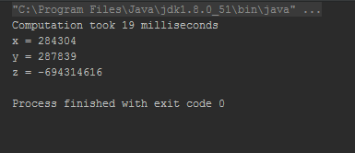

Part 3

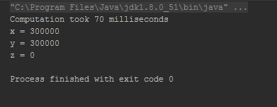

Synchronization took over 3 times as long

Part 4

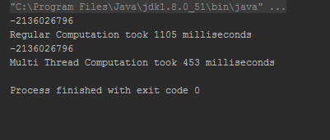

Running multiple threads speeds up computation about 2X