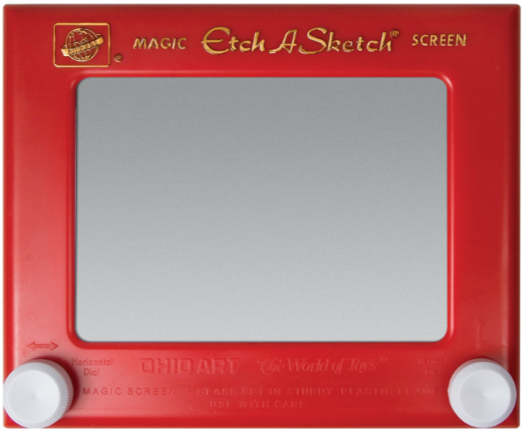
CS349 Etch A Sketch

Part A

Create a Java program that allows you to draw free-hand to the screen using the mouse.
SEE GITHUB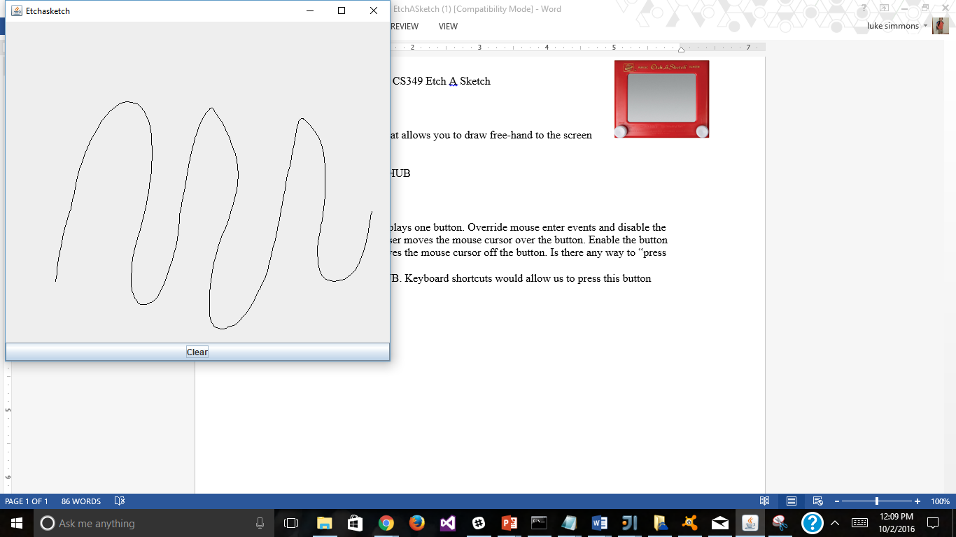

MORE DOWN THE PAGE

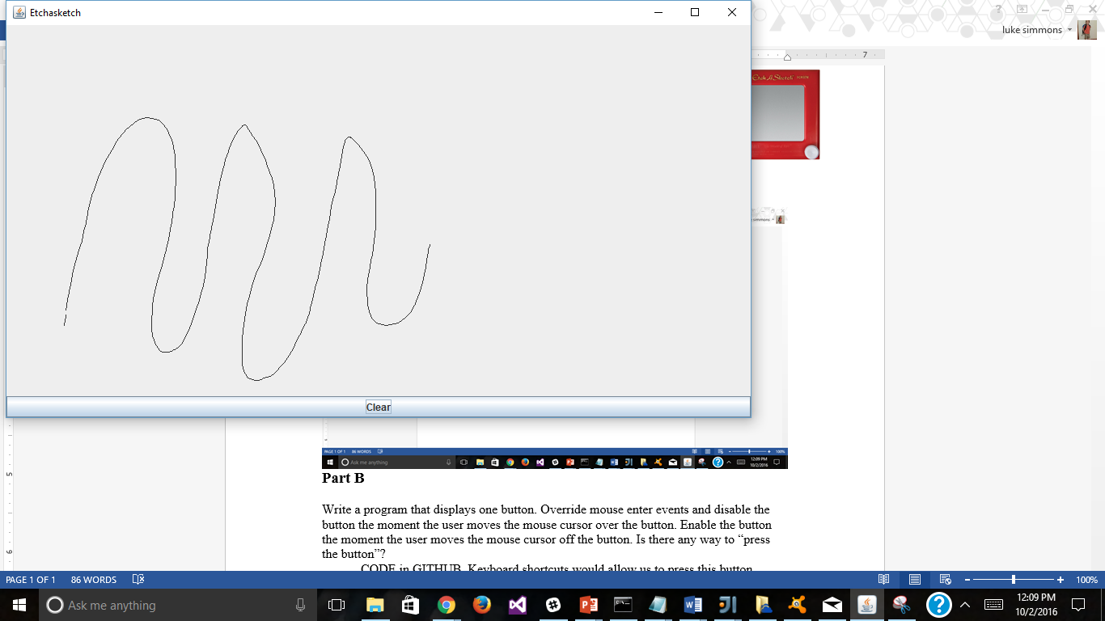

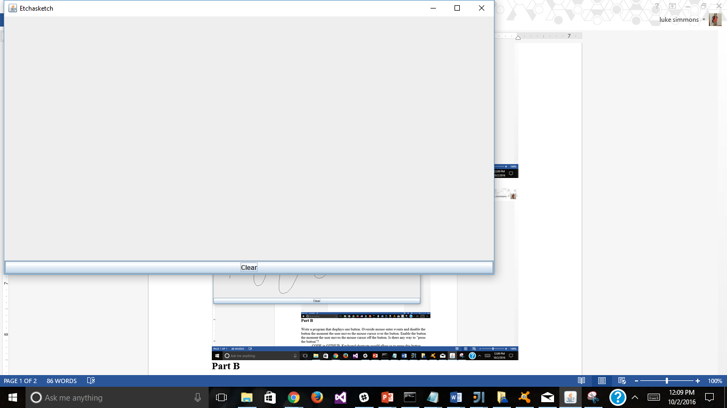
Part B

Write a program that displays one button. Override mouse enter events and disable the button the moment the user moves the mouse cursor over the button. Enable the button the moment the user moves the mouse cursor off the button. Is there any way to “press the button”?
CODE in GITHUB. Keyboard shortcuts would allow us to press this button

