**DAILY ONLINE ACTIVITIES SUMMARY**

|  |  |  |  |  |  |  |  |  |
| --- | --- | --- | --- | --- | --- | --- | --- | --- |
| **Date:** | **17/06/2020** | | | | | **Name:** | **SINDHU N** | |
| **Sem & Sec** | **6th sem & B sec** | | | | | **USN:** | **4AL17CS094** | |
| **Online Test Summary** | | | | | | | | |
| **Subject** | | **C PROGRAMMING (quiz)** | | | | | | |
| **Max. Marks** | | **15** | | **Score** | | | **12** | |
| **Pre-Placement Training Summary** | | | | | | | | |
| **Pre placement training** | **9:00 am to 11:00 am - Programming in C**  **11:00 am to 1:00pm - Applications of python in DA and ML** | | | | | | | |
| **Faculty** | | | **Vivek Sharma**  **Dr.Mohideen Badusha** | | **Duration** | | | **4 hr** |
| **Assessments** | | | | | | | | |
| **Problem Statement:**  1. Write a Java program to find the row, column position of a specified number (row, column position) in a given 2-dimensional array.  2. Examples and Exercises on python. | | | | | | | | |
| **Status: Completed** | | | | | | | | |
| **Uploaded the report in Github** | | | | | **Yes** | | | |
| **If yes Repository name** | | | | | https://github.com/lsindhungowda/Daily-report | | | |
| **Uploaded the report in slack** | | | | | **Yes** | | | |

**SNAPSHOT OF PYTHON WORKSHOP QUIZ:**

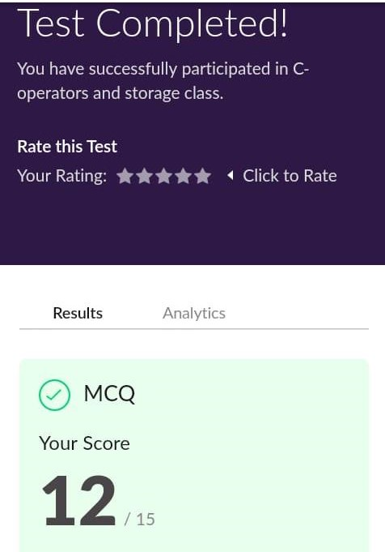

**TRAINING SNAPSHOT:**

**PROGRAMMING IN C-**

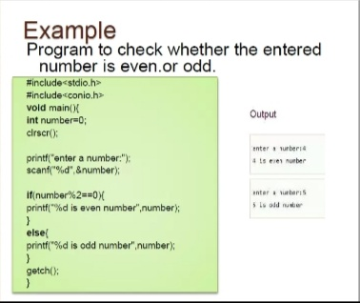

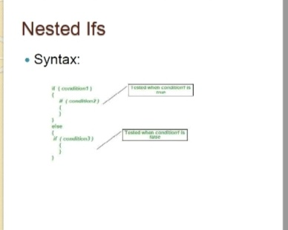

**APPLICATION OF PYTHON PROGRAMMING IN DATA ANAYTICS AND MACHINE LEARNING.**

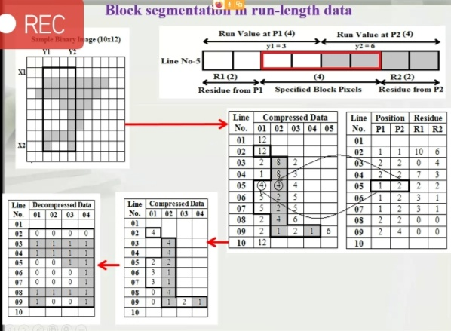

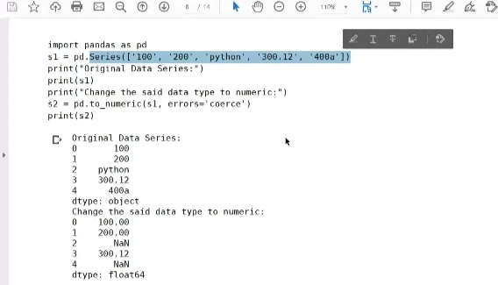

**ASSESSMENTS:**

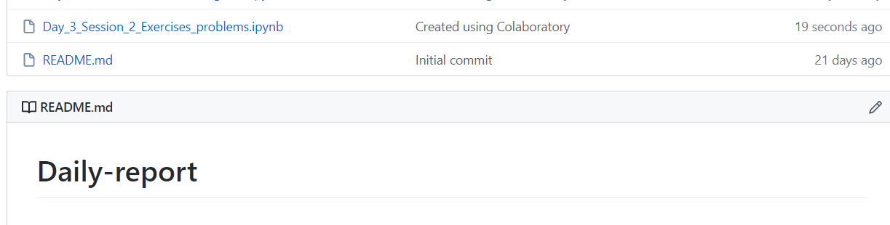

**SNAPSHOT OF JAVA PROGRAM:**

**Write a Java program to find the row, column position of a specified number (row, column position) in a given 2-dimensional array.**

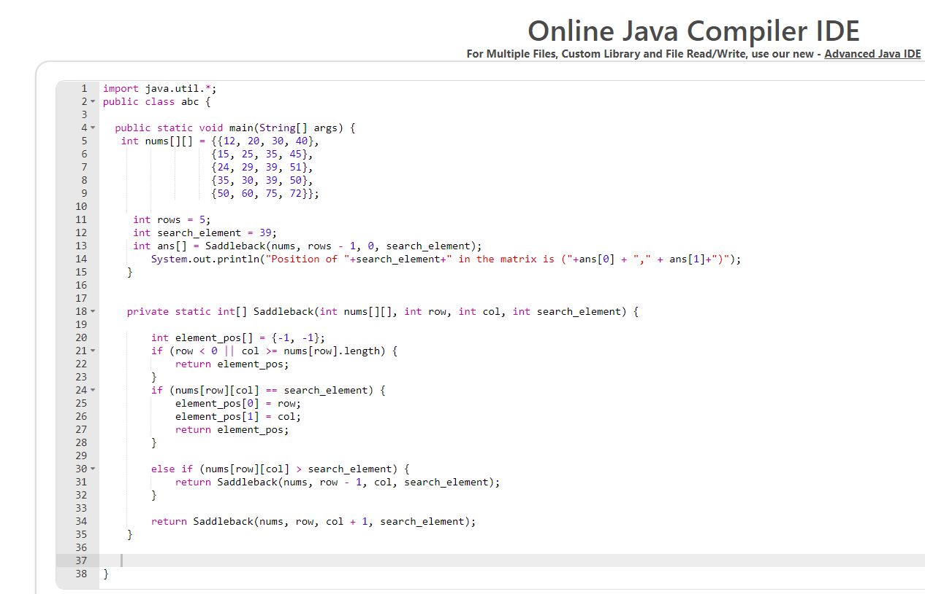

**OUTPUT:**

