**C PROGRAM 1:**

**To swap 2 numbers using pointer and function concept, return value from user defined function and print the swapped values in main() function.**

#include <stdio.h>

void swap(int *x,int *y)

{

int t;

t = *x;

*x = *y;

*y = t;

}

int main()

{

int num1,num2;

printf("Enter value of num1: ");

scanf("%d",&num1);

printf("Enter value of num2: ");

scanf("%d",&num2);

printf("Before Swapping: num1 is: %d, num2 is: %d\n",num1,num2);

swap(&num1,,&num2);

printf("After Swapping: num1 is: %d, num2 is: %d\n",num1,num2);

return 0;

}

**OUTPUT:**

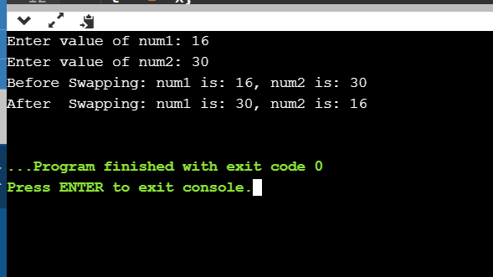

**C PROGRAM 2:**

**Given a positive integer n, count the total number of set bits in binary representation of all numbers from 1 to n.**

#include <stdio.h>

unsigned int countSetBits(unsigned int n)

{

unsigned int count = 0;

while (n) {

count += n & 1;

n >>= 1;

}

return count;

}

int main()

{

int i = 100;

printf("%d", countSetBits(i));

return 0;

}

**OUTPUT:**

