**DAILY ONLINE ACTIVITIES SUMMARY**

|  |  |  |  |  |  |  |  |  |
| --- | --- | --- | --- | --- | --- | --- | --- | --- |
| **Date:** | **24/06/2020** | | | | | **Name:** | **SINDHU N** | |
| **Sem & Sec** | **6th sem & B sec** | | | | | **USN:** | **4AL17CS094** | |
| **Online Test Summary** | | | | | | | | |
| **Subject** | | **______** | | | | | | |
| **Max. Marks** | | **____** | | **Score** | | | **___** | |
| **Pre-Placement Training Summary** | | | | | | | | |
| **Pre placement training** | **9:00 am to 11:00 am - JAVA**  **11:00 am to 1:00pm – DATA STRUCTURE** | | | | | | | |
| **Faculty** | | | **Shilpa**  **Venkatash** | | **Duration** | | | **4 hr** |
| **Assessments** | | | | | | | | |
| **Problem Statement:**  **1.** Create a class named 'Shape' with a method to print "This is This is shape". Then create two other classes named 'Rectangle', 'Circle' inheriting the Shape class, both having a method to print "This is rectangular shape" and "This is circular shape" respectively. Create a subclass 'Square' of 'Rectangle' having a method to print "Square is a rectangle". Now call the method of 'Shape' and 'Rectangle' class by the object of 'Square' class.  **2.** Examples and Exercises on python. | | | | | | | | |
| **Status: Completed** | | | | | | | | |
| **Uploaded the report in Github** | | | | | **Yes** | | | |
| **If yes Repository name** | | | | | https://github.com/lsindhungowda/Daily-report | | | |

**TRAINING SNAPSHOT:**

**JAVA (FORENOON SESSION)**

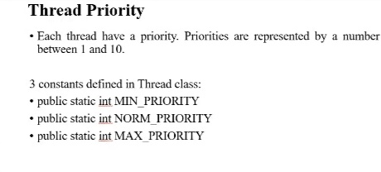

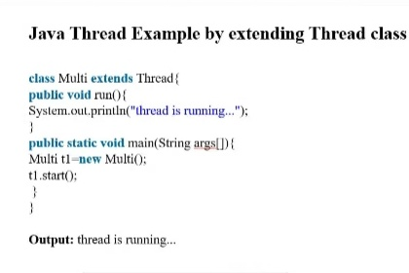

**DATA STRUCTURE:**

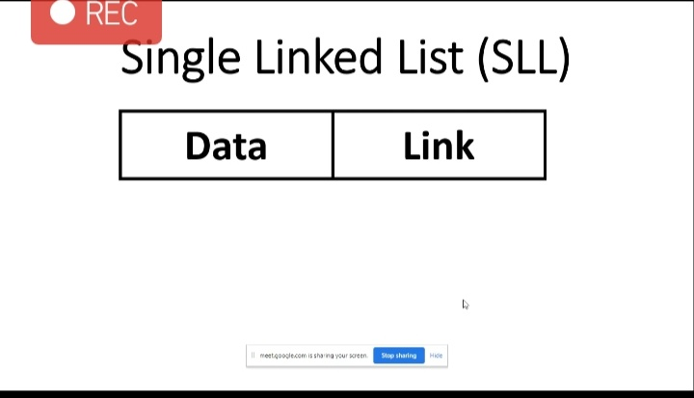

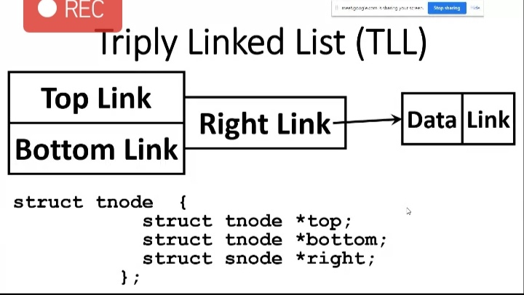

**SNAPSHOT OF JAVA PROGRAM:**

Create a class named 'Shape' with a method to print "This is This is shape". Then create two other classes named 'Rectangle', 'Circle' inheriting the Shape class, both having a method to print "This is rectangular shape" and "This is circular shape" respectively. Create a subclass 'Square' of 'Rectangle' having a method to print "Square is a rectangle". Now call the method of 'Shape' and 'Rectangle' class by the object of 'Square' class.

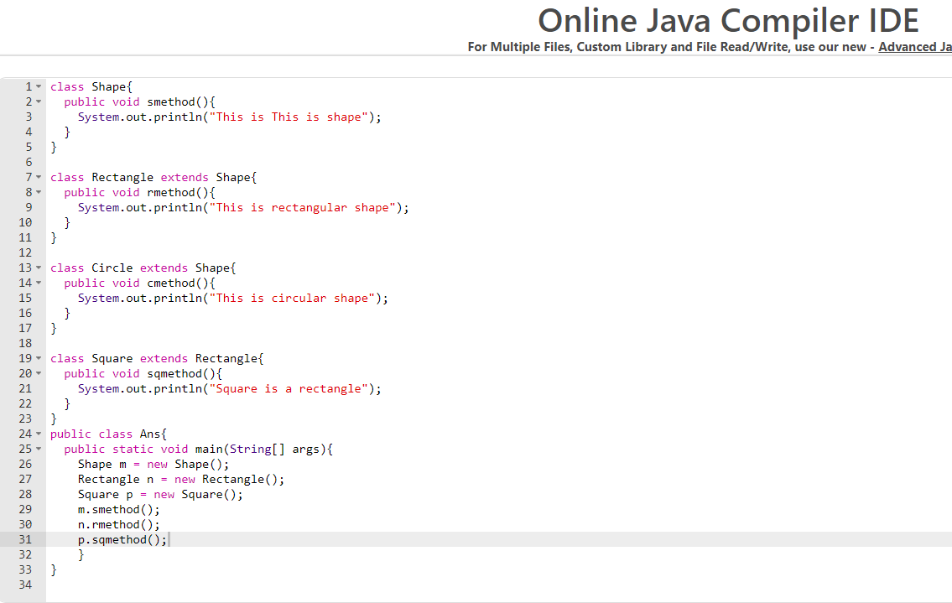

**OUTPUT:**

