**DAILY ONLINE ACTIVITIES SUMMARY**

|  |  |  |  |  |  |  |  |  |
| --- | --- | --- | --- | --- | --- | --- | --- | --- |
| **Date:** | **25/06/2020** | | | | | **Name:** | **SINDHU N** | |
| **Sem & Sec** | **6th sem & B sec** | | | | | **USN:** | **4AL17CS094** | |
| **Online Test Summary** | | | | | | | | |
| **Subject** | | **______** | | | | | | |
| **Max. Marks** | | **____** | | **Score** | | | **___** | |
| **Pre-Placement Training Summary** | | | | | | | | |
| **Pre placement training** | **9:00 am to 11:00 am - JAVA**  **11:00 am to 1:00pm – DATA STRUCTURE** | | | | | | | |
| **Faculty** | | | **Sayeesh**  **Venkatash** | | **Duration** | | | **4 hr** |
| **Assessments** | | | | | | | | |
| **Problem Statement:**  **1.** Write a C program to implement simple queue using SLL.  **2.** Examples and Exercises on python. | | | | | | | | |
| **Status: Completed** | | | | | | | | |
| **Uploaded the report in Github** | | | | | **Yes** | | | |
| **If yes Repository name** | | | | | https://github.com/lsindhungowda/Daily-report | | | |

**TRAINING SNAPSHOT:**

**JAVA (FORENOON SESSION)**

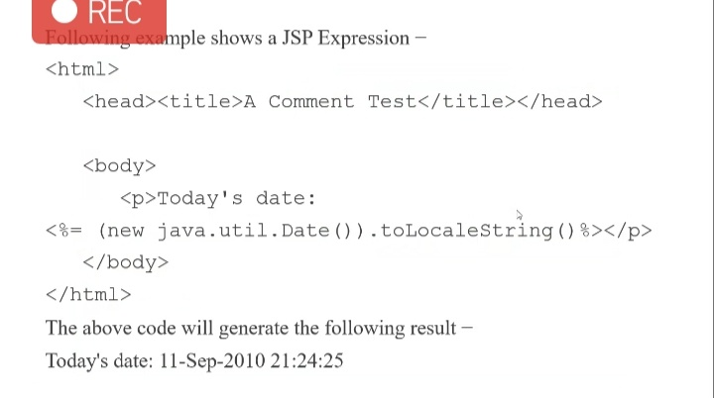

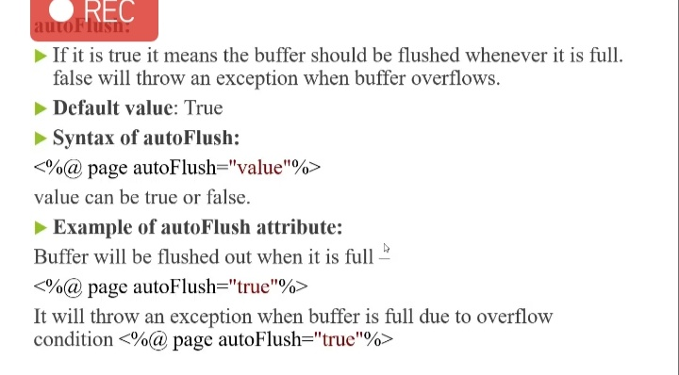

**DATA STRUCTURE:**

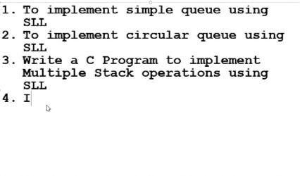

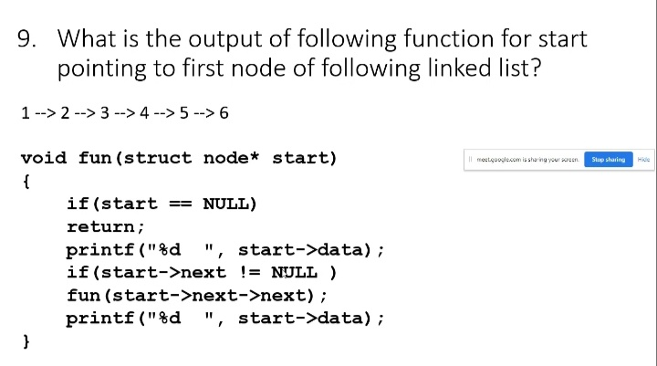

**SNAPSHOT OF C PROGRAM:**

**Write a C program to implement simple queue using SLL.**

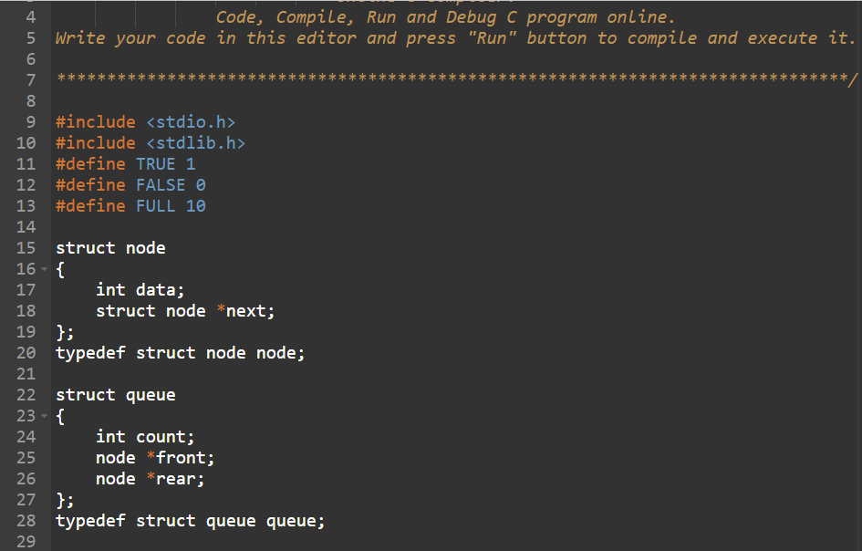

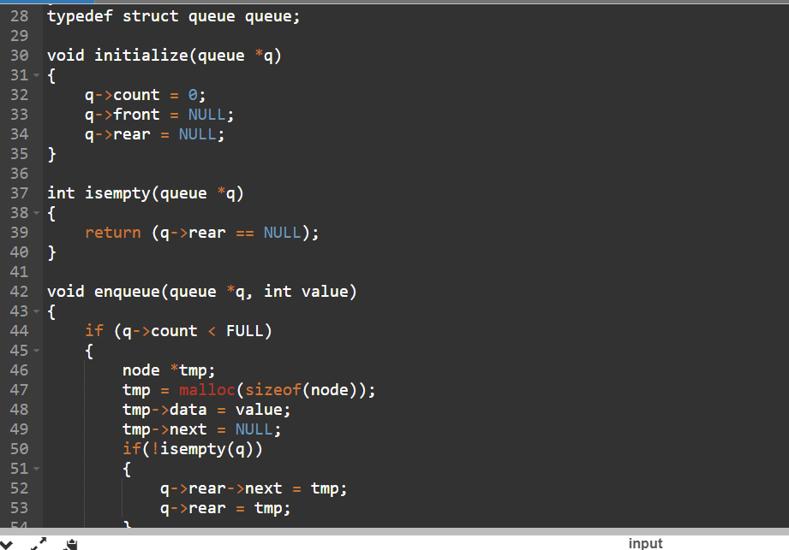

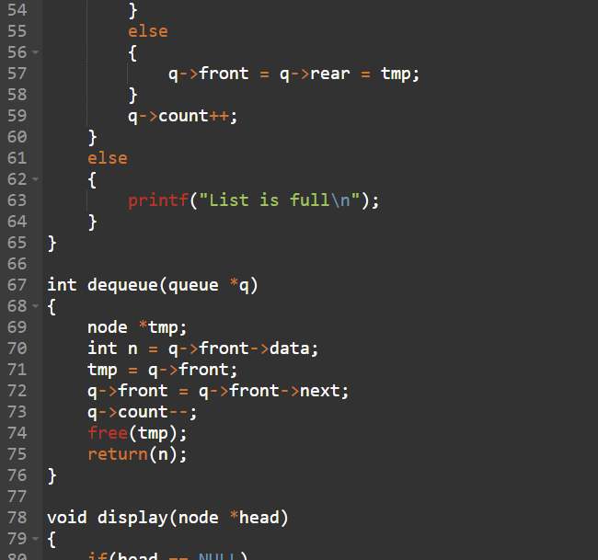

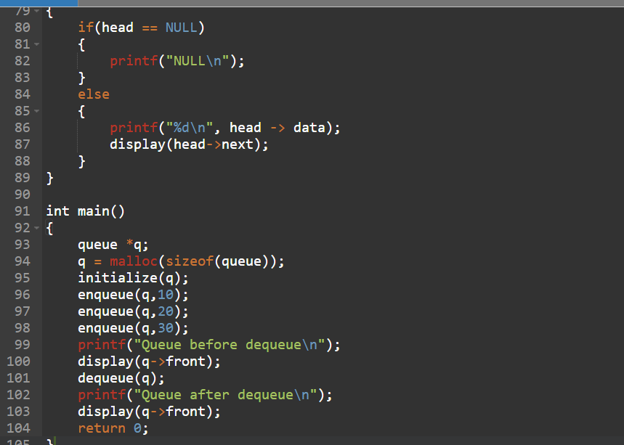

**OUTPUT:**

