**DAILY ONLINE ACTIVITIES SUMMARY**

|  |  |  |  |  |  |  |  |  |
| --- | --- | --- | --- | --- | --- | --- | --- | --- |
| **Date:** | **29/06/2020** | | | | | **Name:** | **SINDHU N** | |
| **Sem & Sec** | **6th sem & B sec** | | | | | **USN:** | **4AL17CS094** | |
| **Online Test Summary** | | | | | | | | |
| **Subject** | | **________** | | | | | | |
| **Max. Marks** | | **_____** | | **Score** | | | **______** | |
| **Pre-Placement Training Summary** | | | | | | | | |
| **Pre placement training** | **9:00 am to 11:00 am - DBMS**  **11:00 am to 1:00pm – CYBER SECURITY** | | | | | | | |
| **Faculty** | | | **Reena**  **Manjunath** | | **Duration** | | | **4 hr** |
| **Assessments** | | | | | | | | |
| **Problem Statement:**  **1.** Python Program to Find Numbers Divisible By Another Number.  **2.**  Examples and Exercises on python. | | | | | | | | |
| **Status: Completed** | | | | | | | | |
| **Uploaded the report in Github** | | | | | **Yes** | | | |
| **If yes Repository name** | | | | | https://github.com/lsindhungowda/Daily-report | | | |

**TRAINING SNAPSHOT:**

**DBMS (FORENOON SESSION)**

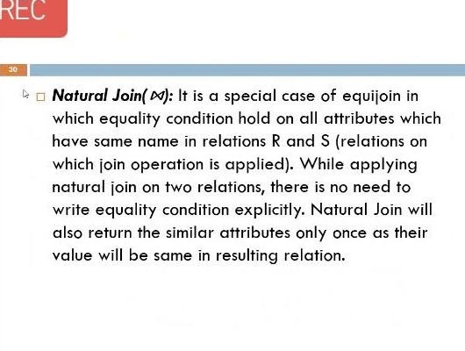

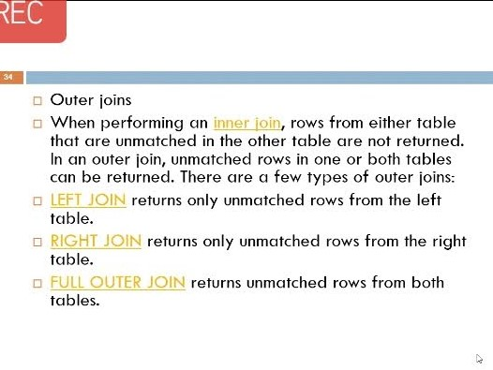

**CYBER SECURITY:**

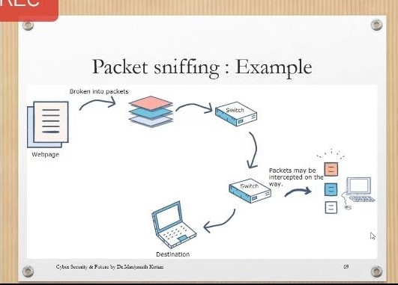

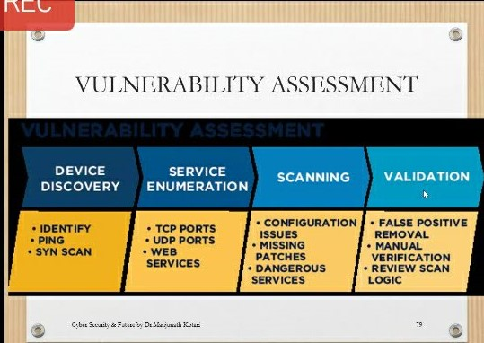

**SNAPSHOT OF PYTHON PROGRAM:**

**Python Program to Find Numbers Divisible by Another Number.**

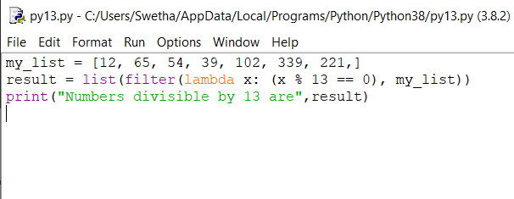

**OUTPUT:**

