**PROGRAM 1:** Write a Python Program which accepts the user’s first and last name print them in reverse order with a space between them.

fname = input("Input your First Name : ")

lname = input("Input your Last Name : ")

print ("Hello " + lname + " " + fname)

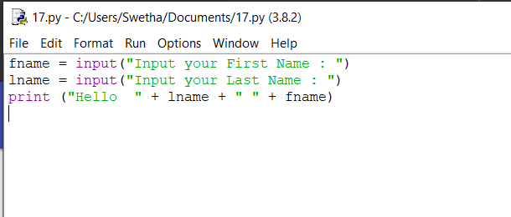

**OUTPUT:**

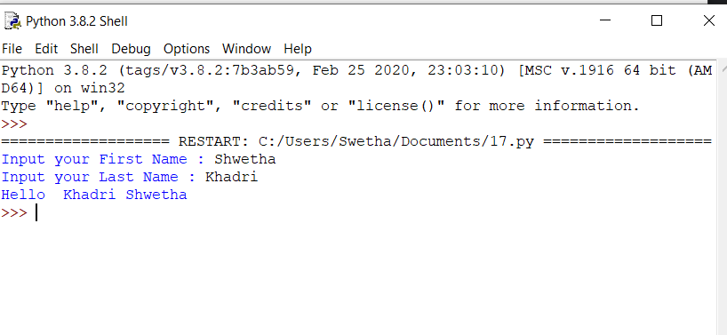

**PROGRAM 2:** Write a Python Program to calculate numbers of days between two dates.

from datetime import date

f_date = date(2014, 7, 2)

l_date = date(2014, 7, 11)

delta = l_date - f_date

print(delta.days)

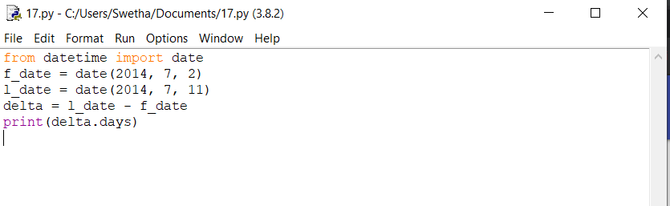

**OUTPUT:**

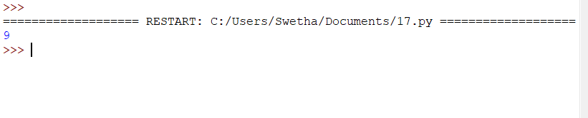

**PROGRAM 3:** Write a python program to test whether a passed letter is a vowel or not.

def is_vowel(char):

all_vowels = 'aeiou'

return char in all_vowels

print(is_vowel('s'))

print(is_vowel('a'))

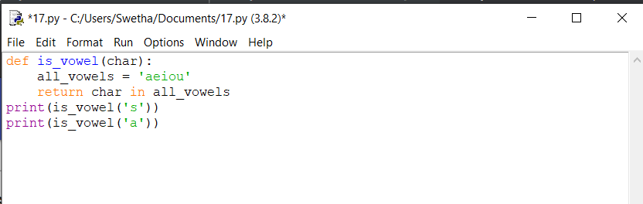

**OUTPUT:**

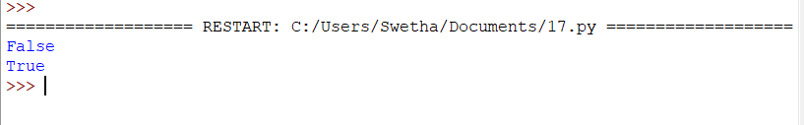

**PYTHON PROGRAM 4:** Write a python program to sum of three given integers. However, if two values are equal sum will be zero.

def sum(x, y, z):

if x == y or y == z or x==z:

sum = 0

else:

sum = x + y + z

return sum

print(sum(3, 1, 3))

print(sum(4, 2, 2))

print(sum(3, 3, 3))

print(sum(1, 2, 3))

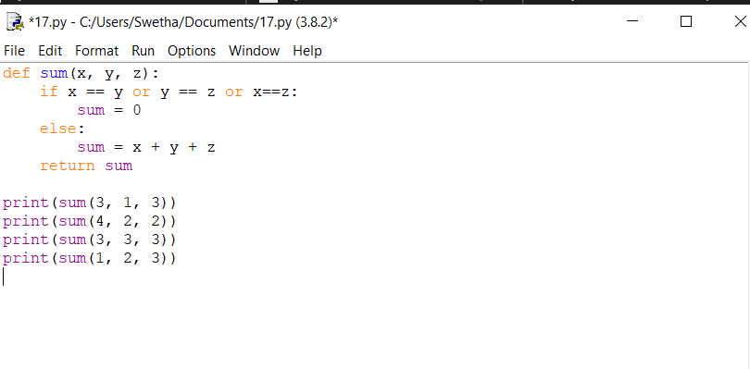

**OUTPUT:**

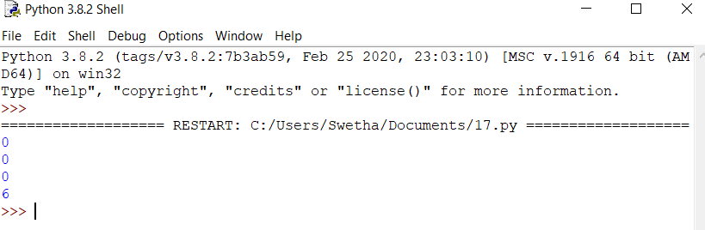

**PROGRAM 5:** Write a Python program to count the number of characters (character frequency) in a string.

def char_frequency(str1):

dict = {}

for n in str1:

keys = dict.keys()

if n in keys:

dict[n] += 1

else:

dict[n] = 1

return dict

print(char_frequency('shwethakhadri1999@gmail.com'))

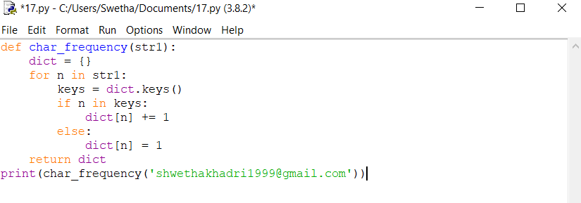

**OUTPUT:**

