ASSIGNMENT 1:

NAME: loveleen Singh ROLl NUMBER: 1024030323

QUE1: Develop a Menudrivenprogramtodemonstrate the following operations of

Arrays

——MENU——- 1.CREATE

2.DISPLAY

3.INSERT

4.DELETE

5.LINEAR SEARCH

6.EXIT CODE:

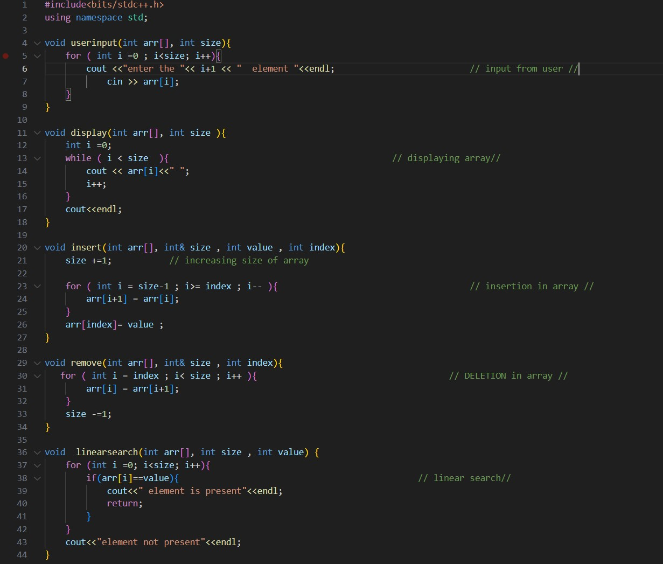

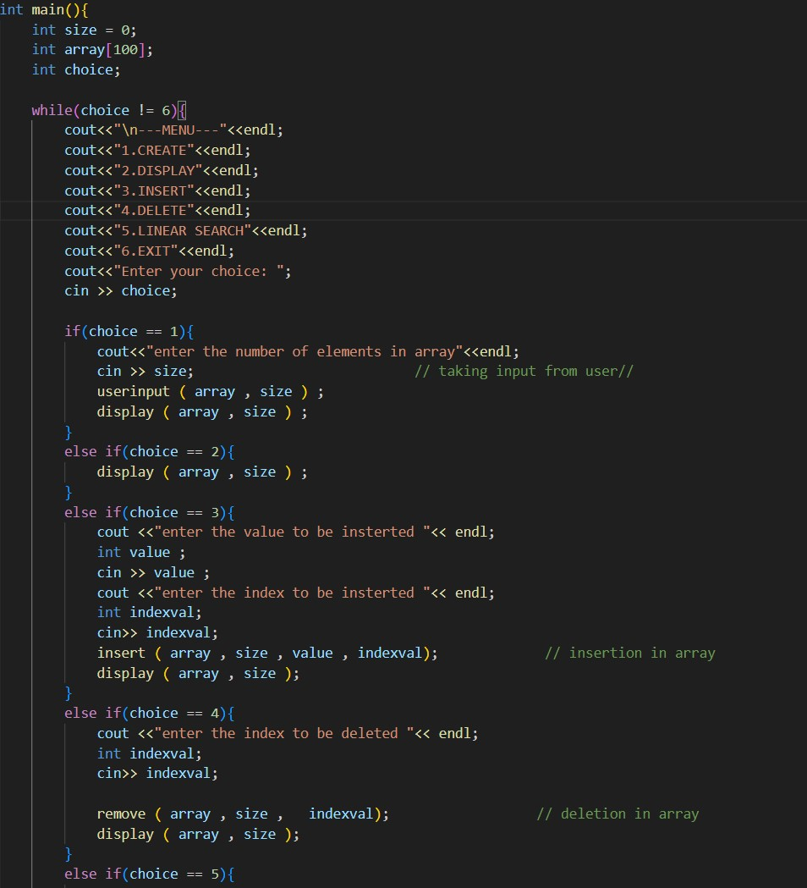

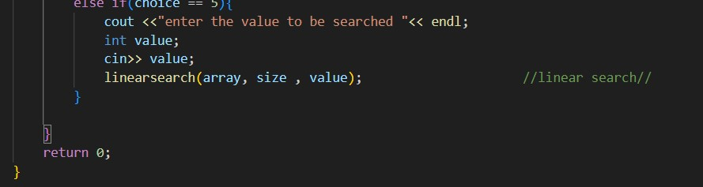

------------------X----------------------X----------------------X------------------------

QUE2: Design the logic to remove the duplicate elements from an Array and after the deletion the array should contain the unique elements. CODE:

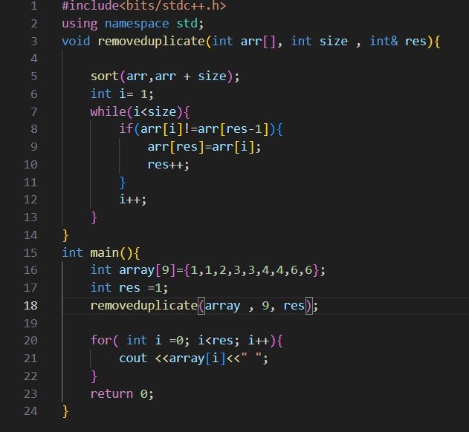



------------------X----------------------X----------------------X------------------------

QUE3: Predict the Output of the following program int main() { int i; int arr[5] = {1}; for (i = 0; i < 5; i++) printf("%d",arr[i]); return 0;

}

SOL: {1,0,0,0,0}

------------------X----------------------X----------------------X------------------------

QUE4: Implement the logic to

1. Reverse the elements of an array
2. Find the matrix multiplication
3. Find the Transpose of a Matrix

CODE A:

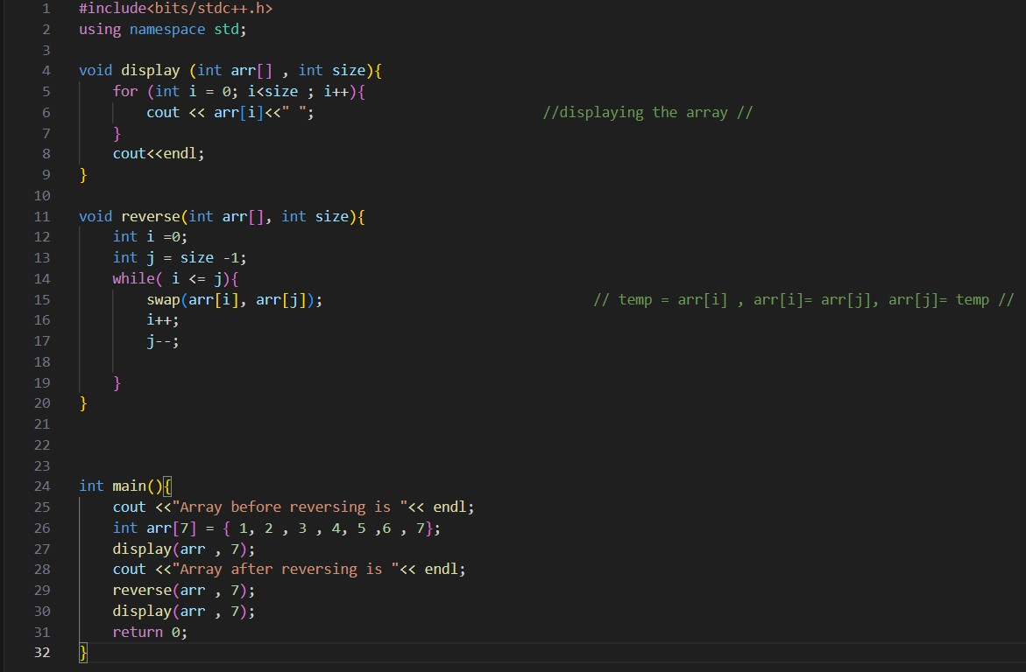

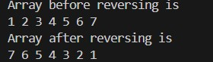

CODE B:

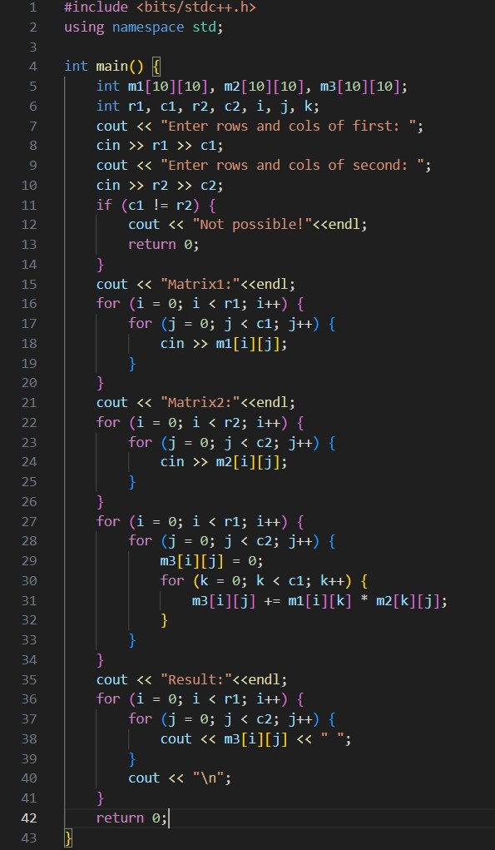

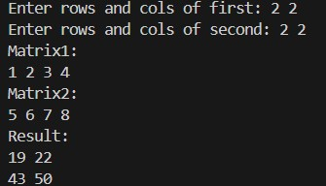

CODE C:

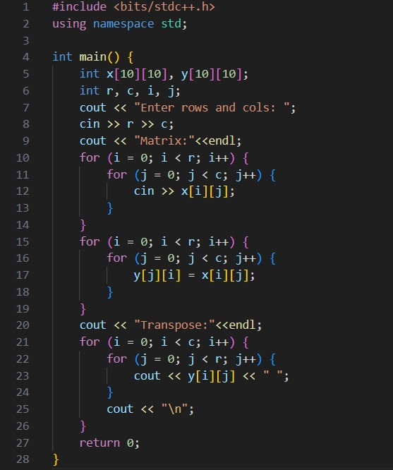

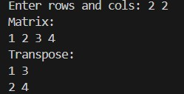

------------------X----------------------X----------------------X------------------------

QUE5: Write a program to find sum of every row and every column in a twodimensional array.

CODE:

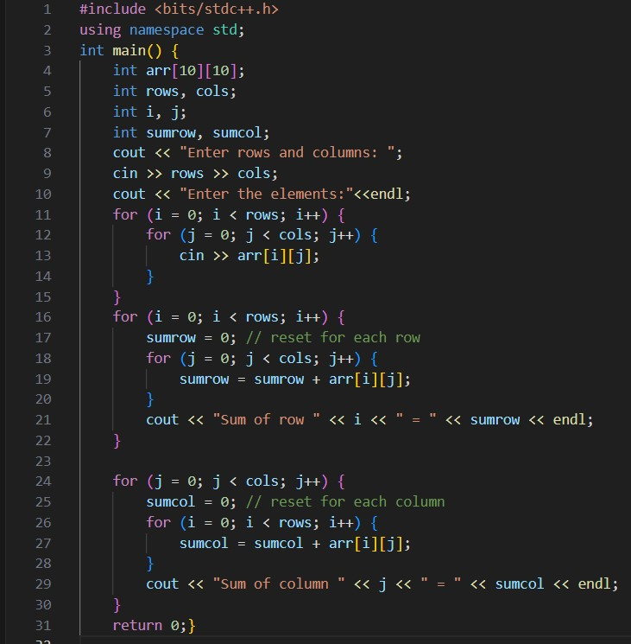

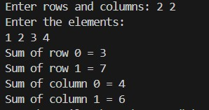

------------------X----------------------X----------------------X------------------------