VNET PEERING
- VNET peering is a feature in Azure that allows to connect two or more virtual networks to connect within the same region or different regions.

VM-01
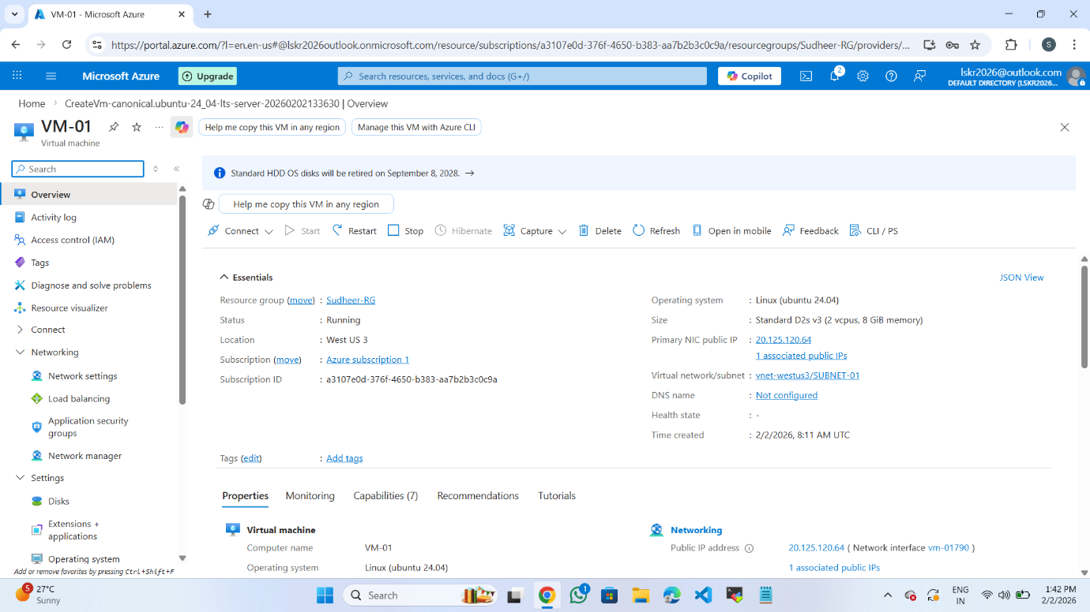

VM-02
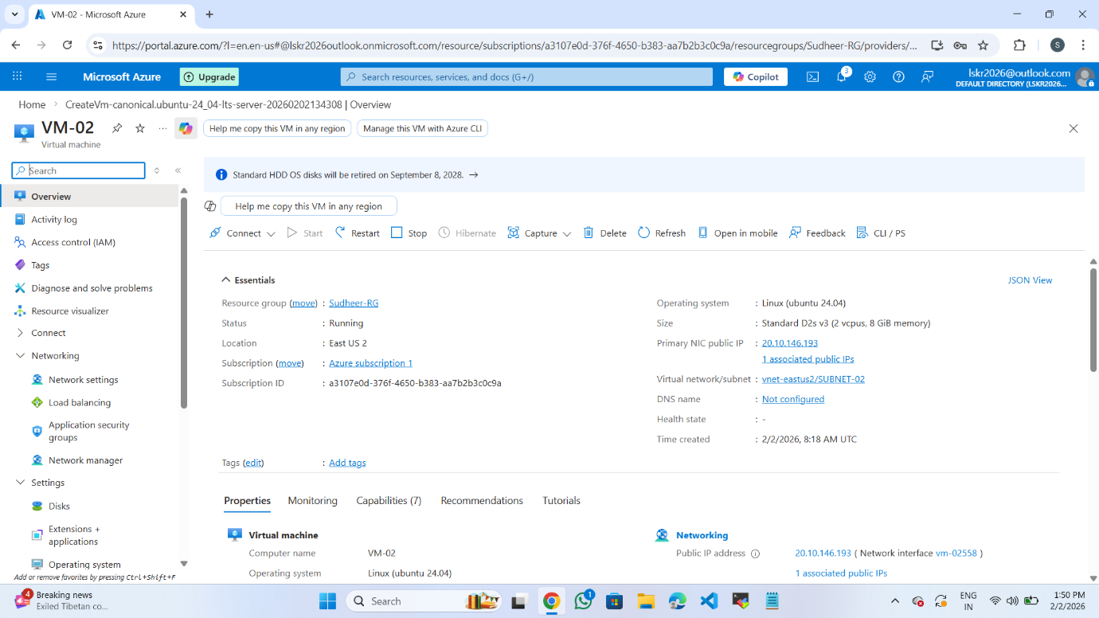
TWO VIRTUAL NETWORKS
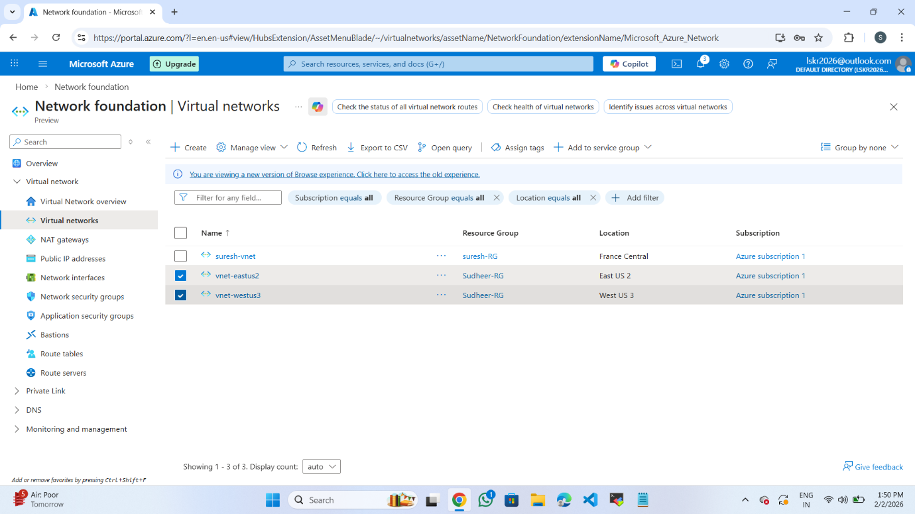

PEERING CONNECTION SUCCESSFUL IN VM-03
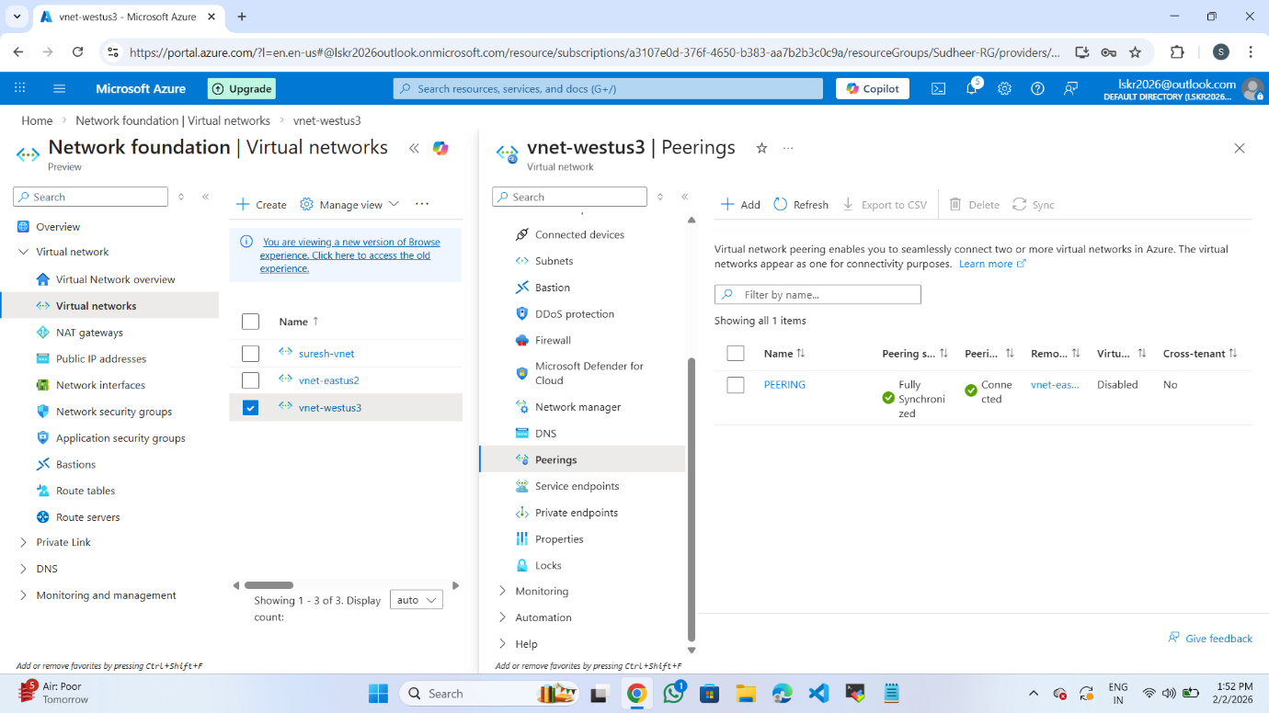

PEERING CONNECTION SUCCESSFUL IN VM-02
