Kubernetes二进制安装

基础环境
本次安装使用6台Linux服务器，系统版本为CentOS7.6,其中3台Master,3台Node,
Master节点主要部署的组件有KeepAlived\HAProxy\Etcd\Kubelet\APIServer\Scheduler;
Node节点主要部署Kubelet;
主机名 | IP地址 | 说明
master01 | 192.168.1.30 | Master节点1
master02 | 192.168.1.31 | Master节点2
master03 | 192.168.1.32 | Master节点3
node01 | 192.168.1.33 | worker节点1
node02 | 192.168.1.34 | worker节点2
node03 | 192.168.1.35 | worker节点3
vip | 192.168.1.100 | Keepalived虚拟IP

修改主机名
#vi /etc/hosts

192.168.1.30 master01
192.168.1.31 master02
192.168.1.32 master03
192.168.1.33 node01
192.168.1.34 node02
192.168.1.35 node03
192.168.1.100 vip
关闭防火墙
#systemctl disable --now firewalld
#systemctl disable --now dnsmasq
#systemctl disable --now NetworkManager

关闭Selinux
#setenforce 0
#vi /etc/sysconfig/selinux

SELINUX=disabled
SELINUXTYPE=targeted
关闭swap分区
#swapoff -a && sysctl -w vm.swappiness=0
#sysctl -p
时间同步
#ln -sf /usr/share/zoneinfo/Asia/Shanghai /etc/localtime
#echo 'Asia/Shanghai' > /etc/timezone
#yum -y install ntp ntpdate
#ntpdate time2.aliyun.com
开启定时任务
#crontab -e
设置每4小时同步一次
* */4 * * * ntpdate time2.aliyun.com > /dev/null 2>&1

配置limit
#ulimit -SHn 65535

免密登录
在Mster01节点上配置免密登录其他节点
#ssh-keygen -t rsa
#for i in master01 master02 master03 node01 node02 node03;do ssh-copy-id -i .ssh/id_rsa.pub $i; done
repo分发（Master01先上传源码中的chap01目录到root目录下）
#for i in master01 master02 master03 node01 node02 node03; do scp -r chap01/1.1/repo/ $i:/opt ; done
所有节点配置repo源
#cd /etc/yum.repos.d
#mkdir bak
#mv *.repo bak/
#mv /opt/repo/* .
所有节点重启
#yum -y install wget jq psmisc vim net-tools
#yum -y update --exclude=kernel* && reboot

内核升级
内核下载/升级
Docker overlay2需要使用kernel 4.x版本，所以我们需要升级内核（这里的内核使用4.18.9），CentOS 7.x 系统自带的 3.10.x 内核存在一些 Bugs，导致运行的 Docker、Kubernetes 不稳定
#export Kernel_Version=4.18.9-1
#wget http://mirror.rc.usf.edu/compute_lock/elrepo/kernel/el7/x86_64/RPMS/kernel-ml{,-devel}-${Kernel_Version}.el7.elrepo.x86_64.rpm

内核升级包复制到其他节点
#for i in master01 master02 master03 node01 node02 node03; do scp kernel-ml-4.18.9-1.el7.elrepo.x86_64.rpm kernel-ml-devel-4.18.9-1.el7.elrepo.x86_64.rpm $i:/root/ ;done

所有节点升级内核
#yum localinstall -y kernel-ml*

所有节点修改内核启动顺序
#grub2-set-default 0 && grub2-mkconfig -o /etc/grub2.cfg
#grubby --args="user_namespace.enable=1" --update-kernel="$(grubby --default-kernel)"

所有节点重启，再确认内核版本（4.18.9-1.el7.elrepo.x86_64）
#uname -r
#reboot
#uname -r
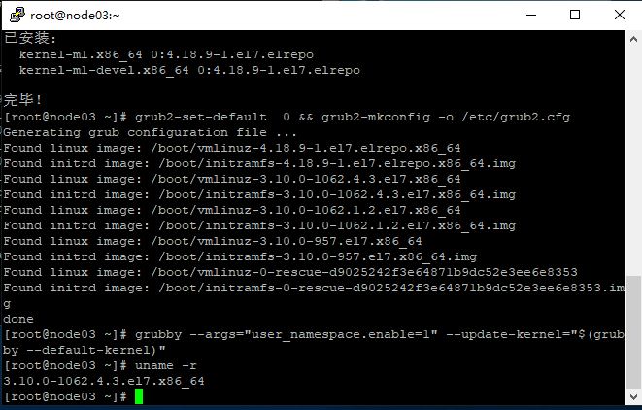
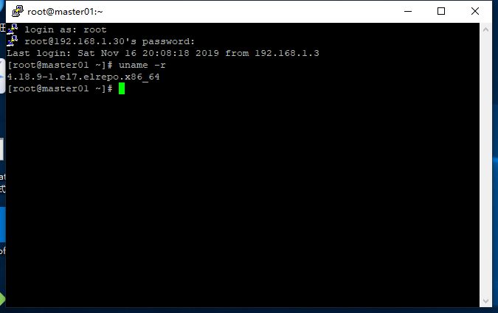

所有节点安装ipvsadm
#yum install -y ipvsadm ipset sysstat conntrack libseccomp

配置ipvs 模块
modprobe -- ip_vs
modprobe -- ip_vs_rr
modprobe -- ip_vs_wrr
modprobe -- ip_vs_sh
modprobe -- nf_conntrack_ipv4
modprobe -- ip_tables
modprobe -- ip_set
modprobe -- xt_set
modprobe -- ipt_set
modprobe -- ipt_rpfilter
modprobe -- ipt_REJECT
modprobe -- ipip
创建文件/etc/sysconfig/modules/k8s.modules写入上述命令即可（开机自动加载）；

#lsmod | grep -e ip_vs -e nf_conntrack_ipv4

内核参数
#cat <<EOF > /etc/sysctl.d/K8S.conf
net.ipv4.ip_forward = 1
net.bridge.bridge-nf-call-iptables = 1
fs.my_detach_mounts = 1
vm.overcommit_memory = 1
vm.panic_on_oom=0
fs.inotify.max_user_watches=89100
fs.file-max=52706963
fs.nr_open=52706963
net.netfilter.nf_conntrack_max = 2310720
net.ipv4.tcp_keepalive_time = 600
net.ipv4.tcp_keepalive_probes = 3
net.ipv4.tcp_keepalive_intvbl = 15
net.ipv4.tcp_max_tw_buckets = 3600
net.ipv4.tcp_tw_reuse = 1
net.ipv4.tcp_maxorphans = 327680
net.ipv4.tcp_orphan_retries = 3
net.ipv4.tcp_syncookies = 1
net.ipv4.tcp_max_syn_backlog = 16384
net.ipv4.ip_conntrack_max = 65536
net.ipv4.tcp_timestamps = 0
net.core.somaxconn = 16384
net.ipv6.conf.all.disable_ipv6 =1
net.ipv6.conf.default.disable_ipv6 =1
EOF
#sysctl --system

基本组件安装
#docker 的工具安装
#yum install -y yum-utils device-mapper-persistent-data lvm2
#查看docker版本
#yum list docker-ce --showduplicates | sort -r
#安装docker，安装指定版本 # yum install -y docker-ce --nogpgcheck （最新版不推荐）
# yum install -y docker-ce-18.06.1.ce-3.el7
#开机启动
#systemctl enable --now docker

kubeadm
二进制安装可以跳过本节

安装kubeadm
#yum install -y kubeadm-1.14.6-0.x86_64 kubectl-1.14.6-0.x86_64 kubelet-1.14.6-0.x86_64

pause配置
默认配置的pause镜像使用gcr.io仓库，国内可能无法访问，所以这里配置kubelet使用阿里云的pause镜像，使用kubeadmin初始化时会读取该文件的变量：
#DOCKER_CGROUPS=$(docker info | grep 'Cgroup' | cut -d ' ' -f3)
#echo $DOCKER_CGROUPS
#cat >/etc/sysconfig/kubelet<<EOF
KUBELET_EXTRA_ARGS="--cgroup-driver=DOCKER_CGROUPS --pod-infra-container-image=registry.cn-hangzhou.aliyuncs.com/google_containers/pause-amd64:3.1"
EOF
#systemctl daemon-reload
#systemctl enable --now kubelet

安装haproxy 和keepalived
详情参照下节

kubeadm-config
apiVersion: kubeadm.k8s.io/v1beta1
kind: ClusterConfiguration
kubernetesVersion: v1.14.6
imageRepository: registry.cn-hangzhou.aliyuncs.com/google_containers
apiServer:
certSANs:
- 192.168.1.100
controlPlaneEndpoint: "192.168.1.100:16443"
networking:
# This CIDR is a Calico default. Substitute or remove for your CNI provider.
podSubnet: "172.168.0.0/16"
---
apiVersion: kubeproxy.config.k8s.io/v1alpha1
kind: KubeProxyConfiguration
ipvs:
minSyncPeriod: 1s
scheduler: rr
syncPeriod: 10s
mode: ipvs

集群初始化
所有Master节点安装HAProxy和KeepAlived
#yum install -y keepalived haproxy

HAProxy
所有Msater节点配置HAProxy (Master节点的HAProxy配置相同)
#mkdir /etc/haproxy
#vi /etc/haproxy/haproxy.cfg
配置HAProxy
global
maxconn 2000
ulimit-n 16384
log 127.0.0.1 local0 err
stats timeout 30s

defaults
log global
mode http
option httplog
timeout connect 5000
timeout client 50000
timeout server 50000
timeout http-request 15s
timeout http-keep-alive 15s

frontend monitor-in
bind *:33305
mode http
option httplog
monitor-uri /monitor

listen stats
bind *:8006
mode http
stats enable
stats hide-version
stats uri /stats
stats refresh 30s
stats realm Haproxy\ Statistics
stats auth admin:admin

frontend k8s-master
bind 0.0.0.0:16443
bind 127.0.0.1:16443
mode tcp
option tcplog
tcp-request inspect-delay 5s
default_backend k8s-master

backend k8s-master
mode tcp
option tcplog
option tcp-check
balance roundrobin
default-server inter 10s downinter 5s rise 2 fall 2 slowstart 60s maxconn 250 maxqueue 256 weight 100
server master01 192.168.1.30:6443 check
server master02 192.168.1.31:6443 check
server master03 192.168.1.32:6443 check

KeepAlived
所有Master节点配置KeepAlived
#mkdir /etc/keepalived
#vi /etc/keepalived/keepalived.conf
配置KeepAlived(不同机器需要修改interface服务器网卡、priority优先级、mcast_src_ip本机IP)
! Configuration File for keepalived
global_defs {
router_id LVS_DEVEL
}
vrrp_script chk_apiserver {
script "/etc/keepalived/check_apiserver.sh"
interval 2
weight -5
fall 3
rise 2
}
vrrp_instance VI_1 {
state MASTER|BACKUP
interface ens32
mcast_src_ip 192.168.1.30|192.168.1.31|192.168.1.32
virtual_router_id 77
priority 100|95|90
advert_int 2
authentication {
auth_type PASS
auth_pass K8SHA_KA_AUTH
}
virtual_ipaddress {
192.168.1.100
}
# track_script {
# chk_apiserver
# }
}
#KeepAlived健康检查文件
#vi /etc/keepalived/check_apiserver.sh

#!/bin/bash
function check_apiserver() {
for((i=0;i<5;i++));do
apiserver_job_id=$(pgrep kube-apiserver)
if[[! -z $apiserver_job_id]]; then
return
else
sleep 2
fi
apiserver_job_id=0
done
}

# 1: running 0:stopped
check_apiserver
if[[$apiserver_job_id -eq 0]]; then
/usr/bin/systemctl stop keepalived
exit 1
else
exit 0
fi

赋执行权限
#chmod +x /etc/keepalived/check_apiserver.sh

启动haproxy和keepalived
#systemctl enable --now haproxy
#systemctl enable --now keepalived
检查状态
#ping 192.168.1.100
#systemctl status haproxy
# systemctl status keepalived
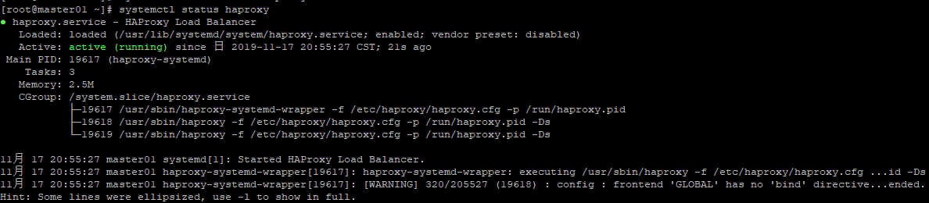
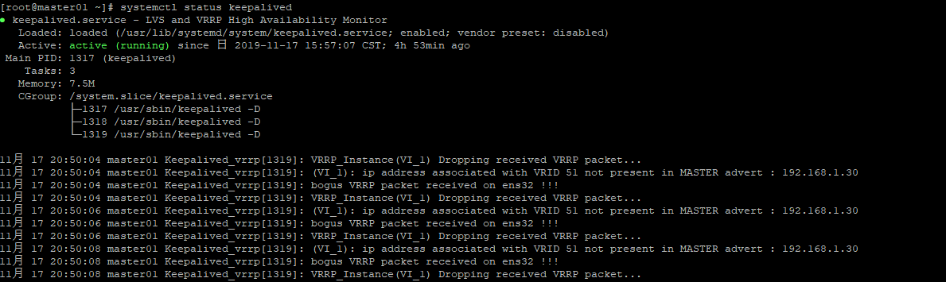
keepalived安装完成后注意检查是否自动在主机生成捆绑的VIP映射,生成后服务器不要随意重启，重启受到影响应该修改所有keepalived.conf文件中的virtual_router_id
#ip a
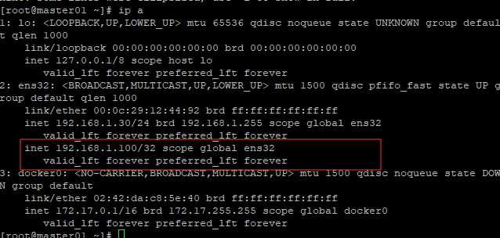

Kubernetes相关准备
下载kubernetes,在这里选择需要的版本
https://github.com/kubernetes/kubernetes/blob/master/CHANGELOG-1.14.md
解压
#tar -xf kubernetes-server-linux-amd64.tar.gz --strip-components=3 -C /usr/local/bin kubernetes/server/bin/kube{let,ctl,-apiserver,-controller-manager,-scheduler,-proxy}

下载Etcd3.3.12
#wget https://github.com/etcd-io/etcd/releases/download/v3.3.12/etcd-v3.3.12-linux-amd64.tar.gz
解压
#tar -zxvf etcd-v3.3.12-linux-amd64.tar.gz
#cp -p etcd-v3.3.12-linux-amd64/etcd /usr/local/bin
#cp -p etcd-v3.3.12-linux-amd64/etcdctl /usr/local/bin

#检查etcd版本
#etcd --version
#curl -l http://127.0.0.1:2379/version

将各组件分发至其他节点
#MasterNodes='master02 master03'
#WorkNodes='node01 node02 node03'
#for NODE in $MasterNodes; do echo $NODE
scp /usr/local/bin/kube{let,ctl,-apiserver,-controller-manager,-scheduler,-proxy} $NODE:/usr/local/bin/;
scp /usr/local/bin/etcd* $NODE:/usr/local/bin/
done
#for NODE in $WorkNodes; do
scp /usr/local/bin/kube{let,-proxy} $NODE:/usr/local/bin/
done

CNI安装
CNI（容器网络接口）是CNCF旗下的一个项目，由一组用于配置容器的网络接口的规范和库组成。CNI解决了容器网络互联的配置并支持多种网络模式。
创建目录
#mkdir -p /opt/cni/bin
下载及解压CNI
#wget https://github.com/containernetworking/plugins/releases/download/v0.7.5/cni-plugins-amd64-v0.7.5.tgz
#tar -zxf cni-plugins-amd64-v0.7.5.tgz -C /opt/cni/bin
分发CNI到其他节点
#MasterNodes='master02 master03'
#WorkNodes='node01 node02 node03'
#for NODE in $MasterNodes; do
ssh $NODE 'mkdir -p /opt/cni/bin'
scp /opt/cni/bin/* $NODE:/opt/cni/bin/
done
#for NODE in $WorkNodes; do
ssh $NODE 'mkdir -p /opt/cni/bin'
scp /opt/cni/bin/* $NODE:/opt/cni/bin/
done

生成证书
二进制安装时需要手动生成证书，这里借助的是cfssl
安装cfssl(下载并重命名)
#wget "https://pkg.cfssl.org/R1.2/cfssl_linux-amd64" -O /usr/local/bin/cfssl
# wget "https://pkg.cfssl.org/R1.2/cfssljson_linux-amd64" -O /usr/local/bin/cfssljson
#chmod +x /usr/local/bin/cfssl /usr/local/bin/cfssljson

生成Etcd证书
创建Etcd证书目录
#mkdir -p /etc/etcd/ssl
使用CSR文件生成etcd的CA key和Certificate
#cd chap01/1.3/pki/
#cfssl gencert -initca etcd-ca-csr.json | cfssljson -bare /etc/etcd/ssl/etcd-ca
生成证书
#cfssl gencert \
-ca=/etc/etcd/ssl/etcd-ca.pem \
-ca-key=/etc/etcd/ssl/etcd-ca-key.pem \
-config=ca-config.json \
-hostname=127.0.0.1,master01,master02,master03,192.168.1.30,192.168.1.31,192.168.1.32 \
-profile=kubernetes \
etcd-csr.json | cfssljson -bare /etc/etcd/ssl/etcd
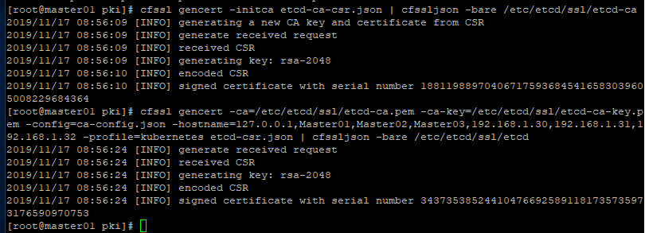
证书复制到其他节点
#for NODE in $MasterNodes; do
ssh $NODE 'mkdir -p /etc/etcd/ssl'
for FILE in etcd-ca-key.pem etcd-ca.pem etcd-key.pem etcd.pem; do
scp /etc/etcd/ssl/${FILE} $NODE:/etc/etcd/ssl/${FILE}
done
done

生成Kubernetes CA
创建目录
#mkdir -p /etc/kubernetes/pki
生成CA证书
#cfssl gencert -initca ca-csr.json | cfssljson -bare /etc/kubernetes/pki/ca
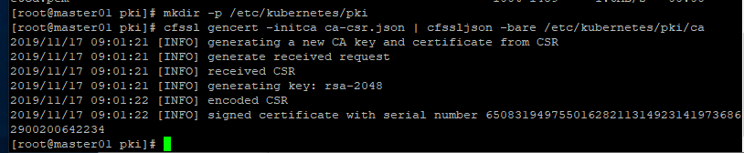

生成API Server证书
Kubernetes的端点Cluster IP(10.96.0.1),用于集群里的Pod调用Kubernetes的API Server,使用时不能与公司在同一个网段
创建证书
#cfssl gencert \
-ca=/etc/kubernetes/pki/ca.pem \
-ca-key=/etc/kubernetes/pki/ca-key.pem \
-config=ca-config.json \
-hostname=10.96.0.1,192.168.1.100,127.0.0.1,kubernetes,kubernetes.default,kubernetes.default.svc,kubernetes.default.svc.cluster,kubernetes.default.svc.cluster.local,192.168.1.30,192.168.1.31,192.168.1.32 \
-profile=kubernetes \
apiserver-csr.json | cfssljson -bare /etc/kubernetes/pki/apiserver
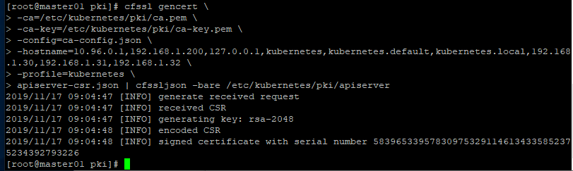

生成Front Proxy证书
创建Front Proxy证书
#cfssl gencert -initca front-proxy-ca-csr.json | cfssljson -bare /etc/kubernetes/pki/front-proxy-ca
#cfssl gencert \
-ca=/etc/kubernetes/pki/front-proxy-ca.pem \
-ca-key=/etc/kubernetes/pki/front-proxy-ca-key.pem \
-config=ca-config.json \
-profile=kubernetes \
front-proxy-client-csr.json | cfssljson -bare /etc/kubernetes/pki/front-proxy-client
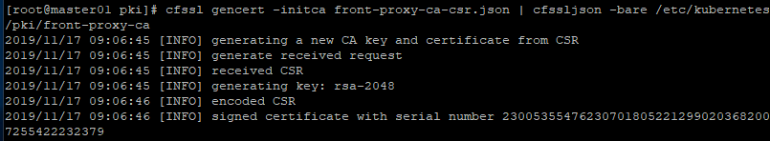
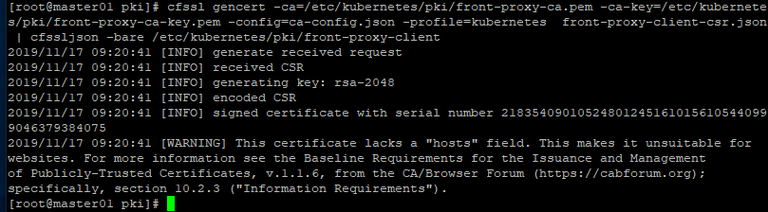

生成ControllerManager证书
#创建ControllerManager
#cfssl gencert \
-ca=/etc/kubernetes/pki/ca.pem \
-ca-key=/etc/kubernetes/pki/ca-key.pem \
-config=ca-config.json \
-profile=kubernetes \
manager-csr.json | cfssljson -bare /etc/kubernetes/pki/controller-manager
创建ControllerManager的kubeconfig文件,注意修改--server地址
#kubectl config set-cluster kubernetes \
--certificate-authority=/etc/kubernetes/pki/ca.pem \
--embed-certs=true \
--server=https://192.168.1.100:6443 \
--kubeconfig=/etc/kubernetes/controller-manager.kubeconfig

#kubectl config set-credentials system:kube-controller-manager \
--client-certificate=/etc/kubernetes/pki/controller-manager.pem \
--client-key=/etc/kubernetes/pki/controller-manager-key.pem \
--embed-certs=true \
--kubeconfig=/etc/kubernetes/controller-manager.kubeconfig

#kubectl config set-context system:kube-controller-manager@kubernetes \
--cluster=kubernetes \
--user=system:kube-controller-manager \
--kubeconfig=/etc/kubernetes/controller-manager.kubeconfig

#kubectl config use-context system:kube-controller-manager@kubernetes \
--kubeconfig=/etc/kubernetes/controller-manager.kubeconfig
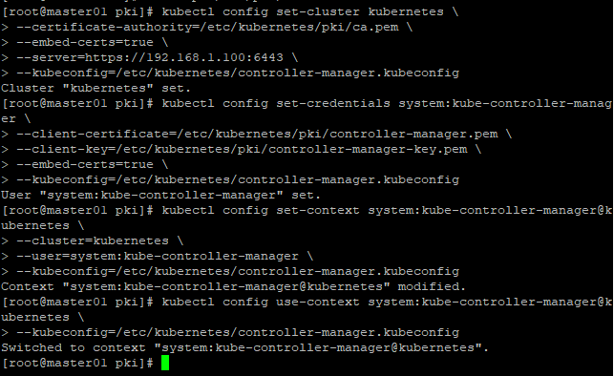

生成Scheduler证书
创建证书
#cfssl gencert \
-ca=/etc/kubernetes/pki/ca.pem \
-ca-key=/etc/kubernetes/pki/ca-key.pem \
-config=ca-config.json \
-profile=kubernetes \
scheduler-csr.json | cfssljson -bare /etc/kubernetes/pki/scheduler
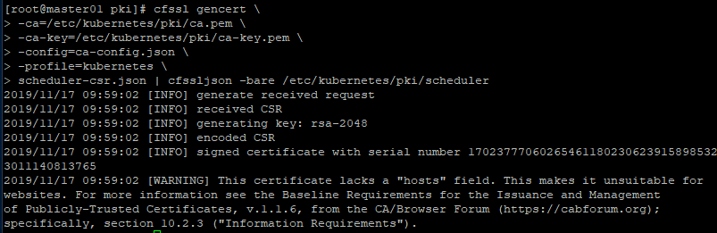
生成Scheduler的kubeconfig文件
#kubectl config set-cluster kubernetes \
--certificate-authority=/etc/kubernetes/pki/ca.pem \
--embed-certs=true \
--server=https://192.168.1.100:6443 \
--kubeconfig=/etc/kubernetes/scheduler.kubeconfig

#kubectl config set-credentials system:kube-scheduler \
--client-certificate=/etc/kubernetes/pki/scheduler.pem \
--client-key=/etc/kubernetes/pki/scheduler-key.pem \
--embed-certs=true \
--kubeconfig=/etc/kubernetes/scheduler.kubeconfig

#kubectl config set-context system:kube-scheduler@kubernetes \
--cluster=kubernetes \
--user=system:kube-scheduler \
--kubeconfig=/etc/kubernetes/scheduler.kubeconfig

#kubectl config use-context system:kube-scheduler@kubernetes \
--kubeconfig=/etc/kubernetes/scheduler.kubeconfig
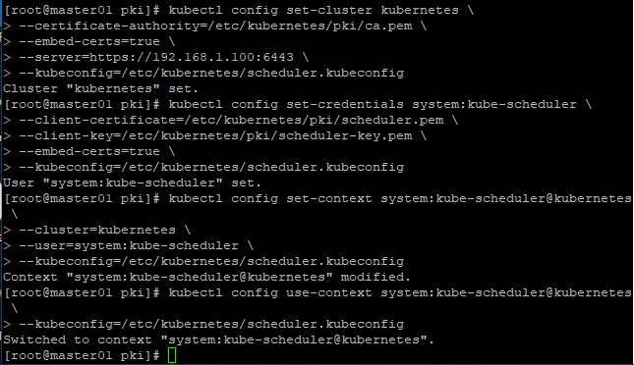

生成Admin Certificate
#创建证书
#cfssl gencert \
-ca=/etc/kubernetes/pki/ca.pem \
-ca-key=/etc/kubernetes/pki/ca-key.pem \
-config=ca-config.json \
-profile=kubernetes \
admin-csr.json | cfssljson -bare /etc/kubernetes/pki/admin
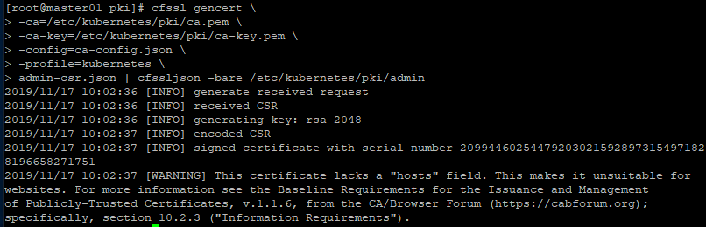
#生成Admin的kubeconfig文件
#kubectl config set-cluster kubernetes \
--certificate-authority=/etc/kubernetes/pki/ca.pem \
--embed-certs=true \
--server=https://192.168.1.100:6443 \
--kubeconfig=/etc/kubernetes/admin.kubeconfig

#kubectl config set-credentials kubernetes-admin \
--client-certificate=/etc/kubernetes/pki/admin.pem \
--client-key=/etc/kubernetes/pki/admin-key.pem \
--embed-certs=true \
--kubeconfig=/etc/kubernetes/admin.kubeconfig

#kubectl config set-context kubernetes-admin@kubernetes \
--cluster=kubernetes \
--user=kubernetes-admin \
--kubeconfig=/etc/kubernetes/admin.kubeconfig

#kubectl config use-context kubernetes-admin@kubernetes \
--kubeconfig=/etc/kubernetes/admin.kubeconfig
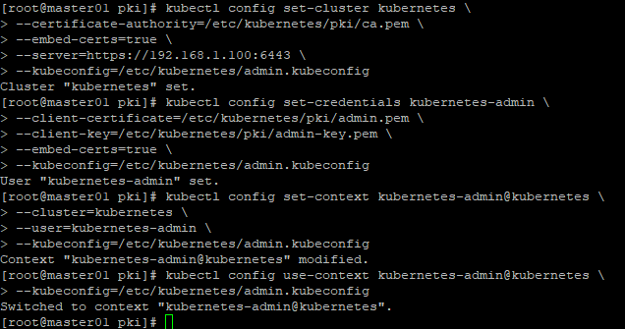

生成所有Master节点的Kubelet凭证
#
#for NODE in master01 master02 master03; do
\cp kubelet-csr.json kubelet-$NODE-csr.json;
sed -i "s/\$NODE/$NODE/g" kubelet-$NODE-csr.json;
cfssl gencert \
-ca=/etc/kubernetes/pki/ca.pem \
-ca-key=/etc/kubernetes/pki/ca-key.pem \
-config=ca-config.json \
-hostname=$NODE \
-profile=kubernetes \
kubelet-$NODE-csr.json | cfssljson -bare /etc/kubernetes/pki/kubelet-$NODE;
rm -f kubelet-$NODE-csr.json
done
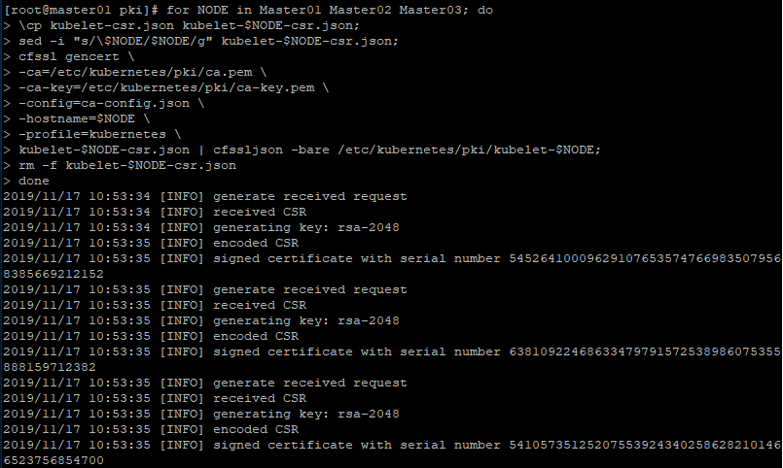
#复制证书到其他节点
#for NODE in master01 master02 master03; do
ssh $NODE "mkdir -p /etc/kubernetes/pki"
scp /etc/kubernetes/pki/ca.pem $NODE:/etc/kubernetes/pki/ca.pem
scp /etc/kubernetes/pki/kubelet-$NODE-key.pem $NODE:/etc/kubernetes/pki/kubelet-key.pem
scp /etc/kubernetes/pki/kubelet-$NODE.pem $NODE:/etc/kubernetes/pki/kubelet.pem
rm -f /etc/kubernetes/pki/kubelet-$NODE-key.pem /etc/kubernetes/pki/kubelet-$NODE.pem
done
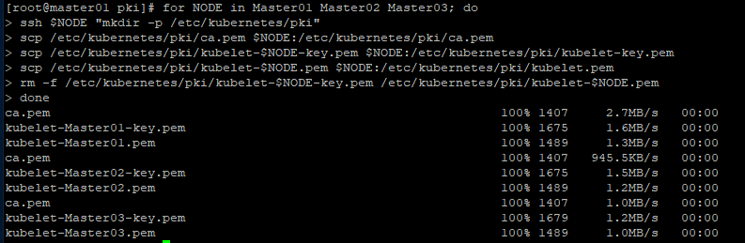

生成所有Master节点的kubeconfig文件
#for NODE in master01 master02 master03; do
ssh $NODE "cd /etc/kubernetes/pki && \
kubectl config set-cluster kubernetes \
--certificate-authority=/etc/kubernetes/pki/ca.pem \
--embed-certs=true \
--server=https://192.168.1.100:6443 \
--kubeconfig=/etc/kubernetes/kubelet.kubeconfig && kubectl config set-credentials system:node:${NODE} \
--client-certificate=/etc/kubernetes/pki/kubelet.pem \
--client-key=/etc/kubernetes/pki/kubelet-key.pem \
--embed-certs=true \
--kubeconfig=/etc/kubernetes/kubelet.kubeconfig && kubectl config set-context system:node:${NODE}@kubernetes \
--cluster=kubernetes \
--user=system:node:${NODE} \
--kubeconfig=/etc/kubernetes/kubelet.kubeconfig && kubectl config use-context system:node:${NODE}@kubernetes \
--kubeconfig=/etc/kubernetes/kubelet.kubeconfig"
done
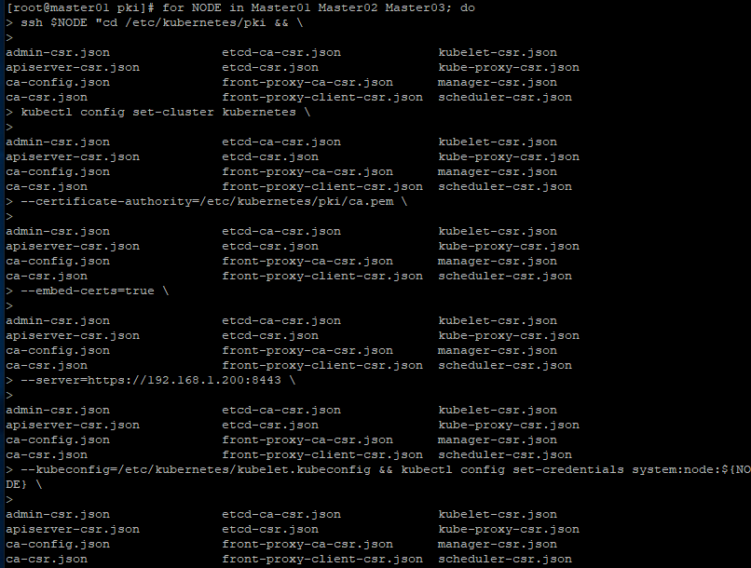
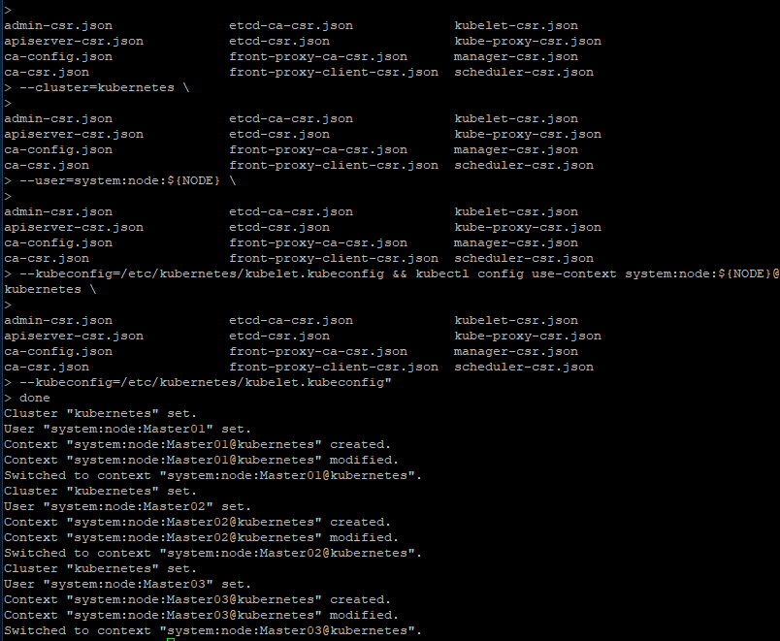

创建Service Account Key
# openssl genrsa -out /etc/kubernetes/pki/sa.key 2048

# openssl rsa -in /etc/kubernetes/pki/sa.key -pubout -out /etc/kubernetes/pki/sa.pub

#ls /etc/kubernetes/pki/sa.*
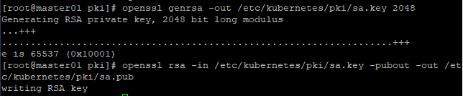
#复制到其他节点
#for NODE in Master02 master03; do
for FILE in $(ls /etc/kubernetes/pki | grep -v etcd); do
scp /etc/kubernetes/pki/${FILE} $NODE:/etc/kubernetes/pki/${FILE}
done
for FILE in admin.kubeconfig controller-manager.kubeconfig scheduler.kubeconfig; do
scp /etc/kubernetes/${FILE} $NODE:/etc/kubernetes/${FILE}
done
done
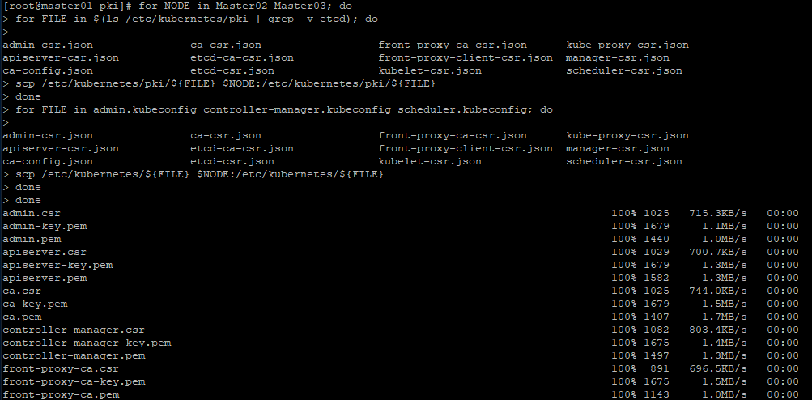

系统组件配置

Etcd集群配置
设置Master01机器的配置，其他机器做相关调整
#vi /etc/etcd/etcd.config.yml
配置详情
name: 'master01'
data-dir: /var/lib/etcd
wal-dir: /var/lib/etcd/wal
snapshot-count: 5000
heartbeat-interval: 100
election-timeout: 1000
quota-backend-bytes: 0
listen-peer-urls: 'https://192.168.1.30:2380'
listen-client-urls: 'https://192.168.1.30:2379,http://127.0.0.1:2379'
max-snapshots: 3
max-wals: 5
cors:
initial-advertise-peer-urls: 'https://192.168.1.30:2380'
advertise-client-urls: 'https://192.168.1.30:2379'
discovery:
discovery-fallback: 'proxy'
discovery-proxy:
discovery-srv:
initial-cluster: 'master01=https://192.168.1.30:2380,master02=https://192.168.1.31:2380,master03=https://192.168.1.32:2380'
initial-cluster-token: 'etcd-k8s-cluster'
initial-cluster-state: 'new'
strict-reconfig-check: false
enable-v2: true
enable-pprof: true
proxy: 'off'
proxy-failure-wait: 5000
proxy-refresh-interval: 30000
proxy-dial-timeout: 1000
proxy-write-timeout: 5000
proxy-read-timeout: 0
client-transport-security:
ca-file: '/etc/kubernetes/pki/etcd/etcd-ca.pem'
cert-file: '/etc/kubernetes/pki/etcd/etcd.pem'
key-file: '/etc/kubernetes/pki/etcd/etcd-key.pem'
client-cert-auth: true
trusted-ca-file: '/etc/kubernetes/pki/etcd/etcd-ca.pem'
auto-tls: true
peer-transport-security:
ca-file: '/etc/kubernetes/pki/etcd/etcd-ca.pem'
cert-file: '/etc/kubernetes/pki/etcd/etcd.pem'
key-file: '/etc/kubernetes/pki/etcd/etcd-key.pem'
peer-client-cert-auth: true
trusted-ca-file: '/etc/kubernetes/pki/etcd/etcd-ca.pem'
auto-tls: true
debug: false
log-package-levels:
log-output: default
force-new-cluster: false

Master节点配置etcd.service
#vi /usr/lib/systemd/system/etcd.service

[Unit]
Description=Etcd Service
Documentation=https://coreos.com/etcd/docs/latest/
After=network.target

[Service]
Type=notify
ExecStart=/usr/local/bin/etcd --config-file=/etc/etcd/etcd.config.yml
Restart=on-failure
RestartSec=10
LimitNOFILE=65536

[Install]
WantedBy=multi-user.target
Alias=etcd3.service

所有Master节点启动Etcd
#mkdir /etc/kubernetes/pki/etcd
#ln -s /etc/etcd/ssl/* /etc/kubernetes/pki/etcd/
#systemctl daemon-reload
#systemctl enable --now etcd

查看etcd运行状态
#systemctl status etcd

etcd集群查看
#etcdctl --ca-file=/etc/etcd/ssl/etcd-ca.pem --cert-file=/etc/etcd/ssl/etcd.pem --key-file=/etc/etcd/ssl/etcd-key.pem member list

Kubernetes集群配置
创建相关目录(所有节点)
#mkdir -p /etc/kubernetes/manifests/ /etc/systemd/system/kubelet.service.d /var/lib/kubelet /var/log/kubernetes

Master节点kube-apiserver
# vi /usr/lib/systemd/system/kube-apiserver.service

[Unit]
Description=Kubernetes API Server
Documentation=https://github.com/kubernetes/kubernetes
After=network.target

[Service]
ExecStart=/usr/local/bin/kube-apiserver \
--v=2 \
--logtostderr=true \
--allow-privileged=true \
--bind-address=0.0.0.0 \
--secure-port=6443 \
--insecure-port=0 \
--advertise-address=192.168.1.100 \
--service-cluster-ip-range=10.96.0.0/12 \
--service-node-port-range=30000-32767 \
--etcd-servers=https://192.168.1.30:2379,https://192.168.1.31:2379,https://192.168.1.32:2379 \
--etcd-cafile=/etc/etcd/ssl/etcd-ca.pem \
--etcd-certfile=/etc/etcd/ssl/etcd.pem \
--etcd-keyfile=/etc/etcd/ssl/etcd-key.pem \
--client-ca-file=/etc/kubernetes/pki/ca.pem \
--tls-cert-file=/etc/kubernetes/pki/apiserver.pem \
--tls-private-key-file=/etc/kubernetes/pki/apiserver-key.pem \
--kubelet-client-certificate=/etc/kubernetes/pki/apiserver.pem \
--kubelet-client-key=/etc/kubernetes/pki/apiserver-key.pem \
--service-account-key-file=/etc/kubernetes/pki/sa.pub \
--kubelet-preferred-address-types=InternalIP,ExternalIP,Hostname \
--enable-admission-plugins=Initializers,NamespaceLifecycle,LimitRanger,ServiceAccount,DefaultStorageClass,DefaultTolerationSeconds,NodeRestriction,ResourceQuota \
--authorization-mode=Node,RBAC \
--enable-bootstrap-token-auth=true \
--requestheader-client-ca-file=/etc/kubernetes/pki/front-proxy-ca.pem \
--proxy-client-cert-file=/etc/kubernetes/pki/front-proxy-client.pem \
--proxy-client-key-file=/etc/kubernetes/pki/front-proxy-client-key.pem \
--requestheader-allowed-names=aggregator \
--requestheader-group-headers=X-Remote-Group \
--requestheader-extra-headers-prefix=X-Remote-Extra- \
--requestheader-username-headers=X-Remote-User \
--token-auth-file=/etc/kubernetes/token.csv

Restart=on-failure
RestartSec=10s
LimitNOFILE=65535

[Install]
WantedBy=multi-user.target

注意:Initializers选项在kube-apiserver1.14.x版本的--enable-admission-plugins已经停用

# cp /root/chap01/1.3/master-systemd/token.csv /etc/kubernetes/token.csv
#cat /etc/kubernetes/token.csv

所有Master节点启动kube-apiserver
#systemctl enable --now kube-apiserver

# systemctl status kube-apiserver

Master节点kube-controller-manager
所有Master创建kube-controller-manager.service,注意修改cluster-cidr的值，此值为PodIP的网段，不要和宿主机在同网段。
#vi /usr/lib/systemd/system/kube-controller-manager.service

[Unit]
Description=Kubernetes Controller Manager
Documentation=https://github.com/kubernetes/kubernetes
After=network.target

[Service]
ExecStart=/usr/local/bin/kube-controller-manager \
--v=2 \
--logtostderr=true \
--address=127.0.0.1 \
--root-ca-file=/etc/kubernetes/pki/ca.pem \
--cluster-signing-cert-file=/etc/kubernetes/pki/ca.pem \
--cluster-signing-key-file=/etc/kubernetes/pki/ca-key.pem \
--service-account-private-key-file=/etc/kubernetes/pki/sa.key \
--kubeconfig=/etc/kubernetes/controller-manager.kubeconfig \
--leader-elect=true \
--use-service-account-credentials=true \
--node-monitor-grace-period=40s \
--node-monitor-period=5s \
--pod-eviction-timeout=2m0s \
--controllers=*,bootstrapsigner,tokencleaner \
--allocate-node-cidrs=true \
--cluster-cidr=10.244.0.0/16 \
--requestheader-client-ca-file=/etc/kubernetes/pki/front-proxy-ca.pem \
--node-cidr-mask-size=24

Restart=always
RestartSec=10s

[Install]
WantedBy=multi-user.target
所有Master节点启动kube-controller-manager
#systemctl daemon-reload
#systemctl enable --now kube-controller-manager
# systemctl status kube-controller-manager

Master节点kube-scheduler
#vi /usr/lib/systemd/system/kube-scheduler.service

[Unit]
Description=Kubernetes Scheduler
Documentation=https://github.com/kubernetes/kubernetes
After=network.target

[Service]
ExecStart=/usr/local/bin/kube-scheduler \
--v=2 \
--logtostderr=true \
--address=127.0.0.1 \
--leader-elect=true \
--kubeconfig=/etc/kubernetes/scheduler.kubeconfig

Restart=always
RestartSec=10s

[Install]
WantedBy=multi-user.target
所有master启动scheduler
#systemctl daemon-reload
#systemctl enable --now kube-scheduler
#systemctl status kube-scheduler

查看集群状态
#cp /etc/kubernetes/admin.kubeconfig ~/.kube/config
#kubectl get cs
#kubectl get svc
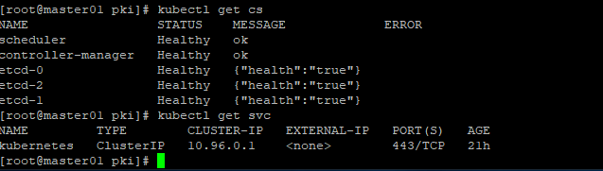
此时如未配置网络组件CNI，可能会出现: No networks found in /etc/cni/net.d ... 可以忽略
查看系统日志(服务启动日志)
#journalctl -n 30

TLS Bootstrapping配置
建立TLS Bootstrapping RBAC 与Secret,用来解决手动对每台节点单独签署凭证的问题。

建立bootstrap-kubelet.conf
kubernetes config文件
#kubectl config set-cluster kubernetes --certificate-authority=/etc/kubernetes/pki/ca.pem --embed-certs=true --server=https://192.168.1.100:6443 --kubeconfig=/etc/kubernetes/bootstrap-kubelet.kubeconfig

#kubectl config set-credentials tls-bootstrap-token-user --token=405d86.c33faabc271aab37 --kubeconfig=/etc/kubernetes/bootstrap-kubelet.kubeconfig

#kubectl config set-context tls-bootstrap-token-user@kubernetes --cluster=kubernetes --user=tls-bootstrap-token-user --kubeconfig=/etc/kubernetes/bootstrap-kubelet.kubeconfig

#kubectl config use-context tls-bootstrap-token-user@kubernetes --kubeconfig=/etc/kubernetes/bootstrap-kubelet.kubeconfig

建立bootstrap secret ,注意token-id与token-secret的值和上述命令set--credentials的--token对应
#cat bootstrap-secret.yaml

apiVersion: v1
metadata:
name: bootstrap-token-433f5d
namespace: kube-system
type: bootstrap.kubernetes.io/token
stringData:
token-id: '405d86'
token-secret: c33faabc271aab37
usage-bootstrap-authentication: "true"
usage-bootstrap-signing: "true"
auth-extra-groups: system:bootstrappers:default-node-token
创建
#kubectl create -f bootstrap-secret.yaml

建立bootstrap RBAC
#cat bootstrap-rbac.yaml

apiVersion: rbac.authorization.K8S.io/v1
kind: ClusterRoleBinding
metadata:
name: kubelet-bootstrap
roleRef:
apiGroup: rbac.authorization.K8S.io
kind: ClusterRole
name: system:node-bootstrapper
subjects:
- apiGroup: rbac.authorization.K8S.io
kind: Group
name: system:bootstrappers:default-node-token
---
apiVersion: rbac.authorization.K8S.io/v1
kind: ClusterRoleBinding
metadata:
name: node-autoapprove-bootstrap
roleRef:
apiGroup: rbac.authorization.K8S.io
kind: ClusterRole
name: system:certificates.K8S.io:certificatesigningrequests:nodeclient
subjects:
- apiGroup: rbac.authorization.K8S.io
kind: Group
name: system:bootstrappers:default-node-token
---
apiVersion: rbac.authorization.K8S.io/v1
kind: ClusterRoleBinding
metadata:
name: node-autoapprove-certificate-rotation
roleRef:
apiGroup: rbac.authorization.K8S.io
kind: ClusterRole
name: system:certificates.K8S.io:certificatesigningrequests:selfnodeclient
subjects:
- apiGroup: rbac.authorization.K8S.io
kind: Group
name: system:node
---
apiVersion: rbac.authorization.K8S.io/v1
kind: ClusterRoleBinding
metadata:
annotations:
rbac.authorization.kubernetes.io/autoupdate: "true"
labels:
kubernetes.io/bootstrapping: rbac-defaults
name: system:kube-apiserver-tokubelet
rules:
- apiGroups:
- ""
resources:
- nodes/proxy
- nodes/stats
- nodes/log
- nodes/spec
- nodes/metrics
verbs:
- "*"
---
apiVersion: rbac.authorization.K8S.io/v1
kind: ClusterRoleBinding
metadata:
name: system:kube-apiserver
namespace: ""
roleRef:
apiGroup: rbac.authorization.K8S.io
kind: ClusterRole
name: system:kube-apiserver-to-kubelet
subjects:
- apiGroup: rbac.authorization.K8S.io
kind: User
name: kube-apiserver
创建bootstrap
#kubectl create -f bootstrap-rbac.yaml
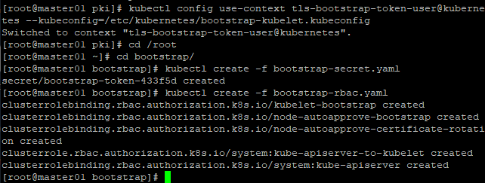

Node节点间配置

Node节点只需要启动Kubelet即可，具体配置步骤如下
将证书复制到Node节点：
#for NODE in node01 node02 node03; do
ssh $NODE mkdir -p /etc/kubernetes/pki /etc/etcd/ssl /etc/etcd/ssl
for FILE in etcd-ca.pem etcd.pem etcd-key.pem; do
scp /etc/etcd/ssl/$FILE $NODE:/etc/etcd/ssl/
done
for FILE in pki/ca.pem pki/ca-key.pem pki/front-proxy-ca.pem bootstrap-kubelet.kubeconfig; do
scp /etc/kubernetes/$FILE $NODE:/etc/kubernetes/${FILE}
done
done
所有Node节点创建相关目录
#mkdir -p /var/lib/kubelet /var/log/kubernetes /etc/systemd/system/kubelet.service.d /etc/kubernetes/manifests/

Kubelet service文件
创建文件
#cat /usr/lib/systemd/system/kubelet.service

[Unit]
Description=Kubernetes Kubelet
Documentation=https://github.com/kubernetes/kubernetes
After=docker.service
Requires=docker.service

[Service]
ExecStart=/usr/local/bin/kubelet

Restart=always
StartLimitInterval=0
RestartSec=10

[Install]
WantedBy=multi-user.target

Kubelet Service参数文件

#cat /etc/systemd/system/kubelet.service.d/10-kubelet.conf

[Service]
Environment=" KUBELET_KUBECONFIG_ARGS=--bootstrap-kubeconfig=/etc/kubernetes/bootstrap-kubelet.kubeconfig --kubeconfig=/etc/kubernetes/kubelet.kubeconfig --allow-privileged=true"
Environment="KUBELET_SYSTEM_ARGS=--network-plugin=cni --cni-conf-dir=/etc/cni/net.d --cni-bin-dir=/opt/cni/bin"
Environment="KUBELET_CONFIG_ARGS=--config=/etc/kubernetes/kubelet-conf.yml"
Environment="KUBELET_EXTRA_ARGS=--node-labels=node-role.kubernetes.io/node='' --pod-infra-container-image=registry.cn-hangzhou.aliyuncs.com/google_containers/pause-amd64:3.1"
ExecStart=
ExecStart=/usr/local/bin/kubelet $KUBELET_KUBECONFIG_ARGS $KUBELET_CONFIG_ARGS $KUBELET_SYSTEM_ARGS $KUBELET_EXTRA_ARGS

Kubelete配置文件
配置Kubelete配置文件，注意clusterDNS的地址
#cat /etc/kubernetes/kubelet-conf.yml

apiVersion: kubelet.config.K8S.io/v1beta1
kind: KubeletConfiguration
address: 0.0.0.0
port: 10250
readOnlyPort: 10255
authentication:
anonymous:
enabled: false
webhook:
cacheTTL: 2m0s
enabled: true
x509:
clientCAFile: /etc/kubernetes/pki/ca.pem
authorization:
mode: Webhook
webhook:
cacheAuthorizedTTL: 5m0s
cacheUnauthorizedTTL: 30s
cgrouDriver: cgroupfs
cgroupsPerQOS: true
clusterDNS:
- 10.96.0.10
clusterDomain: cluster.local
containerLogMaxFiles: 5
containerLogMaxSize: 10Mi
contentType: application/vnd.kubernetes.protobuf
cpuCFSQuota: true
cpuManagerPolicy: none
cpuManagerReconcilePeriod: 10s
enableControllerAttachDetach: true
enableDebuggingHandlers: true
enforceNodeAllocatable:
- pods
eventBurst: 10
eventRecordQPS: 5
evictionHard:
imagefs.available: 15%
memory.available: 100Mi
nodefs.available: 10%
nodefs.inodesFree: 5%
evictionPressureTransitionPeriod: 5m0s
failSwapOn: true
fileCheckFrequency: 20s
hairpinMode: promiscuous-bridge
healthzBindAddress: 127.0.0.1
healthzPort: 10248
httpCheckFrequency: 20s
imaggeGCHighThresholdPercent: 85
imageGCLowThresholdPercent: 80
imageMinimumGCAge: 2m0s
iptablesDropBit: 15
iptablesMasqueradeBit: 14
kubeAPIBurst: 10
kubeAPIQPS: 5
makeIPTablesUtilChains: true
maxOpenFiles: 1000000
maxPods: 110
nodeStatusUpdateFrequency: 10s
oomScoreAdj: -999
podPidsLimit: -1
registryBurst: 10
registryPullQPS: 5
resolvConf: /etc/resolv.conf
rotateCertificates: true
runtimeRequestTimeout: 2m0s
serizlizeImagePulls: true
staticPodPath: /etc/kubernetes/manifests
streamingConnectionIdleTimeout: 4h0m0s
syncFrequency: 1m0s
volumeStatsAggPeriod: 1m0s

所有节点启动kubelet,启动后会自动生产kubelet.kubeconfig文件，并且controller-manager会自动为kubelet颁发证书
#systemctl daemon-reload
#systemctl enable --now kubelet
#systemctl status kubelet

查看集群状态
#kubectl get csr

Kube-Proxy配置
Kube-Proxy用户实现Pod和Pod之间以及外部到Pod的访问。
创建Kube-Proxy的ServiceAccount
#kubectl -n kube-system create serviceaccount kube-proxy serviceaccount/kube-proxy created
创建Clusterrolebinding
#kubectl create clusterrolebinding system:kube-proxy \
--clusterrole system:node-proxier \
--serviceaccount kube-system:kube-proxy

创建kube-proxy的kubeconfig
#SECRET=$(kubectl -n kube-system get sa/kube-proxy --output=jsonpath='{.secrets[0].name}')
#JWT_TOKEN=$(kubectl -n kube-system get secret/$SECRET --output=jsonpath='{.data.token}' | base64 -d)
#PKI_DIR=/etc/kubernetes/pki
#K8S_DIR=/etc/kubernetes
proxy set cluster
#kubectl config set-cluster kubernetes \
--certificate-authority=/etc/kubernetes/pki/ca.pem \
--embed-certs=true \
--server=https://192.168.1.100:6443 \
--kubeconfig=${K8S_DIR}/kube-proxy.kubeconfig
proxy set credentials
#kubectl config set-credentials kubernetes \
--token=${JWT_TOKEN}
--kubeconfig=/etc/kubernetes/kube-proxy.kubeconfig
proxy set context
#kubectl config set-context kubernetes \
--cluster=kubernetes \
--user=kubernetes \
--kubeconfig=/etc/kubernetes/kube-proxy.kubeconfig
proxy set default context
#kubectl config use-context kubernetes \
--kubeconfig=/etc/kubernetes/kube-proxy.kubeconfig

复制kube-proxy文件至所有节点
#cd chap01/1.3
#for NODE in Master01 master02 master03; do
scp ${K8S_DIR}/kube-proxy.kubeconfig $NODE:/etc/Kubernetes/kube-proxy.kubeconfig
scp kube-proxy/kube-proxy.conf $NODE:/etc/kubernetes/kube-proxy.conf
scp kube-proxy/kube-proxy.service $NODE:/usr/lib/systemd/system/kube-proxy.service
done

#for NODE in Node01 Node02; do
scp ${K8S_DIR}/kube-proxy.kubeconfig $NODE:/etc/Kubernetes/kube-proxy.kubeconfig
scp kube-proxy/kube-proxy.conf $NODE:/etc/kubernetes/kube-proxy.conf
scp kube-proxy/kube-proxy.service $NODE:/usr/lib/systemd/system/kube-proxy.service
done

所有节点启动kube-proxy
#systemctl enable --now kube-proxy

Calico配置
Calico组件的安装
#POD_CIDR="10.244.0.0/16" \
sed -i -e "s?192.168.0.0/16?$POD_CIDR?g" calico/v3.6.1/calico.yaml
#kubectl apply -f calico/v3.6.1/calico.yaml
查看Calico Pods的状态
#kubectl get po -n kube-system

CoreDNS配置
CoreDNS用户集群中Pod解析Service的名字，Kubernetes基于CoreDNS用于服务发现功能。
#kubectl apply -f coredns/coredns.yml
查看CoreDNS的Pod状态
#kubectl -n kube-system get po -l K8S-app=kube-dns
解析测试
#cat<<EOF | kubectl apply -f -
apiVersion: v1
metadata:
name: busybox
namespace: default
spec:
restartPolicy: Always
containers:
- name: busybox
image: busybox:1.28
imagePullPolicy: IfNotPresent
command:
- sleep
- "3600"
EOF

解析Kubernetes service:
#kubectl exec -ti busybox -n default -- nslookup

Metrics-Server配置
安装metrics-server
#kubectl create -f metric-server
查看Pod状态
#kubectl -n kube-system get po -l K8S-app=metrics-server
查看Node资源使用
#kubectl top node

Dashboard配置
安装heapster
#kubectl apply -f heapster/
安装Dashboard
#kubectl create -f dashboard/
查看Pod状态
#kubectl get po -n kube-system -l K8S-app=kubernetes-dashboard

