Michigame Highlands Exploration

Laura Slavsky - Conservation Data Lab

4/20/2020

Table of Contents

Questions for Exploration: 1

Background & Brief Definitions 2

What is BPS? & EVT? 2

Group Names and Names 3

Bigger Picture: Group Names 4

Historical Group Names 4

Current Group Names 4

Group Names Recap 5

More Detailed: Ecosystem Names 5

Historical Ecosystem Names 5

Current Ecosystem Names 6

Ecosystem Names Recap 7

Existing Vegetation Height & Cover 7

How to read a Heatmap 7

Existing Vegetation Cover (EVC) 8

Existing Vegetation Height (EVH) 9

Conclusions 9

(Put photo of map here)

# Questions , data and methods:

This document explores the question: **What structural conditions of the ecosystems in the Michigamme Highlands ecoregion of the Upper Peninsula of Michigan?** This information will serve as background for future conservation efforts in the area.

We used data from the LANDFIRE program:

* LANDFIRE ReMap (version 200), Existing Vegetation Cover, Height and Type (EVC, EVH and EVT. )
* LANDFIRE 2012 (version 130) Biophysical Settings (BpS)
* Michigamme Highlands boundary ( polygon supplied by Emily Clegg)

More information on LANDFIRE and these datasets can be found at [www.landfire.gov](http://www.landfire.gov).

The LANDFIRE datasets were extracted to the Michigamme Highlands boundary in ArcGIS 10.3 (<https://www.esri.com/en-us/home>) then performing a combine (Spatial Analyst toolbox) and joining in attributes (Join Field function).

Here we:

* Provide basic graphics and interpretations of the Michigamme Highlands
* Compare past and present acres per ecosystem
* Summarize conditions of existing cover and height for the 5 most prevalent Existing Vegetation Types
* Highlight potentially degraded lands on Northern Hardwood sites

This document is an **introductory** look at the Michigamme Highlands and **not** an in-depth analysis of the area.

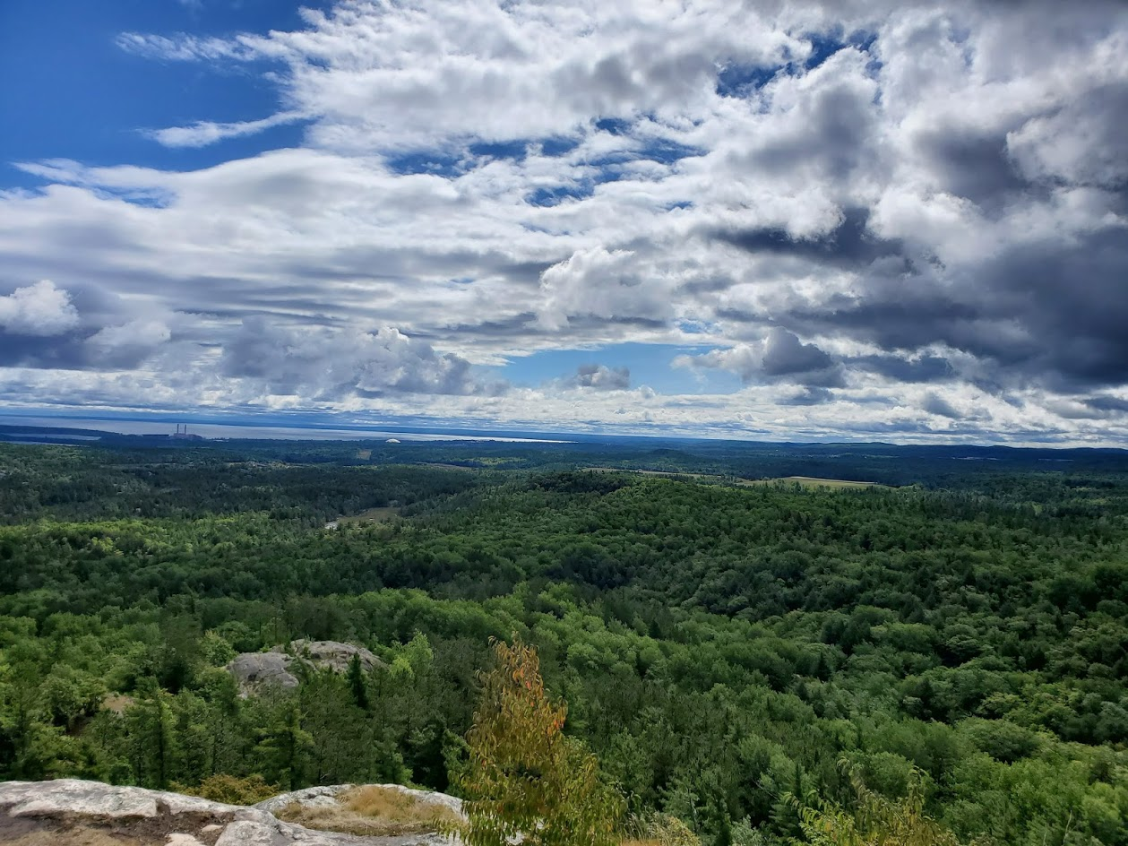

# Background & Brief Definitions

## What is BPS? & EVT?

Please consult the brief definitions below before embarking onto the data visualizations. It is important to understand some key terms when analyzing the data for the MH.

BPS = Biophysical Settings - Historic

BPS stands for Biophysical Settings. BPS data is what vegetation historically dominated landscapes prior to Euro-American settlement - the ecosystems that were once in a given area. This is estimated accoridng to LANDFIRE.GOV by “the current biophysical environment and an approximation of the historical disturbance regime”.

EVT = Existing Vegetation Type - Current

EVT stands for Existing Vegetation Type and includes “the current distribution of the terrestrial ecological systems classification” (LANDFIRE). EVT data is from 2016 and represents current ecosystems.

**BPS = Historic, EVT = Current**. The remainder of this document will use “Historic” and “Current” as the main means of referencing these data.

## Group Names and Names

The data include both “Group Names” and “Names”. “Names” have more specified ecosystem types such as:

* “Laurentian Jack Pine-Red Pine Forest”
* “Laurentian-Acadian Sub-boreal Mesic Balsam Fir-Spruce Forest”
* “Northeastern North American Temperate Forest Plantation”
* Etc.

This means, for example, that two groups that are both Hardwoods may have different names given to them, making looking at the bigger picture of ecosystem types and change over time difficult.

As a result, “Group Names” are also assigned to the data, allowing larger-scale comparisons of all “Hardwoods”, “Conifer”, “Riparian”, etc.

**Group Names = Overall Ecosystem Type, Names = Specified Ecosystem**

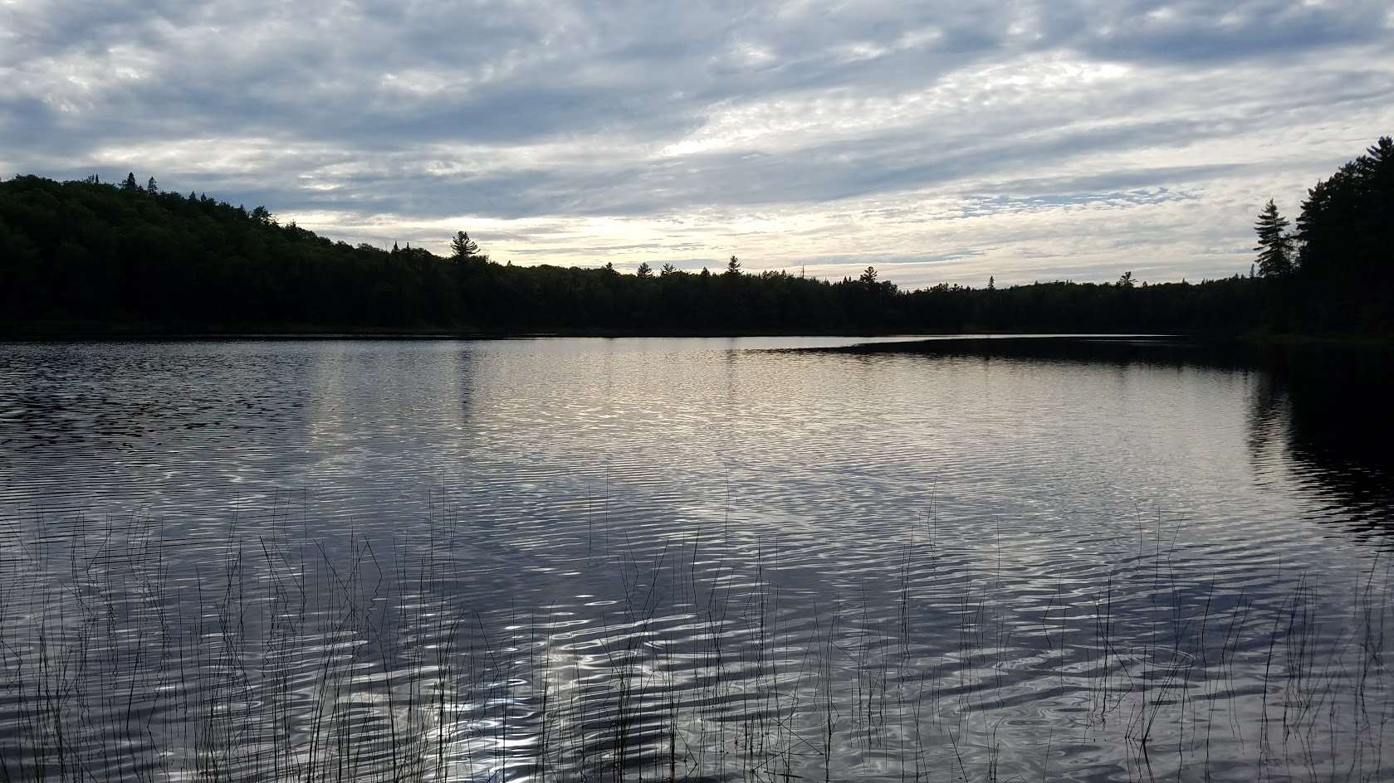

The remainder of this document contains different data visualizations using the data from both BPS and EVT ecosystems. Descriptions are provided to give context and interpretation of each graph.

# Bigger Picture: Group Names

## Historical Group Names

First, let’s start with looking how **group ecosystems** have changed over time.

Using BPS data, the four most common historic ecosystems (Group Names) in the MH were:

* Hardwood
* Riparian
* Conifer
* Hardwood-Conifer

Hardwoods occupied just under half, 47.9%, of the area. (Open Water was removed from the groups as well as Barren-Rock/Sand/Clay which occupied half of one percent of the historic area).

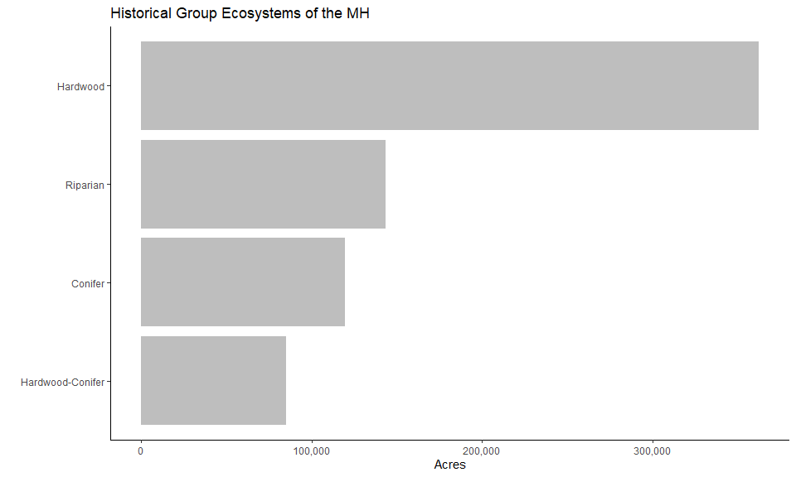

## Current Group Names

Next, looking at the current (EVT) Group Names of the Michigamme Highlands:

There are several more ecosystems currently represented in the Michigamme Highlands compared to the BPS data, even at the group level. The majority of the MH are still hardwood, represented by the “Yellow Birch-Sugar Maple Forest” with over 330,000 acres (44%) in this group.

Any ecosystem <2% of the total acreage was omitted from the following graph.

Compared to total acres, there is a relatively small percentage (5.3%) of developed land, and minimal (0.08%) Agriculture.

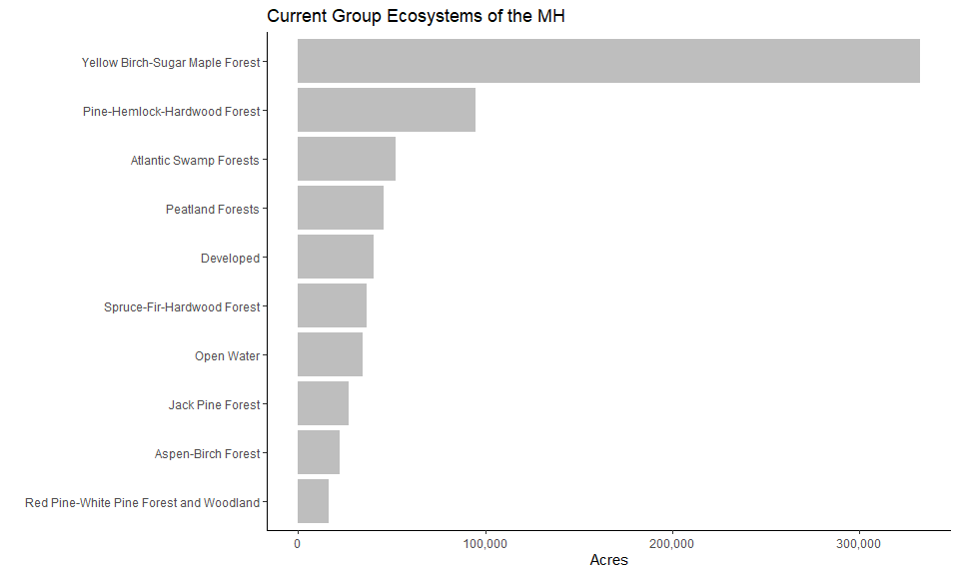

## Group Names Recap

* Hardwoods used to and still compose a significant acreage of the area.
* Currently, there are few (<2% each) degraded group ecosystems such as plantations, agriculture, strip-mining, etc.
* Though there is not much degredation, development is the 5th most common group ecosystem in the MH today.

# More Detailed: Ecosystem Names

Now, let’s focus in on more specific **ecosystem names** historically and currently in the MH.

## Historical Ecosystem Names

Historically, hardwoods made up a significant portion (59.6%) of the Michigamme Highlands, with Laurentian-Acadian Northern Hardwoods, Northern Hardwoods - Hemlock, and Pine-Hemlock-Hardwood forest being the top three named ecosystems.

Any ecosystem name <2% of the total acreage was omitted from the following graph.

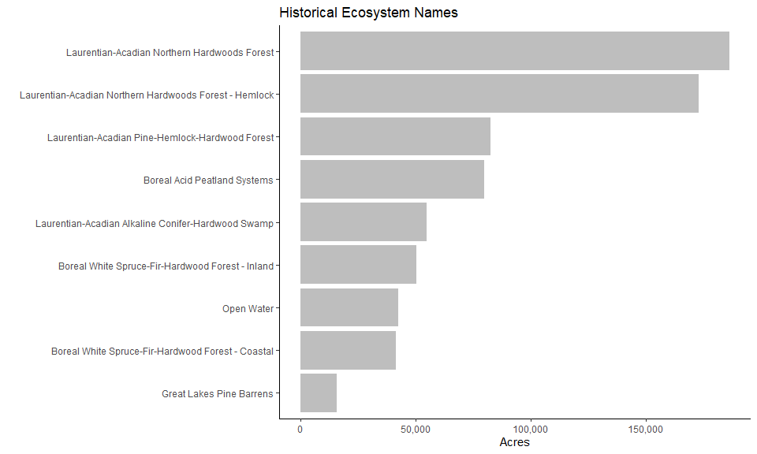

## Current Ecosystem Names

There are 75 named ecosystems for the current (EVT) data of the Michigamme Highlands. However, all ecosystems beyond the top 9 compose less than 2% each of the MH, so have been omitted from the graph.

This final histogram shows the top nine current ecosystem names in the MH. Any ecosystem name <2% of the total acreage was omitted from the following graph.

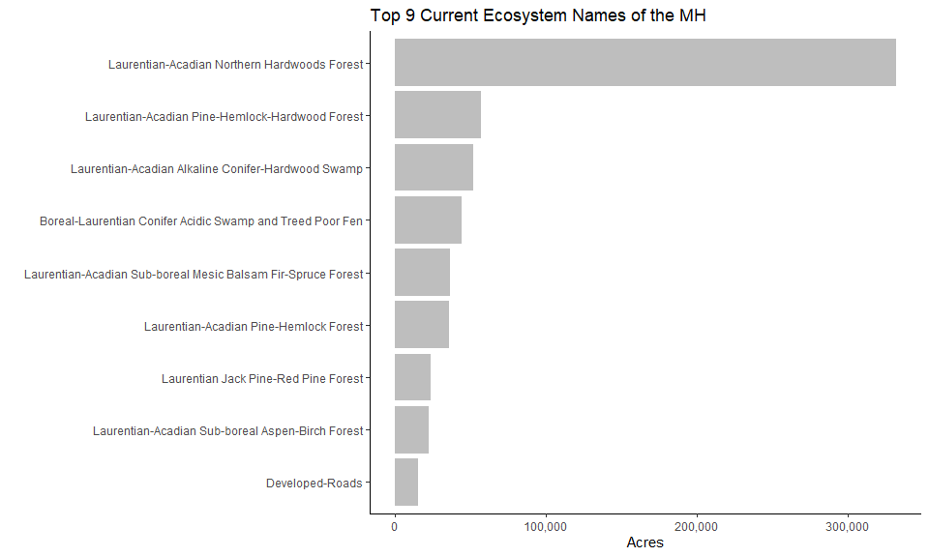

## Ecosystem Names Recap

Looking at more specified ecosystem names, the top ecosystem of Laurentian-Acadian Northern Hardwoods Forest is the same for both historic and current ecosystems. From there however, there are some siginificant differences in what ecosytems are present today.

There are less conifer & hemlock ecosystems than historically present, and there are more aspen/birch ecosystems now (primary successional species) compared to historically. Developed roads make it into the top 9 ecosystems composing 2.1% of the Michigamme Highlands.

Peatlands compose less than 2% of the MH where historically they were fourth most prevalant ecosystem.

Development, recently logged areas, mining, agriculture, and other modern-day disturbances compose less than 2% of the MH each, but are present in the MH today.

# Existing Vegetation Height & Cover

The last components of the Michigamme Highlands we will look at in this document are existing vegetation height and existing vegetation cover. These data are provided by the LANDFIRE database.

## How to read a Heatmap

For looking at EVC & EVH, we decided to create “heatmaps”. They combine color intensity and location on the x-axis to represent data.

The more intense the color/shade in the heatmap, the more prevalant that component of the map (cover or height). So a dark green bar for tree canopy indicates a higher occurance (percentage) of that particular percentage of canopy cover.

Each ecosystem comprises “100%” of the canopy cover percentage, so each ecosystem is looked at individually.

## Existing Vegetation Cover (EVC)

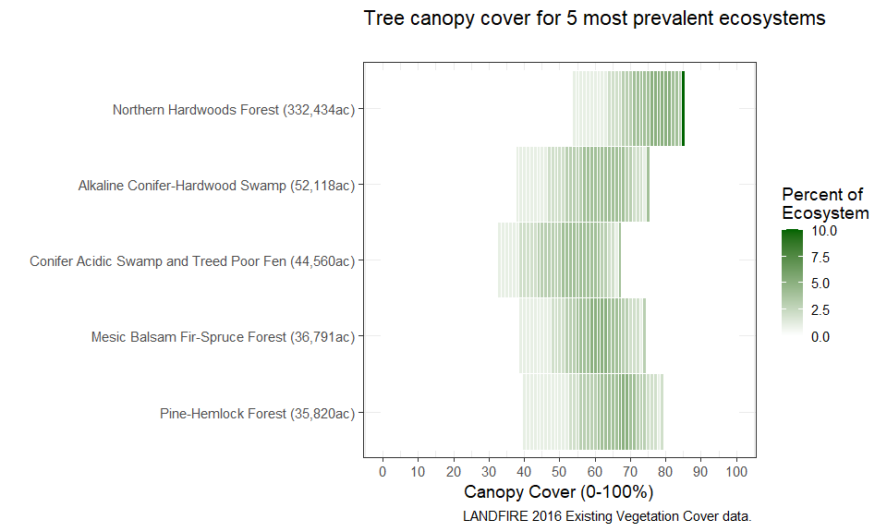

Upon looking at EVC, you can see that Northern Hardwoods Forests have a higher percentage of canopy cover compared the other ecosystems. Conifer Acidic swamp and Treed Poor Fens have the lowest percentage of canopy cover.

Most of the ecosystems’ “average” canopy cover is in the middle of their percentage range, while Northern Hardwoods tend towards the upper end of their percentage range.

## Existing Vegetation Height (EVH)

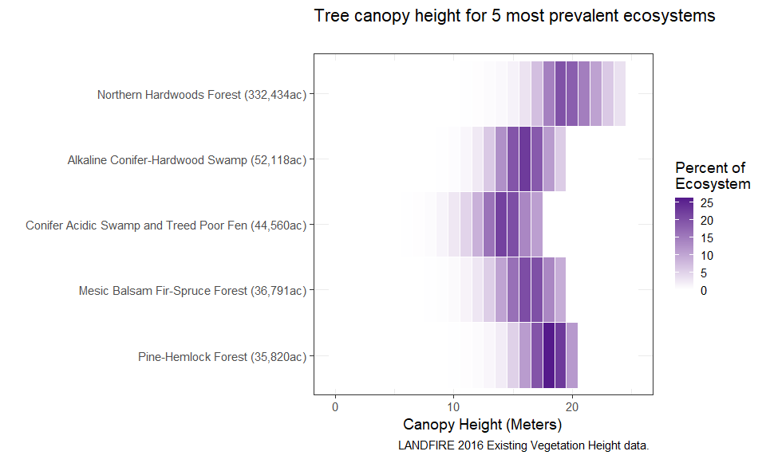

Northern Hardwoods have the tallest canopy, and Conifer Acidic Swamp and Treed Poor Fen have the shortest.

Pine-Hemlock Forests have a distinct 25% of their canopy around 18-19 meters, while the rest of the ecosystems tend to have most of their canopy height in the center of their range.

# Conclusions

The Michigamme Highlands are diverse wiht varying ecosystem types throughout.

The end.