Android Sensing Project

Project Option 1: Bluetooth device survey

Luke Slemon 16421694 (student submitting the report)

*Abstract*  
Android Applications are created for a wide range of scenarios such as locating the nearest ATM, streaming music, and ordering food. The application outlined in this report was created as a Bluetooth Device surveyor, which scans for Bluetooth devices at different locations. The purpose of this is to determine how many Bluetooth devices are active at any one time in a single area, and in particular what kind of device it is, i.e. Laptop, Phone, Heartbeat sensor, headphones, etc. Using the phones GPS and Bluetooth sensor, latitude, longitude, and Bluetooth device information was collected and stored to Google’s own open source Database Firebase.

Keywords—Android;GPS;Bluetooth;Firebase

# Introduction

This report details the development of two Android Applications, both of which utilize GPS location. The primary aim of this task was to teach students how Android development was accomplished and how to use opensource tools such as Android Studio and Firebase to create simple yet useful applications.

Android is a linux based operating system designed specifically for smart phones[1]. It is the counter part to Apple’s IOS in the smartphone game. Android, like linux, is open source and can be modified or remodeled to make more specialized OS similar to Cyanagen.

Android apps are typically designed using either Java or a newer language Kotlin using the dedicated IDE, Android Studio. Android applications are composed of 2 primary components, Activities and Services. Activities are the primary entry point for the user to the application, they handle all UI and presenting data to the User[2]. Services are similar to Activities without a UI. They are typically bound to an Activity and run in the background while the Activity is alive. Once the Activity is closed, the service will terminate.

If application state is important, then a layer of persistence is required to ensure the application state remains unchanged after the app is closed. Android developers are given the choice between using either the Android Room database or Google’s Firebase. The room database is a local SQLite database cached directly on the host device[3], while Firebase is a remote database holding JSON tree records.

# Workshop application : GPS location Upload and Retrieval

## Before working on the Bluetooth Surveyor application, a short workshop was completed where a simple GPS application that stored and retrieved GPS data was developed. The aim of this workshop was to teach students to use Android Studio for creating apps, how to use the devices sensors in an application and how to store the recorded data to a Firebase database and retrieve it when it’s needed.

## Application Description

The primary function of this application was to utilize the phone’s GPS sensor to determine the location of the phone every time the phone moves more than 5 meters or 10 seconds. Once the a location update is fired, the new location data is stored to the firebase database by utilizing a locationData object to abstract the data being stored to the Data base.

The user also has the option to force a location update at the push of a button allowing them to record their location data at will. Drop pins/markers are placed at the stored co-ordinates, where the user can tap on the marker and are presented with the co-ordinates.

## Application Code and Behaviour

### Structure

### The application is structured using a single Activity with a Map UI and a single button. The single Activity (MapsActivity) handles the location updates, the permission controls, and the database read/write operations.

### When the application is opened, the onCreate method is called which is used to inflate the view using the XML file, assign a button handler to the single button, check permissions and finally initiate location updates.

Once the UI has been loaded, the onMapReady method for the Map UI is called and a new data listener for the database is called either when new data is entered to the Database or when the listener is initially created.

### Permissions

Before the application can access the phone’s location, the user must grant the Coarse Access Location, and Fine Access Location permissions. When requesting the User’s permission, a dialog will be presented which asks them to grant their permission in order to allow the app to record their location.

### GPS Location Handling

After permissions have been granted, before location updates can be initiated, the app determines if the Location service or network service is enabled. If neither of them are, the user is prompted with a dialog requesting they enable their location.

The location of the user will be determined either by using the GPS provider which utilizes three satelites to triangulate the phone’s position, or by using the network provider which performs a lookup based on nearby cell towers and WiFi access points[4].

The application requests location updates every 27 minutes or every 100 meters. When one of these conditions is met, the onLocationChanged method of the LocationListener will be called. When this method is called, the Location object holding the Latitude and Longitude co-ordinates can be accessed and stored to the database.

The alternative option for requesting the current location of the user is by pressing the only button in the application. Once pressed, the forceGetLocation method is called which makes a call to the SingleSotLocationProvider class requesting a single update. The single request is made to the Location Manager and the GPS co-ordinates are used to add a new marker to the Map.

### Firebase Read/Write Operations

The Firebase Realtime database used for this application is a cloud based database hosted by Google. The data is stored as JSON and all devices are kept up to date when any changes occur to the data[5].

LocationData Objects are stored to the Database with attributes latitude, longitude, and timestamp. The JSON tree structure detailed in Figure 1 represents how the data is structure in the database, where locations are a child to the head of the database and each entry is a child to locations.

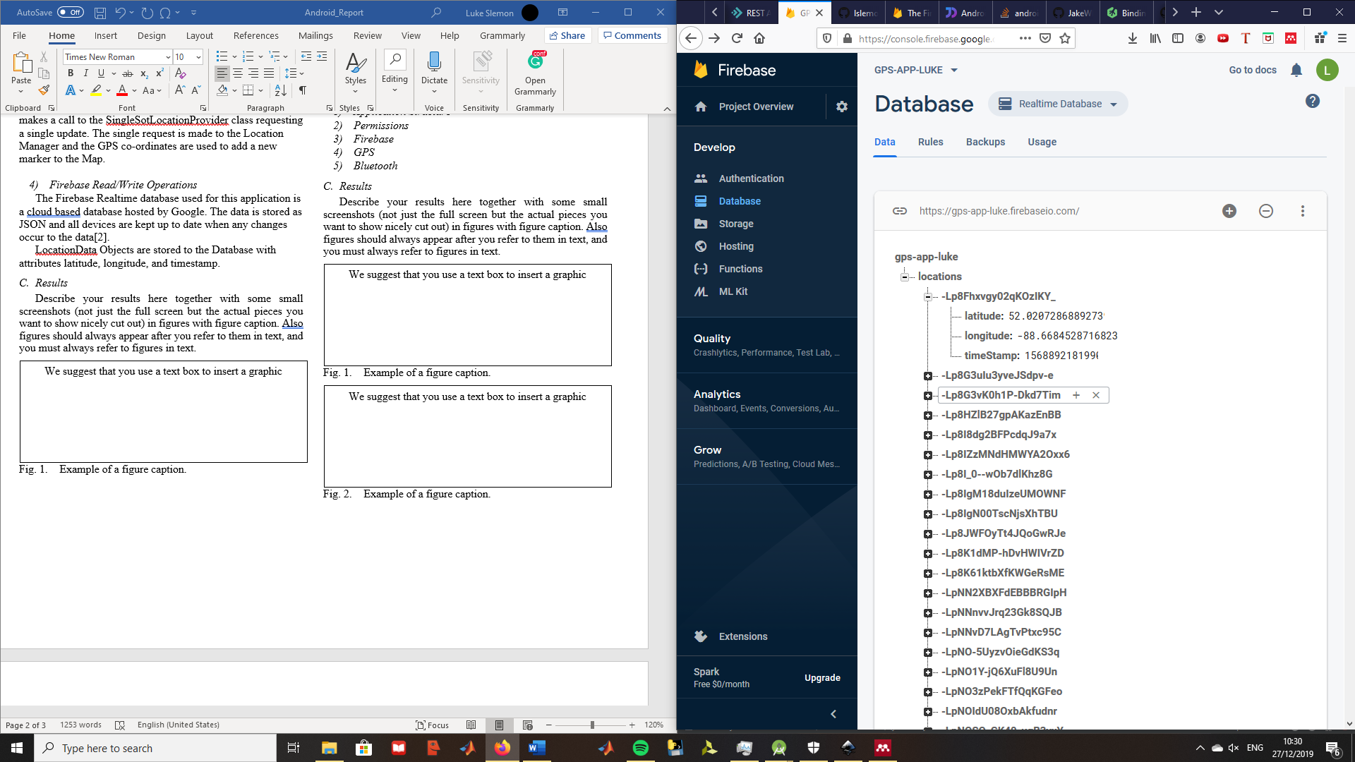

**Fig. 1. Example JSON tree for storing data in Firebase**

When a location update is received, the GPS co-ordinates of the new location are wrapped in a Location Data Object before pushing to the database. To determine where the data will be stored, push to the database to create a new node with a unique key[6]. Using a reference to the specified child, in this scenario it is locations, the new key is used to update the values at the new node.

Reading data from the database is handled using asynchronous listeners which are triggered once for the initial state of the database, and triggered again with any subsequent database changes[6]. When the listener is triggered, a data snapshot, which is a picture of the state of data at a particular key in the database. The snapshot of the data can then be cast to the LocationData object to make it easier for the code to access it.

## Results

The Application successfully recorded my location as seen in Figure 1, and each location is matched with a timestamp to keep a record of when a user was detected. The following Figures show the UI of the Maps Activity correctly placing markers for every location saved to the Database.

Figure 3 shows that the onClick listener for the markers work sufficiently by opening the Marker’s title, the time and date the entry was saved. Finally, figure 4 shows the onClick listener for the Force Get Location button works because the Loading Location Alert dialog is presented to the user while the SingleShotProvider is awaiting the location update.

**Fig. 2. Maps Activity UI with markers for every saved location**

**Fig. 3. Maps Activity UI with marker title presented after marker clicked**

**Fig4. Maps Activity UI with alert Dialog presented after force get location pressed.**

# Project Application: Bluetooth Surveyor

The Bluetooth Surveyor Application was developed as a tool to determine how many devices leave their Bluetooth active and what kind of device was detected. This could be a useful tool for cybersecurity experts ensuring their system has no physical entry points for any hackers. Hackers can potentially gain remote access via a Bluetooth Keyboard. A cybersecurity expert can potentially use this tool to then locate any pitfalls and see how easily devices be located from a hacker’s position (i.e. public toilet next door).

## Application Description

The primary function of this application is to use the Bluetooth sensor on the host device to scan for nearby Bluetooth devices, while keeping a note of the location of the phone when it discovered each device. Using the on-board GPS sensor, and the devices Location Manager the phone can request location updates every 100 meters or 30 minutes. With every location update, a brief scan for Bluetooth devices will save a collection of devices associated with that location. Each discovered device will be stored to a remote Firebase database instance.

The recorded devices will be presented to the user in a list with information regarding their Bluetooth Address, Device name, and class of device be it a computer, headphones, a smartphone, keyboard, or heart monitor. On the Map each marker will represent a stored location, and when any of the markers are pressed, they will tell the user how many devices were discovered at this location.

## Application Code and Behaviour

### Application Structure

The application is structured using three activities and a single Service for handling all background, long running operations. When the application is opened, the user is presented with the opening Activity which has a logo and two buttons, one of which will open the Device List Activity and the other will open the Maps Activity. This activity just works to help separate the two primary Activities from each other, and also to demonstrate the use of navigation within in Android applications.

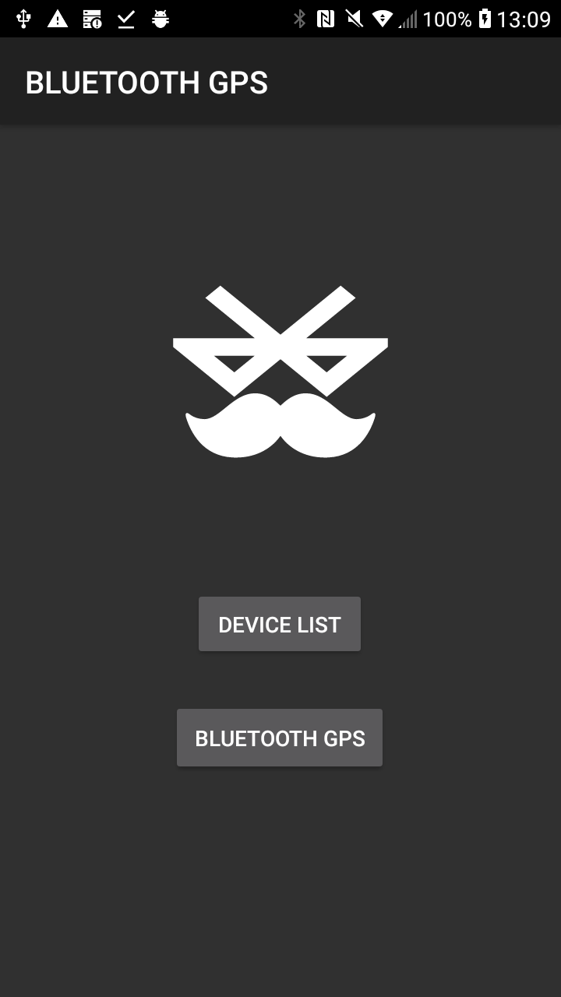

###### Fig5. Opening Activity with two buttons an vector graphic icon

The Device List Activity presents a list of all discovered devices to the User, with information regarding class of device, the device name, and the Bluetooth Address. When any of the records in this list are clicked, the Maps Activity will be opened and the marker with the corresponding location of the device will be highlighted.

###### Fig6. Device List Activity with 3 discovered devices

The Maps Activity presents a Google Maps style map to the user with a collection of markers positioned at the previously stored locations. When any of the markers are selected, they present the number of devices detected at this location as well as the time and date the entry was saved.

###### Fig7. Maps Activity with location of discovered devices

Finally, the Service will be utilized for handling all background operations such as location updates and Bluetooth scanning. When a location update is fired, then a brief Bluetooth scan will begin for 1 minute. In this minute, the scanned Bluetooth devices will be saved to a collection, and once the timer completes, the devices and the location will be saved to the Firebase.

### Permissions

Before the application can access the phone’s location, the user must grant the Coarse Access Location, and Fine Access Location permissions. When requesting the User’s permission, a dialog will be presented which asks them to grant their permission in order to allow the app to record their location.

Finally, before the app can access the devices Bluetooth sensor it must request the Bluetooth Permissions.

### GPS

Similarly to the previous app outlined in this report, the location of the device is determined either by using 3 satellites for GPS tracking or by using a lookup based on nearby cell towers or WiFi access points. A location update will be fired every 10 minutes or every 100 meters.

When the onLocationChanged callback is called, the Bluetooth scanner will be initiated for a duration of 1 minute, after which a Runnable Object will execute terminating the scan, deleting the location entry if no devices were discovered , and clearing any arraylists used in the discovery process,

### Firebase

The firebase will store records of locations and devices discovered at each location. The location Objects will have attributes latitude, longitude and timestamp, while the device Objects have attributes location key, device name, device address, and device type.

As previously mentioned, the Bluetooth will begin after a triggered location update. The new location update will be wrapped in a LocationData Object and stored to the Database. The devices which are discovered following scan initiation will be stored to the firebase with the associated LocationData key, and the device address will be the device key to make sure there are no duplicate devices discovered.

### Bluetooth

The Bluetooth adapter hosted by the Android Framework will be utilised for device discovery. As mentioned before, when a location update is triggered, the Bluetooth adapter will initiate Device discovery.

A broadcast receiver will be utilised in this application for handling device discovered updates. In Android, broadcasts can be sent between different applications and processes[7], and a broadcast receiver can be instantiated with a filter to catch specific broadcasts, in this case BluetoothDevice Action_Found broadcasts.

A Callback for the receiver is utilised to handle any incoming broadcasts. When this callback is triggered, the newly discovered devices are stored to the Firebase database if they have not been discovered before in this particular scanning session.

## Results

The Application correctly discovered and stored any Bluetooth devices in the user’s vicinity, as well as the location of the user at that point in time as seen in Figure 8. All activities worked together, and when any of the device entries were selected in the DeviceListActivity, the Maps Activity was opened and it zoomed into the marker with the corresponding co-ordinates.

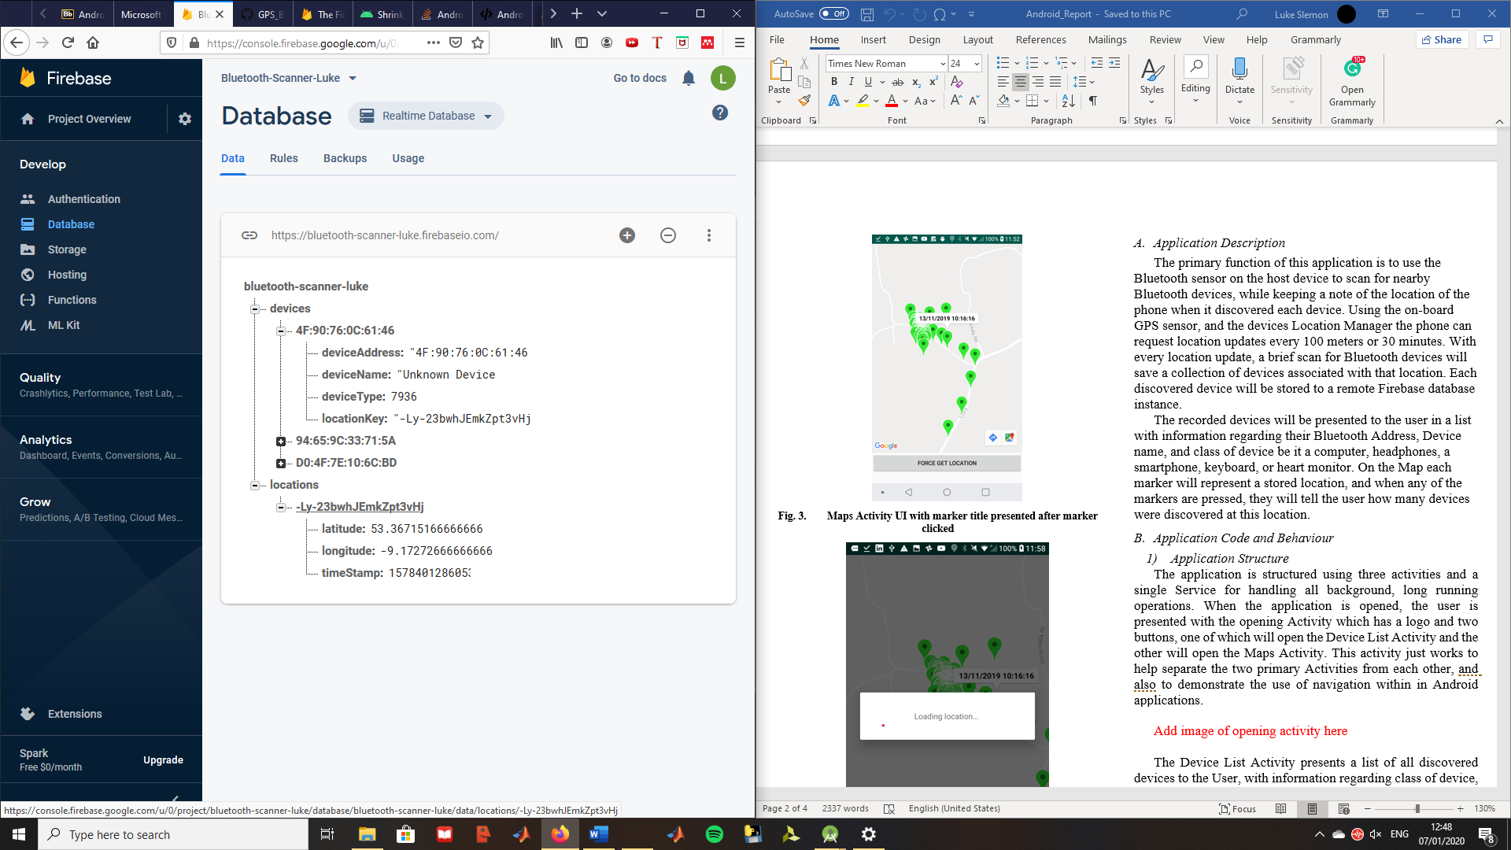

**Fig8. JSON tree of data stored in Firebase**

##### Conclusions

In conclusion, both apps were a success, they were both capable of storing data to Firebase and accessing the data wherever the phone was aslong as it had a connection. The Bluetooth scanner worked successfully to discover new devices and the GPS service worked also.

In order to get the functionality of the app to work, there was a steep learning curve to understand how the Callbacks for device discovery, and location updated were controlled. Before creating layouts, the designer would need to understand how the different layers interact and how each layout may have a parent layout, i.e. the list activity had a list view parent and a list entry child.

Finally, understanding the layout of the Firebase database was one of the more complicated steps of the project. Firebase does not hold arrays of data within their entries, which first made associating location data with devices discovered at those locations. The easier solution was to create two separate children for each data object and have the Device entries hold a reference to the Location data entry.

##### Contributions

### Luke

* GPS
* Firebase Handling
* Application Structure

### Caolan

* Bluetooth

##### References

[1] “What is Android? Everything you need to know about Google’s OS.” [Online]. Available: https://www.androidauthority.com/what-is-android-328076/. [Accessed: 29-Dec-2019].

[2] “Android Activity and its Lifecycle.” [Online]. Available: https://blog.mindorks.com/android-activity-lifecycle. [Accessed: 29-Dec-2019].

[3] “Room Persistence Library  |  Android Developers.” [Online]. Available: https://developer.android.com/topic/libraries/architecture/room. [Accessed: 29-Dec-2019].

[4] “Android Location Providers (gps, network, passive) | developerlife.com.” [Online]. Available: https://developerlife.com/2010/10/20/gps/. [Accessed: 26-Dec-2019].

[5] “Firebase Realtime Database.” [Online]. Available: https://firebase.google.com/docs/database. [Accessed: 27-Dec-2019].

[6] “Saving Data  |  Firebase Realtime Database.” [Online]. Available: https://firebase.google.com/docs/database/admin/save-data. [Accessed: 27-Dec-2019].

[7] “Broadcasts overview  |  Android Developers.” [Online]. Available: https://developer.android.com/guide/components/broadcasts. [Accessed: 07-Jan-2020].