***This is the part of report for data collection, classifier training and deploy:***

To collect the EEG signals from the brain activities, the smartphone is connected to the MUSE 2 EEG sensor via the Bluetooth, the mind monitor APP is then used to capture the real time EEG data by monitoring 5 different brain frequency bands of alpha, beta, delta, theta, and gamma, respectively. All frequency data are collected and sent to the laptop for data processing through the UDP connection by knowing the IP address and port number. Once enough samples are collected, we use the Edge Impulse platform to train the machine learning classifier by setting different parameters’ combinations. To test and figure out the classifier model with the best performance, these parameters shall include different types and number of the brain activities, different group of the frequency bands and components, time duration change in the measurement, and different number of training samples. Under these conditions, we can have a multiple sets of training samples, then we can train several classifier models based on these sample sets. Because the models we trained may have different performance in the measurement, we need to choose the one with the highest validation accuracy to be deployed in the program and use it to predict the activity catalog if any new EEG signal is collected later. The output class will be then used to control the robot arm. Figure 1 below shows the EEG data collection, classifier training and deploy process.

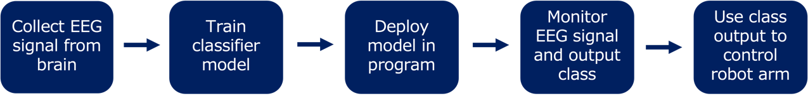

Fig. 1. Shows the EEG signal data collection, classifier training and deploy process. Firstly, we collect the raw EEG signals from brain activities, and then we use these data to train a classifier model, and deploy the model when classifier satisfies the validation accuracy requirement. The model can be used to predict the class of the new EEG signal and we can use the class information to control the robot arm.

Specifically, user needs to define 2 brain activities firstly, such as eye blink and jaw teeth. When we collect the EEG signals of these two activities, we monitor 6 seconds EEG signals variation for one brain activity. Because the sensor signals need some delay to response, the program can capture the proper moment with a significant frequency change if time duration is large enough. After monitoring the first brain activity, we allow the main monitoring thread to sleep for 3 to 4 seconds to let the sensor signals recover to a normal level, then we monitor next 6 seconds EEG signals variation for the other brain activity, one data collection cycle is completed. We used the same way to collect more data until the sample number is enough for training the machine learning classifier model. A sample dataset has 21 columns with one index column and 20 frequency columns which include 5 different frequency bands. Total 60 rows in one dataset which is corresponding to 6 seconds data collection. Figure 2 shows a sample dataset.

Fig. 2. Shows a sample data after collecting the sensor EEG signals with 5 different frequency bands and each frequency band has 4 channels values.

We realize that the frequency variation of two brain activities may be close to each other. After training the classifier, the model could be so sensitive to the environment that it has a possible overfitting issue. Thus, in the experiment, we define more than one combination of brain activities. In addition to the eye blink and jaw teeth, we also include the leg and hand movements, we expect these actions could provide a higher frequency variance in attributes so the brain activity types could be easy to be classified. The data collection process of each activity’s combination is same as introduced above.

After we have the enough samples for the machine learning, we used the Edge Impulse platform to train several machine learning classifier models. The classification task developed by this platform is usually based on the TensorFlow and Keras open-source libraries. In the training process, the learning rate is always kept at 0.0005, the training epoch is set to 30, the training and validation sample ratio is 80/20, and for each activity’s combination, we used the same neural network architecture, which input layer has 400 input features, one dense layer with 20 neurons, the other dense layer has 10 neurons, and last output layer can output 2 classes. Figure 3 below shows some classification results after training the classifier models for different activity’s combination.

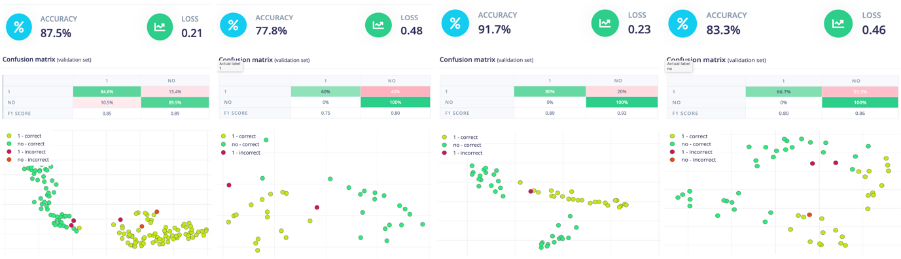

Fig. 3. Shows the sample classification results after training the machine learning classifier models for different brain activity’s combination. From the left to right: 1. two brain activities of eye blink and jaw teeth with 100 samples, data collection time is 2 second on all frequency bands; 2. two brain activities of right hand and left hand with 30 samples, data collection time is 6 second on all frequency bands; 3. two brain activities of eye blink and jaw teeth with 30 samples, data collection time is 4 second on all frequency bands; and 4. two brain activities of eye blink and jaw teeth with 60 samples, data collection time is 6 second on alpha and beta frequency bands only.

The figure 3 shows that by having different brain activities’ combination, the performance of classifier model may also be different. In the observation, the model with a greater number of training sample could have a clear classification trend and apparently, certain types of brain activities combination, such as eye blink and jaw teeth may have a better validation accuracy than other activities, such as the hand movements, it indicates that the frequency response of eye blink and jaw teeth can vary significantly and has a larger variance than other actions. For different brain activities’ combinations, no matter how we changed the frequency bands combinations, it seems that the classification performance has no improvement at all. Finally, the classification performance may be somehow determined by the sensor data collection time, 4 second is better than 2 second which may be short to capture the right moment of sensor signal change, it is also better than 6 second which may be long to include redundant signals data.

We deploy the best classifier model which has the highest validation accuracy and use it to predict the class of new EEG signal and use the output class to control the robot arm. The classifier with binary classification task is usually better than the ones with more than 2 statuses. In the measurement, we find that the test accuracy is still not good as what we expect, one possible reason is that the overfitting issue may still exist, and it is also possible that the frequency variation between two brain activities may be still not clear. The eye blink and jaw teeth actions are the most reliable ones in the combinations. We believe that there are couples’ methods could improve the test accuracy of the classifier model, first one is to get more EEG sensor data by collecting the data from different area of brain, such as the top and side parts of the brain, these signals can give more realistic status of the brain activities, it is easy for the machine learning model to find and identify the difference. The second option is to use the dimensionality reduction to get rid of irrelative frequency components for optimizing the attributes concentration. And the third method is to use the metric learning to maximize the inter class variance and minimize the intra class variance by Mahalanobis distance, it helps for the classification task.