**Business Type and Crime Ocurrence in Sao Paulo regions**

1. Description of the problem

The problem consists in clustering Sao Paulo state regions in respect to their business and crime occurrence, Brazil is a country that have an elevated crime rate especially in some neighborhoods, Brazil suffers from an ineffective police operations due to police infrastructure and government investment, in conclusion the idea is to understand what type of crimes and their occurrence based on Foursquare information and local crime data from our government.

2.Data Description

The data that will be used in this project comes both from Foursquare API and 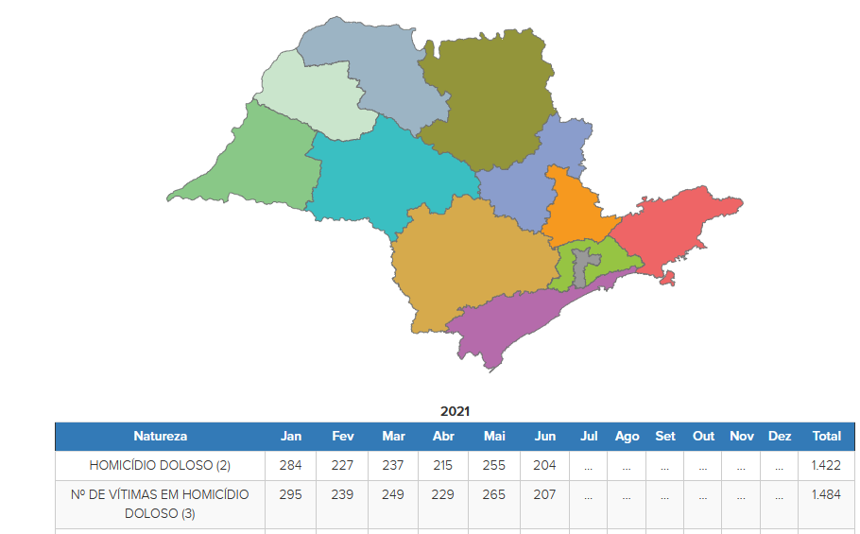São Paulo Defense Secretary which have summarized data per year,region and type about crimes that have occurred in a certain region so with this data we can link certain regions with others and see a pattern and see where crimes like robbery and that kind happens in which region.