小程序二手房详情页接口文档

# 请求

* 请求url:

<https://miniappfang.58.com/api/infodetail?infoid=35710929135429&openid=oIArb4jVPt_DapBBzxXxH5l1YE70>

其中, infoid是帖子id openid是小程序 用户id。可以直接使用这个定值。

* 返回结果：

正确：code： 0

错误/异常: code: 1

合规返回的实体信息：

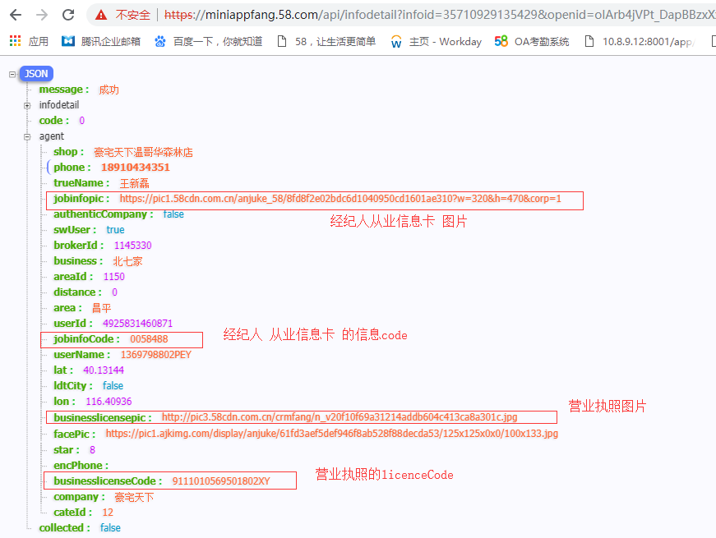

说明：

经纪人从业信息卡的信息：

jobinfopic : 图片

jobinfoCode: 代码

经纪人公司 营业执照信息：

businesslicensepic: 图片

businesslicenseCode: 代码

* 不合规返回结果：

至少没有jobinfopic, businesslicensepic两个字段中的一个、或者值为””。

含义 就是 没有从业信息卡 或者 没有营业执照

* 正常返回的数据结构：

{

"message": "成功",

"infodetail": {

"xiaoquName": "麦卡伦地",

"anxuan": true,

"postDate": "3天前",

"tag": [

"满五年"

],

"business": "北七家",

"mianji": "500㎡",

"title": "麦卡伦地 新出边户独栋 客厅挑空 南入户 送花园车库 满五年",

"pics": [

"//pic1.58cdn.com.cn/anjuke_58/ef16d79ee3fcf5800140a3cc98c9a4d6?w=750&h=562&crop=1",

"//pic2.58cdn.com.cn/anjuke_58/80fa6cd6b268241f9c571445cbfbb647?w=750&h=562&crop=1",

"//pic3.58cdn.com.cn/anjuke_58/3e5e754d7dfe7e5c2bc998dc8084c75b?w=750&h=562&crop=1",

"//pic4.58cdn.com.cn/anjuke_58/6ce5fe91e8a894b374d2bcea7f7565bc?w=750&h=562&crop=1",

"//pic5.58cdn.com.cn/anjuke_58/9cd666dcbbbcce083803cd1b08ce8665?w=750&h=562&crop=1",

"//pic6.58cdn.com.cn/anjuke_58/0b9130db972637fcdca3b29aad205ace?w=750&h=562&crop=1",

"//pic7.58cdn.com.cn/anjuke_58/44fbf56c2a3ec78013b30b4ca1396ee3?w=750&h=562&crop=1",

"//pic8.58cdn.com.cn/anjuke_58/e97ff72470f5604542de056e4b2f393a?w=750&h=562&crop=1",

"//pic1.58cdn.com.cn/anjuke_58/c28b990c0ff4a5f04b165f882a6611bc?w=750&h=562&crop=1",

"//pic2.58cdn.com.cn/anjuke_58/301af8c0dc86e103b45fe7becd2e6b23?w=750&h=562&crop=1"

],

"area": "昌平",

"housedetail": [

{

"tit": "核心卖点",

"des": "麦卡伦地别墅位于以\"龙脉温泉\"闻名于世的小汤山镇，北距温榆河1.5公里，南距亚运村仅12公里。立汤路、京昌、京承、北六环、规划中轻轨5号线等多条线路瞬间到达，畅达的交通和良好的自然环境造就了定位于第一居所的麦卡伦地·新学院派别墅。1.此房有钥匙看房随时2.业主委托本人，详细情况我了解3.南北通透，花园300平米，边户比较安静4.客厅挑空，位置好双客厅设计5.可加建，改造空间巨大！6.联系王新磊豪宅网"

},

{

"tit": "业主心态",

"des": "业主诚心出售，委托本人，已在本公司备案。"

},

{

"tit": "小区配套",

"des": "北京市昌平区北七家中学 、伊顿双语幼儿园(晨浩花园西) 、橄榄树双语幼儿园 、育新双语幼儿园、天骄双语艺术幼儿园商场佳美康廉超市、超市发超市(羊各庄店) 、家乐美超市 、北七祥荣超市 、迎客隆超市 医院北京太阳城医院 、北七家医院平坊服务站。中国银行 、北京银行(北七家支行)餐饮东北大馅饺子、灶台鱼娱乐娱乐智通宝(九华山庄贵宾楼店) 、益康骨伤推拿理疗中心 、 九华山庄度假村"

},

{

"tit": "服务介绍",

"des": "做人宗旨：本人是此社区专家，所有在售房源了如指掌，从事此行业已经有5年的时间了，我特别热爱我的这份工作，每帮助一个客户解决了他们的困难都会让我充满成就感，客户对我的评价也不错，很认可我的真诚和用心，我希望能通过我的专业知识，我的正能量，我的热忱为您解决此刻的难题，豪宅网顾问"

}

],

"toward": "南北",

"yongjin": "≤0.5%",

"fittype": "毛坯",

"ditie": [],

"userId": 4925831460871,

"huxing": "5室2厅3卫",

"xiaoquDitu": "http://api.map.baidu.com/staticimage?center=116.420075,40.146403&markers=116.420075,40.146403&labels=116.420075,40.146903&labelStyles=麦卡伦地,1,14,0x000000,0xffffff,1&width=640&height=220&zoom=16&copyright=1",

"gongnuan": "自供暖",

"wosVideo": true,

"lat": 40.146403,

"jianzhuniandai": "2007年",

"lon": 116.420075,

"xiaoquId": 9160,

"louxing": "暂无信息",

"fushu": "",

"infoId": 35710929135429,

"localname": "bj",

"biz": true,

"cityid": "1",

"shipin": true,

"videourl": "14_1049234500954931200.m405.mp4",

"tuijianInfoList": [

{

"mianji": "518㎡",

"distanceMap": {},

"title": "0 拥 金 独栋,600万装修未住,9米挑空大...",

"price": "2100",

"anxuan": true,

"tag": [

"满五唯一"

],

"huxing": "4室3厅",

"pic": "https://pic5.58cdn.com.cn/anjuke_58/d8a83de18b394ecd20ceed52e0b0f5fe?w=240&h=180&crop=1",

"infoId": 35654367337163,

"towards": "北",

"xiaoqu": "麦卡伦地",

"brokerId": 3314764,

"shipin": false

},

{

"mianji": "518㎡",

"distanceMap": {},

"title": "麦卡独栋 业主未住 大客厅9米挑空 双车库",

"price": "2100",

"anxuan": true,

"tag": [

"满五唯一"

],

"huxing": "5室2厅",

"pic": "https://pic4.58cdn.com.cn/anjuke_58/eb2b62be75f672bfce6989eb383d21ea?w=240&h=180&crop=1",

"infoId": 35597705159870,

"towards": "南北",

"xiaoqu": "麦卡伦地",

"brokerId": 104629,

"shipin": false

},

{

"mianji": "467㎡",

"distanceMap": {},

"title": "麦卡伦地 业主委托 467平1650万 北入户...",

"price": "1650",

"anxuan": false,

"tag": [],

"huxing": "5室4厅",

"pic": "https://pic6.58cdn.com.cn/anjuke_58/5dade910cb1118332457bfae2fa2dffc?w=240&h=180&crop=1",

"infoId": 35366806407489,

"towards": "南北",

"xiaoqu": "麦卡伦地",

"brokerId": 1791953,

"shipin": true

},

{

"mianji": "556㎡",

"distanceMap": {},

"title": "麦卡伦地 独栋别墅 采光好 花园600平米看房...",

"price": "1900",

"anxuan": false,

"tag": [],

"huxing": "5室3厅",

"pic": "https://pic2.58cdn.com.cn/anjuke_58/191b5a4424b0f3585cc356c61fcd29f5?w=240&h=180&crop=1",

"infoId": 35366733171882,

"towards": "南北",

"xiaoqu": "麦卡伦地",

"brokerId": 1791953,

"shipin": true

},

{

"mianji": "505㎡",

"distanceMap": {},

"title": "6室,税少，606平米1900万随时看房签约",

"price": "1900",

"anxuan": false,

"tag": [],

"huxing": "6室3厅",

"pic": "https://pic5.58cdn.com.cn/anjuke_58/d41497bcb3134faa8933ceff0e4923df?w=240&h=180&crop=1",

"infoId": 35364068323525,

"towards": "南北",

"xiaoqu": "麦卡伦地",

"brokerId": 5150007,

"shipin": true

},

{

"mianji": "505㎡",

"distanceMap": {},

"title": "6室,税少，606平米1900万随时看房签约",

"price": "1900",

"anxuan": false,

"tag": [],

"huxing": "6室3厅",

"pic": "https://pic6.58cdn.com.cn/anjuke_58/d41497bcb3134faa8933ceff0e4923df?w=240&h=180&crop=1",

"infoId": 35364068846899,

"towards": "南北",

"xiaoqu": "麦卡伦地",

"brokerId": 5150007,

"shipin": true

},

{

"mianji": "505㎡",

"distanceMap": {},

"title": "6室,税少，606平米1900万随时看房签约",

"price": "1900",

"anxuan": false,

"tag": [],

"huxing": "6室3厅",

"pic": "https://pic6.58cdn.com.cn/anjuke_58/d41497bcb3134faa8933ceff0e4923df?w=240&h=180&crop=1",

"infoId": 35312893235894,

"towards": "南北",

"xiaoqu": "麦卡伦地",

"brokerId": 5150007,

"shipin": true

},

{

"mianji": "505㎡",

"distanceMap": {},

"title": "6室,税少，606平米1900万随时看房签约",

"price": "1900",

"anxuan": false,

"tag": [],

"huxing": "6室3厅",

"pic": "https://pic3.58cdn.com.cn/anjuke_58/d41497bcb3134faa8933ceff0e4923df?w=240&h=180&crop=1",

"infoId": 35257601740985,

"towards": "南北",

"xiaoqu": "麦卡伦地",

"brokerId": 5150007,

"shipin": true

},

{

"mianji": "505㎡",

"distanceMap": {},

"title": "6室,税少，606平米1900万随时看房签约",

"price": "1900",

"anxuan": false,

"tag": [],

"huxing": "6室3厅",

"pic": "https://pic6.58cdn.com.cn/anjuke_58/d41497bcb3134faa8933ceff0e4923df?w=240&h=180&crop=1",

"infoId": 35257600251582,

"towards": "南北",

"xiaoqu": "麦卡伦地",

"brokerId": 5150007,

"shipin": true

},

{

"mianji": "505㎡",

"distanceMap": {},

"title": "6室,税少，606平米1900万随时看房签约",

"price": "1900",

"anxuan": false,

"tag": [],

"huxing": "6室3厅",

"pic": "https://pic8.58cdn.com.cn/anjuke_58/d41497bcb3134faa8933ceff0e4923df?w=240&h=180&crop=1",

"infoId": 35242354008891,

"towards": "南北",

"xiaoqu": "麦卡伦地",

"brokerId": 5150007,

"shipin": true

},

{

"mianji": "505㎡",

"distanceMap": {},

"title": "6室,税少，606平米1900万随时看房签约",

"price": "1900",

"anxuan": false,

"tag": [],

"huxing": "6室3厅",

"pic": "https://pic3.58cdn.com.cn/anjuke_58/d41497bcb3134faa8933ceff0e4923df?w=240&h=180&crop=1",

"infoId": 35209194076362,

"towards": "南北",

"xiaoqu": "麦卡伦地",

"brokerId": 5150007,

"shipin": true

},

{

"mianji": "505㎡",

"distanceMap": {},

"title": "6室,税少，606平米1900万随时看房签约",

"price": "1900",

"anxuan": false,

"tag": [],

"huxing": "6室3厅",

"pic": "https://pic7.58cdn.com.cn/anjuke_58/d41497bcb3134faa8933ceff0e4923df?w=240&h=180&crop=1",

"infoId": 35209192793407,

"towards": "南北",

"xiaoqu": "麦卡伦地",

"brokerId": 5150007,

"shipin": true

}

],

"price": "1650",

"danjia": "33000元/㎡",

"floor": "中层/3层",

"chanquan": "商品房70年",

"dianti": "无电梯",

"objectType": "别墅"

},

"code": 0,

"agent": {

"shop": "豪宅天下温哥华森林店",

"phone": "18910434351",

"trueName": "王新磊",

"jobinfopic": "https://pic1.58cdn.com.cn/anjuke_58/8fd8f2e02bdc6d1040950cd1601ae310?w=320&h=470&corp=1",

"authenticCompany": false,

"swUser": true,

"brokerId": 1145330,

"business": "北七家",

"areaId": 1150,

"distance": 0,

"area": "昌平",

"userId": 4925831460871,

"jobinfoCode": "0058488",

"userName": "1369798802PEY",

"lat": 40.13144,

"ldtCity": false,

"lon": 116.40936,

"businesslicensepic": "http://pic3.58cdn.com.cn/crmfang/n_v20f10f69a31214addb604c413ca8a301c.jpg",

"facePic": "https://pic1.ajkimg.com/display/anjuke/61fd3aef5def946f8ab528f88decda53/125x125x0x0/100x133.jpg",

"star": 8,

"encPhone": "",

"businesslicenseCode": "9111010569501802XY",

"company": "豪宅天下",

"cateId": "12"

},

"collected": false

}