Figure X. Entity Relationship Diagram of LSPU ScholarHub

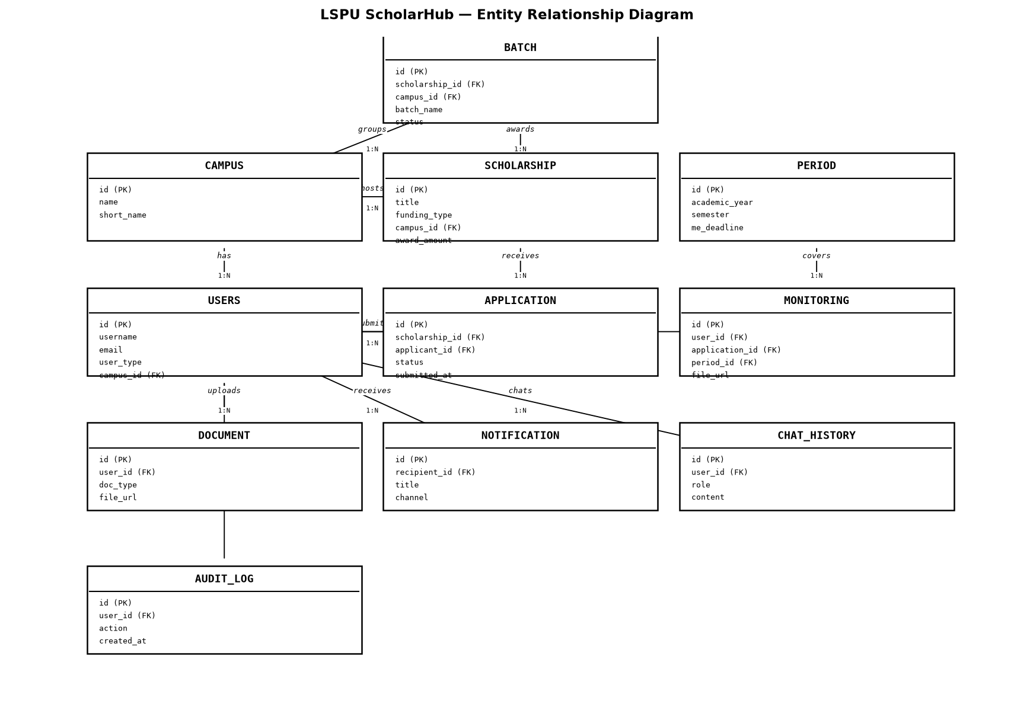
Figure 1. Entity Relationship Diagram of the LSPU ScholarHub Database

The LSPU ScholarHub database consists of eleven (11) entities centered on USERS, which anchors student, staff, and administrator accounts. CAMPUS scopes every major entity for the university-wide, multi-campus deployment. SCHOLARSHIP programs receive APPLICATIONS submitted by students, and approved applications are grouped into BATCHES per academic PERIOD. Students upload registration DOCUMENTS and Monitoring & Evaluation (MONITORING) submissions, and receive NOTIFICATIONS. CHAT_HISTORY stores AI assistant conversations, and AUDIT_LOG records administrative actions for accountability.

