SYSTEM CONTEXT DIAGRAM
LSPU ScholarHub — Scholarship Management System

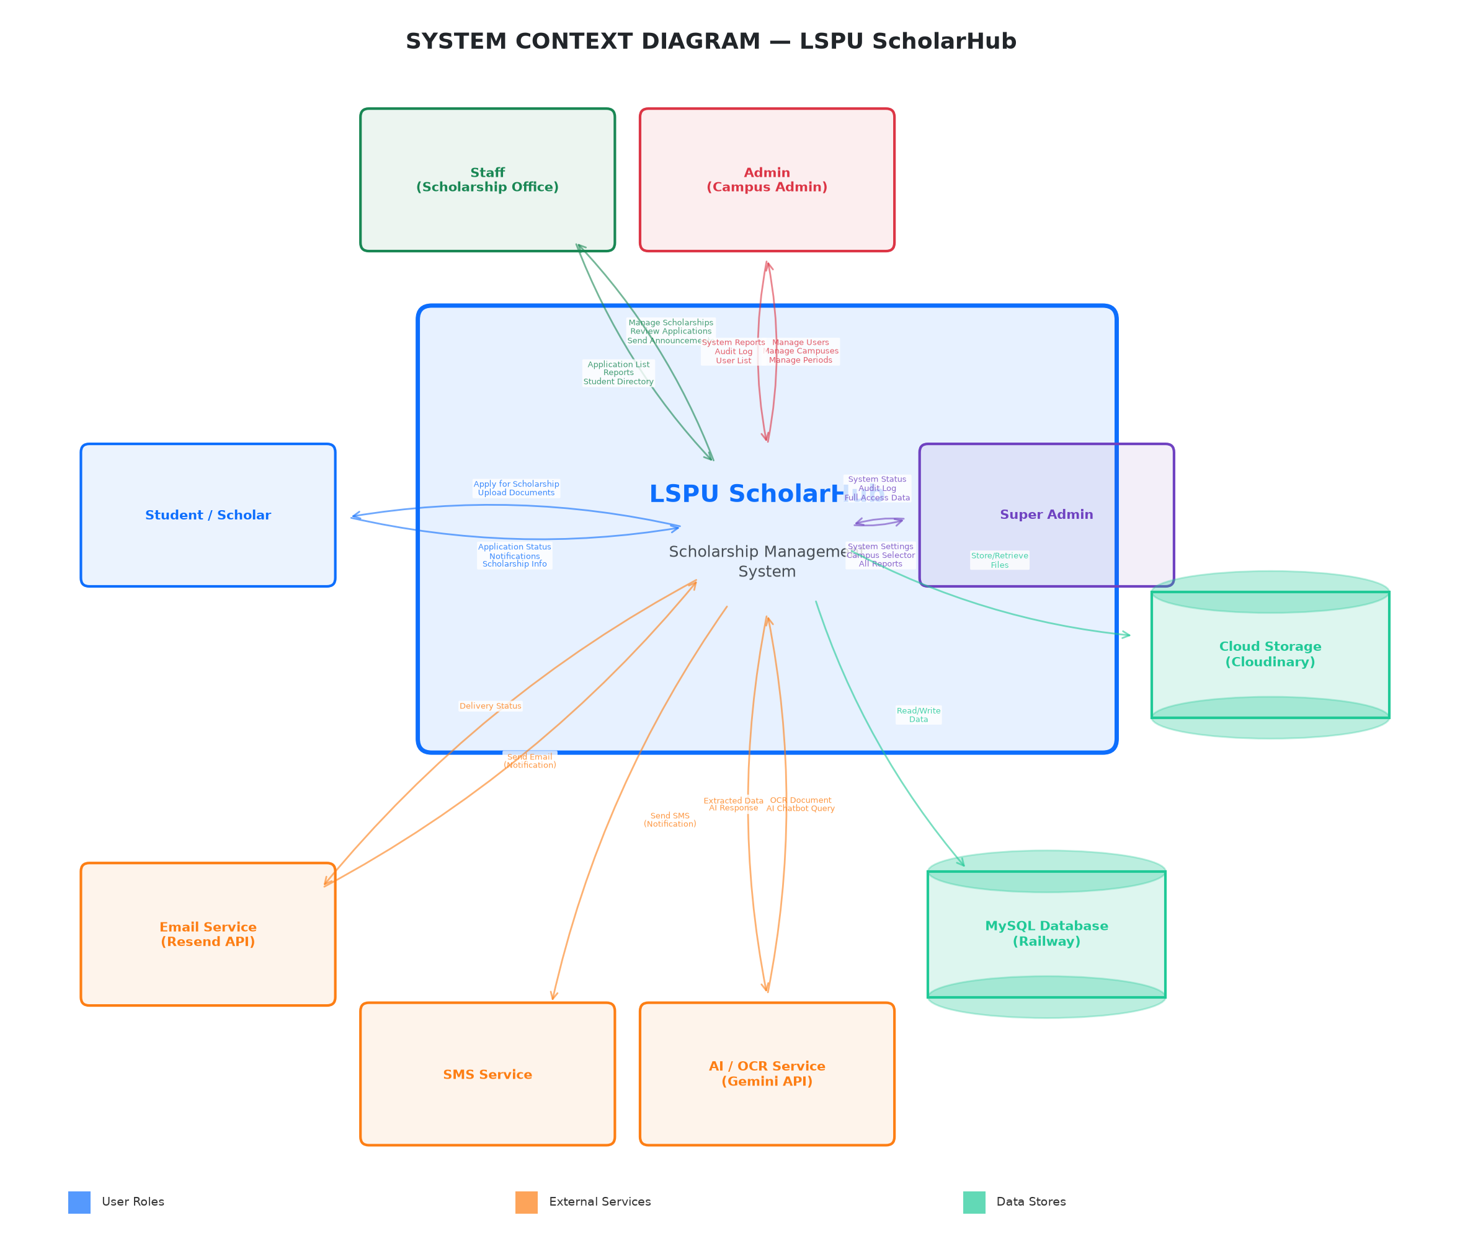
Figure A-2. System Context Diagram of LSPU ScholarHub

SYSTEM CONTEXT DESCRIPTION
The System Context Diagram illustrates the boundaries of the LSPU ScholarHub system and its interactions with external entities. The system operates as a centralized web-based platform deployed on Railway (cloud hosting) and connects to several external services for email delivery, SMS notifications, AI-powered document processing, and cloud file storage.

EXTERNAL ENTITIES
Entity | Type | Description
Student / Scholar | User | Registers an account, applies for scholarships, manages profile and documents, views application status, receives notifications, and interacts with the AI chatbot.
Staff (Scholarship Office) | User | Manages scholarship programs, reviews applications, batches approved students, monitors scholars, sends announcements, and generates reports. Assigned to one or more campuses.
Admin (Campus Admin) | User | Manages users, campuses, and academic periods. Has full management access within their campus. Views system reports and audit logs.
Super Admin | User | System-wide administrator with unrestricted access across all campuses. Manages system settings, all users, all campuses, and views the complete audit log.
Email Service (Resend API) | External Service | Sends email notifications to students and staff including application updates, announcements, and system alerts. Integrated via Resend API.
SMS Service | External Service | Sends SMS notifications to students for critical alerts such as application status changes.
AI / OCR Service (Gemini API) | External Service | Processes uploaded documents (COR, ROG) using OCR to extract student details. Powers the AI chatbot for answering scholarship-related queries.
MySQL Database (Railway) | Data Store | Stores all system data including user accounts, scholarship programs, applications, batches, notifications, and audit logs. Hosted on Railway cloud platform.
Cloud Storage (Cloudinary) | Data Store | Stores uploaded files including student documents (COR, ROG), monitoring forms, and announcement attachments. Provides secure file retrieval via URL.

DATA FLOW DESCRIPTIONS
Data Flow | Description
Student → System | Application submission, document uploads (COR/ROG), profile updates, M&E form uploads, chatbot queries.
System → Student | Application status updates, scholarship information, notifications, AI chatbot responses, downloadable forms.
Staff → System | Scholarship program management, application review decisions, batch creation, announcement composition, report generation.
System → Staff | Application lists, student directories, monitoring data, reports and analytics, audit trail.
Admin → System | User management, campus configuration, academic period management.
System → Admin | System reports, audit logs, user lists, campus summaries.
Super Admin → System | System settings, campus selection, global configuration.
System → Super Admin | System-wide status, complete audit log, all campus data.
System → Email Service | Notification content, recipient addresses, attachment URLs.
Email Service → System | Delivery confirmation, bounce status.
System → SMS Service | SMS message content, recipient phone numbers.
System → AI/OCR Service | Document images for OCR processing, chatbot queries.
AI/OCR → System | Extracted text data (student ID, name, GWA, course), AI responses.
System → Database | CRUD operations on all data entities.
System → Cloud Storage | File upload (documents, forms, attachments).
Cloud Storage → System | File URLs for retrieval and display.

