LSPU ScholarHub
User Storyboard
The storyboard presents the sequence of screens for each user role, describing the purpose of every page and the action that leads to the next screen.

Guest User Storyboard
The following figures present the screens available to the guest role (4 screens).

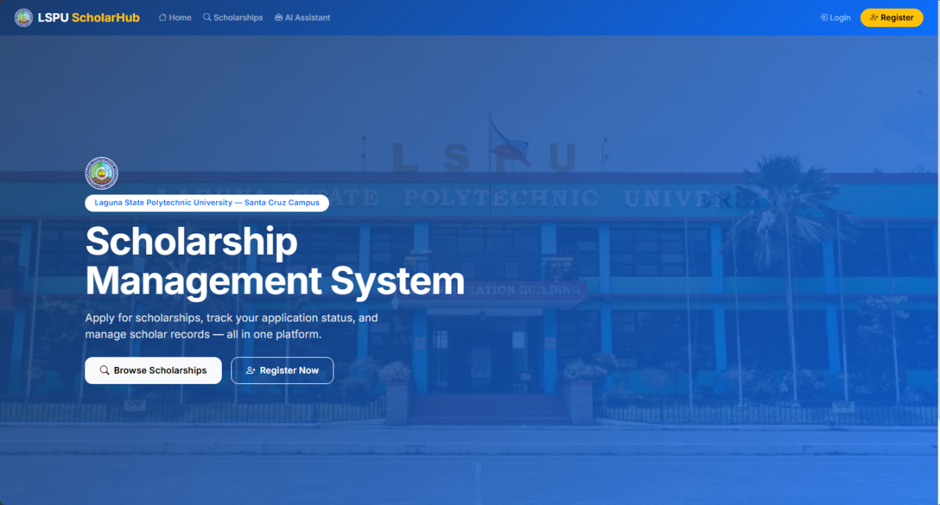
Figure 1. Landing Page
The public entry point of the system. It presents the Scholarship Office information, an overview of available scholarship programs, and navigation options for logging in or registering.
↓ User Action: The guest clicks Register to create an account.

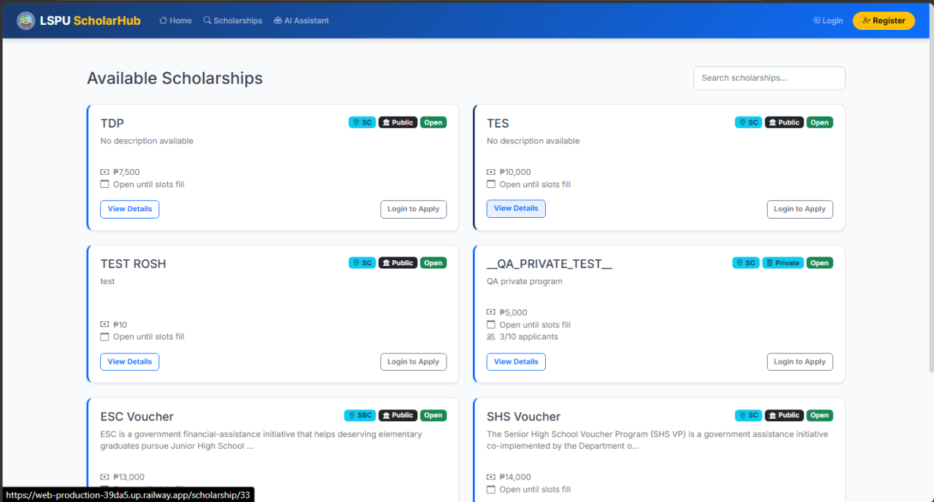
Figure 2. Browse Scholarships
Allows visitors to view all publicly available scholarship programs, including descriptions, benefits, and eligibility criteria, before creating an account.
↓ User Action: The guest clicks Login to access an existing account.

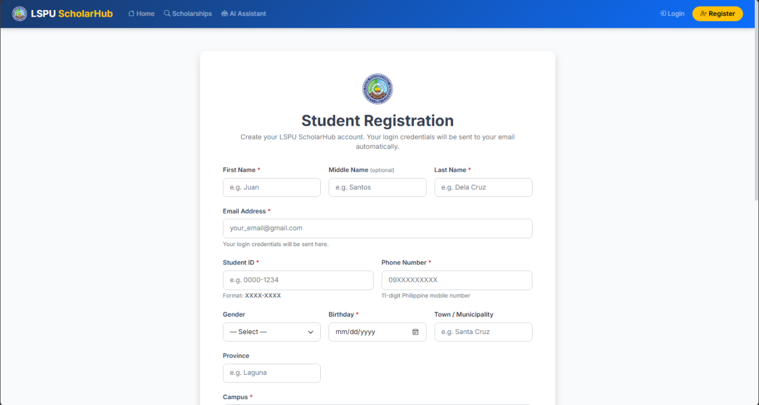
Figure 3. Registration Page
Enables new students to create an account by uploading their Certificate of Registration (COR) and Report of Grades (ROG). OCR automatically extracts the name, student number, course, year level, units, and GWA, and verifies them against the uploaded files.
↓ User Action: After successful registration, the student is redirected to the login page.

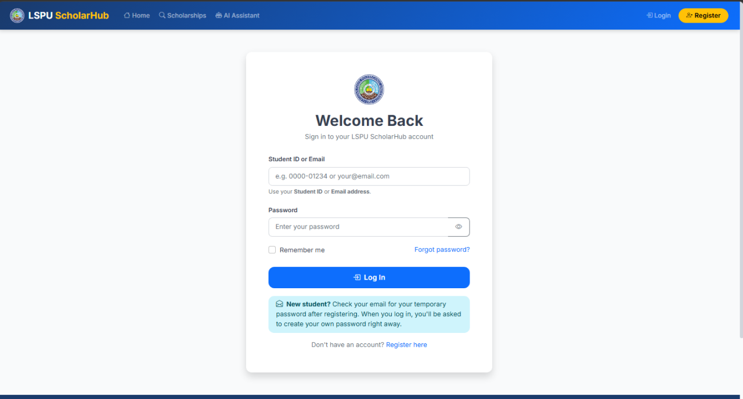
Figure 4. Login Page
Provides secure authentication for all users. Each user is redirected to the dashboard appropriate to their role after logging in.

Student User Storyboard
The following figures present the screens available to the student role (10 screens).

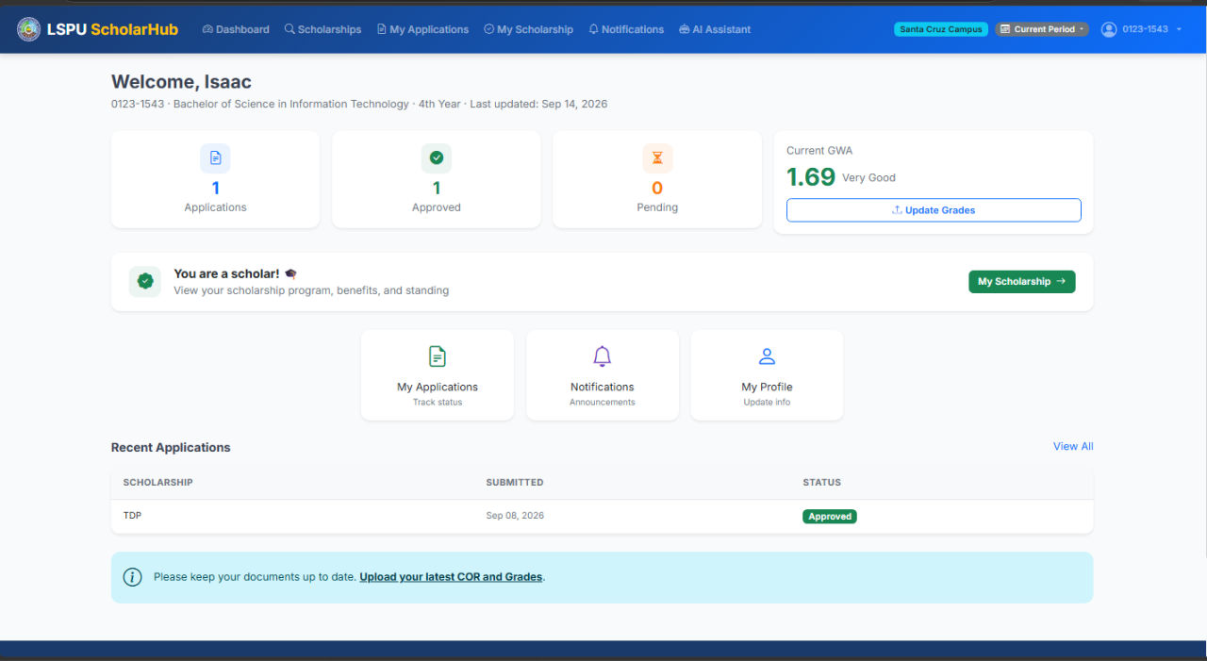
Figure 5. Student Dashboard
Displays the student's overview: total applications, pending/under-review count, approved scholarships, and a reminder to keep their COR and grades up to date.
↓ User Action: The student clicks Browse Scholarships in the navigation bar.

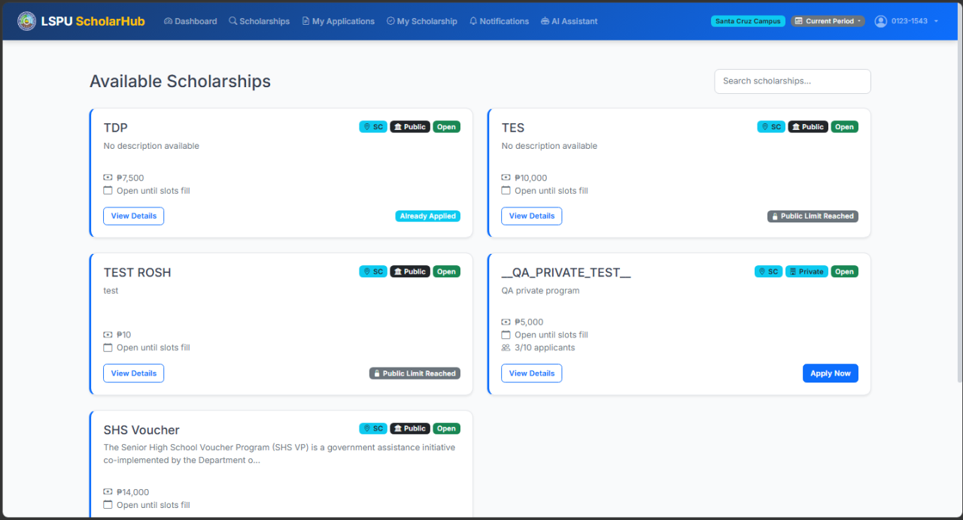
Figure 6. Browse Scholarships
Shows scholarship programs available to the student based on campus and academic period, with an Apply button for open programs. The system enforces the one-public-program rule.
↓ User Action: The student clicks Apply on a scholarship program.

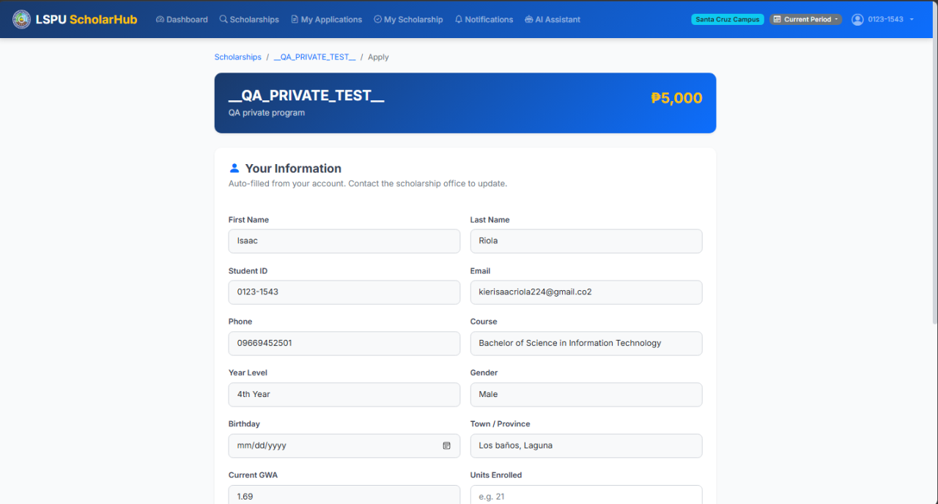
Figure 7. Scholarship Application Form
The application form with student details pre-filled from the profile (birthday, course, GWA, units). The student verifies the information and submits the application.
↓ User Action: After submission the student opens My Applications.

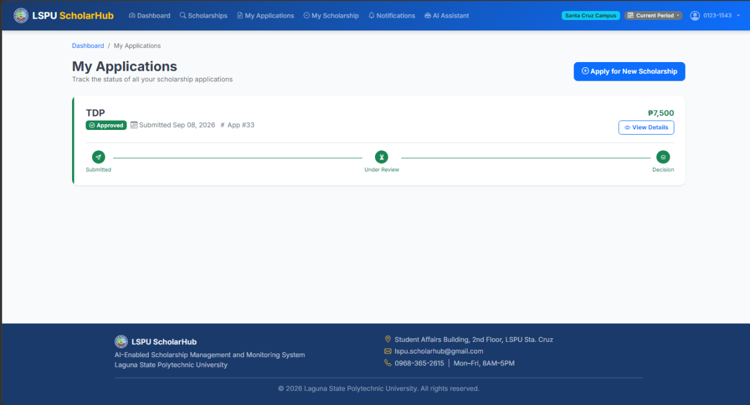
Figure 8. My Applications
Lists all submitted applications with status tracking (Submitted, Under Review, Approved, Rejected) and the scholar tag per application.
↓ User Action: The student clicks an application to view its details.

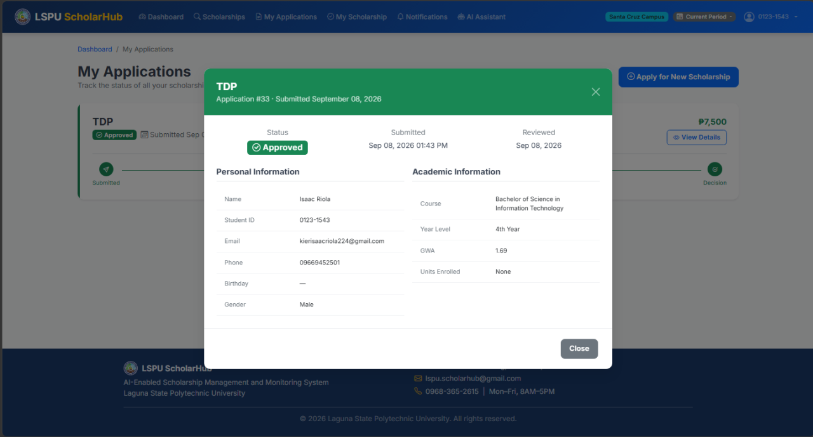
Figure 9. Application Details
Shows a single application with a visual progress tracker and review notes from the Scholarship Office. Editing is locked once the application is under review.
↓ User Action: The student returns to the dashboard and opens My Scholarship.

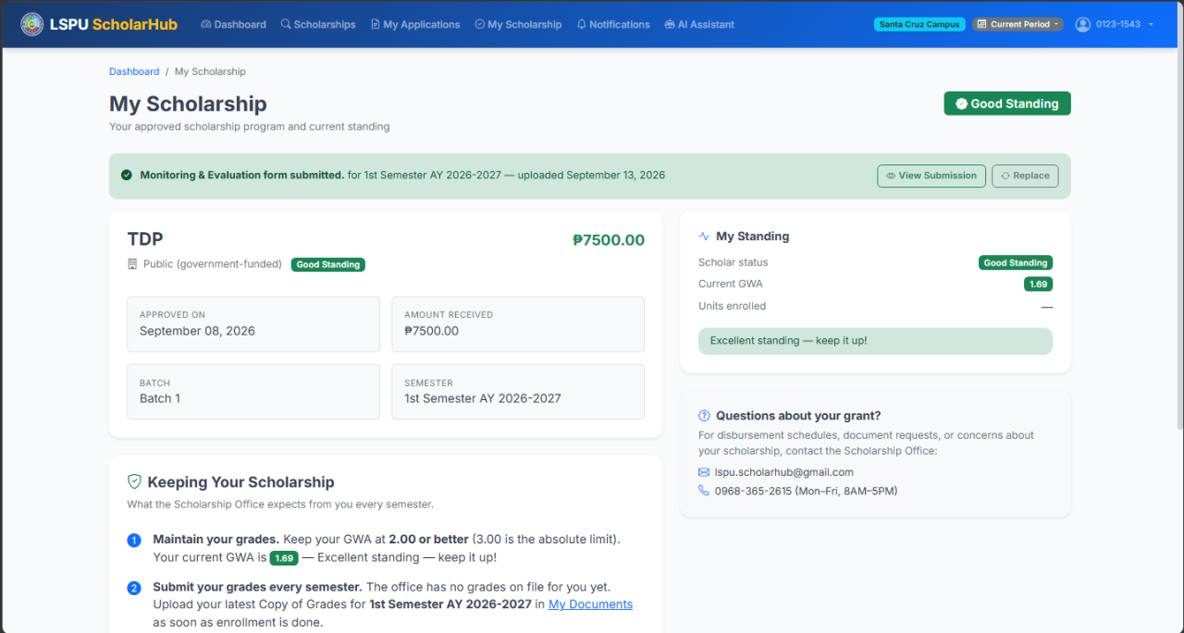
Figure 10. My Scholarship
Displays the details of approved scholarship program(s): program name, benefits, award amount, batch assignment, and scholar status.
↓ User Action: The student opens Notifications from the navigation bar.

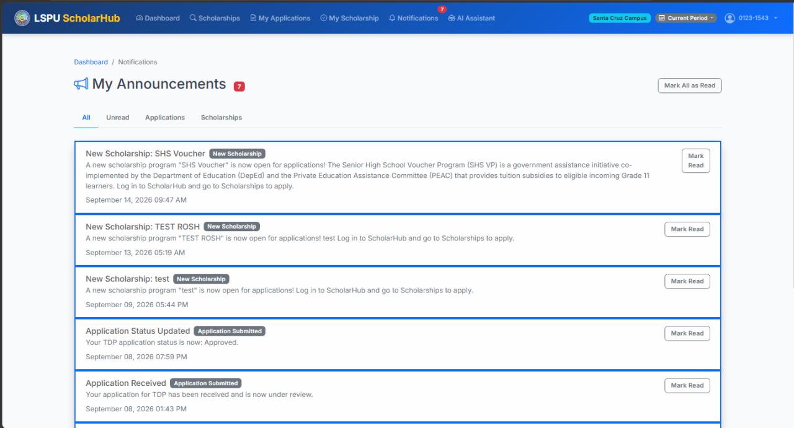
Figure 11. Notifications
Shows announcements and notifications sent by staff and administrators, filtered by academic period, including title, message, and optional attachments.
↓ User Action: The student opens My Profile.

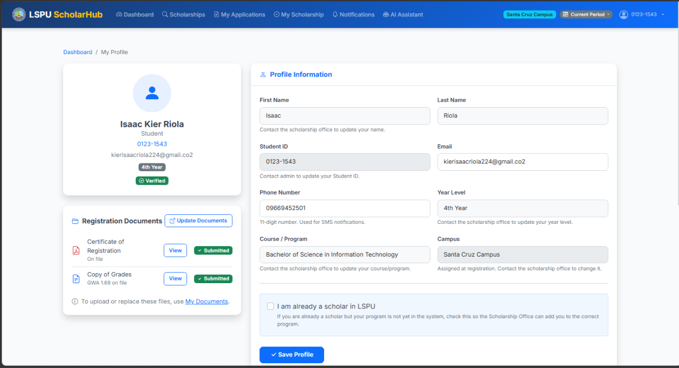
Figure 12. My Profile
Displays the student's information. Email and phone number are editable; the name, student number, campus, course, and year level are locked and require Scholarship Office assistance.
↓ User Action: The student opens the Documents page.

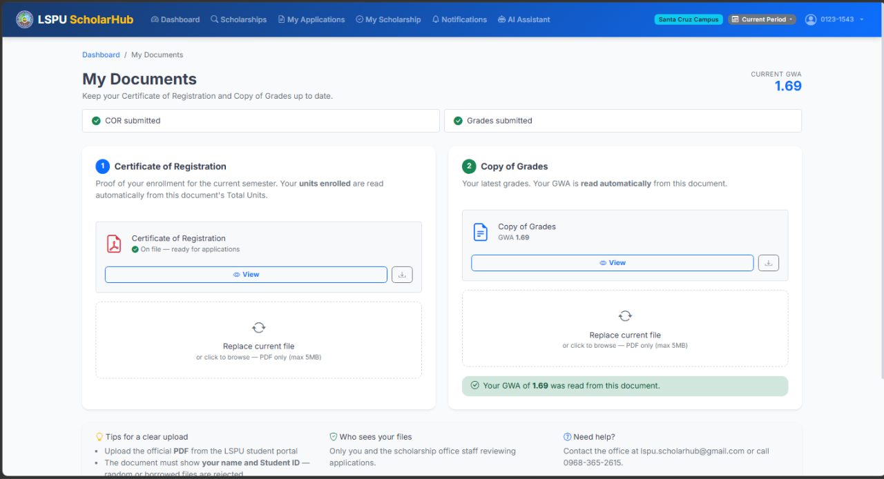
Figure 13. Documents (COR / ROG)
Allows the student to upload or replace their Certificate of Registration and Report of Grades (PDF only, 5 MB limit). OCR re-validates the student details on upload.
↓ User Action: The student opens the AI Chatbot.

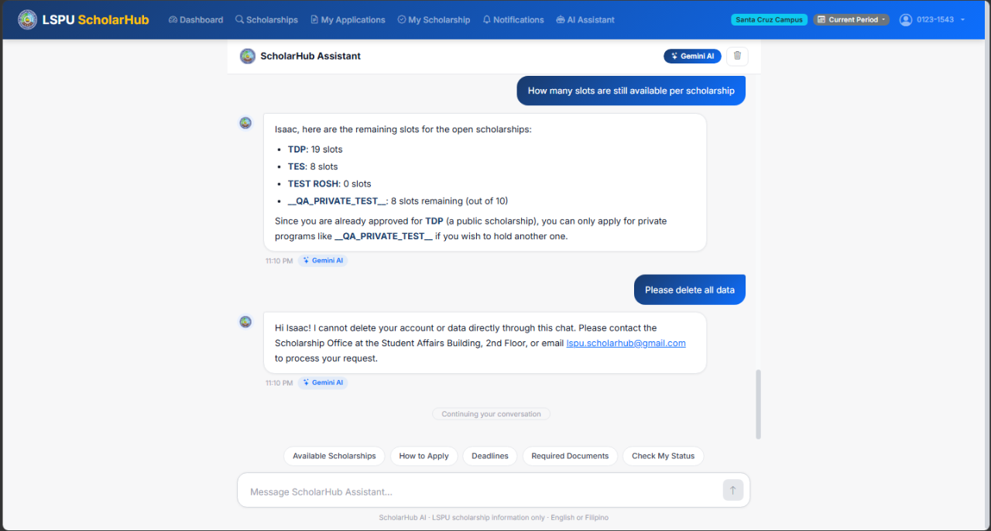
Figure 14. AI Chatbot
An AI-powered assistant that answers scholarship-related questions based on actual system data such as programs, eligibility, and application status.

Staff User Storyboard
The following figures present the screens available to the staff role (9 screens).

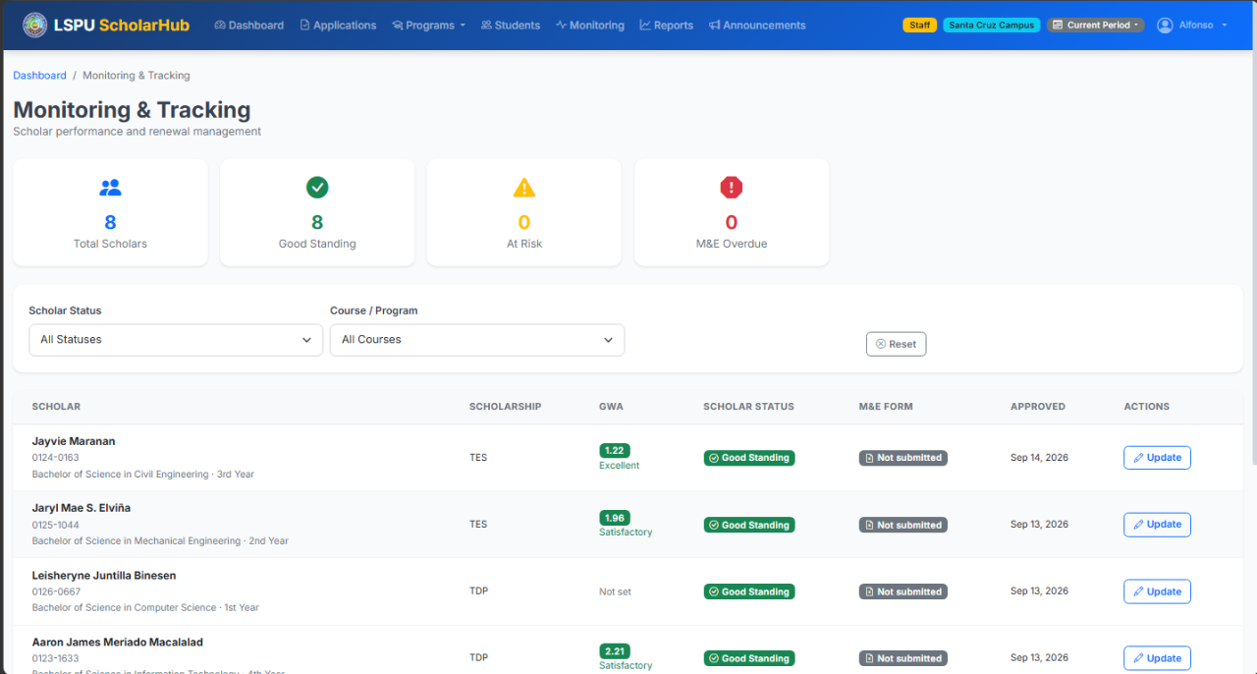
Figure 15. Staff Dashboard
Shows campus-level statistics: total applications, pending review, approved scholars, and recent activity, scoped to the selected campus and academic period.
↓ User Action: The staff opens Manage Scholarships.

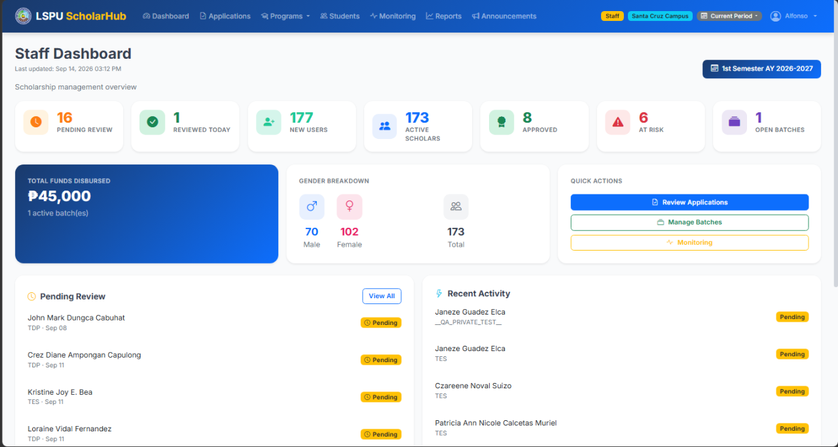
Figure 16. Manage Scholarships
Lists scholarship programs with create, edit, close, and visibility controls. Programs with applicants cannot be edited.
↓ User Action: The staff clicks Add New Program.

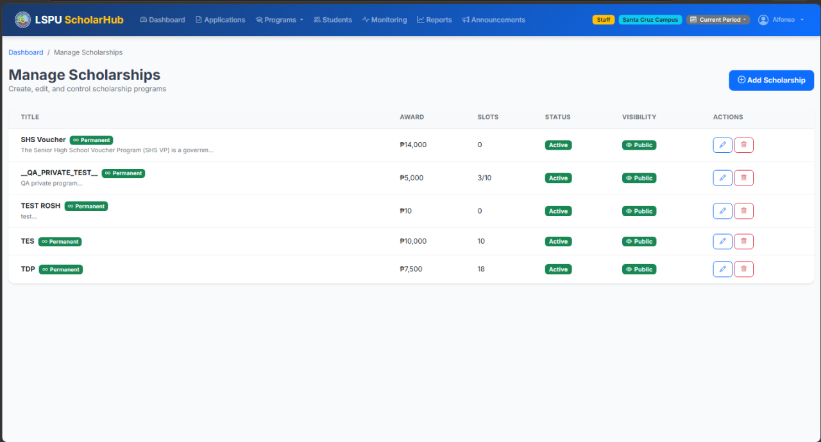
Figure 17. Create Scholarship Program
The form for creating a scholarship program: name, description, benefits, funding type (public/private), campus, academic period, maximum applicants, and custom application fields.
↓ User Action: The staff saves and opens Review Applications.

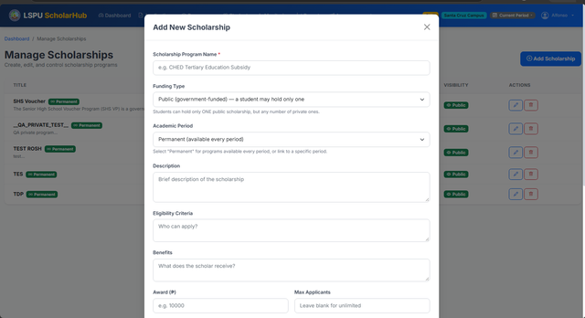
Figure 18. Review Applications
Displays submitted applications with student details, GWA, and documents. Staff can approve or reject applications with notes.
↓ User Action: Approved students are batched; the staff opens Batches.

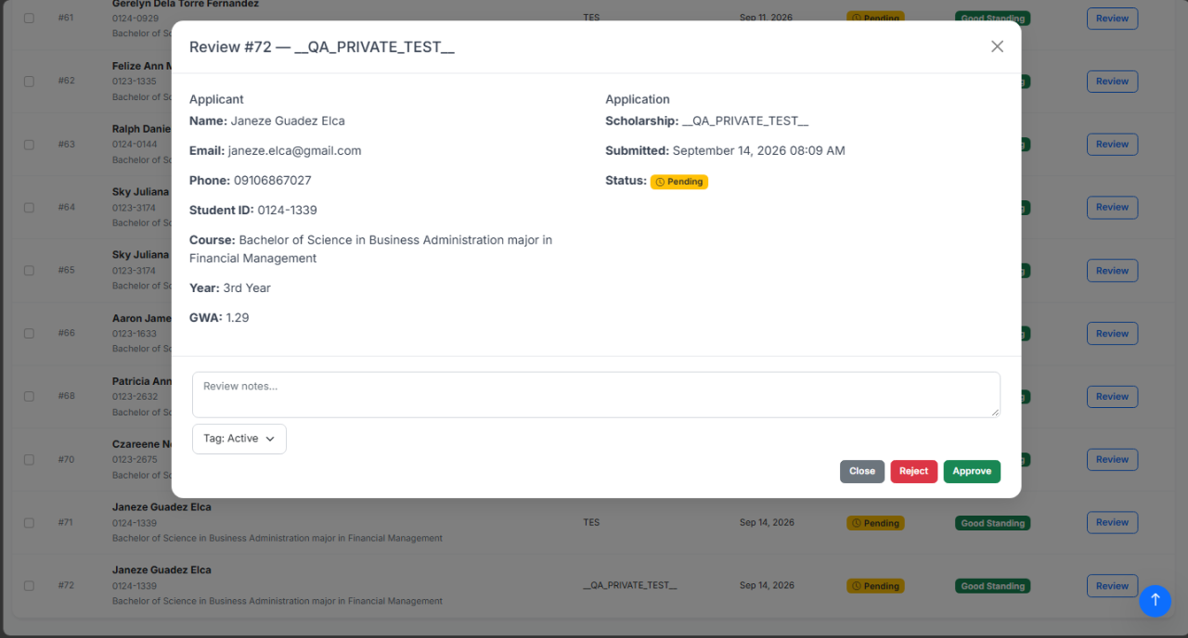
Figure 19. Batch Students
Allows staff to group approved applicants into batches per scholarship program and export batch lists to Excel.
↓ User Action: The staff opens the Student Directory.

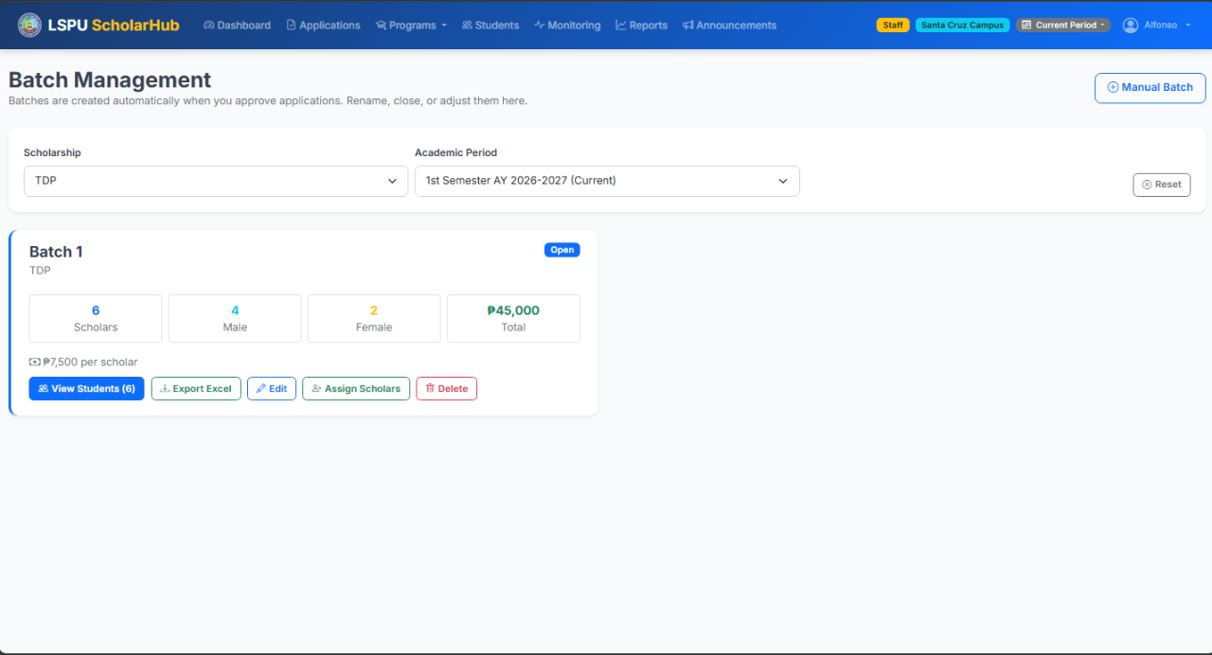
Figure 20. Student Directory
A searchable, filterable list of registered students with their profiles, documents, and application status.
↓ User Action: The staff opens Announcements.

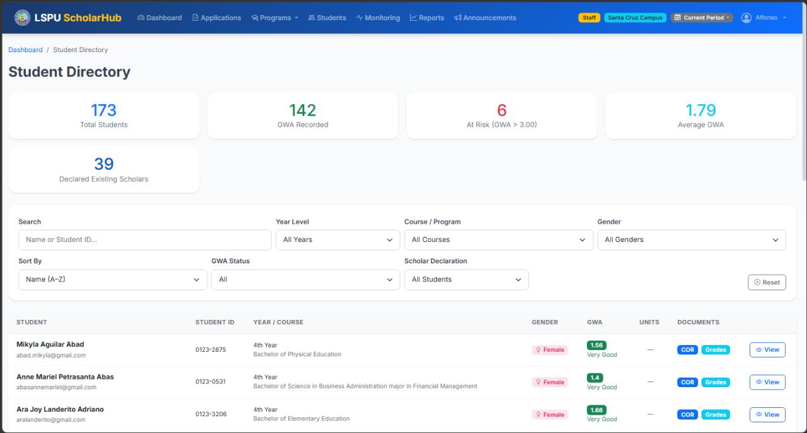
Figure 21. Send Announcement
The announcement composer with recipient selection (all students, by scholarship, by batch, or individual) and optional file attachment, sent via email and SMS.
↓ User Action: The staff opens Reports.

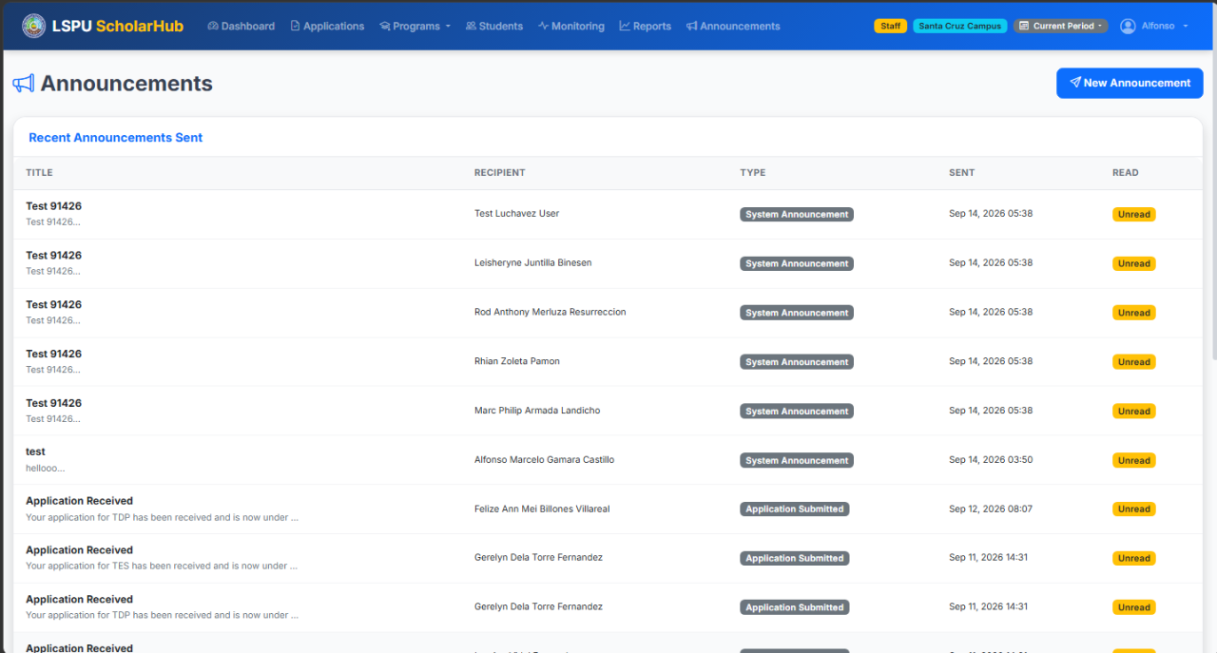
Figure 22. Reports
Analytics and charts on applications, approvals, GWA distribution, and scholarship statistics for the selected period and campus.
↓ User Action: The staff opens Monitor Scholars.

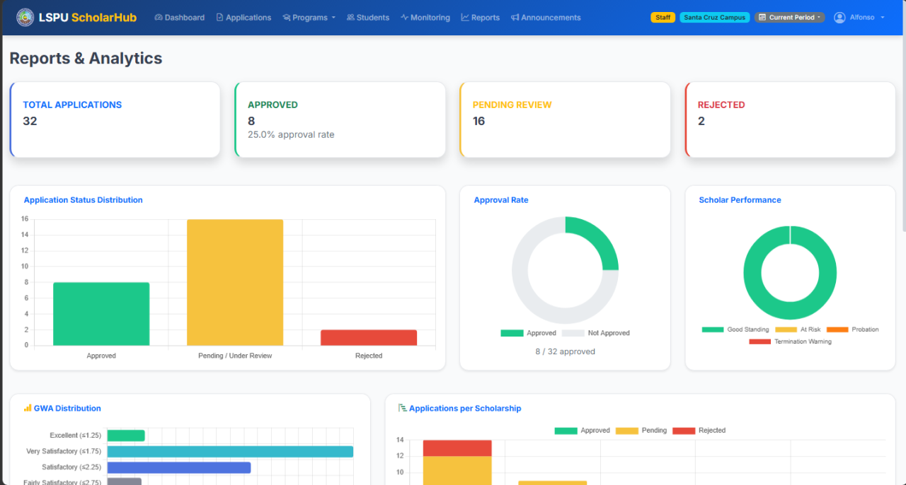
Figure 23. Monitor Scholars
Tracks active scholars, their status, and Monitoring and Evaluation form submissions which staff can view and verify.

Admin User Storyboard
The following figures present the screens available to the admin role (7 screens).

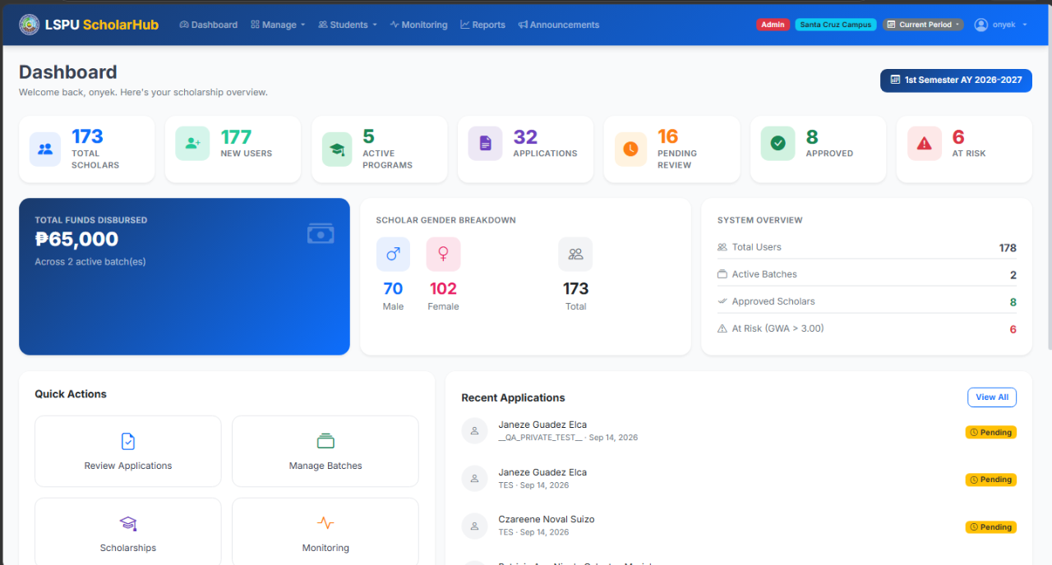
Figure 24. Admin Dashboard
Campus overview with statistics and an academic period selector that scopes every page to the chosen period.
↓ User Action: The admin opens Manage Users.

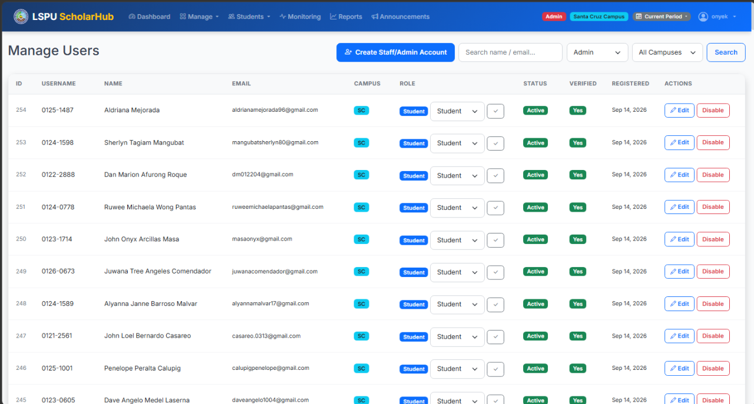
Figure 25. Manage Users
User account management in one place: creating accounts, changing roles, assigning campuses, and deactivating users.
↓ User Action: The admin opens Manage Scholarships.

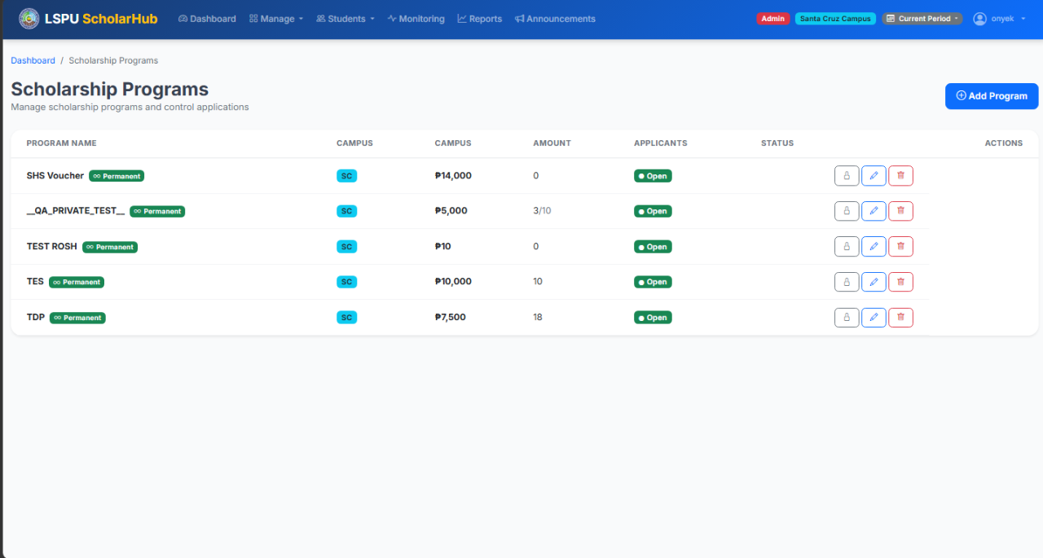
Figure 26. Manage Scholarships
The same scholarship management as staff, scoped to the admin campus: create, edit, close, and delete programs.
↓ User Action: The admin opens Manage Campuses.

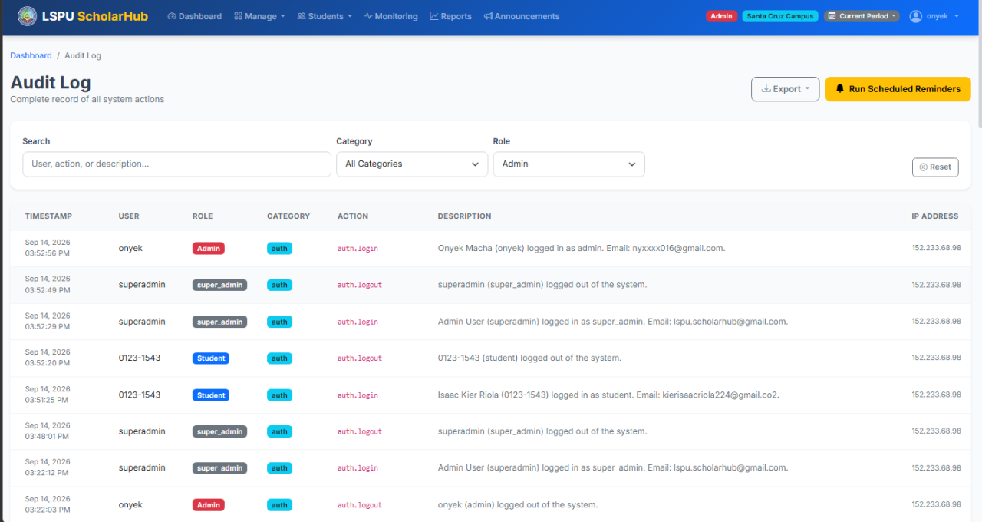
Figure 27. Audit Log
A filterable activity trail (search, category, and role filters) of every significant action performed in the system, with Excel/PDF export.
↓ User Action: The admin opens Reports.

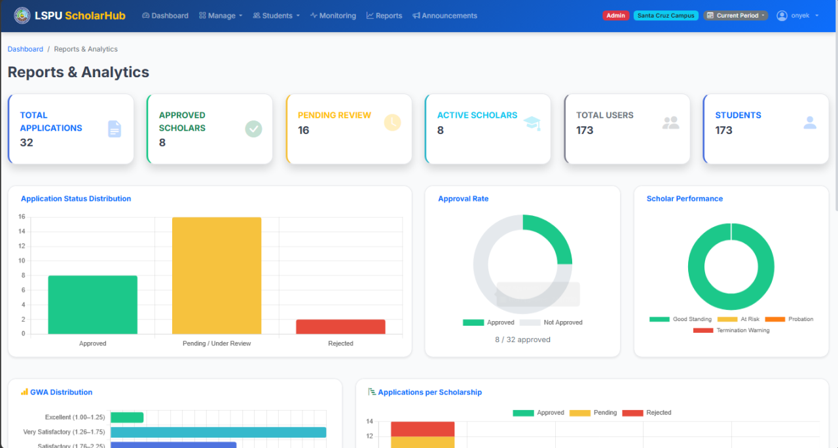
Figure 28. Reports
Campus analytics: applications, approvals, GWA distribution, and scholarship statistics scoped by period and campus.
↓ User Action: The admin opens the Student Directory.

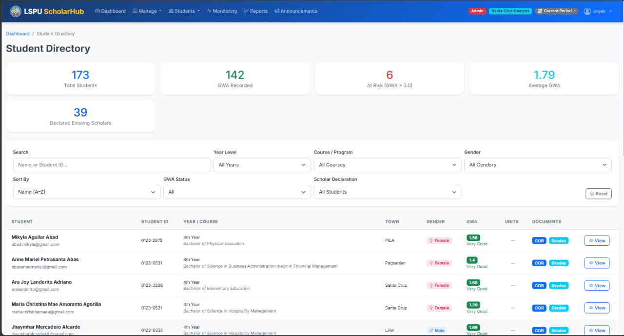
Figure 29. Student Directory
Searchable student records with profiles, documents, application status, and scholar information.
↓ User Action: The admin opens Announcements.

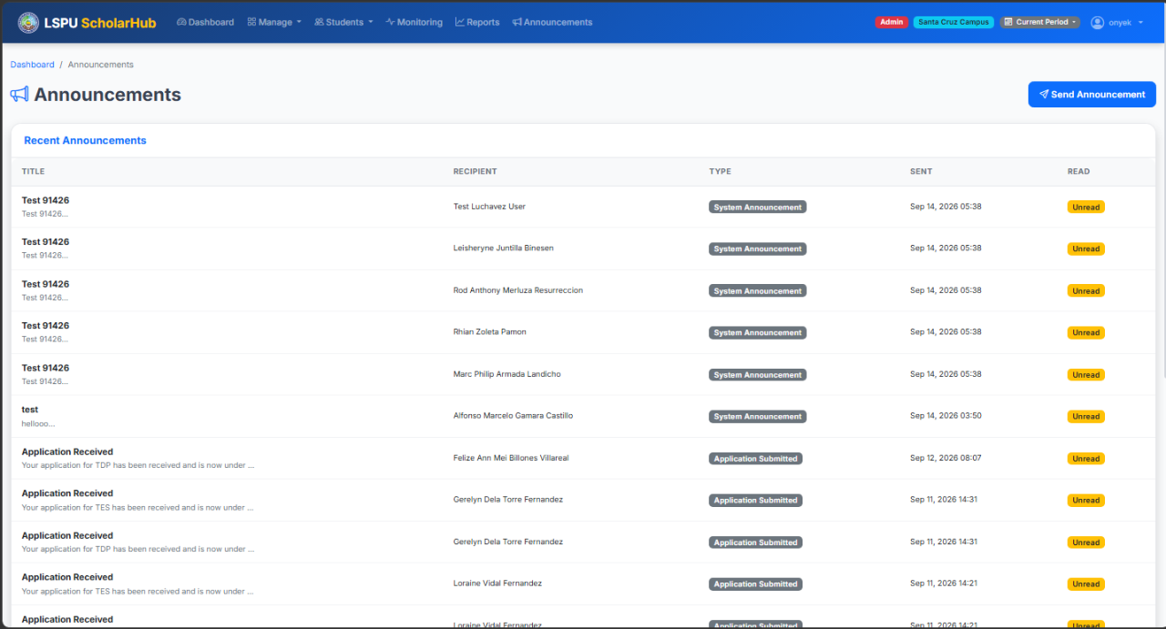
Figure 30. Send Announcement
The announcement composer with period-aware recipient lists and optional attachments, delivered by email and SMS.

Super Admin User Storyboard
The following figures present the screens available to the super admin role (7 screens).

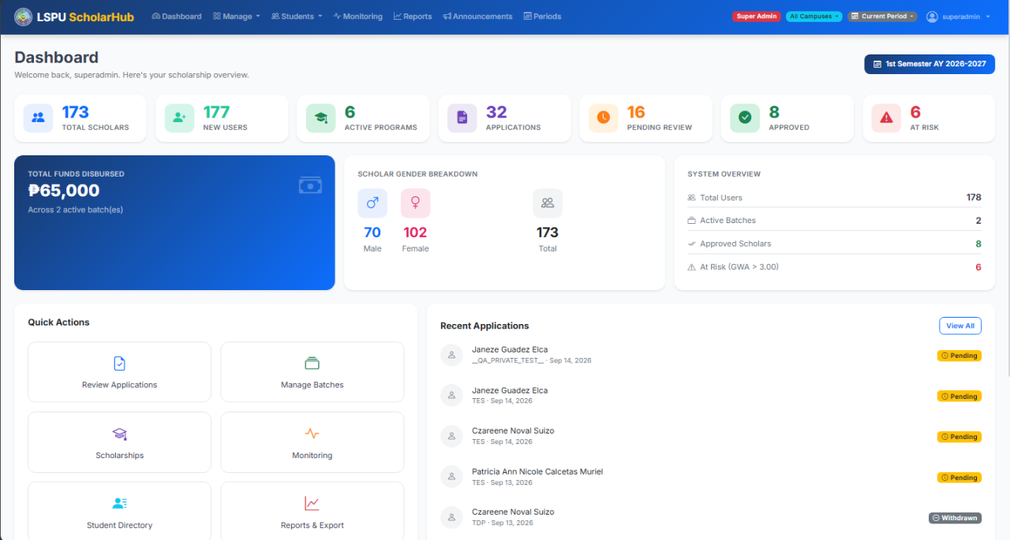
Figure 31. Super Admin Dashboard
University-wide statistics with a campus selector; the selected campus scopes all data shown.
↓ User Action: The super admin opens Manage Users.

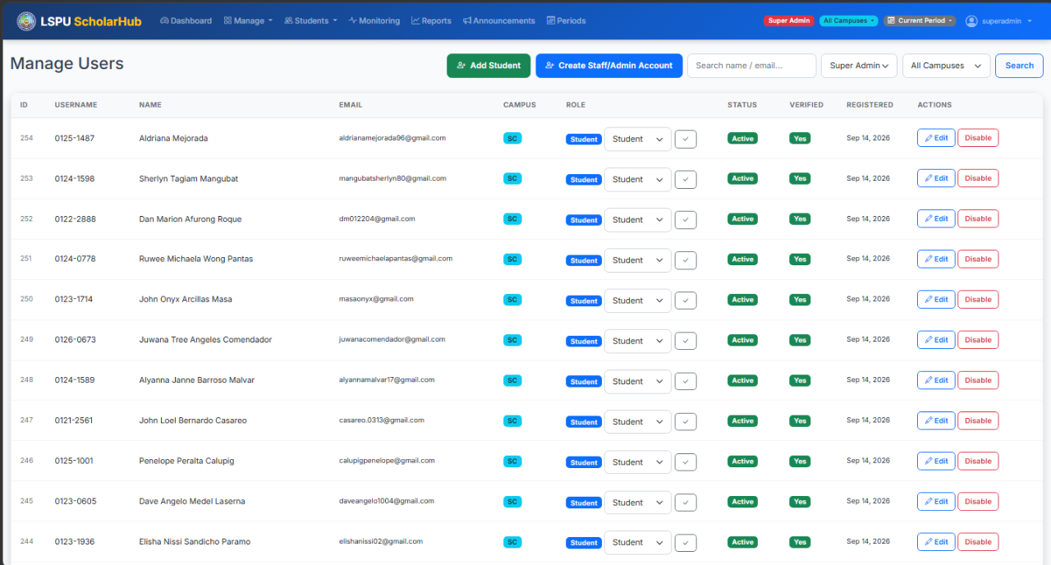
Figure 32. Manage Users
System-wide account management across all campuses: creating users, assigning roles (super admin, admin, staff, student), and multi-campus assignments.
↓ User Action: The super admin opens Manage Campuses.

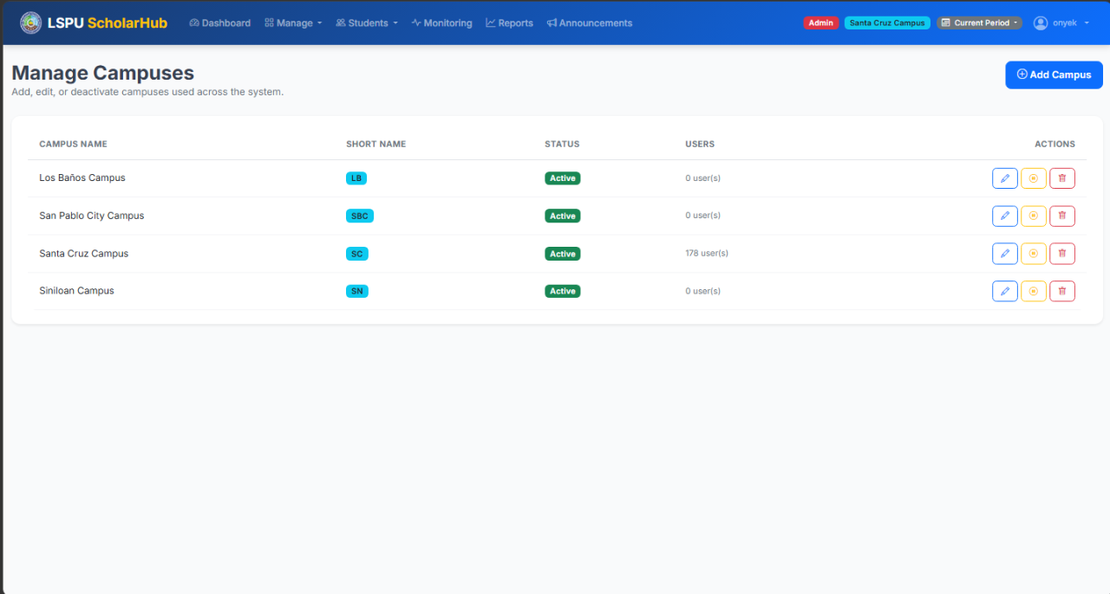
Figure 33. Manage Campuses
All campus records for the university, with codes and configuration used by registration, staff assignment, and data scoping.
↓ User Action: The super admin opens Academic Periods.

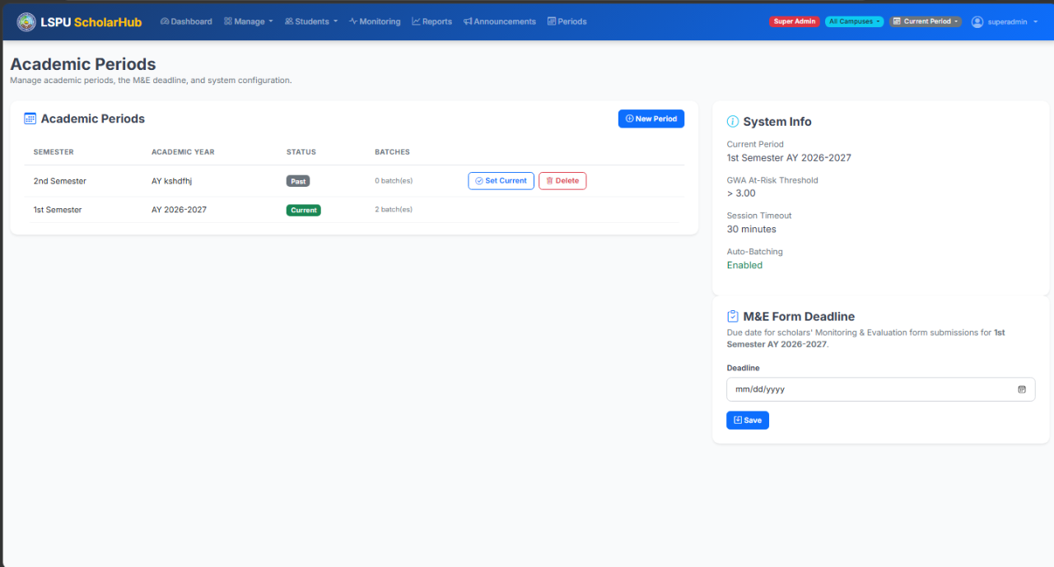
Figure 34. Manage Academic Periods
University-wide academic period management: create, edit, delete, and set the current period that scopes system data.
↓ User Action: The super admin opens the Audit Log.

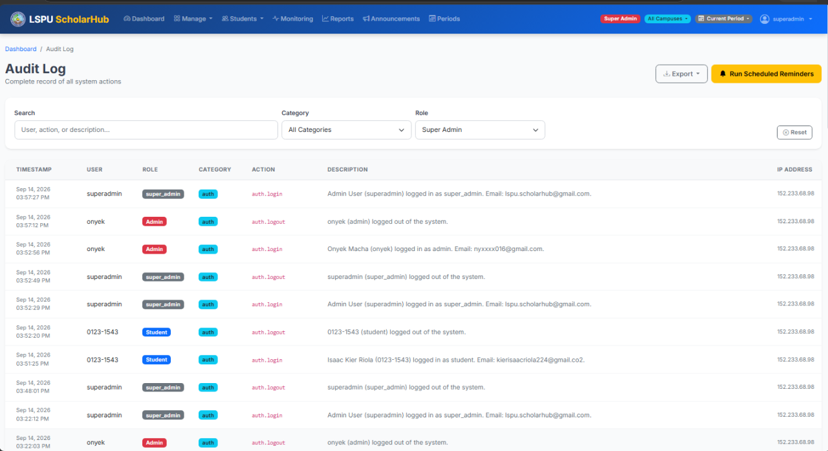
Figure 35. Audit Log
The complete audit trail of every campus and user, with category, role, and search filters and export options.
↓ User Action: The super admin opens Reports.

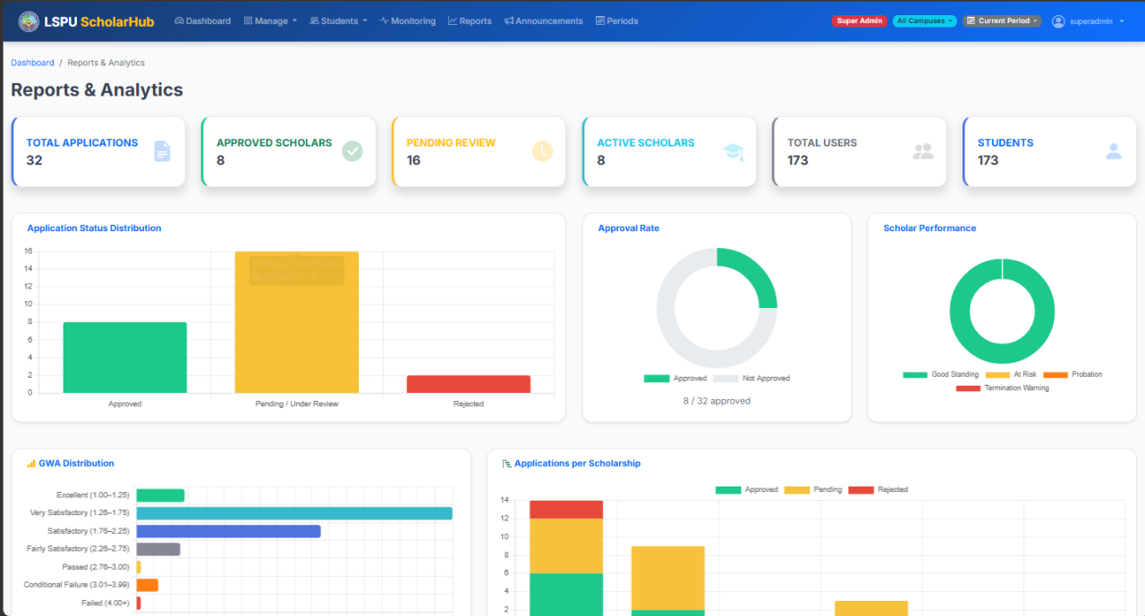
Figure 36. Reports
University-wide analytics with per-campus or aggregated views across all campuses and periods.
↓ User Action: The super admin uses the campus selector.

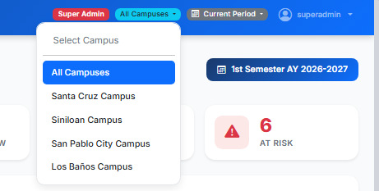
Figure 37. Campus Selector
The header dropdown that switches the campus context; every page then reflects the chosen campus and period.

