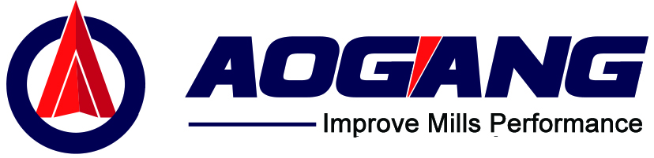

76 Cold-Cut Flying Saw User Manual

Shijiazhuang Aogang Machinery Co., Ltd.

May 2019 V1.36

Safety Precautions
The following lists very important safety instructions, which are basic requirements for ensuring personal safety; all operations must comply with these requirements. For other operational requirements, please refer to the subsequent chapters.

- Non-professionals must not set up, disassemble, or repair the equipment without supervision.
- Do not touch any moving parts of the equipment while it is in operation.
- When performing mechanical maintenance or troubleshooting, ensure that the saw carriage is in the disengaged position.
- Please follow the steps and instructions outlined in the user manual.
- If an operating error occurs while the flying saw system is connected to machinery, it will not only cause damage to the machinery but may also result in personal injury.

- Inspection, maintenance, and repair of the electrical system must be performed by personnel qualified to operate electrical systems.
- Before opening the main control cabinet, be sure to confirm that the power has been completely shut off.
- Do not touch any internal electrical components or terminal blocks inside the cabinet while power is on (when the green light on the main control cabinet panel is lit).
- Do not touch the terminal blocks inside the cabinet within 5 minutes of turning off the power.
- Be sure to ground the grounding terminal inside the cabinet.
- Do not modify this product (including adding electrical components, using the power supply inside the cabinet, or adding wiring).

Table of Contents
Safety Precautions I
Table of contents II
Chapter1: Parameter Descriptions 6
1.1 Screen Overview 6 6
1.2 Parameter Description 9
1.2.1 Main Page Parameter Description 9
1.2.2 Length Order Page Parameter Description 12
1.2.3 Tube Type Parameter Page Parameter Description 14
1.2.4 System Parameter Page Parameter Description 19
1.2.5 Manual Parameter Page Parameter Description 23
1.2.6 Motor Parameter Page Parameter Description 27
1.2.7 Manual Operation Page Parameter Description 31
Chapter2: System Function Description 32
2.1 Operating Modes 32
2.1.1 Manual Mode 32
2.1.2 Simulation Operating Mode 32
2.1.3 Automatic Operation Mode 33
2.2 Power Management Functions 33
2.2.1 Power Supply System 33
2.2.2 Power System 33
2.2.3 Power System 34
2.2.4 Load/Unload Enable 34
2.2.5 Servo Power Failure Protection 35
2.3 Jog Function 35
2.3.1 Drag Jog Function 35
2.3.2 Feed Jog Function 35
2.4 Drag Back to Origin Function 36
2.4.1 Drag Back to Origin Function 36
2.4.2 Drag Manual Origin Function 36
2.4.3 Feed Back to Origin Function 37
2.4.4 Feed Manual Origin Function 38
2.5 Clamping Function 38
2.6 Cutting Function 38
2.7 Short Ruler/Long Ruler Function 39
2.7.1 Short Ruler Function 39
2.7.2 Long Ruler Function 40
2.8 Length Memory Function 40
2.9 Order Scheduling Function 41
Chapter3:Operating Instructions 42
3.1 Power-on Procedure 42
3.2 Manual Forward/Reverse Feed Operation 43
3.3 Return to Origin Feed Operation 43
3.3.1 Return to Origin Feed Operation 43
3.3.2 Return to Origin Feed Operation 44
3.4 Feed Torque Test 45
3.5 Manual Clamping 46
3.6 Manual Sawing 46
3.7 Start Simulation 47
3.8 Start Automatic Operation 48
3.9 Set Schedule 49
3.10 Return to Memory Point 50
3.11 Short Ruler/Long Ruler Function 51
3.11.1 Short Ruler Function 51
3.11.2 Long Ruler Function 52
3.12 Synchronization Measurement 52

Chapter 1: Parameter Description

1.1 Screen Overview
In the KK-5S cold-cut flying saw control system, the touchscreen is the most important component for production operations and monitoring system status. The touchscreen layout diagram is shown in Figure 1-1: KK-5S Cold-Cut Flying Saw Control System Touchscreen Layout Diagram.

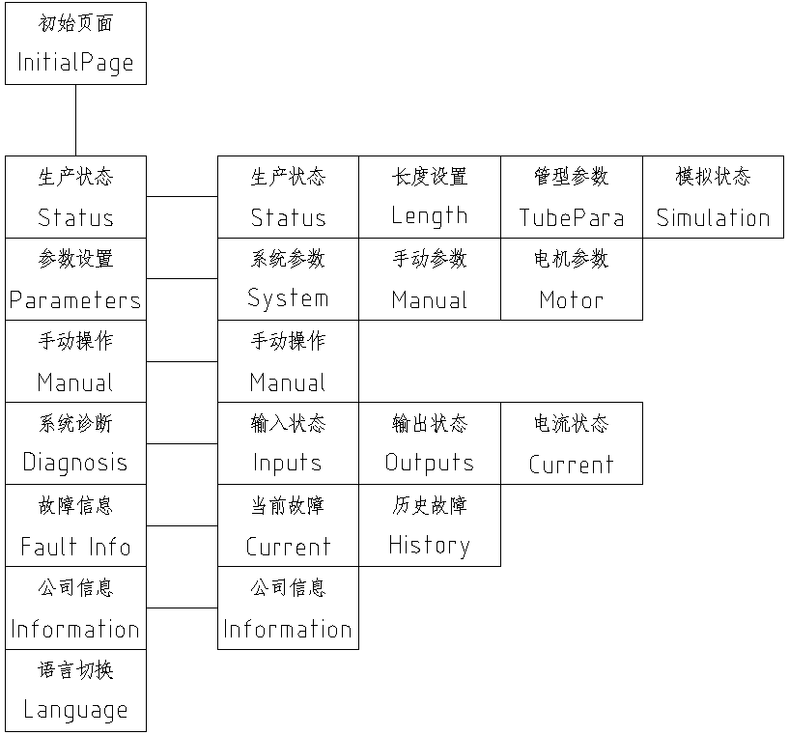
Figure 1-1: Touchscreen Screen Topology Diagram for the KK-5S Cold-Cut Flying Saw Control System

On each touchscreen screen, there are two rows of screen-switching buttons at the bottom. The bottom row consists of primary navigation buttons, which are displayed on every page; the top row consists of secondary navigation buttons, which are displayed only when the corresponding page is accessed. See Figure 1-2: Main Screen of the KK-5S Cold-Cut Flying Saw Control System.
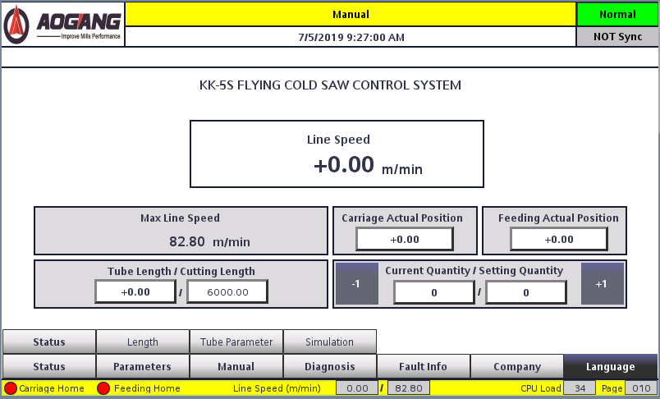
Figure 1-2: Main Screen of the KK-5S Cold-Cutting Flying Saw Control System

Production Status Page: Includes the “Production Status” page, “Length Settings” page, “Pipe Type Parameters” page, and “Simulation Status” page. This page primarily serves as the area for modifying production parameters used in daily operations, such as setting length and quantity, material parameters, and more.
System Settings Page: Includes the “System Parameters” page, “Manual Parameters” page, and “Motor Parameters” page. This section allows users to modify various parameters used in the flying saw.
Manual Operation Page: Includes the “Manual Operation” page, where users can modify various parameters available in the flying saw.
System Diagnostics Page: Includes the “System Diagnostics” page, which allows users to monitor the input and output of the flying saw system.
Alarm Information Page: Includes the “Current Alarms” and “Historical Alarms” pages; this section primarily displays current and historical alarms.
Company Information Page: Includes the “Company Information” page, which provides the company’s contact information.
Language Switch Button: Allows switching between Chinese and English.

1.2 Parameter Descriptions

1.2.1 Main Page Parameter Description
The main page is shown in Figure 1-2: KK-5S Cold-Cut Flying Saw Main Page.

Figure 1-2: KK-5S Cold-Cut Flying Saw Main Page
The parameters on the main page are listed in Table 1-4: KK-5S Cold-Cut Flying Saw Main Page Parameter List
Table 1-4: List of Main Screen Parameters for the KK-5S Cold-Cut Flying Saw
KK-5S Cold-Cut Flying Saw Main Page Parameter List
Parameter Name | Description | Unit | Configurable | Factory Default
Production Line Speed | Current production line speed | m/min | ○ | -
Maximum Line Speed | Maximum production line speed calculated based on current parameters | m/min | ○ | -
Current Material Length | Current distance traveled by this piece of material | mm | ○ | -
Current cut length | Current cutting length set in the production schedule | mm | ○ | -
Current position of the saw carriage | Current saw carriage position relative to the origin | mm | ○ | -
Current Feed Position | Current feed position relative to the origin | mm | ○
Quantity Produced | Quantity produced in the current job order settings | pieces | ○ | -
Set Production Quantity | Production quantity in the current scheduling settings | Root | ○ | -

Production Line Speed
Unit: m/min;
Description: Material production line speed in automatic operation mode. Displayed in real time; can be viewed on the main page or above the divider line in any window.

Maximum Production Line Speed
Unit: m/min;
Description: The maximum production line speed allowed under the current parameters. When operating in automatic mode, ensure that the production line speed does not exceed this value.

Current Material Length
Unit: mm;
Description: The distance the material has already advanced.

Current Cut Length
Unit: mm;
Description: The cut-off length set for the current job. This can be changed by switching jobs; see Section 7.9, Job Settings.

Current Saw Car Position
Unit: mm;
Description: The current position of the saw carriage relative to the origin.

Current Feed Position
Unit: mm;
Description: The current position of the feed relative to the origin.

Quantity Produced
Unit: pieces;
Description: The number of pieces already produced in the current production order. You can make minor adjustments using the plus and minus signs above for easier tracking.

Set Production Quantity
Unit: pieces;
Description: The production quantity specified in the current schedule. This can be changed by modifying the schedule; see 7.9 Schedule Settings.

1.2.2 Parameter Descriptions for the Length Scheduling Page
The Length Scheduling page is shown in Figure 1-3: KK-5S Cold-Cut Flying Saw Length Scheduling Page.
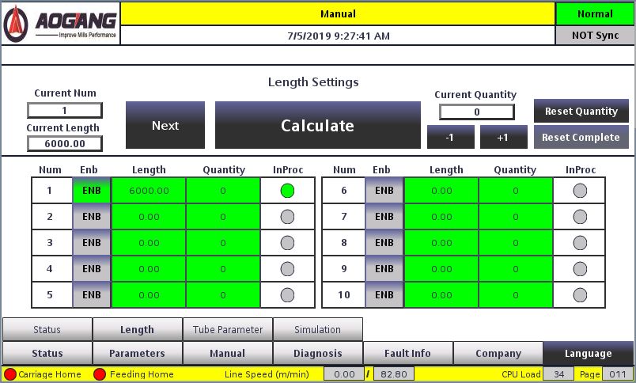
Figure 1-3: KK-5S Cold-Cut Flying Saw Length Scheduling Page
The parameters on the Length Scheduling page are listed in Table 1-5: KK-5S Cold-Cut Flying Saw Length Scheduling Page Parameter List.

Set Length for Orders 1–10
Setting range: 0–104,857.5;
Unit: mm;
Note: If the user does not require the scheduling function during normal operation, it is recommended to use this order to set the production length. The setting range for this unit of length can accommodate most of the user’s production length requirements.
When setting up the scheduling, the “Select” status for the order to be produced must be selected; otherwise, the set length for the current order will not be executed.
Table 1-5: Parameter List for the KK-5S Cold-Cut Flying Saw Length Scheduling Page
KK-5S Cold-Cut Flying Saw Length Scheduling Page Parameter List
Parameter Name | Description | Unit | Configurable | Factory Default
Single-row 1–10 Setting Length | Individual row-by-row length settings | mm | ● | 6000
Set Quantity for Orders 1–10 | Production Quantity for Each Order | pieces | ● | 6,666
Current Production Order Number | Currently selected order number | - | ○ | -
Current production length | Currently selected production length | mm | ○ | -
Current Quantity | Current production quantity | units | ○ | -

Orders 1–10: Set Quantity
Specified range: 0–99,999;
Unit: pieces;
Description: Corresponds to the production quantity for Orders 1–10. When using the scheduling function, users must set the production quantity for each order.
Note: If the quantity is set to 0, production for this order is unlimited.

Current Production Order Number
Description: The currently selected order number.

Current Production Length
Description: The set length for the currently selected order.

Current Quantity
Description: The quantity that has been produced so far.

1.2.3 Tube Type Parameters Page: Parameter Descriptions
The Pipe Type Parameters page is shown in Figure 1-4: KK-5S Cold-Cut Flying Saw Pipe Type Parameters Page.
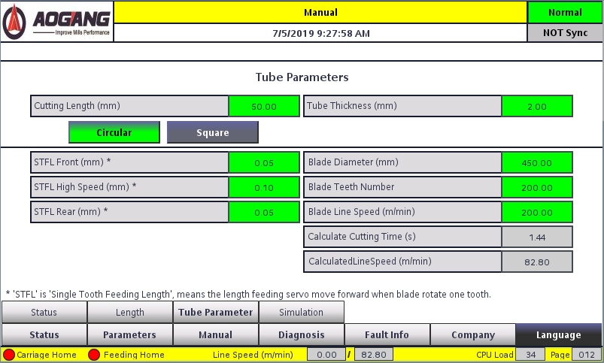
Figure 1-4: KK-5S Cold-Cut Flying Saw Pipe Profile Parameters Page
The parameters on the Pipe Profile Parameters page are listed in Table 1-6: Parameter List for the KK-5S Cold-Cut Flying Saw Pipe Profile Parameters Page.

Feed Distance
Range: 0–200;
Unit: mm;
Description: The travel distance of the feed axis during feeding.
Enter this value based on the actual pipe diameter of the material. For round pipes, enter the pipe diameter directly; for square or special-shaped pipes, enter the equivalent feed length based on the feed angle to ensure a full cut during sawing.
Table 1-6: Parameter List for the KK-5S Cold-Cut Flying Saw Pipe Type Parameter Page
KK-5S Cold-Cut Flying Saw Pipe Type Parameter Page Parameter List
Parameter Name | Description | Unit | Configurable | Default Value
Feed Distance | Feed Distance During Cutting | mm | ● | 32
Material wall thickness | Tube wall thickness when cutting round tubes | mm | ● | 2
Slow-speed percentage for the first segment | Use slow speed within this range when cutting square or special-shaped tubes | % | ● | 10
Slow-Speed Percentage for Final Section |  | % | ● | 20
Tube Type Selection | Select round, square, or special-shaped tubing | - | ● | -
Single-tooth feed rate for the first section | Single-tooth feed rate during slow sawing in the first stage | mm | ● | 0.04
Per-tooth feed rate for the high-speed stage | Per-tooth feed rate during high-speed sawing | mm | ● | 0.08
Single-tooth feed rate for the final stage | Single-tooth feed rate during the second stage of slow sawing | mm | ● | 0.04
Saw blade linear speed | Linear speed at the saw blade edge | m/min | ● | 200
Number of teeth on the saw blade | Total number of teeth on the saw blade | teeth | ● | 200
Saw Blade Diameter | Effective diameter of the saw blade | mm | ● | 350
Recommended Cutting Time | Calculated Recommended Cutting Time | s | ○ | -
Maximum Production Speed | Maximum linear speed at current parameters | m/min | ○ | -

Material wall thickness
Appears only when "Round Pipe" is selected for the pipe type
Unit: mm;
Description: The wall thickness of the tube during the production of round tubes.
During feeding, when the system encounters areas such as the tube wall that require greater cutting force, it will slow down the feed rate and use a low-speed tooth feed rate to protect the saw blade from damage caused by excessive impact. After passing through the slow-speed zone, feeding will resume at the high-speed tooth feed rate. This parameter is used to determine the length of the slow-speed zone where slow feeding is required.For round tubes, the slow-speed zones are located at the tube walls at both ends and at the inner and outer feed allowances. Feeding in the tube wall areas will proceed at the low-speed tooth feed rate. When configuring this parameter, please enter values based on actual production data. If this parameter is set too high, it will affect cutting speed; if set too low, it will fail to protect the saw blade, potentially causing blade damage.
Note: Use this only when producing round tubes; for square and special-shaped tubes, use the “Initial Slow-Speed Percentage” and “Final Slow-Speed Percentage” parameters.

Slow-Speed Percentage for First Segment, Slow-Speed Percentage for Last Segment
Appears only when “Square Tube” is selected as the tube type
Setting Range: 0–100%;
Description: The full names are “Percentage of Slow-Feed Zone for the Initial Segment” and “Percentage of Slow-Feed Zone for the Final Segment.” When producing square tubes and special-shaped tubes, these values represent the percentage of the total material diameter occupied by the slow-feed zones at the beginning and end of the cut.
During feeding, when the system encounters areas such as tube walls that require greater cutting force, it will slow down the feed speed and use a low-speed feed rate to protect the saw blade from damage caused by excessive impact. After passing through the slow-speed zone, feeding resumes at high speed. During the sawing process for square tubes and special-shaped tubes, the slow-speed zones cannot be determined solely by wall thickness parameters; the length of the slow-speed feed zones must be defined.According to calculations, when cutting square tubes, the percentage of the slow-speed zone at the beginning is generally 5%–10%, while the percentage at the end is typically 20%–45%. Both the tube wall thickness and the tube exit angle affect the value of this parameter.Please adjust this value based on the tube wall thickness and exit angle. You may also adjust the percentage of the low-speed section based on the cutting curve displayed by the system after material identification is complete. If this parameter is set too high, it will affect cutting speed; if set too low, it will fail to protect the saw blade, potentially causing blade damage.
Note: Use this setting only when producing square or special-shaped tubes; for round tubes, use the material wall thickness parameter.

Tube Type Selection
Options: Round Tube, Square Tube, and Special-Shaped Tube;
Description: Select the tube type to be produced—round tube, square tube, or special-shaped tube. When producing round tubes, use the material wall thickness as the basis for positioning the slow-speed zone; when producing square tubes or special-shaped tubes, use the “First Segment Slow-Speed Percentage” and “Final Segment Slow-Speed Percentage” as the basis for positioning the slow-speed zone.

Feed Per Tooth for Initial Section, Feed Per Tooth for High-Speed Section, Feed Per Tooth for Final Section
Unit: mm;
Note: During sawing, the distance the feed shaft moves for each rotation of a saw tooth is the single-tooth feed rate.
During feeding, when the system encounters areas such as pipe walls that require greater cutting force, it will slow down the feed speed to protect the saw blade from damage caused by excessive impact. The feed speed is adjusted based on the high-speed and low-speed tooth feed rates; during low-speed operation, the low-speed tooth feed rate is used to protect the saw blade, while during high-speed operation, the high-speed tooth feed rate is used to ensure cutting speed.
When producing round tubes, the single-tooth feed rate for the initial and final sections ranges from 0.03 to 0.05 mm, while the range for the high-speed section is 0.08 to 0.12 mm; the feed rate at the tube wall is minimized as much as possible.
When producing square tubes and special-shaped tubes, the single-tooth feed rate for the initial and final sections ranges from 0.01 to 0.07 mm, while the range for the high-speed section is 0.1 to 0.14 mm. Due to the characteristics of sawing square tubes, the single-tooth feed rate for the initial and final sections can be higher than that for round tubes, and the difference between high-speed and low-speed feed rates can be smaller than for round tubes.
This parameter depends primarily on the saw blade. Generally, it should be set according to the saw blade manufacturer’s guidelines, though fine adjustments can be made based on actual cutting conditions. This setting directly affects the cutting speed; if set too high, it will fail to protect the saw blade, leading to blade damage; if set too low, it will reduce cutting speed.

Saw Blade Linear Speed
Unit: m/min;
Description: The linear velocity at a specific point on the outer edge of a saw tooth as the saw blade rotates. Formula for calculating the valid range: Saw Blade Linear Velocity × 1000 × Reduction Ratio / Saw Blade Diameter × π < Maximum Speed of the Sawing Motor. Please set appropriate parameters based on the selected saw blade model.

Number of Saw Blade Teeth
Description: The total number of teeth on the saw blade. Please enter the correct parameter based on the actual number of teeth on the saw blade. Incorrect parameters may affect the saw blade’s service life or even prevent the system from operating normally.

Saw Blade Diameter
Unit: mm;
Description: The actual diameter of the saw blade. This value determines the final rotational speed of the saw blade and affects the cutting speed. Please enter the correct parameter based on the actual specifications of the saw blade; incorrect parameters may affect the service life of the saw blade or even prevent the system from operating normally.
Note: If using a re-ground saw blade, please measure the actual diameter after regrinding and enter that value here.

Recommended Cutting Time
Unit: s;
Description: The recommended cutting time, automatically calculated based on the current pipe type and saw blade parameters.
This value serves as a reference for setting the cutting time and represents a setting that provides relatively good protection for the saw blade. Users can refer to this value to appropriately reduce the cutting time to achieve higher production line speeds, or increase the cutting time to extend the service life of the saw blade.

1.2.4 Description of Parameters on the System Parameters Page
The System Parameters page is shown in Figure 1-12: KK-5S Cold-Cut Flying Saw System Parameters Page.
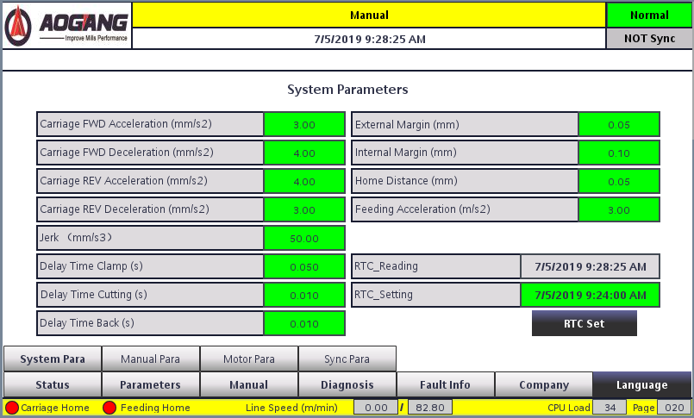
Figure 1-12: KK-5S Cold-Cut Flying Saw System Parameters Page
The parameters on the System Parameters page are listed in Table 1-14: List of Parameters on the KK-5S Cold-Cut Flying Saw System Parameters Page.
Table 1-14: Parameter List for the KK-5S Cold-Cut Flying Saw System Parameters Page
List of Parameters on the KK-5 Cold-Cut Flying Saw System Parameters Page
Parameter Name | Description | Unit | Configurable | Factory Default
Saw Car Forward Acceleration | Acceleration during the forward movement of the saw carriage | mm/s² | ● | 3
Forward deceleration of the saw carriage | Deceleration of the saw carriage during the forward travel segment | mm/s² | ● | 4
Acceleration of the saw carriage during the return phase | Acceleration of the saw carriage during the return phase | mm/s² | ● | 4
Deceleration of the saw carriage during return travel | Deceleration of the saw carriage during the return leg | mm/s² | ● | 3
Acceleration of the saw carriage | Acceleration of the saw carriage | mm/s ³ | ● | 50
Clamping delay | Delay from saw carriage synchronization to clamping | s | ● | 0.05
Cut Delay | Delay from clamping to start of cutting | s | ● | 0.01
Return delay | Delay from the end of cutting to the start of the saw carriage deceleration | s | ● | 0.01
Slow-speed allowance outside the pipe | Slow-speed allowance beyond the material wall thickness | mm | ● | 0.1
Slow-speed allowance inside the pipe | Slow-speed allowance within the material wall thickness | mm/s | ● | 10
Distance to Feed Origin | Distance the pipe retraction travels backward after pipe jacking during return to origin | mm/s | ● | 10
Feed acceleration | Acceleration during feed motion | mm/s² | ● | 2
Real-time clock settings | System time setting | - | ● | -

Acceleration and Deceleration of the Saw Car During the Forward Movement Segment
Acceleration and deceleration of the saw carriage during the return phase
Unit: m/s²;
Factory settings: 3, 4, 4, 3;
Description: Acceleration and deceleration of the drive feed motor during the forward and return phases.
The saw carriage operation is under closed-loop control.The system calculates the acceleration and deceleration curves for the forward direction based on the set acceleration and deceleration values, while driving the drive shaft based on the material shaft speed. Setting these values too high will increase the load on the drive motor, resulting in severe overshoot when accelerating to the synchronous zone or decelerating to zero speed. Servo overshoot affects positioning accuracy and positioning time; conversely, setting them too low will reduce the system’s operating speed. Please enter appropriate values based on the actual mechanical conditions.

Saw Car Acceleration
Unit: m/s ³;
Factory Setting: 50;
Description: The acceleration rate of the drive feed motor during the forward and return strokes.

Clamping Delay
Unit: s;
Factory setting: 0.05;
Description: After the saw carriage reaches the synchronization zone, the clamping signal is output after this time has elapsed.
As the saw carriage accelerates from zero speed to synchronous speed, there will be some overshoot when it moves from the acceleration zone to the synchronous zone. The magnitude of the overshoot depends on the acceleration and the mechanical weight. The clamping signal begins to be output after this set time has elapsed, which prevents desynchronization caused by clamping during the fluctuations of the saw carriage’s overshoot. Setting this value too high will affect the system’s maximum operating speed.

Cut-off Delay
Unit: s;
Factory Setting: 0.01;
Description: After the preceding clamping delay time has elapsed, the system outputs the clamping action signal; this time is allocated for the clamping mechanism to actuate.

Return Delay
Unit: s;
Factory setting: 0.01;
Description: After sawing is complete, the saw blade returns to the origin, and the system outputs a clamping release signal. After this time has elapsed, the system enters the deceleration zone and continues with subsequent operations.

Slow-Speed Allowance (Inner), Slow-Speed Allowance (Outer)
Unit: mm;
Factory setting: 1;
Description: This value represents the allowance reserved before and after the material wall thickness during feed, which also prevents failure to cut due to mechanical precision errors.

Distance to Feed Origin
Setting range: 0–255;
Unit: mm;
Factory Setting: 5;
Description: When the “Feed to Origin” command is executed, the feed axis moves forward according to the set torque. The distance the saw blade travels back after contacting the material is the “Feed Origin Distance.” Adjusting this value changes the distance between the saw blade’s origin position and the material.

Feed Acceleration
Unit: m/s²;
Factory setting: 2;
Description: The acceleration of the feed servo motor.
This parameter is used to calculate acceleration and deceleration times based on the motor’s maximum speed. Setting this value too high will increase the load on the drive motor, resulting in severe overshoot when accelerating to the synchronous zone or decelerating to zero speed. Servo overshoot affects positioning accuracy and positioning time; conversely, setting it too low will reduce the system’s operating speed. Please enter an appropriate value based on the actual mechanical conditions.

Real-Time Clock Settings
Description: System time settings.

1.2.5 Parameter Descriptions for the Manual Parameters Page
The Manual Parameters page is shown in Figure 1-12: KK-5S Cold-Cut Flying Saw System Manual Page.
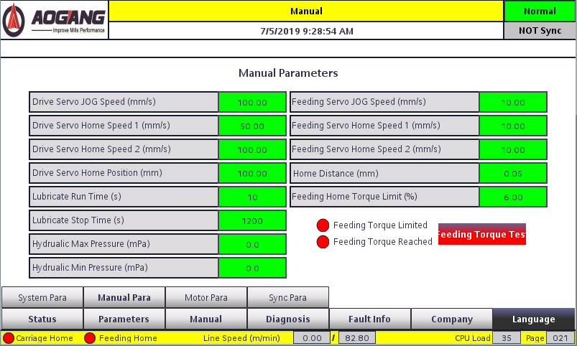
Figure 1-12: KK-5S Cold-Cut Flying Saw Manual Parameters Page
The parameters on the Manual Parameters page are listed in Table 1-14: Parameter List for the KK-5S Cold-Cut Flying Saw Manual Parameters Page.
Table 1-14: Parameter List for the KK-5S Cold-Cut Flying Saw Manual Parameters Page
List of Parameters on the KK-5 Cold-Cut Flying Saw Manual Parameter Page
Parameter Name | Description | Unit | Configurable | Factory Default
Servo Jog Speed | Manual Forward/Reverse Speed of Drive Servo | mm/s | ● | 100
Driven Servo Home Position Speed 1 | Speed for locating the home position limit switch during return to home | mm/s | ● | 50
Home Position Return Speed 2 | Speed after the home position proximity switch is detected during return to home | mm/s | ● | 100
Servo origin drag distance | Distance from origin to rear limit switch | mm | ● | 50
Lubrication pump runtime | Duration of each lubrication cycle | s | ● | 15
Lubrication Pump Shutdown Interval | Interval between lubrication cycles | s | ● | 1200
Hydraulic station pressure limit | Delay from reaching the synchronization point to the start of clamping | mPa | ● | 12
Lower limit of hydraulic station pressure | Delay from start of clamping to start of feed | mPa | ● | 15
Feed servo jog speed | Delay from end of feed to start of return | mm/s | ● | 10
Feed-to-home speed 1 | Speed at which the home position proximity switch is detected during the return-to-home feed | mm/s | ● | 10
Feed Rate for Return to Origin 2 | Speed after the home position proximity switch is detected during the return-to-home feed | mm/s | ● | 10
Distance to Home Position | Distance retracted after the pipe is pushed during the return-to-origin feed | mm | ● | 5
Feed Servo Home Position Torque Limit | Percentage of torque limit during forward movement after the home position proximity switch is detected during feed return to home | % | ● | 5
Driven Servo Jog Speed
Unit: mm/s;
Factory setting: 100;
Description: The running speed of the saw carriage when the drive axis is operated manually in forward or reverse direction.

Drive Servo Home Position Speed 1
Unit: mm/s;
Factory setting: 100;
Description: The speed at which the saw carriage moves when the drag servo retracts to locate the rear limit switch during homing.

Drive Servo Home Position Speed 2
Unit: mm/s;
Factory setting: 100;
Description: The speed at which the saw carriage moves forward the distance to the drag servo origin after the drag servo has located the rear limit switch during the return to origin.

Drag Servo Home Distance
Unit: mm;
Factory setting: 50;
Description: The distance the saw carriage travels back after reaching the rear limit switch during the return-to-home motion.

Lubrication Pump Run Time, Lubrication Pump Stop Time
Unit: s;
Factory settings: 15, 1200;
Description: The duration of each lubrication cycle and the interval between cycles for the lubrication pump.

Feed servo jog speed
Unit: mm/s;
Factory setting: 10;
Description: The operating speed of the feed axis when moving forward or backward in manual mode.

Feed Servo Home Position Speed 1
Unit: mm/s;
Factory setting: 10;
Description: The speed at which the feed servo retracts to locate the feed rear limit switch during a homing operation.

Feed Servo Home Position Speed 2
Unit: mm/s;
Factory setting: 5;
Description: The speed at which the feed servo moves forward to locate the material after reaching the feed rear limit switch during a return-to-origin operation.

Feed Home Distance
Unit: mm;
Factory setting: 5;
Description: After executing the feed home command, the feed axis moves forward at the set torque to locate the material. The distance the feed axis travels back after the saw blade contacts the material is the feed home distance. Adjusting this value changes the distance between the saw blade’s home position and the material.

Feed Servo Home Position Torque Limit
Unit: mm;
Factory Setting: 5;
Description: The percentage of torque applied to drive the feed motor during the feed home operation. The typical operating range is 5%–15%. If set too low, the motor may be unable to drive the load; if set too high, it may damage the material and the saw blade by applying excessive force. If this parameter is set to a high value but the motor still cannot drive the load, it may be due to insufficient lubrication of the feed lead screw, resulting in excessive resistance. In this case, check whether the lubrication lines are unobstructed.

1.2.6 Parameter Descriptions on the Motor Parameters Page
The Motor Parameters page is shown in Figure 1-13: KK-5S Cold-Cut Flying Saw Motor Parameters Page.
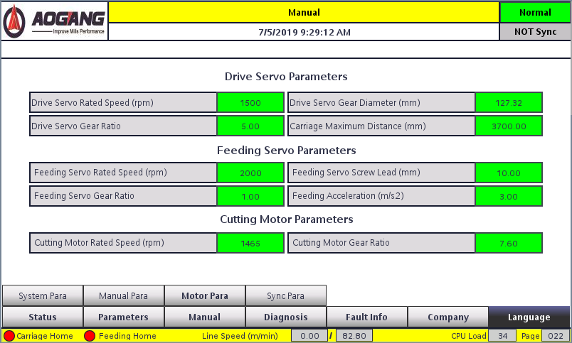
Figure 1-13: KK-5S Cold-Cut Flying Saw Motor Parameters Page
The parameters on the Motor Parameters page are listed in Table 1-15: Parameter List for the KK-5S Cold-Cut Flying Saw Motor Parameters Page.

Table 1-15: Parameter List for the KK-5S Cold-Cut Flying Saw System Motor Page
KK-5S Cold-Cut Flying Saw Motor Parameters Page Parameter List
Parameter Name | Description | Unit | Configurable | Factory Default
Rated Speed of the Drive Servo | Rated Speed of the Drive Motor | rpm | ● | 2000
Drive servo gear diameter | Equivalent diameter of the drive servo gear | mm | ● | 127.32
Drive servo gear reduction ratio | Drive Shaft Gearbox Ratio | - | ● | 6
Maximum stroke of the saw carriage | Maximum effective stroke of the saw carriage | mm | ● | 2700
Rated Speed of Feed Servo Motor | Maximum Speed of Feed Motor | rpm | ● | 2000
Feed screw lead | Distance Traveled Per Revolution of the Feed Motor | mm | ● | 10
Feed motor reduction ratio | Feed reducer reduction ratio | - | ● | 1
Feed acceleration | Acceleration during feed motion | mm/s² | ● | 2
Rated speed of the sawing motor | Rated speed of the sawing motor | rpm | ● | 1465
Cutting Motor Reduction Ratio | Cutting Shaft Gearbox Ratio | - | ● | 9.3
Maximum Frequency of the Sawing Motor | Upper Limit of Sawing Inverter Frequency | Hz | ● | 60

Rated Speed of Drive Motor
Unit: rpm;
Factory setting: 2000;
Note: Enter the rated speed of the drive shaft motor as indicated on the servo motor’s nameplate.

Drive Gear Diameter
Unit: mm;
Factory setting: 127.32;
Description: The pitch circle diameter of the gear on the load end of the drive shaft.
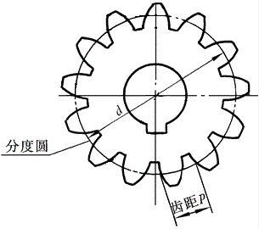
Figure 1-3: Schematic Diagram of the Gear Pitch Circle

Drive Reduction Ratio
Factory setting: 6;
Description: Reduction ratio of the drive shaft reducer. Enter the value as indicated on the reducer nameplate.

Maximum Travel of the Saw Car
Unit: mm;
Factory setting: 2700;
Description: The maximum travel distance of the saw carriage via the gear-rack drive with the bed.
Measurement Method: 1) Enter the correct drive gear diameter and reduction ratio, then power on the machine again;
2) Perform the "Return to Origin" operation;
3) After homing is complete, manually advance the saw carriage until it reaches the front limit switch;
4) The current saw carriage position displayed on the main screen represents the maximum travel of the saw carriage; reduce this value slightly and enter it as the saw carriage travel.

Feed Servo Rated Speed
Unit: rpm;
Factory Setting: 2000;
Description: The rated speed of the feed motor. Enter the value based on the servo motor’s nameplate.

Feed Screw Pitch
Unit: mm;
Factory setting: 10;
Description: The distance the nut moves per revolution of the lead screw. Please enter the parameter based on the actual conditions of the machine.

Feed Reduction Ratio
Factory default: 1;
Description: Reduction ratio of the feed axis gearbox. Enter the value as indicated on the gearbox nameplate; if there is no gearbox, enter 1.

Feed Origin Distance
Unit: mm;
Factory setting: 5;
Description: When the “Feed to Home” command is executed, the feed axis moves forward at the set torque to locate the material. The distance the feed axis travels back after the saw blade contacts the material is the feed home position distance. Adjusting this value changes the distance between the saw blade’s home position and the material.

Saw Motor Speed
Unit: rpm;
Factory setting: 1465;
Description: The rated speed of the sawing motor. Enter the value based on the information on the sawing motor’s nameplate.

Sawing Reduction Ratio
Factory setting: 9.3;
Description: Reduction ratio of the saw shaft gearbox. Enter the value based on the gearbox nameplate.

Maximum Frequency of Sawing Inverter
Unit: Hz;
Factory Setting: 60;
Description: Upper limit of the sawing inverter frequency.

1.2.7 Description of Parameters on the Manual Operation Screen
The manual operation screen is shown in Figure 1-7: KK-5S Cold-Cut Flying Saw Manual Operation Screen.
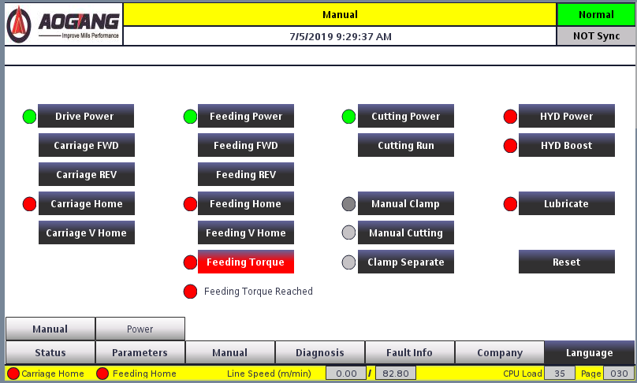
Figure 1-7: Manual Operation Screen of the KK-5S Cold-Cut Flying Saw

Chapter 2: System Function Description

2.1 Operating Modes
This system has three operating modes: Manual, Simulation, and Automatic.
To switch modes, rotate the “Operating Mode” knob on the control panel: turn it to the left for Simulation Mode, to the right for Automatic Mode, and to the center for Manual Mode.

2.1.1 Manual Mode
Manual mode is the default mode for the KK-5S cold-cut flying saw. When powering on the system, users should ensure that the “Operating Mode” selector on the control panel is set to Manual mode.In this mode, all operations at the machine’s workstations can be performed manually, such as manually advancing the drag shaft, returning the feed to the origin, manual clamping, and manual sawing. Users must complete the preparation of the flying saw through manual mode operations before entering Simulation Mode or Automatic Mode.

2.1.2 Simulation Mode
Simulation mode is used to monitor the operational status of the KK-5S cold-cut flying saw offline. In this mode, the material encoder is disabled, and the flying saw is driven by signals generated by a virtual axis within the controller that simulate normal production conditions. Users can adjust the virtual axis’s operating speed within a certain range to monitor the saw carriage’s operational status and troubleshoot electrical and mechanical faults.

2.1.3 Automatic Operation Mode
Automatic Operation Mode is the mode for online production with the KK-5S cold-cut flying saw. In this mode, the cold-cut saw operates based on the length and speed measured by the material encoder. Under normal conditions, the cold-cut flying saw performs online fixed-length cutting according to the processing length set by the user, while simultaneously monitoring the saw carriage’s operating status to ensure normal equipment operation and the quality of the processed products.

2.2 Power Management Functions

2.2.1 Power Supply System
Note: The control cabinet contains a main circuit breaker. Once the main circuit breaker is closed, the red power indicator light on the control cabinet door will remain lit, and the power system inside the cabinet will be energized. Non-professionals should stay away from the control cabinet to avoid the risk of electric shock.

2.2.2 Power System
Operation: Press the power button on the control panel to turn the main power on or off.
Note: The power button on the control panel serves as the system’s main power on/off switch. Pressing the power button initiates the system’s power-up initialization process; at this time, both the power button indicator light and the “RUN” indicator light on the control cabinet door will illuminate simultaneously. Pressing the power button again will disconnect the main power supply.

2.2.3 Drive System
Operation: The servo power supply starts automatically after power-up. Press and hold (for 10 seconds) the drive, feed, or sawing power buttons on the control panel to shut off the corresponding servo power. After the power-off protection period (20 seconds), press and hold (for 10 seconds) the corresponding button again to restart the servo power supply.
Note: After power-up, the system automatically starts the drive, feed, and sawing axes. The control panel features Drive Power, Feed Power, and Sawing Power buttons corresponding to these three axes, respectively. During power-up, once the indicator lights for these three power buttons change from flashing to steady, the system enters operating mode; the startup time is approximately 15 seconds.

2.2.4 Enabling/Disabling
Operation: Enable is automatically applied upon power-up. Briefly press (1 second) the drive, feed, or sawing power buttons on the control panel to disable the corresponding servo; briefly press (1 second) again to re-enable the servo.
Note: When the system is in manual mode, the servo’s start and stop can be controlled via the power buttons for the three axes. In operating mode, the servo’s power indicator remains steady. Pressing the power button causes the indicator to flash; at this point, the servo is powered on but has not yet entered operating mode. The motor is de-energized and can rotate freely. If a servo fault occurs, press the power button to reset the fault; pressing it again will return the servo to operating mode.
Note: If the saw carriage is out of mesh, the drive servo cannot engage the gear with the rack while in the enabled state. In this case, press the drive power button to disable the drive servo motor. After manually moving the saw carriage to engage the gear with the rack, re-enable the drive servo.

2.2.5 Servo Power-Off Protection
Description: When the drive power, feed power, or cutting power buttons are held down for more than 5 seconds in manual mode, the system will disconnect the power contactor for the corresponding servo, placing the servo in a power-off state. To prevent damage to the servo caused by excessive start-stop cycles, the servo cannot be powered on again until 20 seconds have elapsed (servo power-off protection time). During the power-off protection period, the power buttons are disabled.

2.3 Jog Function

2.3.1 Drag Jog Function
Operation: In manual mode, rotate the jog control knob on the control panel to manually move the saw carriage forward or backward.
Note: This function can only be executed in manual mode. During operation, when the saw carriage reaches the front or rear limit switch, it stops, and the screen displays the warning messages “Saw carriage has reached the front limit switch” or “Saw carriage has reached the rear limit switch.” At this point, the saw carriage can only move in the opposite direction.
Note: After performing a drag-and-jog operation, the saw carriage’s home position will be lost. You must perform the “Drag to Home” operation again before re-entering run mode.

2.3.2 Feed Jog Function
Operation: In manual mode, rotate the feed jog knob on the control panel to manually advance or retract the feed axis.
Description: This function can only be executed in manual mode. During operation, when the carriage reaches the front or rear limit, it stops, and the screen displays the warning status “Feed has reached front/rear limit”; at this point, the carriage can only move in the opposite direction.
Note: After performing feed jog, the feed origin will be lost; you must perform the “Feed Return to Origin” operation again before re-entering Run Mode.

2.4 Drag-to-Origin Function
The KK-5S cold-cut flying saw control system must undergo the drag-and-feed homing operation after each power-up before it can enter simulation or automatic operation mode.

2.4.1 Drag-to-Home Function
Operation: In manual mode, press the “Drag to Home” button on the control panel.
Note: Before performing the home position return, ensure that the drag axis servo is powered on and enabled, and that the saw carriage is within the front and rear limit switches; only then will the home position return function operate normally. If the saw carriage is moved forward or backward manually, or if the emergency stop button is pressed or other fault alarms are triggered, the home position will be lost. The home position return operation must be performed again before entering run mode.
The sequence of operations after executing the "Drag to Home" function is as follows:
1. The saw carriage begins moving toward the home position and starts decelerating and coming to a stop upon reaching the rear limit switch;
2. Once the speed drops to zero, it begins moving forward by 50 mm;
3. After completing the above steps, the homing process is complete, and the saw carriage’s current position becomes the dragged home position.
Note: After executing the drag-to-home operation, the saw carriage begins moving toward the rear limit switch. At this point, you can press the reset button on the control panel to cancel the return-to-home operation.

2.4.2 Manual Home Position Dragging Function
Operation: Press the “Drag Manual Home” button on the touchscreen’s simulation status page.
Description: This function sets the current saw carriage position as the origin. When executed in manual mode, the system records the current position as the saw carriage’s origin. The return-to-origin operation can be completed without requiring coordination between the saw carriage and limit switches. Users can employ this function to ensure system operation when external limit switches malfunction and the drag-to-origin function fails to operate normally; it also facilitates debugging and troubleshooting by maintenance personnel.
Note: It is not recommended that users treat this function as a standard home position return function. When using this function, ensure the saw carriage is positioned close to where it would stop in drag-to-home mode. Pressing the “Drag Manual Home” button causes the system to record the current position as the home position. Users should avoid using this function when they cannot determine the home position.

2.4.3 Feed Home Function
Operation: In manual mode, press the “Feed Home” button on the control panel.
Description: Feed Home returns the saw blade to the origin by driving it forward with a set percentage of torque via the feed servo, causing the blade’s tooth tips to contact the material and recording this position. This position affects both the quality of the cut and the service life of the saw blade. Before executing this function, ensure that the system’s mechanical, pneumatic or hydraulic clamping systems, and electrical systems are in normal operating condition, and that the workpiece is securely clamped in the fixture.
If the saw blade does not make contact with the material and returns during the Feed Home operation, it may be due to insufficient drive torque during the home position return. For specific adjustment procedures, refer to Section 3.4, “Home Position Torque Learning.”
Procedure for the Feed-to-Home Motion:
1. The fixture clamps the material;
2. The feed carriage moves backward at low speed and stops when it reaches the rear limit switch;
3. The feed carriage moves forward at low speed to locate the contact point between the saw blade and the material; the feed carriage stops when the saw blade makes contact with the material;
4. The feed motor retracts a fixed distance and stops, completing the feed home position operation.

Note: 1) If the wall thickness of the workpiece is less than 1 mm, this may cause an error in the feed home position. In this case, replace the current workpiece with a thicker one to ensure the home position is accurate.
2) When no material is present, the feed return-to-origin operation cannot be completed automatically. The system will continuously execute Step 3 above. In this case, press the reset button on the control panel to cancel the return-to-origin operation. When the carriage reaches the front limit switch, the system will trigger an alarm, and the carriage will return to the rear limit switch.

2.4.4 Manual Feed Home Function
Operation: Press the “Manual Feed Home” button on the simulation status page of the touchscreen.
Description: This function sets the current feed position as the origin. When executed in manual mode, the system records the current position as the origin for the feed axis. The return-to-origin operation can be completed without the need for material or limit switches. Users can employ this function to ensure system operation when external limit switches malfunction or when no material is present—situations where the standard return-to-origin function cannot be executed normally. It also facilitates debugging and troubleshooting by maintenance personnel.
Note: It is not recommended that users treat this function as a standard home position function. When using this function, ensure the saw blade is positioned close to the material before pressing the Manual Home Position button; the system will then record the current position as the home position. Users should avoid using this function when they are unable to determine the home position.

2.5 Clamping Function
Operation: In manual mode, rotate the clamping knob on the control panel.
Description: Manual clamping can be used to adjust the clamping mechanism’s operational status and troubleshoot mechanical faults.

2.6 Cutting Function
Operation: In manual mode, with the feed axis at the origin position, press the manual cut button on the control panel.
Note: The cutting function in manual mode performs a single static cut. Users can observe the sawing process and the quality of the material cut through this operation.
The sequence of operations after executing a manual cut is as follows:
1. The fixture clamps;
2. The saw motor starts, and the saw blade rotates;
3. After a two-second delay, the feed motor begins the feed motion;
4. Cutting is complete; the feed returns to the starting position;
5. The fixture releases the workpiece;
6. The saw motor stops, and the saw blade stops rotating.

2.7 Short-Scale and Long-Scale Functions

2.7.1 Short-Length Function
Operating Instructions: In simulation or automatic operation mode, press the manual cut-off button on the control panel when the simulation speed or production line speed does not exceed 60% of the maximum line speed.
Note: The manual cut-off button functions as the short-length feature in both simulation and automatic operation modes, facilitating the removal of substandard materials during actual production.
After activating the short-length function, the sequence of operations is as follows:
1. The system begins detecting the saw carriage’s direction of travel;
2. If the saw carriage is moving forward, it decelerates to a stop, then immediately returns to the home position at high speed before resuming normal production mode;
3. If the saw carriage is moving in the return direction, it accelerates directly to maximum speed to return to the origin, then resumes normal production mode.
Note: In run mode, the short-length function only takes effect after sawing is complete; it becomes inactive once the production line speed exceeds 60% of the maximum line speed.

2.7.2 Long-Length Function
Operation: In simulation or automatic operation mode, turn the manual clamping knob on the control panel to the clamped position.
Description: The manual clamping knob switches to the long-length function in simulation or automatic operation modes. Users can apply this function during actual production to process materials with uneven lengths.
After activating the long-length function, the operation sequence is as follows:
1. The system begins detecting the saw carriage’s direction of travel;
2. If the saw carriage is moving forward, it decelerates to a stop and then immediately returns to the home position at high speed to wait;
3. If the saw carriage is moving in the return direction, it accelerates directly to maximum speed and returns to the home position to wait;
4. Turn the manual clamping knob on the control panel to the “unclamped” position;
5. The saw carriage begins tracking the cut and returns to normal production mode.

2.7 Length Memory Function
When the equipment is in automatic operation mode, the system records the current production length of the material in real time. In the event of a normal exit from automatic mode, a sudden power outage, or a shutdown caused by a machine malfunction, a selection window will pop up on the touchscreen the next time the user enters automatic mode, allowing the user to choose whether to return to the last saved production length. Please note that if the material is moved after exiting automatic operation mode or following a power outage, the system will not be able to record any subsequent changes in the measurement values.
To use this function, press the “Yes” button in the pop-up window on the touchscreen. The saw carriage will move to the previously stored position. During this process, the system will not record measurements from the external encoder. Ensure the material remains stationary until the function is complete; once the saw carriage reaches the stored position, the machine will resume automatic production.
If you do not wish to use this function, press the “No” button in the pop-up window on the touchscreen to close the memory window, or proceed directly with production. This window will close automatically once the material length changes.
Note: The memory function records only the production length of the current piece. If you exit automatic operation mode when the current production length is very short, the system will not record this value. The next time you enter automatic mode, the system will proceed directly to automatic production.

2.8 Order Scheduling Function
Description: If you produce a wide variety of lengths and pipe types, you can use the length scheduling and pipe type recipe functions to facilitate switching between production lengths and pipe types. This system includes 10 sets of length schedules; for specific usage instructions, please refer to Section 3.9, “Setting Up Schedules.”

Chapter 3: Operating Instructions

3.1 Power-On Procedure
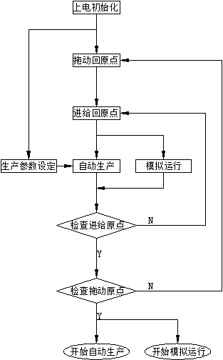
1. After connecting the external power supply to the cabinet, close the circuit breaker inside the main control cabinet. Once power is supplied to the cabinet, the power indicator light on the front panel of the main control cabinet will illuminate. At this point, press the power button on the control panel to power on the system. Note: When power is supplied to the cabinet, the power indicator light on the front panel of the main control cabinet will remain lit.
2. While the system is powered on, press the power button on the control panel to shut down the system.
3. After power-up, the system requires approximately 60 seconds to initialize. During initialization, the drive power, feed power, and sawing power indicator lights on the control panel will flash. Once these indicator lights change from flashing to steady, the system initialization is complete. Note: Do not operate the system before initialization is complete to prevent abnormal behavior after startup.
Figure 7-1: Power-On Flowchart for the KK-5S Cold-Cut Flying Saw Control System
4. If the clamping system is hydraulic, the user must manually start the hydraulic power unit after initialization is complete.

3.2 Manual Forward and Reverse Feed
In manual mode, the KK-5S Cold-Cut Flying Saw Control System allows the user to control the forward and backward movement of the saw carriage and feed axes via the manual forward and reverse controls.
In manual mode, hold down the manual feed knob on the control panel or press and hold the “Manual Feed Forward” or “Manual Feed Reverse” buttons on the touchscreen’s manual operation page to control the manual forward or reverse movement of the saw carriage. Release the knob or button to stop the saw carriage from moving forward or backward. To prevent excessive impact on the motor, the saw carriage starts and stops gradually.
In manual mode, hold down the manual feed knob on the control panel or press and hold the “Feed Forward” or “Feed Back” buttons on the touchscreen’s manual operation page to control the manual forward or backward movement of the feed axis. Release the knob or button to stop the feed axis from moving forward or backward.

3.3 Dragging the Feed Axis to Home Position
Before the KK-5S cold-cut flying saw control system enters simulation or automatic operation mode, the drag axis and feed axis must be positioned at the origin.

3.3.1 Dragging to Home Position
When returning to the origin via drag, the origin position is determined by the saw carriage reaching the rear limit switch. If the rear limit switch is faulty, you can use the manual drag-to-origin function.
Drive Home Operation: Press the “Drive Home” button on the control panel or the “Drive Home” button on the manual operation page of the touchscreen.
The sequence of actions after executing the "Drag Back to Origin" command is as follows:
1. The saw carriage begins moving toward the origin and starts decelerating and coming to a stop upon reaching the rear limit switch;
2. Once the speed drops to zero, the saw carriage begins moving forward by the drag-to-origin distance;
3. After completing the above actions, the saw carriage returns to the origin, and its current position becomes the dragged origin.

Manual Home Position Operation: Press the “Drag Manual Home” button on the manual operation page of the touchscreen.
After executing the “Drag Manual Home” command, the saw carriage will perform simulated or automatic operations using its current position as the home point. When using this function, be sure to allow sufficient space for the saw carriage to move.
If a problem is detected during the return-to-origin process, press the Reset button on the control panel to stop the return-to-origin procedure. After pressing Reset, the saw carriage will stop at its current position.

3.3.2 Feed Home
Feed Home determines the home position by having the saw blade contact the material. This function requires that the production material be placed in the fixture; if this is not possible, use the Feed Manual Home function to determine the home position.
Feed Home Operation: Press the Feed Home button on the control panel or the Feed Home button on the manual operation page of the touchscreen.
The procedure for executing the Feed Home operation is as follows:
1. The fixture clamps the material;
2. The feed carriage moves backward at low speed and stops when it reaches the rear feed limit switch;
3. The feed carriage moves forward at low speed to locate the contact point between the saw blade and the workpiece; the feed carriage stops when the saw blade makes contact with the workpiece;
4. The feed motor returns to the feed home position and stops; the current feed position becomes the feed home position.

Manual Feed Home Operation: Press the “Manual Feed Home” button on the touchscreen’s manual operation page.
After executing the manual feed origin operation, the feed axis will perform a simulated or automatic run using the current position as the origin. When using this function, be sure to allow sufficient clearance for the feed axis to move.
If a problem is detected during the return-to-origin process, you can stop the process by pressing the Reset button on the control panel. After pressing Reset, the feed axis will stop at its current position.
Please note: If the material being cut has a thin wall, performing the feed-to-home operation may cause the tube wall to bend, resulting in inaccurate position recording and affecting the cutting quality. In this case, you should use a material with the same diameter but a thicker wall, or a solid material, to perform the feed-to-home operation to ensure the home position is accurate.

3.4 Feed Torque Test
After prolonged operation, the Flying Saw may require increased torque when performing the feed-to-home operation. In this case, a feed torque test must be conducted to adjust the torque value and ensure normal feed-to-home operation.
The torque test is performed on the Machine Learning page of the touchscreen, as shown in Figure 3-2: Feed Torque Test Function.
On this page, press the “Feed Torque Test” button. Once the “Feed Torque Limit Enabled” indicator on the left turns green, press “Manual Feed Forward.” The feed axis will then move forward according to the torque limit set for the feed servo home position.If excessive resistance is encountered during forward movement—such as a malfunction in the lubrication circuit causing poor lubrication, or the saw blade coming into contact with the material—the feed axis will stop, and the “Feed Torque Limit Reached” indicator on the left will turn green.After stopping, press the “Feed Torque Test” button again. Once the “Feed Torque Limit Enabled” indicator on the left turns red, you can manually retract the feed shaft to move the saw blade out of the fixture’s range, then place the material in position to perform the home position return operation.

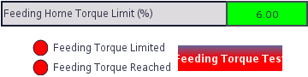
Figure 3-2: Feed Torque Test Function
The drive torque parameter specifies the torque value required to drive the feed axis back to the origin; it is typically set between 1–15%. If the feed axis still cannot be driven even when set to a high value, check whether the lubrication circuit is functioning properly.
Please note: If the material being cut has a thin wall, performing the feed-to-home operation may bend the tube wall, resulting in inaccurate position recording and affecting cutting quality. In this case, use a material with the same diameter but a thicker wall or a solid material to perform the feed-to-home operation to ensure the home position is accurate.

3.5 Manual Clamping
Manual clamping is used to test the fixture’s operation and verify the clamping result. If using pneumatic clamping, turn on the air supply; if using hydraulic clamping, turn on the hydraulic power unit. Once preparations are complete, in manual mode, turn the manual clamping knob on the control panel to the “Clamp” position to engage clamping, or to the “Release” position to release the clamp.
You can determine whether the fixture is securely clamped by checking if the material wobbles after clamping;
After making one manual cut, push the cut material inward from both ends of the fixture and manually tighten it; check whether the gap is smooth to determine if there is any angular error in the fixture.

3.6 Manual Cutting
The cutting function in manual mode performs a single static cut. Users can use this function to manually cut materials to different lengths, as well as to observe the cutting process and the quality of the cut.
Procedure: In manual mode, with the feed axis at the origin position, press the “Manual Cut” button on the control panel or the manual operation page of the touchscreen.
The following preparations are required before performing a manual cut:
1. The system is in manual mode;
2. If using a hydraulic clamp, confirm that the hydraulic power unit is turned on and can provide sufficient pressure;
3. Confirm that the feed axis has been returned to the home position and is currently at the home position;
4. Ensure absolutely that the forming unit will not move in any way during manual cutting. If the unit moves forward or backward during manual cutting, it could result in serious damage to the saw blade!
5. Check that the pipe parameters have been entered correctly;
6. Place the material into the clamping fixture.
The procedure for manual cutting is as follows:
1. Clamp the workpiece in the fixture;
2. The sawing motor starts, and the saw blade rotates;
3. After a two-second delay, the feed motor begins the feed motion;
4. Cutting is complete; the feed returns;
5. The fixture releases the workpiece;
6. The saw motor stops, and the saw blade stops rotating.
If any issues are detected during manual sawing—such as the fixture not clamping securely, abnormal sawing noises, or the forming unit starting up—press the emergency stop button to exit the manual sawing process and protect the saw blade.

3.7 Enable Simulation
Simulation mode is used to monitor the operational status of the KK-5S cold-cutting flying saw line. In this mode, the material encoder is disabled, and the flying saw is driven by signals from a virtual axis within the controller that simulate normal production conditions. Users can adjust the virtual axis’s operating speed within a specified range to check the saw carriage’s operational status and troubleshoot electrical and mechanical faults.
The following preparations are required to enter simulation mode:
1. The system power-up procedure must be complete, and the system must be in manual mode;
2. Ensure there is absolutely no material in the clamping fixture (including material coming from the forming unit);
3. Confirm that the drive axis has been returned to the home position and is located at the home position;
4. Confirm that the feed axis has been returned to home or manually set to home and is in a safe position;
5. You must absolutely ensure that the forming unit will not move in any way during manual sawing. If the unit moves forward or backward while in simulation mode, it could result in serious consequences such as the saw carriage overturning!
6. Check whether the length settings and pipe profile parameters have been entered correctly;
7. Set the simulation speed.
After completing the above preparations, turn the operating mode selector knob on the control panel to the “Simulation” position to enter simulation mode.
Once in simulation mode, the saw blade rotates, the virtual axis sends signals at the set simulation speed, the saw carriage tracks the signal, the feed axis advances to begin cutting, and after the cut is complete, the saw carriage moves forward to the predetermined position before returning to the origin to begin the next cut.
To exit simulation mode, simply turn the operating mode selector knob on the control panel to the “Manual” position. The saw carriage will exit simulation mode after completing one cut and returning to the origin.

3.8 Enabling Automatic Mode
Automatic operation mode is the online production mode for the KK-5S cold-cut flying saw. In this mode, the cold-cut saw operates based on the length and speed measured by the material encoder. Under normal conditions, the cold-cut flying saw performs online fixed-length cutting according to the processing length set by the user, while simultaneously monitoring the saw carriage’s operating status to ensure normal equipment operation and the quality of the processed products.
The preparations required to enter automatic operation mode are as follows:
1. The system power-up procedure is complete, and the system is in manual mode;
2. Confirm that the material coming from the production line has been loaded into the clamping fixture;
3. If using a pneumatic clamping device, confirm that the air supply is turned on; if using a hydraulic clamping device, confirm that the hydraulic power unit is turned on; confirm that the clamping device is operating normally;
4. Confirm that the feed axis has been returned to the home position and is located at the home position;
5. Confirm that the feed axis has been returned to the home position and is at the home position;
6. Check that the length settings and tube type parameters have been entered correctly.
After completing the above preparations, turn the operating mode selector knob on the control panel to the “Automatic” position to enter automatic operation mode.
Once in automatic operation mode, the saw blade begins to rotate, and the material encoder starts recording the material’s position. After the main unit starts, the saw carriage tracks the material; the feed axis advances to begin cutting. After the cut is complete, the saw carriage moves forward to the predetermined position, then returns to the home position to begin cutting the next piece.
To exit automatic operation mode, first slowly decelerate and stop the upstream forming unit. Once the forming unit has come to a complete stop, turn the operating mode selector knob on the control panel to the “Manual” position. The system will record the current positions of the saw carriage and the material (to facilitate resuming production later; see Section 3.10, “Memory Points”) and slowly move toward the origin. Once the origin is reached, the system will exit automatic mode.

3.9 Setting Up Production Schedules
In the KK-5S cold-cut flying saw system, length settings are configured using the length scheduling function. The system includes 10 built-in length schedules. For each schedule, you can set the corresponding production volume and choose whether to proceed with production.
The Length Batch Planning page is shown in Figure 7-3: Length Batch Planning Settings.
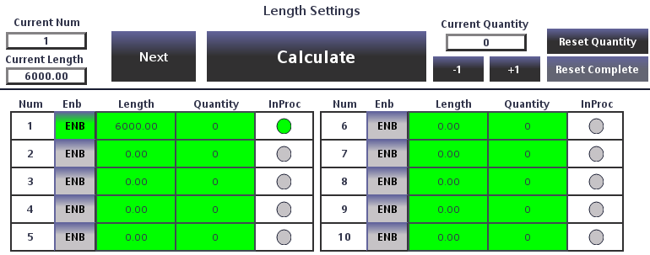
Figure 3-3: Length Batch Order Settings
Figure 3-2: In the Length Batch Scheduling Settings, Order 1 is the currently selected order. During automatic production, the system will process orders sequentially by order number in ascending order according to the set lengths and quantities. The “In Production” indicator to the right of Order 1 is lit, indicating that this order is currently being produced. Orders with a light green background have been completed. Above the batch list are function buttons and the quantity already produced for the current order. The function buttons are used as follows:
Calculate: Pressing this button prompts the system to calculate the maximum feasible production line speed based on the user-defined cutting time and the material length of the currently selected order. The calculated results are displayed on the main page, the pipe parameter page, and the simulation status page. When the system is in run mode, users can use this function to modify the current material length in real time, facilitating minor adjustments.
Next Order Function: This function is available in both automatic and simulation modes. If production requirements arise during the production process that require an immediate switch to the next order, pressing this button will jump directly to the next selected order without requiring a machine shutdown or changes to the set production volume.
Clear Production Quantity: Pressing this button clears the quantity already produced.
Clear Completed Orders: This function is only available in Manual Mode. Pressing this button clears orders that have already been completed.
Note: The set length of the selected order cannot be zero!
1. If the set length of the selected order is zero, a warning message will pop up during calculation: “[38] Warning: The set length of the selected order is 0”;
2. If the set quantity for the selected order is zero, it indicates continuous production of this order with an unlimited quantity; in this case, the system will not check whether the production volume has reached the set value.

3.10 Memory Points
When the KK-5S cold-cut flying saw is in automatic operation mode, the system records the current production length of the material in real time. After a shutdown caused by normal exit from automatic mode, a sudden power outage, or equipment failure, when re-entering automatic mode, a selection window will pop up on the touchscreen, allowing the user to choose whether to resume production from the point where it last stopped or from the point where automatic mode was exited.
Please note that if the user moves the material after exiting automatic mode or following a power outage, the system will be unable to record the updated values. This will result in an inaccurate memory point, potentially causing the finished product to be too long when production resumes. Users must exercise caution when operating the machine.
Figure 3-4: Return to Memory Point Pop-up Window
Procedure for Returning to the Memory Point: After the user presses the “Continue Production” button in the pop-up window, the saw carriage will slowly move to the position saved when automatic mode was last exited. During this process, the system does not record measurements from the external encoder; therefore, ensure that the actual position of the material remains unchanged until the return to the memory point is complete. Once the saw carriage reaches the memory position, it enters automatic production mode, and production can resume by starting the unit.
If the user does not wish to execute this function, they may press the “Restart Production” button to close the memory window, or directly start the machine for production. The pop-up window will automatically close once the material length changes.

3.11 Short and Long Pieces
The Short-Length and Long-Length functions allow cutting material to lengths other than the set dimensions in either Simulation or Automatic operation modes, facilitating the removal of defective material or material with weld points during actual production.

3.11.1 Short-Length Function
The manual cut button is converted to the short-length function in simulation or automatic operation modes.
The requirements for the Short-Length function are as follows:
1. In simulation or automatic operation mode
2. The simulation speed or production line speed does not exceed 60% of the maximum line speed
3. The manual cut button on the control panel must be pressed.
After the short-length function is executed, the sequence of operations is as follows:
1. The system begins detecting the saw carriage’s direction of travel;
2. If the saw carriage is moving forward, it decelerates to a stop, then immediately returns to the home position at high speed before resuming normal production mode;
3. If the saw carriage is moving in the return direction, it accelerates directly to maximum speed to return to the origin, then resumes normal production mode.

3.11.2 Long-Length Function
The manual clamping knob switches to the long-length function in either simulation or automatic operation mode
To activate the long-piece function, simply rotate the manual clamping knob on the control panel to the clamped position in either simulation or automatic operation mode.
After executing the long-piece function, the sequence of operations is as follows:
1. The system begins detecting the saw carriage’s direction of travel;
2. If the saw carriage is moving forward, it decelerates to a stop and then immediately returns to the home position at high speed to wait;
3. If the saw carriage is moving in the return direction, it accelerates directly to maximum speed and returns to the home position to wait;
4. Turn the manual clamping knob on the control panel to the released position;
5. The saw carriage begins tracking the cut and returns to normal production mode.

3.12 Synchronization Measurement
During automatic production with a cold-cut flying saw, synchronization between the saw carriage and the material is essential for ensuring normal operation. After a new machine has been commissioned and has been running for some time, mechanical wear or other factors may cause the material and the saw carriage to become out of sync, leading to issues such as inaccurate lengths or saw blade damage. Therefore, users should regularly monitor synchronization during operation and make timely adjustments if any desynchronization is detected.
In the KK-5S cold-cut flying saw control system, synchronization is adjusted via the “Material Speed Sensor Wheel Diameter” parameter, as shown in Figure 3-5: Synchronization Parameters
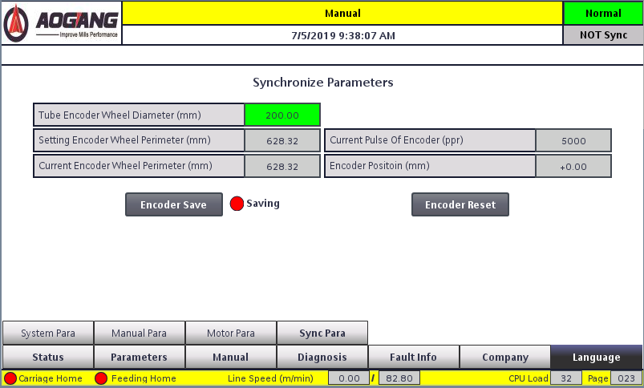
Figure 3-5: Synchronization Parameters
The procedure for measuring material synchronization is as follows:
1. Measure the diameter of the speed measurement wheel with a caliper and enter the value into the “Material Speed Measurement Wheel Diameter” parameter; this parameter serves as the initial reference value for the system’s calculations;
2. Start the unit and allow a small section of the material to pass through the clamping device; after stopping, perform the “Feed to Home” operation;
3. Press the “Manual Cut” button on the control panel to perform a manual cut; after the cut is complete, the current material length is reset to zero;
4. Start the machine again and allow the material to travel a certain distance (approximately 2 meters);
5. Press the “Material Cut” button on the touchscreen to turn it green; this ensures that the current material length will not be reset to zero after the cut is complete;
6. Press the “Manual Cut” button on the control panel again to perform a manual cut;
7. Use a tape measure to measure the actual length of the cut material, enter this length into the “Actual Material Length” field on the touchscreen, and also enter the thickness of the saw blade currently in use;
8. Press the “Data Calculation” button on the touchscreen. The diameter of the material speed measurement wheel will then automatically be recalculated based on the test data;
9. Repeat steps 4 through 7 until the actual material length plus the saw blade thickness equals the current material length.

