LSST Operation Simulator
(New Install Guide)
Version 2.3

Srinivasan Chandrasekharan
LSST

Package Requirements for Operations Simulator and Plotting Utilities on Fedora Core 6 starting from Scratch.

The Simulator has some requirements in terms of software. They are listed below:

- MySQL 5.0 or greater
  - yum install mysql
  - yum install mysql-devel
- Python 2.4 or greater
  - MySQLdb (MySQL-python) available in Fedora Core 6
  - Numeric (python-numeric package) available in Fedora Core 6
  - SimPy (python-simpy) available in Fedora Core 6
  - Pyx (PyX package) available in Fedora Core 6
  - matplotlib (python-matplotlib, python-matplotlib-tk) available in Fedora Core 6
  - Electric Fence – (yum install ElectricFence) available in Fedora Core 6
  - yum install compat-gcc-34-g77
  - TableIO – Should be available on opsimx machines /home/lsst/opsim-extras
and not as root “python setup.py build” and then as root “python setup.py install”
  - slalib (Please use “cvs co slalib_c” with password “iitjee00” in order to get slalib and follow instructions to install)
  - Pyrex installation – yum install Pyrex
  - pysla (Installation is required separately) – Look further in this document
  - heapqc (available in Python 2.4 release)
  - Sun (included in the Opsim Code)

For all packages available in Fedora Core 6 one should use “yum install <python-package>” to install the packages. Yum will make sure that dependencies will be taken care of. For all the other packages that have url links please install them from the links.

You can also install packages available in Fedora Core 6 using the software updater.
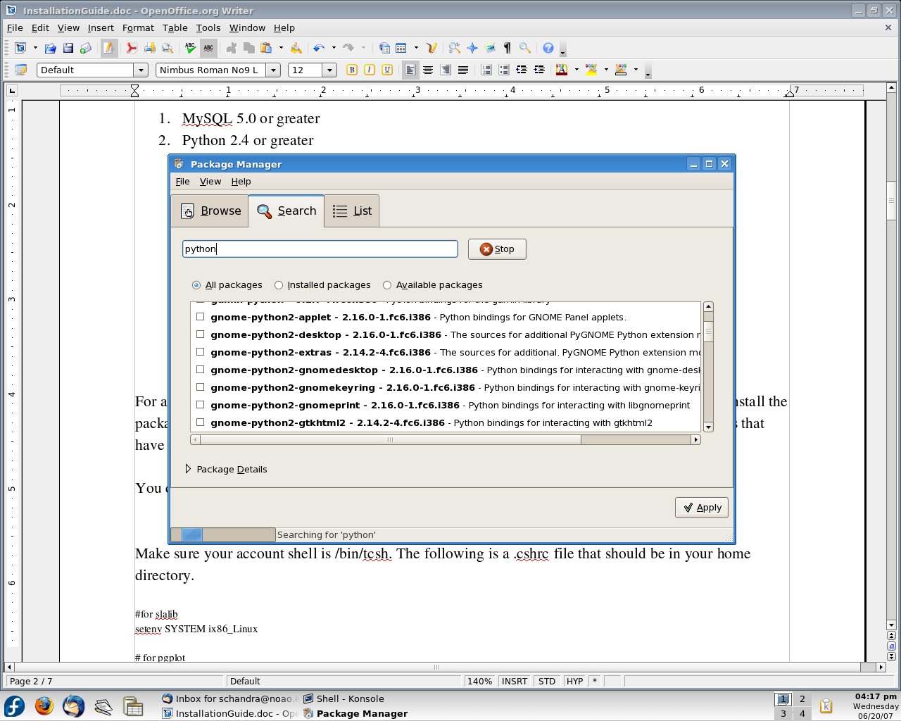

Make sure your account shell is /bin/tcsh. The following is a .cshrc file that should be in your home directory. If you already have one please add the following to your .cshrc file.

#for slalib
setenv SYSTEM ix86_Linux

# for pgplot
setenv PGPLOT_DIR {$HOME}/tools/pgplot
setenv PGPLOT_DEV /xwin

set path = (/usr/local/mysql/bin $path)

setenv LD_LIBRARY_PATH /usr/local/mysql/lib/mysql:/usr/lib/python2.4/site-packages
setenv PYTHONPATH /usr/lib/python2.4/site-packages

For slalib installation please find slalib.so and libsla.so. Copy these files into /usr/lib/python2.4/site-packages.

For pysla installation, make sure that you build the package using “python setup.py build” and then as root “python setup.py install” to install the package. If Pyrex package is required for the build or the install please install Pyrex using “yum install Pyrex” as root.

Once all these packages are installed and MySQL 5.0 running on your machine you can now proceed to the next section of the installation.

Operations Simulator Installation Guide

0. Introduction
The installation of the Observation Simulator is not particularly quick but it is pretty simple.

0. Installing the LSST specific python site-packages
1. Creating the necessary database and database tables.
2. Populating the database tables.
3. Editing the relevant configuration files.

Each of these steps is described in detail in the following paragraphs.

0. The directory: "lsst/simulation/site-packages" contains python modules to install in the system's "python/lib/<python_version>/site-packages/" directory.

For example:
cd /data1/simulator/sw/python/lib/python2.3/site-packages
cp <$LSST>/lsst/simulator/site-packages/LSSTDBInit.py .

1. Creating the necessary database and database tables. The Observation Simulator expects a database and some tables to be already in place. For the time being the following requirements apply to
the database:
a. The database has to be a MySQL database.
b. The database name should be 'LSST' (without quotes).
c. The MySQL DBMS should define a user called 'www' with password 'zxcvbnm'
d. The 'LSST' database should be readable and writable for the user 'www'.
e. The 'LSST' database should be running on the localhost.

The requirements b, c and e can be changed by manually editing the DBHOST, DBPORT, DBDB, DBUSER and DBPASSWD constants in the file 'lsst/simulator/site-packages/LSSTDBInit.py'.
As the Simulator writes data in the DBMS, requirement d cannot be lifted. Lifting requirement a is definitely possible, and would not require much work, but it would require some (trivial) code changes.

In the reminder of this document, the assumption is made that requirements a to e are going to be satisfied as written. The adaptation of the following instruction to a customized setting is left as a
trivial exercise to the reader.

1.1. Creation of the 'LSST' database and of user 'www'
Using the utilities supplied with the standard MySQL distribution, add a user 'www' identified by password 'zxcvbnm' to the DBMS. Also create a
database called 'LSST'. More information on how to do this can be found at
<http://dev.mysql.com/doc/mysql/en/mysqladmin.html>

and

<http://dev.mysql.com/doc/mysql/en/adding-users.html>

For example:
mysqladmin -u root password 'zxcvbnm'
mysql -u root -p
-> create database LSST;
-> grant all privileges on LSST.* to 'www'@'localhost' identified by 'zxcvbnm' with grant option;
-> flush privileges;
-> quit;

1.2. Creation of the necessary database tables
Some setup SQL scripts ease the creation of the necessary database structure. these are located in $SIMULATOR_ROOT_DIR/sql

The 'BuildNewWeather.sql' script should be modified to 'source' all site-specific weather (cloud*.sql, seeing*.sql) SQL scripts relating to sites to be simulated.

In order to create the table structure, start a mysql session (as user 'www' and using the 'LSST' database). Then, from the mysql prompt

mysql> source timeHist.sql;
mysql> source BuildNewVolatile.sql;
mysql> source BuildNewWeather.sql;
mysql> source field.sql;

What is left now is to populate the tables. This is done in three steps using scripts in $SIMULATOR_ROOT_DIR/test:

shell> cd $SIMULATOR_ROOT_DIR/test
shell> ./ingestClaverSeeing<place>.py <place's seeing data>.dat
shell> ./ingestClaverCloud<place>.py <place's cloud data>.txt

For example:
shell> ./ingestClaverSeeingPachon.py pachon_fwhm_2yr_300_050104.dat
shell> ./ingestClaverCloudPachon.py pachon-cloud-94_050103.txt
shell> ./ingestClaverSeeingLaPalma.py lapalma_fwhm_yr1_300_050106.dat
shell> ./ingestClaverCloudLaPalma.py lapalma-cloud-03_050106.txt
shell> ./ingestClaverSeeingMartir.py martir_fwhm_yr1_300_050107.dat
shell> ./ingestClaverCloudMartir.py martir-cloud-94_050107.txt
shell> ./ingestClaverSeeingCampanas.py campanas_fwhm_3yr_300_050121.dat
shell> ./ingestClaverCloudCampanas.py campanas-cloud-94_050104.txt
shell> ./ingestClaverCloudTololo.py 1996-2005_CloudTololo.txt
shell> ./ingestClaverCloudTololoSD.py 1996-2005_SD_CloudTololo.txt
shell> ./ingestClaverCloud3yrTololo.py 3yr_cloudTololo.txt
shell> ./ingestClaverCloud3yrTololoSD.py 3yr_cloudTololoSD.txt
shell> ./ingestClaverCloud2000Tololo.py 2000_CloudTololo.txt

for the weather data.

For the target list, one needs to generate the appropriate list of RA and Dec values given a telescope FoV. The steps involved are compiling both the FieldGen and AddGalEcl tools, creating the tile list and then ingest the data into the database:

For example:
shell> cd $SIMULATOR_ROOT_DIR/src/FieldGen
shell> ../ingestTargetsByFov.py --fov=3.5 –fields=tessellationFields

where <fov> is the value if the instrument FoV in decimal degrees.
Comments and Problems Faced during installation

===============================================================================
Installation Gotcha's
===============================================================================
PYREX installation problem
===============================================================================
# Stuart comment regarding a problem with pyrex installation:
Special thanks go to google for finding:
http://lists.copyleft.no/pipermail/pyrex/2005-February/001137.html
which solved my

TypeError: swig_sources() takes exactly 2 arguments (3 given)
problem.

[Pyrex] bug in distutils, or a python bug?
Charles Moad cmoad at indiana.edu
Tue Feb 22 13:26:47 CET 2005

* Previous message: [Pyrex] bug in distutils, or a python bug?
* Messages sorted by: [ date ] [ thread ] [ subject ] [ author ]

distutils was modified in 2.4. This patch was posted on the list a
while back.

--- build_ext.py Fri Apr 30 08:00:46 2004
+++ new-build_ext.py Wed Dec 29 03:11:19 2004
@@ -32,7 +32,7 @@
if self.compiler == 'mingw32':
self.swig_cpp = 1

- def swig_sources (self, sources):
+ def swig_sources (self, sources, extension=None):
if not self.extensions:
return

- Charlie

Simon Wittber wrote:
> I've just installed the free MS compiler using the instructions at:
> vrplumber.com/programming/mstoolkit/
>
> I've also installed:
> http://www.prescod.net/pyximport/
>
> Now for the weird error:
> File "c:\python\24\lib\distutils\command\build_ext.py", line 443, in
> build_extension
> sources = self.swig_sources(sources, ext)
> TypeError: swig_sources() takes exactly 2 arguments (3 given)
>
> If you look closely at the above error, you will notice it is a method
> call, and therefore, the self argument is passed implicitly.
>
> The method signature contains 3 arguments, and looks like:
> def swig_sources (self, sources, extension)
>
> Any idea why this error is occuring? At forst glance, it looks like a
> rather nasty python2.4 bug!
>
> Sw.

===============================================================================
matplotlib installation problem
===============================================================================
Stuart comments:
Perhaps I have a too new version but I still have trouble with
matplotlib.

I changed:
from matplotlib.matlab import *
to
from matplotlib.mlab import *

since there was no matlab module/class in the matplotlab area.
(I think they changed the name to avoid legal issues)
and I had to add:

from pylab import *

as shown on the matplotlab web page:
http://matplotlib.sourceforge.net/pylab_commands.html

to get it to quit complaining about no "figure()" command
defined.

This needs to be done in the following modules:
lsst/simulator/viz/{newextract.py newbri.py eqgal.py plotfields.py}
lsst/simulator/src/{extractdata.py}

