IBISS Operation

* Correctly wire the Renishaw Read head Rl32BES001C10F to a D-Sub 9 Male

connector (female contacts)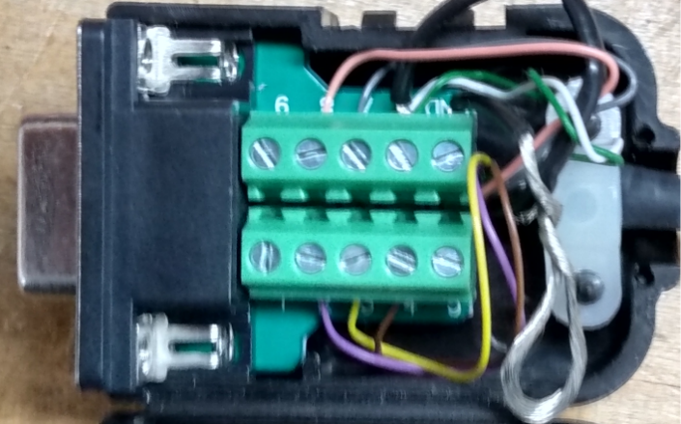 for use with MB5U

* NC _ None _ Pin1
* MA+ _ Violet _ Pin2
* MA- _ Yellow _ Pin3
* +5V _ Brown _ Pin4
* NC _ None _ Pin5
* 0V _ Shield _ Pin6
* SLO+ _ Gray _ Pin7
* SLO- _ Pink _ Pin8
* NC _ None _ Pin9
* Connect Renishaw read Head to IC Haus MB5U
* Connect USB cable from MB5U to PC
* Open 'Biss interface library Demo.Vi' (modified)
* Click the ‘run’ button
* Click the ‘Open’ button top right
* Verify ‘BISS_InterfaceEnum’ displays ‘BISS_MB5U’
* Click the top ‘Set’ button on the right
* Verify the Led on the read head illuminates
* Click on ‘BiSS_Getinterface’ ‘Get’ button
* Verify ‘BiSS_MB5U’ is displayed
* Click on ‘BiSS_Getinterfaceinfo’ ‘Get’ button
* Verify a serial number is displayed
* Click to open the ‘Misc’ tab
* Verify ‘….\BiSS_config.cfg’ is displayed
* Click the ‘LOAD’ button on that line
* Click to open the ‘SCD Labels’ tab
* On the ‘BiSS_GetSlavelabel’ line, click the ‘Get’ button
* Verify the ‘pcSlaveLabel’ box displays ‘test’ (this verifies the file loaded correctly)
* Click to open the ‘Initialization’ tab
* On the ‘BiSS_SetFTDIFrequency’ line, verify both the uLFreqH and uLFreqL boxes are set to 4
* Press the ‘Write’ button to set the comms frequency
* Verify no error messages.
* Click to open the ‘SCD Frames’ tab
* verify the ‘BiSS_ReadSCDFrames’ line, ‘ulCycleCount’ box displays 1
* Move the encoder to a valid read position by observing that the LED on top turns blue
* Click on the ‘Read’ button on that same line to read encoder data in the ‘pulDataScdL’ box (hex)
* When done: Click to open the ‘Communication’ tab
* Press the ‘Close’ button to turn off the encoder
* Press the Stop sign or the ‘Stop’ button to stop the Vi