D3.12.2 Alert system trial project with broker data



|  |  |
| --- | --- |
| **Project Acronym** | LUSC-B |
| **Project Title** | UK Involvement in the Legacy Survey of Space and Time |
| **Document Number** | LUSC-B-44 |

|  |  |
| --- | --- |
| **Submission date** | day/month/year |
| **Version** |  |
| **Status** | Draft |
| **Author(s) inc. institutional affiliation** | C. Lintott (Oxford) |
| **Reviewer(s)** | Clare Higgs (Rubin),  Stephen Smartt (QUB/Oxford) |

|  |  |
| --- | --- |
| **Dissemination level** | |
| Public |  |

# Version History

|  |  |  |  |
| --- | --- | --- | --- |
| **Version** | **Date** | **Comments, Changes, Status** | **Authors, contributors, reviewers** |
| 0.1 | 01/AUG/23 | Transferred from Google doc to LSST:UK Word format |  |
|  |  |  |  |
|  |  |  |  |
|  |  |  |  |
|  |  |  |  |
|  |  |  |  |

Table of Contents

Version History 2

1 Executive Summary 4

2 Introduction 5

3 Implementation 5

3.1 Superluminous Supernovae project 5

3.2 Development 6

3.2.1 Code 6

3.2.2 Data 6

3.2.3 Changes to Zooniverse 6

4 Follow-up work 6

# Executive Summary

This document briefly describes deliverable D3.12.2 “*Alert system trial project with broker data”* from the LSST:UK Phase B WP 3.12 *“Support of EPO software”.* The aim of the deliverable is to test integration and data flow from a broker to a Zooniverse project.

# Introduction

This document reports on deliverable D3.12.2 *“Alert system trial project with broker data”* from the LSST:UK Phase B WP 3.12 *“Support of EPO software”*.

WP3.12 forms part of the LSST:UK In-kind contribution, UKD-UKD-S2 *“LSST:UK’s contribution to EPO software”*.

D3.12.2 is a Zooniverse broker test project. The deliverable aim is to test integration and data flow from a broker to a Zooniverse project.

Section 3 describes briefly the Zooniverse project used in the implementation of the test and lists the associated repositories and Zooniverse updates. Section 4 briefly describes possible future work.

# Implementation

## Superluminous Supernovae project

The Zooniverse project used in the test is titled *“Superluminous Supernovae”* (see Figure 1) and is located at

<https://www.zooniverse.org/projects/mrniaboc/superluminous-supernovae>

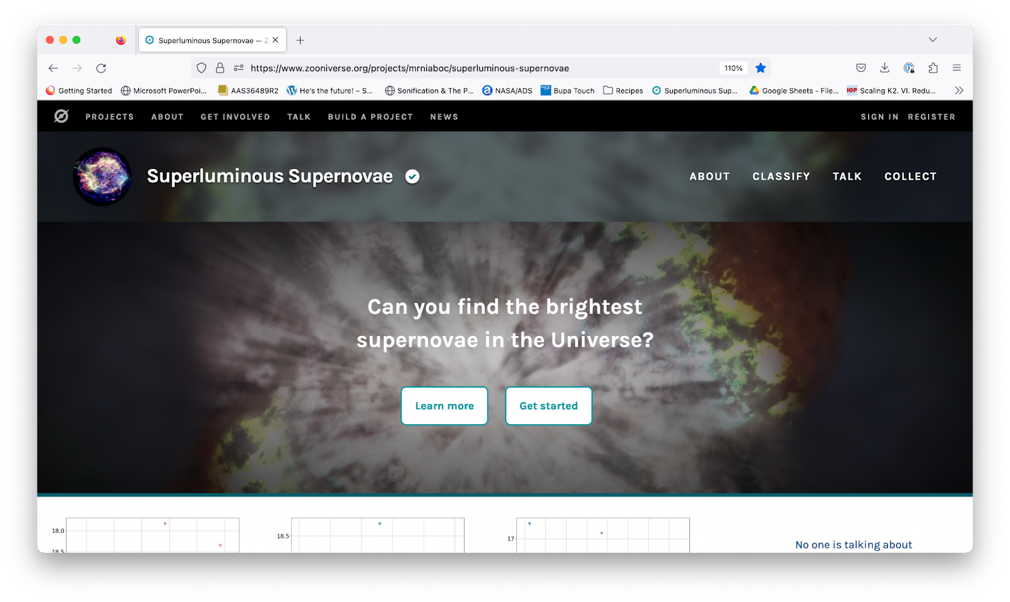

Figure 1: The Zooniverse project

The alert broker used for the test is Lasair (https://lasair-ztf.lsst.ac.uk/).

The goal of the Zooniverse project is to inspect candidates that show the characteristic slow rise to brightness that might be associated with superluminous supernovae. We adapted the Zooniverse front end to include viewing JSON subjects, the native format received from the broker.

The Zooniverse project launched 9th June 2023, after delays due to engineering and weather at ZTF. The site is populated by a query against Lasair. The query runs every Wednesday morning. Currently (31st July 2023), 44,644 classifications have been received, with each subject classified within a week, with data delivered to the science team (via Web browser) on request.

## Development

### Code

The client for interacting with Lasair is available at:

<https://github.com/zooniverse/Zooniverse_SLSN>

### Data

The instructions for inspecting the downloaded data are available at:

<https://github.com/zooniverse/slsn-data>

### Changes to Zooniverse

This project required adapting the Zooniverse codebase to deal with JSON subjects. The relevant PR is:

<https://github.com/zooniverse/front-end-monorepo/pull/4285>

Some debugging of the Zooniverse python client was also required. See

[https://github.com/zooniverse/panoptes-python-client/issues/210#issuecomment-1437758746](https://github.com/zooniverse/panoptes-python-client/issues/210%23issuecomment-1437758746)

# Follow-up work

In designing and developing this project, we identified further work required on the Zooniverse front-end for displaying time series (light curve) subjects. This is being scoped with the Rubin project team.

The Rubin project would like instructions for future users of the system in the form of a technical notebook. This is planned for Q3 2023, alongside talking to other system broker developers to understand how they wish to interact with our system.