Phase C D3.5.2: Lasair Version 6

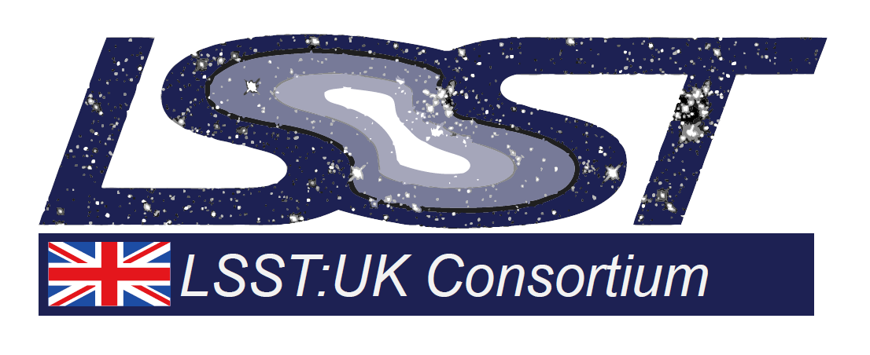

|  |  |
| --- | --- |
| **Project Acronym** | LUSC-C |
| **Project Title** | UK Involvement in the Legacy Survey of Space and Time |
| **Document Number** | LUSC-C-13 |

|  |  |
| --- | --- |
| **Dissemination level** | Public |

|  |  |  |  |  |
| --- | --- | --- | --- | --- |
| **Due Date** | | 30/APR/24 | **Submission Date** | 03/MAY/24 |
| **Version** | | *0.1* | **Status** | Draft |
| **Contributor(s)** | Gareth Francis, Roy Williams (both Edinburgh)  Ken Smith (Queen’s University, Belfast) | | | |
| **Reviewer(s)** | Sarah Casewell (Leicester)  Cosimo Inserra (Cardiff) | | | |
| **Deliverable Description** | This document is a cover note to accompany the LSST:UK Phase C deliverable D3.5.2 “Lasair Version 6” from the Phase C Workpackage WP3.5 “Lasair: the UK's community broker”. D3.5.2 is a prototype of Lasair running on LSST simulated alert data supplied by the Vera C. Rubin Observatory. This prototype LSST alert broker is located at https://lasair-lsst-dev.lsst.ac.uk. | | | |
| **Notes on Deliverable (details of scope, any deviation from the plan, and testing/ validation steps undertaken)** | This latest version of Lasair contains the following major improvements.   1. Gravitational wave skymaps and candidates. See <https://lasair-lsst.lsst.ac.uk/mma_watchmaps/12/> 2. Access to the Rubin Science Platform from Lasair for users with appropriate credentials. See <https://lasair-lsst.lsst.ac.uk/objects/1998401965901479990/> 3. Forced and real photometry in 6 bands. See <https://lasair-lsst.lsst.ac.uk/objects/1998401965901479990/>   Other improvements include:   1. Ingested DP0.2 for Lasair 6 2. Works with 6-filter photometry 3. New lightcurve features (2D time/wavelength) 4. Start/Stop rebuilt as system services 5. Refactored and cleaner filter stage 6. Rebuilt the deployment system with Terraform 7. Much improved unit test coverage 8. Asynchronous database ingest 9. Cutouts stored in Cassandra-NoSQL, not filesystem | | | |