参考：

<http://www.codeka.com.au/blog/2009/03/got-visual-studio-2008-professional-want>

1. 点击工程名称，右键->属性：

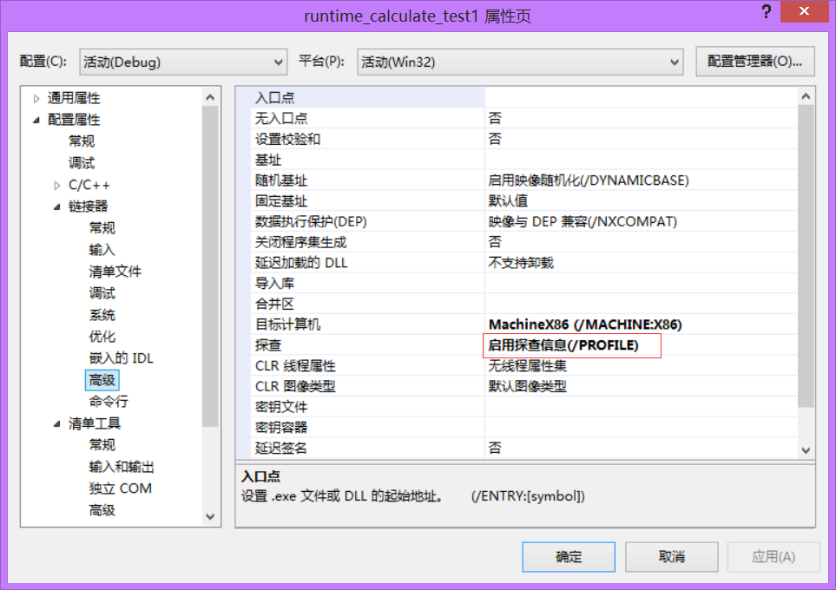

cd \path\to\my\program

vsinstr.exe MyProgram.exe

vsperfcmd /start:trace /output:MyProgram.vsp

Run your program

vsperfcmd /shutdown

vsperfreport MyProgram.vsp /output:c:\study\temp /summary:all

会在c:\study文件夹下生成以temp开头的.csv文件