异常处理：

例：程序exception_test1.py

try:  
 print(5 / 0)  
except ZeroDivisionError:  
 print("You can't divide by zero!")  
print()  
  
try:  
 print("try...")  
 result = 10 / int(input('division number: '))  
except ValueError as e:  
 print('ValueError:', e)  
except ZeroDivisionError as e:  
 print('ZeroDivisionError:', e)  
else: # 没有异常发生会自动执行else块  
 print('no error!')  
 print('result ', result)  
finally: # 无论如何都会执行的块  
 print("divide finally")  
print()  
  
# 处理文件异常  
file_name = 'alice.txt'  
try:  
 with open(file_name) as f_obj:  
 contents = f_obj.read()  
except FileNotFoundError:  
 msg = "Sorry, the file " + file_name + " doesn't exist"  
 print(msg)  
else:  
 print("The file " + file_name + " has about " + str(len(contents)) + " words")

输出为：

You can't divide by zero!

try...

division number: 0

ZeroDivisionError: division by zero

divide finally

Sorry, the file alice.txt doesn't exist

记录异常：

例：程序exception_test2.py

import logging  
  
  
def foo(s):  
 return 10 / int(s)  
  
  
def bar(s):  
 return foo(s) * 2  
  
  
# 记录异常信息  
def main():  
 try:  
 bar('0')  
 except Exception as e:  
 logging.exception(e)  
  
  
main()  
print('End')

输出为：

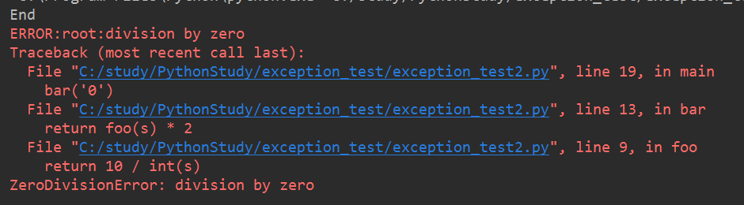

异常抛出：

例：程序exception_test3.py

def foo(s):  
 n = int(s)  
 if n == 0:  
 raise ValueError('invalid value: %s' % s)  
 return 10 / n  
  
  
def bar():  
 try:  
 foo('0')  
 except ValueError as e:  
 print('ValueError!')  
 raise  
  
  
bar()

输出为：

