ESP-Prog
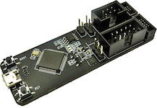
ESP-Prog is one of Espressif’s development and debugging tools, with functions including automatic firmware downloading, serial communication, and JTAG online debugging. ESP-Prog’s automatic firmware downloading and serial communication functions are supported on both the ESP8266 and ESP32 platforms, while the JTAG online debugging is supported only on the ESP32 platform. Official reference can be found here.
Contents
- Configuration
- Drivers
- Wiring Connections
- Tutorials
- Platforms
- Frameworks
- Boards

Configuration
You can configure debugging tool using debug_tool option in “platformio.ini” (Project Configuration File):
[env:myenv]
platform = ...
board = ...
debug_tool = esp-prog
If you would like to use this tool for firmware uploading, please change upload protocol:
[env:myenv]
platform = ...
board = ...
debug_tool = esp-prog
upload_protocol = esp-prog
More options:
- Debugging options
- Upload options

Drivers
Windows: | - Step-by-step guide: Drivers, Zadig, Wiring  - Video tutorial
Mac: | macOS contains default FTDIUSBSerialDriver driver which conflicts with debug tools which are based on this chip. FTDI Chip company recommends removing this default driver from a system. Everything should work after system rebooting. See detailed instruction in official application note (Page 16, Section 4: Uninstalling FTDI Drivers on OS X) AN134: FTDI Drivers Installation guide for MAC OS X
Linux: | Please install “udev” rules 99-platformio-udev.rules. If you already installed them before, please check that your rules are up-to-date or repeat steps.

Wiring Connections
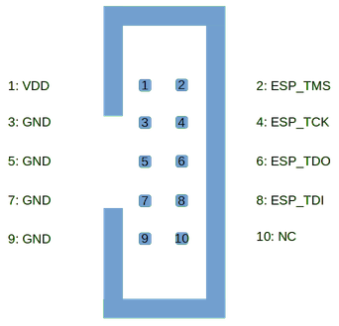
ESP-Prog JTAG 10-Pin Connector | Board JTAG Pin | Description
1 | VDD | Positive Supply Voltage — Power supply for JTAG interface drivers
3 | GND | Digital ground
2 | ESP_TMS | Test Mode State
4 | ESP_TCK | JTAG Return Test Clock
6 | ESP_TDO | Test Data Out
8 | ESP_TDI | Test Data In

Tutorials
- Use the PlatformIO Debugger on the ESP32 Using an ESP-prog

Do not use JTAG pins for something else
Operation of JTAG may be disturbed, if some other h/w is connected to JTAG pins besides ESP32 module and JTAG adapter. ESP32 JTAG us using the following pins:
 | ESP32 Pin | JTAG Signal
1 | MTDO / GPIO15 | TDO
2 | MTDI / GPIO12 | TDI
3 | MTCK / GPIO13 | TCK
4 | MTMS / GPIO14 | TMS
JTAG communication will likely fail, if configuration of JTAG pins is changed by user application. If OpenOCD initializes correctly (detects the two Tensilica cores), but loses sync and spews out a lot of DTR/DIR errors when the program is ran, it is likely that the application reconfigures the JTAG pins to something else, or the user forgot to connect Vtar to a JTAG adapter that needed it.

In order to use PIO Unified Debugger, we need to connect an external JTAG probe and the board using the following pins:
ESP32 pin | JTAG probe pin
3.3V | Pin 1(VTref)
GPIO 9 (EN) | Pin 3 (nTRST)
GND | Pin 4 (GND)
GPIO 12 (TDI) | Pin 5 (TDI)
GPIO 14 (TMS) | Pin 7 (TMS)
GPIO 13 (TCK) | Pin 9 (TCK)
GPIO 15 (TDO) | Pin 13 (TDO)

