TTGO LoRa32 SX1276 OLED V1.0

2pcs TTGO LORA32 Lora 868/915MHz ESP32 LoRa OLED 0.96
Inch Display Bluetooth WIFI ESP-32 Development Board Module With Antenna

Features and specifications:
Key features:
SX1276 chip based on ESP32 Wi-Fi, 868 – 915 MHz frequency, high sensitivity over -148 dBm, + 20 dBm output power, high reliability, long-transmission distance
Onboard 32 MB flash Wi-Fi antenna, 0.96-inch OLED display, lithium battery charging circuit, CP2102 interface and USB serial chip, perfect support for Arduino development environment, can be used for program checking, product development is very easy and fast

Specifications:
• Operating voltage: 3.3 – 7 V
• Operating temperature range: -40 to 90°C (-40 to 194°F)
• Support for Sniffer software protocol analysis, Station, SoftAP, and Wi-Fi Direct modes
• Data rates: 150 Mbps @ 11n HT40, 72 Mbps @ 11n HT20, 54 Mbps @ 11g, 11 Mbps @ 11b
• Transmit power: 19.5 dBm @ 11b, 16.5 dBm @ 11g, 15.5 dBm @ 11n
• Receiver sensitivity up to -98 dBm
• UDP sustained throughput: 135 Mbps

Reminders:
1) The 868/915 MHz antenna needs to be connected with the IPEX interface (If the antenna is not connected, the signal may be almost)
2) When the battery is full, the blue LED will stop working.
3) When using, pay attention to “+” and “-” of the battery, otherwise it will be damaged.
4) With the IO port touchscreen touch signal input, you need to add the 100nF pull-down capacitor to this pin.

LILYGO® 2pcs TTGO LORA32 Lora 868/915MHz ESP32 LoRa OLED 0.96 Inch Display Bluetooth WIFI ESP-32 Development Board Module

Test code: https://github.com/LilyGO/TTGO-LORA32-V2.0/tree/LilyGO-868-V1.0
https://github.com/Xinyuan-LilyGO/TTGO-LoRa-Series
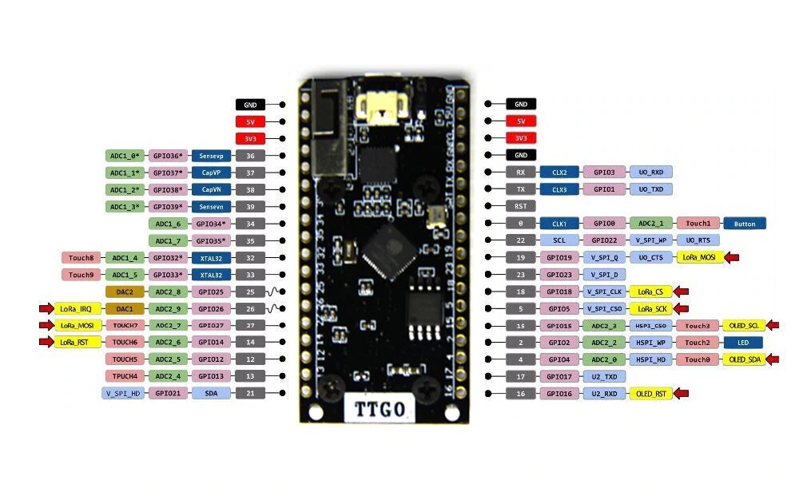

https://github.com/sandeepmistry/arduino-LoRa/blob/master/API.md
documentazione Libreria Arduino LoRa

http://www.lilygo.cn/prod_view.aspx?TypeId=50003&Id=1142&FId=t3:50003:3
sito del produttore.

LED = GPIO02
SX1276 LoRa Pin
MISO GPIO 19
MOSI GPIO 27
SCK GPIO 5
CS GPIO 18
IRQ GPIO 26
RST GPIO 14

OLED SSD1306
SCL GPIO 15
SDA GPIO 4
RST GPIO 16
I2C ADDR 0x3C

CP2102 Interface
The board uses CP2102 interface and USB serial chip, so it is easy to upload code.
You just need to use an USB cable (with data wires) to connect it to your computer and upload code.
Power supply
You can power this board through the USB cable, or using a lithium battery.
Connecting the battery is easy as it comes with a lithium battery charging circuit and a 2-pin JST header.
When you get the board, you’ll also get a battery connector.
PRG and RST Buttons
As other ESP32 development boards, this also has two buttons:
one to reset the board (RST) and other to put the board in flashing mode (PRG).
Antenna
You must connect the antenna to the IPEX connector to use the board.
If you don’t use the antenna, you may damage the board.
TTGO LoRa32 OLED Pinout
The following figure shows the TTGO LoRa32 OLED pinout.

On the ESP32, the JTAG pins are GPIO pins at the same time. So during debugging, you cannot use them. They are:
GPIO12 — TDI
GPIO15 — TDO
GPIO13 — TCK
GPIO14 — TMS
The reset pin (TRST) is not fully supported by OpenOCD. Fortunately, it’s optional.

Configuring your PlatformIO project
Next go to your PlatformIO project and two lines to the project’s platform.ini file:
debug_tool = esp-prog
debug_init_break = tbreak setup

