Group 3: Colin Beveridge, Scott Partacz, Abbey Guilliat, Lucas Stefanic

Dev10 Module 8 Pandas Final Project Report

Due: 1/17/2022

**Factors Impacting Adaptations of New Technology**

**Introduction**

Over the better part of the last 50 years, computer processing power has grown exponentially. Along with this have come myriad innovations in the uses of advanced technology to enhance scientific and business endeavors. With such rapid technological advancement, businesses are asked to constantly adapt to these advances to maintain and potentially increase their market share. Businesses investing in the right technology at the right time could mean the difference between steady growth for years and bankruptcy. Accurate and comprehensive data on how businesses are making these decisions is crucial to predict the next technology trend in each industry. By analyzing data on several different general technology groups, some key trends in this area can be identified.

**Datasets**

The Annual Business Survey is a yearly survey done by the United States (US) Census Bureau. All responding firms answer questions about their industry, size, employees, owners, annual payroll and market share. The specific table relevant to this project is titled Technology Characteristics of Businesses (US Census Bureau). This table has all the prior mentioned information aggregated over each group. Additionally, this table contains responses about different technologies and the different reasons businesses have for not adapting each technology. The five general categories are Artificial Intelligence, Cloud Based Technology, Specialized Software, Robotics and Specialized Equipment. The firms could respond that no factors had prevented them from adapting the technology, or that the technology was not applicable to their industry. But outside of these responses, they were presented with eight possible factors that prevented them from adapting each technology. The factors were, “Technology was too expensive”, “Technology was not mature”, “Lacked access to required data”, “Required data not reliable”, “Lacked access to required human capital and talent”, “Laws and regulations”, “Concerns regarding safety and security (physical or cyber)” and “Lacked access to capital.” The firms were able to answer as many factors as applicable.

**Limitations**

This data set is quite general. The values are aggregated because the original data set is much too large to manipulate as is. Because of this, there is only so much analysis that can be done before more data is needed. Additionally, businesses can answer as many factors as they want, so the percentage fields do not add up to 100% which creates some overlap in responses that is difficult to account for. Another limitation, related to the previous, is that the factors listed are not exclusive of each other in terms of the actual cause of the limitation. For example, the reason “Technology was too expensive” happens to be a very common reason. It seems that most businesses checked this, along with at least one other factor. This makes a lot of sense intuitively. Generally, there are no limiting factors if businesses have the money to work around them. So having this as an option made things a little less clear. Some of the other factors overlap with each other as well.

**Questions**

Limitations of this dataset aside, some important trends can still be identified. The first question to answer is quite general. What are the most common limiting factors for each technology? Tangential to this, what are the annual payrolls and market shares of companies for companies that responded to each technology? After analyzing these figures, the group decided to drill down to some more specific industry comparisons. The group chose to compare the financial sector to the healthcare sector across the three most relevant technologies in these fields. Do the limiting factors for adapting new technologies look different for these very different sectors? As previously mentioned, the technology being too expensive was a very common response. How does the frequency of this response compare to all other responses? Does this comparison vary by industry? After more examination the group noticed that by far the most prevalent response was that there were security concerns associated with the adaptation of Cloud Based Technology. Is this trend common across all industries, or are there specific industries that are high outliers with regards to security concerns?

**General Analysis**

The first analysis done is across several numeric columns of the dataset, looking at aggregations over all demographics, industries, and firm sizes. Figure 1 simply looks at all responses for all technologies, to try to divine the most common responses.

Figure 1

One observation jumps out immediately, far more businesses checked that the technology was ‘Too Expensive’ as the reason for not adapting that technology. This gets at the issue raised in the limitations section. Because many factors can be checked, businesses seemed very likely to check ‘Too Expensive’ and at least one other reason, skewing the distribution a bit. Without considering the too expensive column, another interesting outlier is the ‘Security Concerns’ limitation for the Cloud Based Technology. The report will dive more into this discrepancy in later sections.

Next, it is informative to examine the annual payrolls of businesses that answered each factor for each technology. As can be seen from Figure 2, though ‘Too Expensive’ is still the dominant factor, the payrolls of other factors being checked are more comparable to the payrolls of businesses checking ‘Too Expensive.’

Figure 2

One general explanation for this is simply that the larger companies less likely to say that a technology is too expensive have much larger payrolls, which gives more weight to the other factors.

Another outlier here is that companies that are limited on Artificial Intelligence, for any reason, seem to have much higher payrolls than those limited for other technologies. There could be several explanations for this, but one is simply that too even try implementing Artificial Intelligence, to not just imply that it is too expensive from the start, a company must be rather large and therefore have a large payroll. The companies that tend to benefit from Artificial Intelligence also are most likely to be very large and profitable, including technology and financial companies.

Figure 3

Finally, Figure 3 examines the market shares of companies over the same technologies and responses. Most of the same trends already mentioned are visible here. Again, there are now two factors that outweigh ‘Too Expensive’ for Artificial Intelligence, reinforcing the idea that the most profitable companies tend to attempt implementing AI, only to find some other limiting factor in their way, such as immature technology or insufficient human talent.

Now with a general overview, the group decided to drill down and compare two specific industries to see if there are any key differences. The industries chosen are Health and Finance.

**A Cross-Comparison of Industries: Health + Finance**

To build off previous questions, we also wanted to provide a more comprehensive analysis for two distinct industries, exploring how limiting factors vary between the health and finance sectors for specialized software, AI, and cloud-based technologies. Additionally, in exploring the data for these sectors, we hope to shed light on the prevalence of limitations within each industry and measure the urgency for technological development within each respective sector. We decided to focus on the health and financial sectors as they are essential to our modern way of life and over the years, have experienced rapid growth and change. By highlighting the limitations within these specific industries, we hope to target any major issues impeding the further growth and development of these fields.

We begin our analysis by considering the limiting factors that exist within each sphere: factors relating to expenses, security concerns, skepticism surrounding the reliability of the technologies, etc. Health and finance firms responded to the ABS by considering the list of technologies and indicating whether any of the listed limiting factors were applicable to their business.

Our initial explorations revealed that ‘Technology was too expensive’ was, by far, the greatest limiting factor for both the health and finance sectors across all the technologies of interest: specialized software, AI, and cloud-based. For this reason, we decided to first isolate the expense variable and compare it against all other limiting factors for each of the industries. We include the following two pie charts to illustrate our results.

From these visuals, we see clearly that expense seems to be the greatest limiting factor accounting got ~39% of business firm responses and ~47% of health firm responses. While we expected for the expenses of technology to take up a larger proportion of the responses, we were surprised to see how prevalent and pervasive this limiting factor really is, particularly for the health sector as it makes up almost half of the limiting factor reports. This suggests that firms in the health and finance industries are perhaps not so skeptical of new developing technologies but are more so unable to implement them due to insufficient funding and resources.

From here, we wanted to also consider the distributions of less frequent, but still obstructive factors impeding the technological development of the health and finance sectors. To do this, we have removed the ‘Too expensive’ factor from this analysis and consider only the remaining limiting factors which we have previously grouped as ‘Other’. The following two bar charts display our results.

From these, we find relatively similar distributions for both sectors. Notably, we find higher concerns for security and regulation of cloud-based technologies in both sectors. We also see a spike in AI technology for each of the industries, highlighting a concern that the technology is not yet matured and well-developed enough for use. Further, it is important to note the lack of responses for the improper and unreliable data factors. Once again, this suggests that the health and finance industries may be very open to the adaptation of these technologies within their fields but, are unable to do so because they do possess the required funds. Overall, from these plots, we find that two very distinct industries have reported very similarly across all the considered technologies, pointing towards an acceptance of technological integration impeded by a financial limitation.

Finally, we also wanted to consider the prevalence of technological limitations within each industry. The ABS provided firms with several options to choose to from and in addition to marking pertinent factors, firms could also select ‘Technology not applicable to this business’ or ‘No factors adversely affected the adoption of this technology’ options. By considering these fields, we hope to gauge the need for action in both the health and financial industries. To explore this, we have included two pie charts below which show the breakdowns of these two responses against all other limiting factor responses which we have previously discussed. The plots we have included are representative, showing results specifically for the specialized software data. In our exploration, we have found similar results for both the AI and cloud-based technology filtered datasets.

From these, we see that ~55% of health firms and ~63% of finance firms responded to the survey by stating that they experienced no limiting factors in their pursuits to adapt specialized software. This is a very positive result as the technology seems to be accessible for the majority of firms in each of the fields. Conversely, we see that only 12.5% of health firm responses and ~9% of finance firm responses were reports of limiting factors. While these numbers are encouraging, we do feel that efforts to alleviate existing obstacles should still be made. As the results have been taken from the 2019 ABS we also feel that it is important to consider the impact of more recent events and how these may have impacted both sectors but particularly health firms and businesses. To decrease the limitations of technological development within the health sector, we recommend targeting the most popularly reported limitation: expenses.

Further, we were surprised to also note the proportion of firms in each of the sectors to report: ‘Technology not applicable to this business’. For this response, we see reports by ~33% of health firms and 27.5% of finance firms. Given the rapid growth and development of modern technology, we expected to see a smaller percentage of firms in both sectors opting for this survey prompt. The health and financial industries have both had to adapt and change with the times but it seems that not all independent firms find some of these new developing technologies to be relevant for their businesses.

**Security concerns surrounding Cloud Based Technology**

Total for all Sectors:

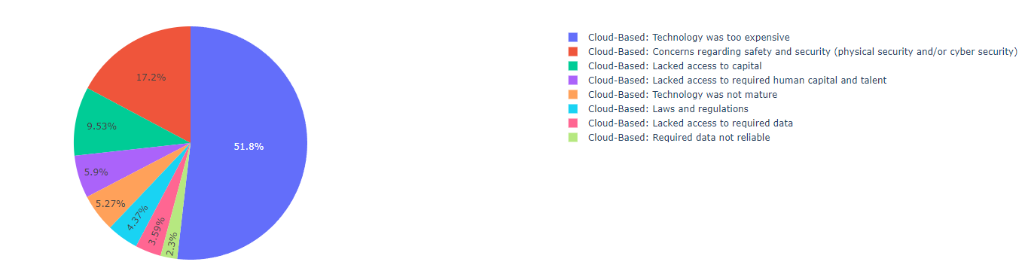

Looking at the responses for all the sectors combined we saw that security concerns both physical and cyber was considerably higher for cloud-based technology compared to the other forms of new tech. we wanted to explore this further and see which sectors were causing this larger percentage.

Finance and Insurance Sector:

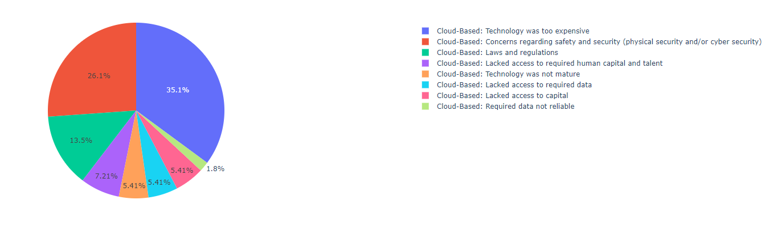

Professional, Scientific, and Technical Services:

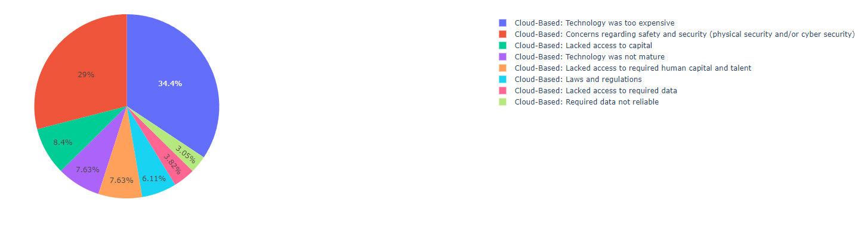

Management of Companies and Enterprises:

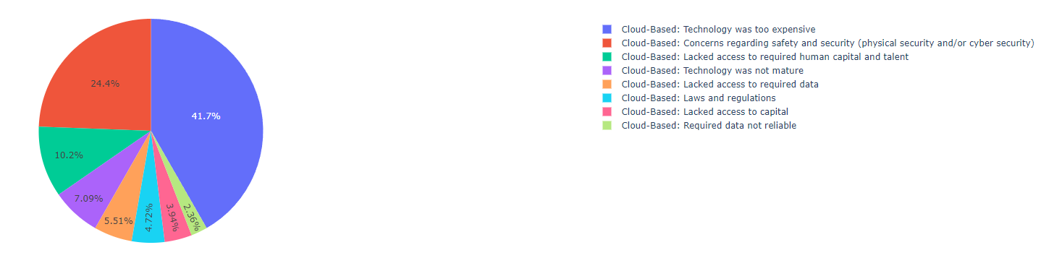

Utilities:

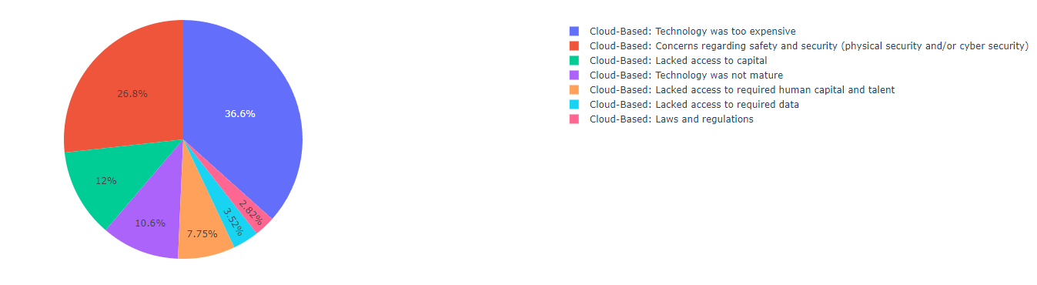

When we started to look through all the reasons for why companies weren’t implementing newer technologies. We found the main reason was of course cost, however this wasn’t all that interesting since newer technologies always come with a large price tag. So, we looked for any outliners for the second reason. We saw that security concerns were a big factor for some sectors of the market. Out of all the sectors these four (Finance and Insurance Sector, Professional, Scientific, and Technical Services, Management of Companies and Enterprises and Utilities) had the largest percentage for security concerns. Surprisingly, the Professional, Scientific, and Technical Services concern for security almost over took their concern for the cost.