Exercise 1

CST8333

Professor: Stanley Pieda

By: Lucas Estienne (esti0011)

040 819 959

1. Program source & screenshot:

// CST8333 Exercise 1 - Lucas Estienne

package main

import (

    "fmt"

)

// main function, this is the entrypoint

func main() {

    // output to stdout

    fmt.Println("CheeseId,CheeseNameEn,CheeseNameFr,ManufacturerNameEn,ManufacturerNameFr,ManufacturerProvCode,ManufacturingTypeEn,ManufacturingTypeFr,WebSiteEn,WebSiteFr,FatContentPercent,MoisturePercent,ParticularitiesEn,ParticularitiesFr,FlavourEn,FlavourFr,CharacteristicsEn,CharacteristicsFr,RipeningEn,RipeningFr,Organic,CategoryTypeEn,CategoryTypeFr,MilkTypeEn,MilkTypeFr,MilkTreatmentTypeEn,MilkTreatmentTypeFr,RindTypeEn,RindTypeFr,LastUpdateDate")

    fmt.Println("Lucas Estienne")

}

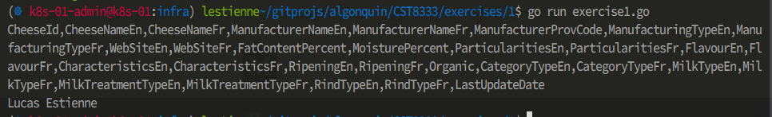

1. Learning Resources:

Programming Style:   
[1] "Effective Go - The Go Programming Language", *Golang.org*, 2019. [Online]. Available: https://golang.org/doc/effective_go.html. [Accessed: 12- Sep- 2019].

[2]"golang/go – Code Review Comments", *GitHub*, 2019. [Online]. Available: https://github.com/golang/go/wiki/CodeReviewComments. [Accessed: 12- Sep- 2019].

Documentation Style:

[3]A. Gerrand, "Godoc: documenting Go code - The Go Blog", *Blog.golang.org*, 2011. [Online]. Available: https://blog.golang.org/godoc-documenting-go-code. [Accessed: 12- Sep- 2019].  
[4]"Command: godoc", *Godoc.org*, 2019. [Online]. Available: https://godoc.org/golang.org/x/tools/cmd/godoc. [Accessed: 12- Sep- 2019].