**Introduction**

The following analysis for the restaurant is based on a customer survey ranking the customer experience at the restaurant. The variables assessed were combined to form the predictor groups of food quality, service and convenience. The results of this study should be used as a means to improve the overall restaurant experience for customers and hopefully lead to increased business performance over time.

**Analysis**

The results of the ratings from the customers were analyzed through a multitude of different models to assess which one would provide the best fit and insights into actionable insights. The models were compared against each other, including a base model that was multivariate and contained all of the variables from the survey. There was also a least squares model based off looking at a correlation matrix. I kept taste, wait and location as the predictor variables for this one, due to their high correlation score with overall. I also didn’t want to choose variables that had extreme collinearity. This was very similar to the concept between creating three PCA groups. Instead of getting an equal weighting for each of the variables to make one new factor for each three predictors, we were just given one variables interactions and results. From a philosophical perspective, this usually isn’t a statistically sound idea since your ignoring possible variation that other features could be having with the response variable. In essence, we could be giving false or incorrect predictions due to an unknown effect by one of the predictors.

**Model Selection and Conclusion**

After a thorough assessment of the various models, the restaurant owner would be best suited to look at model three. It has very good AIC/BIC scores which signifies a good fitting model. It also has the second-best R Squared score. It also has the same R squared as model five, which is due to its relationship with the eigenvectors and being the inverse of it. The decision to use only three factors is backed up by the Scree Plot. It is listed below and shows an elbow at 3 and signifies that the scree, leftovers, are from that point on. The first 3 factors as signified by the high eigenvalues are the most salient for the exercise. Below is a copy of the chart, with marks, along with a summary of all the model statistics.

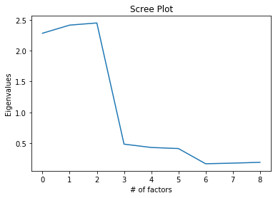





Proportion of variance explained: [0.27051531 0.26603802 0.24572407 0.06231153 0.05578657 0.05420122

0.01592382 0.01532158 0.01417787]

Based on the data and results that were computed, the owner should focus on the three groups as a whole and work to improve the scores over time. Taste, temp and freshness have similar eigenvalue scores around .24 to. 27, in terms of proportion of variance explained. The restaurant owner should focus first on making those scores better and improving food quality. The service related and convivence related variables had less variance and should be addressed after the food quality issues are addressed. Due to less consistency issues with those variables they should be easier to address vs. having to explain why someone’s food is fresh and warm one time, but old and cold the next. The owner could also use this data as a point for needing to invest in better kitchen equipment and /or increased kitchen staffing. This study would be nice to see re-done after a set amount of time to revisit the results and measure possible improvement from the customer scores.