scaled-delay

Abridged Software Requirements Specification

Version 1.0

Oct. 14, 2014

Edgar Berdahl
Software Module Designer

Prepared for
MUS 4745—Computer Music
Instructor: Edgar Berdahl
Fall 2014

1. General Description
The scaled-delay abstraction takes an input integer, delays it by the number of milliseconds specified by the integer, and then outputs a bang. However, a “time-scaling constant” can be employed to speed up or slow down the delay proportionally. This object will be useful for building standard metronomes, randomized metronomes, and serving related functions for algorithmic composition. This is different from the delay object in that the input time both sets the delay and triggers a bang in the future. It is different from the metronome in that it requires a feedback loop to be setup around it in order for it to keep time like a metronome. It will improve my workflow in Max by reducing the number of objects I need to use in higher-level patches. It could be combined with other event-based objects for algorithmic composition, and specifically rhythm generation.

2. Specific Requirements
2.1 Functional Requirements
This section describes the functionalities that the software module should implement.
2.1.1 Ability To Implement a Standard Metronome
By placing a feedback loop for events around the abstraction, it should be possible to create a metronome. It should be possible to both enable and disable this metronome using an external toggle.
2.1.2 Ability To Implement a Randomized Metronome
By placing a feedback loop for events around the abstraction, it should be possible to create a randomized metronome. It should be possible to both enable and disable this metronome using an external toggle.
2.1.3 Ability To Scale the Delay Time
It should be possible to scale the delay time proportionally using a floating point number.
2.2 Inlets and Outlets
scaled-delay has three inlets and one outlet as shown below:
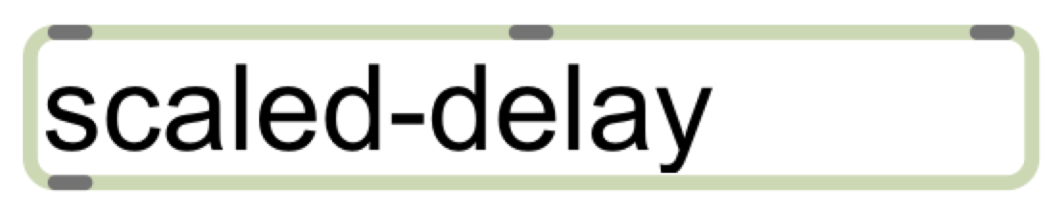
(Optional hint: You can make a dummy patch already that is empty except for inlet and outlet objects in order to create graphic for the documentation here.)
2.2.1 Inlet #1
An integer in this inlet sets the delay time in ms. (Note: Be sure to use units whenever possible/appropriate!) The default delay time is 200ms.
2.2.2 Inlet #2
A float in this inlet sets the
2.2.3 Inlet #3
By default, the abstraction will operate as described above. However, by sending a 0 in the 3rd inlet, the delayed bangs can be disabled. Similarly, by sending a 1 back in the 3rd inlet, the delayed bangs can be re-enabled.
2.2.a Outlet #1
This is the outlet that the delayed bangs come out of.
2.3 External Dependencies
There are no external dependencies.

3. Testing
3.1 Test Patch 1
Test patch 1 will ensure that the delay time isn’t initialized to zero. (Otherwise, when building a metronome for example, we could have problems with creating an “infinite loop” of events, which causes a stack overflow error in Max.)
3.2 Test Patch 2
Test patch 2 will verify that a standard metronome can be implemented using scale-delay.
3.3 Test Patch 3
Test patch 3 will verify that scale-delay can also be used to implement a random metronome.
3.4 Test Patch 4
Test patch 4 will verify that scale-delay can be enabled/disabled via a toggle.
3.5 Test Patch 5
Test patch 5 will verify that the delay time for scale-delay can be scaled using a float.

