MACHINE LEARNING WITH LENDING LOAN CLUB

.Hemamalini Madhanguru, Lakshmi Sundararajan, Pallavi Attimakula
Department of Information Systems, California State University
hmadhan@calstatela.edu
lsundar@calstatela.edu
pattima@calstatela.edu

Abstract: The main motive of our project is to predict the installment rates using interest rates and loan amounts. The installment calculation is depended on parameters such as number of monthly payments, principal amount, interest rate. The missing values in our dataset includes the number of payments, hence this prediction comes in handy for different purposes.

- Introduction
Lending Club is the world’s largest online credit marketplace. In addition to personal and business loans, the company provides quality, responsible options for people looking for loans. Our dataset was chosen from this ‘Lending Club’. The dataset contains complete loan data for all loans issued through 2007-2015, including the current loan status (Current, Late, Fully Paid, etc.) and latest payment information. The file containing loan data through the "present" contains complete loan data for all loans issued through the previous completed calendar quarter. It includes information such as loan amount, interest rate, monthly installment amount, current loan status, purpose of loan, city, loan period, etc. Additional features include credit scores, number of finance inquiries, address including zip codes, and state, and collections among others. The file is a matrix of about 890 thousand observations and 75 variables.

As per our prediction is concerned, we want to calculate the monthly installment amount. An installment is calculated using the formula:
(P x I) x ((1 + r) n)/ (t x ((1 + r) n)- 1) where

P = Principal amount borrowed
I = annual interest rate,
r = periodic monthly interest rate,
n = total number of monthly payments and
t = number of months in a year.

The dataset which we picked doesn’t have total number of monthly payment which is a major variable in calculating an installment and we have a column named interest rate which can be either annual interest rate or monthly, which is kind of ambiguous. So, we decided to predict monthly installments.

- Work Flow:

Data Collection & Cleaning
Loading data into Azure ML
Creating project in Azure ML

Analyzing using two algorithms.
Loading data into Spark ML
Visualize & compare results

Query data using python code
Use two algorithms to query

Visualize & compare results

Figure 1.1
- Data Preprocessing
Data preprocessing is a data mining technique that involves transforming raw data into an understandable format.Since our dataset was huge, we had to select the columns that we wanted to predict and perform analyses inorder to find the outliers.So as mentioned earlier the columns used for prediction were the loan amount,interest rate and monthly installment.In general banking scenarios, when the loan amount is high there is a higher interest rate.But by doing an analyses with these columns, we found that few installments fall in the range of higher loans and lesser interest rates which are considered as outliers.
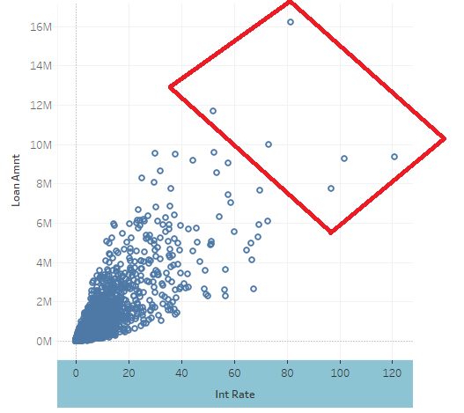

Figure 1.2 Visual Before Removing Outliers

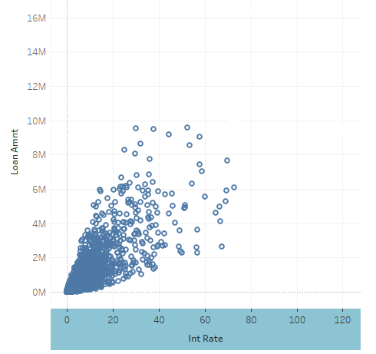
Figure 1.3 Visual After Removing Outliers

Outliers were removed using SQL query as follows:
- Select avg(int_rate), avg(loan_amt), installment from loanStats3c where avg(int_rate)<80% and avg(loan_amt)<95,00000

The above query shows the data which violates the rule. Using this query, we have set a condition with respect to average int_rate and loan_amt to remove the outliers
- Platform Specifications

- File System – Data Bricks File System (DBFS)
- Apache Spark Version – Spark 2.1 (Auto – updating, Scala 2.10)
- Memory – 6GigaBytes
- CPU Speed: 2.7Ghz
- Number of CPU cores: 0.88cores
- Number of nodes: 1 node on demand
- Total Memory Size: 6GB

- Algorithm Selection
Choosing the best algorithm is another challenging task. It depends on the size, quality, and nature of the data. Even the most experienced data scientists can't tell which algorithm will perform best before trying them. With the help of this Machine Learning cheat sheet below we shortlisted the algorithms that we wanted to try.
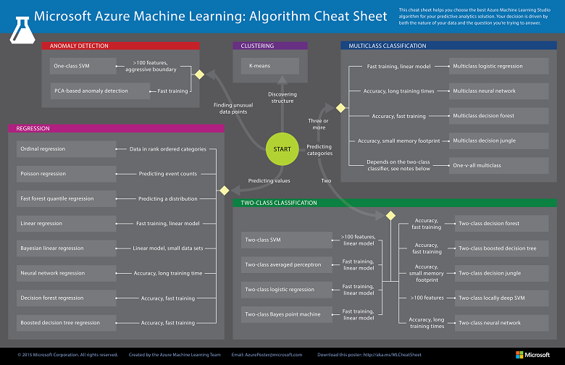
Figure 1.4 Cheat Sheet for ML Algorithm
After shortlisting two algorithms i.e. Decision Tree Regression and Linear Regression we tested them in two different platforms for checking the accuracy. The Platforms used where Azure ML and Spark ML which are further explained below.
- Azure ML
Microsoft Azure Machine Learning, or just Azure ML, is a cloud-based platform for designing, developing, testing and deploying predictive models. Those models can use many well-known machine learning algorithms, such as decision forests or neural networks, to ﬁnd useful patterns in your data. The heart of Azure ML toolkit is ML Studio, a web-based graphical environment where we uploaded and validated our data models, which Azure ML refers to as experiments. This is an apt name, because an experiment can consist of multiple models and much additional logic, or other helpful calculations and data preparation tasks.
As the dataset contains continuous values, regression algorithm is being chosen. The algorithms that are used to analyze and predict the data are Decision Forest Tree Regression and Linear Regression. The main reasons for picking these two algorithms are they are trained faster and gives more accurate values.
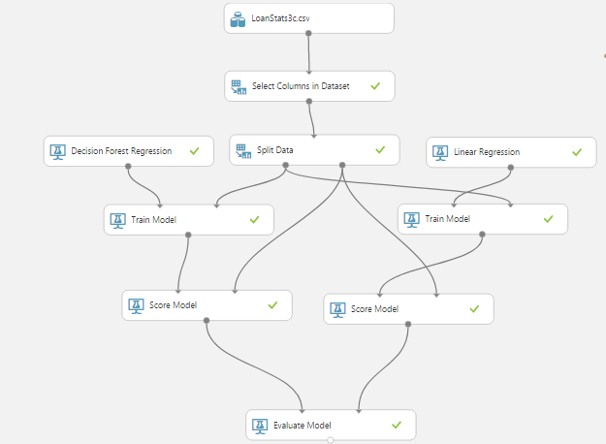
Figure 1.5 Flow Diagram of Azure ML
Then we selected the features and label for prediction. Feature is a parameter with which the model is trained and label is the value that must be trained. In our prediction, features such as Loan amount, Interest Rates were passed into the Split Model and Label such as Installment Amount were passed into the train model. The result of the trained data and original data where compared using the score model. The score model output depicts the accuracy of prediction in comparison with the features used for training.
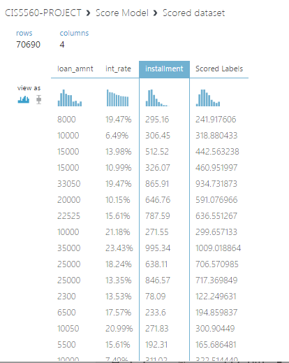
Figure 1.6 Score Model Output of Linear Regression
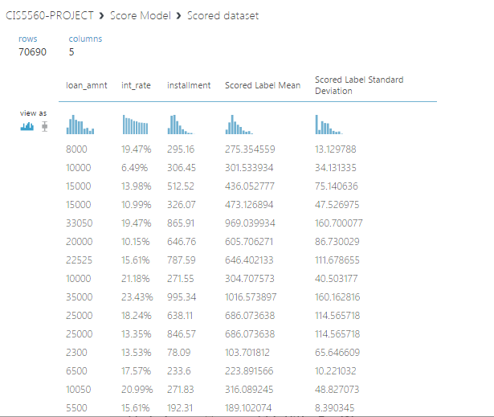
Figure 1.7 Score Model Output of Decision Forest Tree Regression
Finally, by visualizing the evaluate model output shown below we can see that, for Decision Forest Regression, the Coefficient of Determination is 90.7% and Root Mean Squared Error is 74.5. Similarly, for Linear Regression, the Coefficient of Determination is 90.1% and Root Mean Squared Error is 76.8.
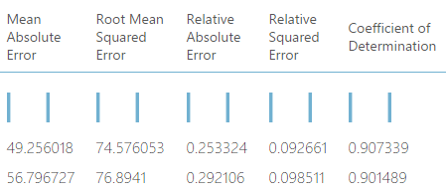
Figure 1.8 Evaluation Model Results

- Azure ML Evaluation:
In Azure ML, after performing the above steps as explained earlier we found that the Decision Tree Regression is more accurate when compared with Linear Regression.
 | Linear Regression | Decision Forest Regression
Root Mean Square Error | 76.9 | 74.5
Relative Squared Error | 0.0985 | 0.0926
Co-efficient of Determination | 90.1% | 90.7%
Table 1.1 Evaluation Results in Azure ML

- Spark ML
Apache Spark ML is a powerful open source processing engine built around speed, ease of use, and sophisticated analytics. The algorithms that are used to analyze the data are Linear Regression and Decision Forest Tree Regression.
Linear Regression
The screenshot below depicts the scatter plot for Linear Regression algorithm. From the scatter plot we can see the relationship between the predicted and existing values. The relationship is compared based on the Root Mean Square Error (RMSE) value which is 78.1.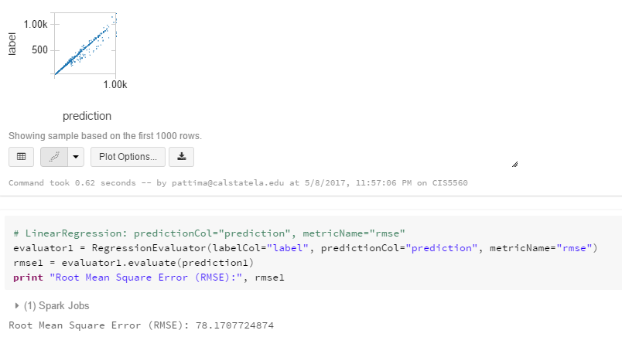
Figure 1.9 Scatter plot of Linear Regression
Decision Tree Regression
The scatter plot shown below depicts the relationship between the predicted and existing values. It gives the accuracy of the algorithm. In the below diagram, the plot is almost a diagonal line. The Root Mean Square Error (RMSE) for decision tree regression is 75.5
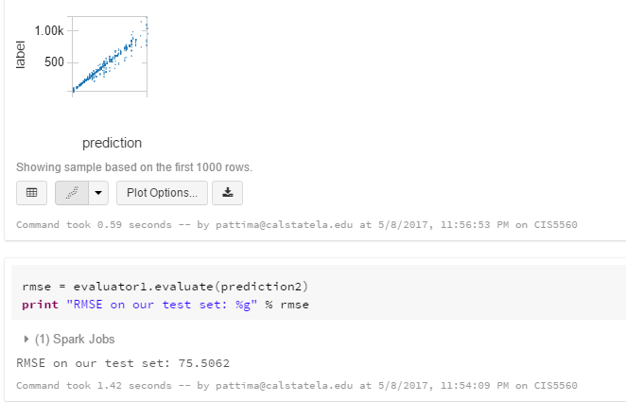

Figure 1.10 Scatter Plot output of Decision Tree Regression

- Spark ML Evaluation:

In Spark ML, the best is chosen based on the Root Mean
Square Error value. The Decision Tree Regression is more accurate when compared with Linear Regression.

 | Linear Regression | Decision Forest Regression
Root Mean Square Error | 78.1 | 75.8
Table 1.2 Evaluation Results in Spark ML
- Comparison Between Azure ML and Spark ML

The platforms Azure ML and Spark ML are used for comparing which algorithm is more accurate amongst the two Linear Regression and Decision Forest Regression. The values Root Mean Square Error of both the algorithms are taken as base to determine which platform gives more accurate values.

Azure ML |  | Spark ML
Decision Forest Regression | Linear Regression | Decision Forest Regression | Linear Regression
RMSE:74.5 | RMSE:76.9 | RMSE:75.8 | RMSE:78.1
Table 1.3 Comparison

The Root Mean Square Error values of both Linear Regression and Decision Forest Regression algorithms are more accurate in Azure ML than in Spark ML.

Conclusion:

The Azure ML platform has more advanced features and supports more algorithms when compared with Spark ML. For Continuous values, Regression model can only give accurate results. Amongst the two-regression model we selected Decision Forest Algorithms accuracy is more efficient when compared with Linear Regression algorithm. The business advantage of this prediction is that it can be used to build an application that helps end user to decide the loan amount depending on the predicted installments that lies within their range.

- Dataset URL
- https://www.kaggle.com/wendykan/lending-club-loan-data

- GITHUB LINK
- https://github.com/lsundar1203/PROJECT-5560

- REFERENCES
- https://projectbotticelli.com/knowledge/what-is-microsoft-azure-ml-video-tutorial
- https://docs.microsoft.com/en-us/azure/machine-learning/machine-learning-algorithm-choice

