* Jupyter Notebook extensions offers lot of features which makes our work little easier.
* Following are some features which I loved it and following is the process to enable them.

Jupyter Notebook Extensions

1. Go to Anaconda prompt
2. pip install jupyter_contrib_nbextensions
3. jupyter contrib nbextension install –user
4. jupyter nbextensions_configurator enable –user
5. After installation, start Jupyter Notebook
6. You would be able to see the new Nbextensions tab

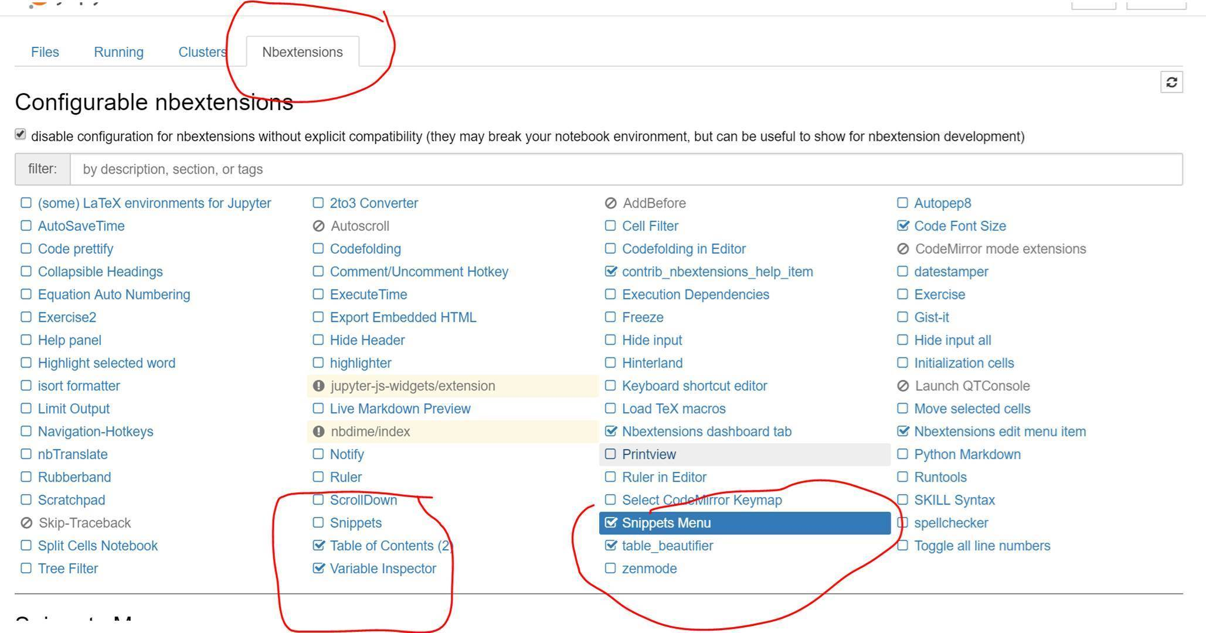

1. By clicking on the Nbextensions tab, we will be provided with a list of available widgets. Select Table of Contents and Snippets
2. Once you have them, by clicking the option in Red, we get following Table of Contents

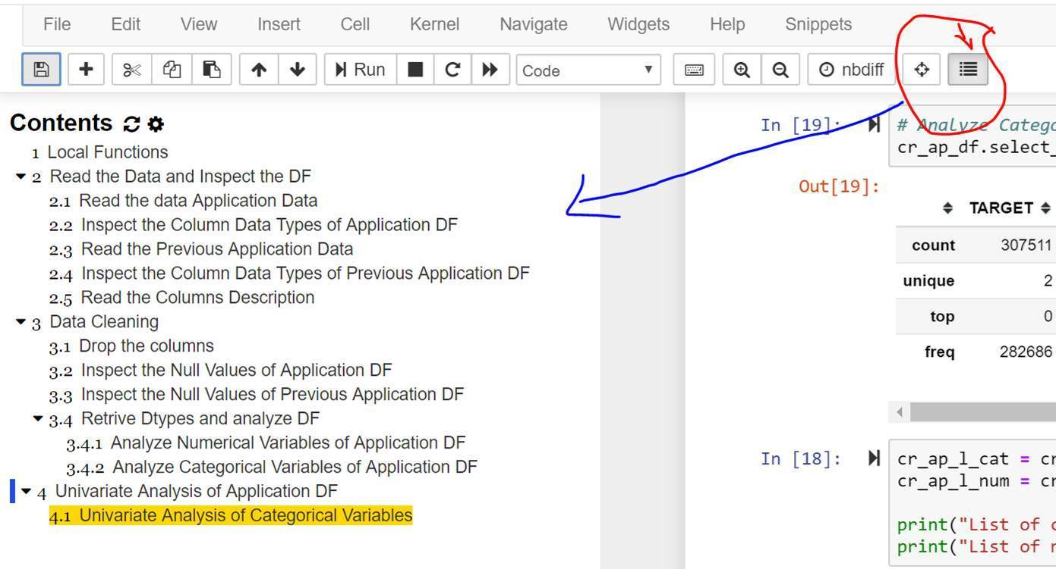

Snippets of NB Extensions offers lot of good things

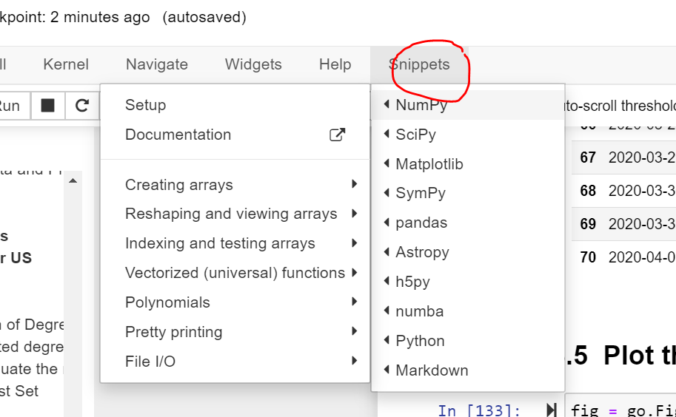

I use it mainly for inserting preconfigured Markdown sets

