Task1:

Low and high thresholds for hysteresis

If the value of pixel > high_threshold, set to 255. If the value of pixel < low_threshold, set to 0. For the value between low and high threshold, using “8 - Nearest neighbor” to decide the new value.

I set low_threshold=0.5, high_threshold=1.0

By calculating the mean, max, min and std, I find that although the max is 360.62445, most of the values of pixels is between 0 and1.

So the low threshold and high threshold should be set between 0 and 1.

By trying different value of threshold, choose the suitable value.

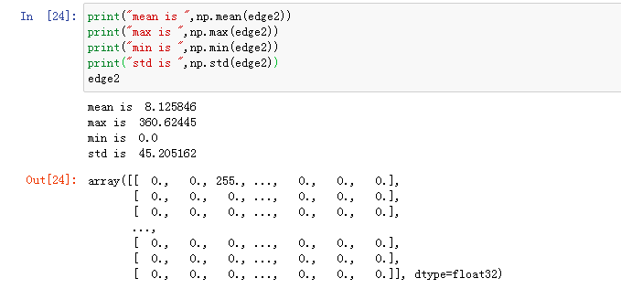

Task2:

method in CollageCreate()

First, I create an empty array, the height is 5 times the height of a frame, that is, horizontally stitch the pictures.

Then calculate the histograms for the five frames and sort them according to the standard deviation of histograms.

Place the picture with the smallest standard deviation in the middle of the stitched picture, that is, place the picture with the smallest color change in the middle, and then place the pictures with the larger standard deviation in turn around. Place the picture with the largest standard deviation on the two boundaries to complete the collage.