PfSense WAN 10.10.10.55/24 or 192.168.122.xxx
pfSense LAN 192.168.1.1/24

Kali LAN 10.10.10.26 or 192.168.122.xxx
Ubuntu LAN 10.10.10.67 or 192.168.122.xxx

Host 192.168.10.104

ee /tmp /rules.debug
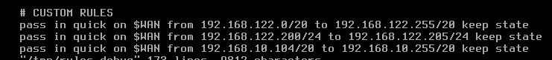
pftctl -f /tmp /rules.debug

If we give the pfSense VM another IP address with option 2) the other Vms lose their DHCP leases after we reboot them

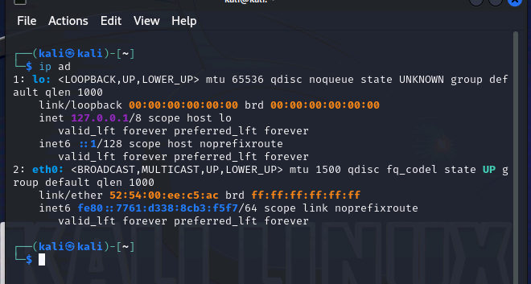
if we configure the vms to start with 10.0.0.0/24 addresses from terraform and then edit the pfSense VM to match 10.0.0.0/24 its gucci.

With these options we can bind the docker containers to the wanted IP address range that we want to use for the internal network
1076* sudo docker network create --driver=macvlan --subnet=10.0.0.0/24 -o parent=virbr1 mynet2
1077* sudo docker ps
1078* sudo docker run nginx
1079 history
1080 sudo docker ps
1081 sudo docker network connect mynet2 gallant_sinoussi
1082 sudo docker network disconnect bridge gallant_sinoussi
1083 sudo docker inspect -f '{{range .NetworkSettings.Networks}}{{.IPAddress}}{{end}}' gallant_sinoussi
