|  |  |
| --- | --- |
| **Politechnika Białostocka Wydział Informatyki** | Data: 26.05.2015r |
| **Przedmiot:** Modelowanie i analiza systemów informatycznych **Sprawozdanie nr: 11**  **Temat**: Model Poczty  **Autor:** Łukasz Świderski  **Studia:** stacjonarne, II stopnia, semestr 1 | **Prowadzący:**  dr inż. Walenty Oniszczuk  **Ocena:** |

1. **Treść zadania**

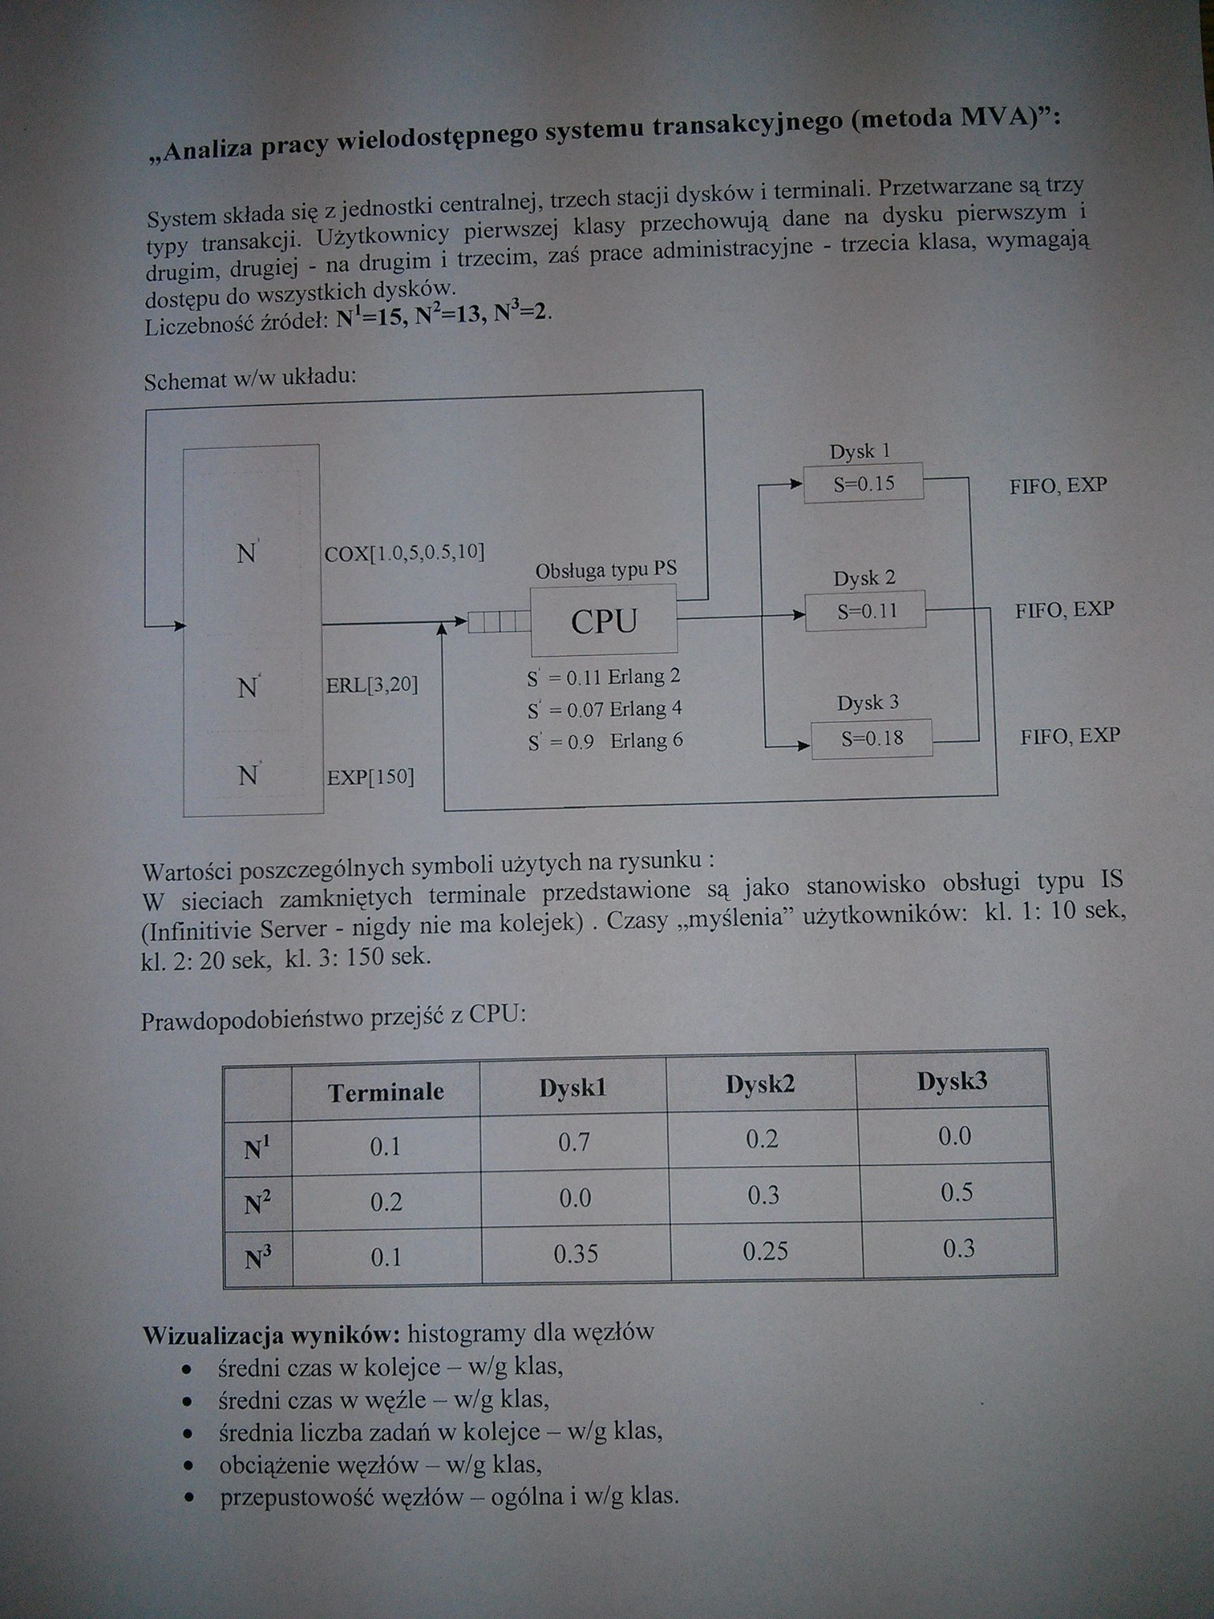

1. **Część teoretyczna**

**AMOK –**jest pakietem programowym, umożliwiającym praktyczne stosowanie modeli teorii masowej obsługi, a w szczególności modelowania systemów komputerowych. Został on stworzony do opisu i oceny efektywności takich systemów, lecz może znaleźć zastosowanie wszędzie tam, gdzie stosuje się teorie masowej obsługi i model w postaci sieci stanowisk obsługi, między którymi krążą klienci ustawieni w razie potrzeby w kolejki, może odnosić się do wieku sytuacji i obiektów.

**MVA –** w medodzie MVA wykorzystywana jest metoda wartości średnich, pozwalająca na dokładne rozwiązywanie zamkniętych sieci dekomponowanych. Jeżeli w sieci znajdują się stanowiska z regulaminem naturalnym i różnymi od wykładniczych rozkładami czasów obsługi, a więc sieć nie jest dekomponowana, wyniki obliczeń są przybliżone. Dopuszczalny jest podział klientów na klasy. Podejście do rozwiąznaia sieci kolejkowej metodą wartości średnich pozwala na otrzymanie „miar pracy” stanowisk wprost, bez obliczania stałej normalizacyjnej, stanowiącego istotny numeryczny w innych metodach.

1. **Rozwiązanie**

|  |
| --- |
| SOUR mva  *DECLARATION*  /CLASS/ NAME=kl_1[15]  /CLASS/ NAME=kl_2[13]  /CLASS/ NAME=kl_3[2]  /STATION/ NAME=TERMINAL  /STATION/ NAME=CPU  /STATION/ NAME=DYSK1  /STATION/ NAME=DYSK2  /STATION/ NAME=DYSK3  *END*  *DESCRIPTION*  /STATION/ NAME=TERMINAL  SCHEDULE=IS  SERVICE(:kl_1)=COX[1.0,5,0.5,10]  SERVICE(:kl_2)=ERL[3,20]  SERVICE(:kl_3)=EXP[150]  TRANSIT=CPU;  /STATION/ NAME=CPU  SCHEDULE=PS  SERVICE(:kl_1)=ERL[2,0.11]  SERVICE(:kl_2)=ERL[4,0.07]  SERVICE(:kl_3)=ERL[6,0.9]  TRANSIT(:kl_1)=[0.1]TERMINAL,[0.7]DYSK1,[0.2]DYSK2;  TRANSIT(:kl_2)=[0.2]TERMINAL,[0.3]DYSK2,[0.5]DYSK3;  TRANSIT(:kl_3)=[0.1]TERMINAL,[0.35]DYSK1,[0.25]DYSK2,[0.3]DYSK3;  /STATION/ NAME=DYSK1  SCHEDULE=FIFO  SERVICE=EXP[0.15]  TRANSIT=CPU;  /STATION/ NAME=DYSK2  SCHEDULE=FIFO  SERVICE=EXP[0.11]  TRANSIT=CPU;  /STATION/ NAME=DYSK3  SCHEDULE=FIFO  SERVICE=EXP[0.18]  TRANSIT=CPU;  *END* |

|  |  |  |  |  |  |  |  |  |  |  |  |  |  |  |  |  |  |  |  |  |  |  |  |  |  |  |  |  |  |  |  |  |  |  |  |  |  |  |  |  |  |  |  |  |  |  |  |  |  |  |  |  |  |  |  |  |  |  |  |  |  |  |  |  |  |  |  |  |  |  |  |  |  |  |  |  |  |  |  |  |  |  |  |  |  |  |  |  |  |  |  |  |  |  |  |  |  |  |  |  |  |  |  |  |  |  |  |  |  |  |  |  |  |  |  |  |  |  |  |  |  |  |  |  |  |  |  |  |  |  |  |  |  |  |  |  |  |  |  |  |  |  |  |  |  |  |  |  |  |  |  |  |  |  |  |  |  |  |  |  |  |  |  |  |  |  |  |  |  |  |  |  |  |  |  |  |  |  |  |  |  |  |  |  |  |  |  |  |  |  |  |  |  |  |  |  |  |  |  |  |  |  |  |  |  |  |  |  |  |  |  |  |  |  |  |  |  |  |  |  |  |  |  |  |  |  |  |  |  |  |  |  |  |  |  |  |  |  |  |  |  |  |  |  |  |  |  |  |  |  |  |  |  |  |  |  |  |  |  |  |  |  |  |  |  |  |  |  |  |  |  |  |  |  |  |  |  |  |  |  |  |  |  |  |  |  |  |  |  |  |  |  |  |  |  |  |  |  |  |  |  |  |  |  |  |  |  |  |  |  |  |  |  |  |  |  |  |  |  |  |  |  |  |  |  |  |  |  |  |  |  |  |  |  |  |  |  |  |  |  |  |  |  |  |  |  |  |  |  |  |
| --- | --- | --- | --- | --- | --- | --- | --- | --- | --- | --- | --- | --- | --- | --- | --- | --- | --- | --- | --- | --- | --- | --- | --- | --- | --- | --- | --- | --- | --- | --- | --- | --- | --- | --- | --- | --- | --- | --- | --- | --- | --- | --- | --- | --- | --- | --- | --- | --- | --- | --- | --- | --- | --- | --- | --- | --- | --- | --- | --- | --- | --- | --- | --- | --- | --- | --- | --- | --- | --- | --- | --- | --- | --- | --- | --- | --- | --- | --- | --- | --- | --- | --- | --- | --- | --- | --- | --- | --- | --- | --- | --- | --- | --- | --- | --- | --- | --- | --- | --- | --- | --- | --- | --- | --- | --- | --- | --- | --- | --- | --- | --- | --- | --- | --- | --- | --- | --- | --- | --- | --- | --- | --- | --- | --- | --- | --- | --- | --- | --- | --- | --- | --- | --- | --- | --- | --- | --- | --- | --- | --- | --- | --- | --- | --- | --- | --- | --- | --- | --- | --- | --- | --- | --- | --- | --- | --- | --- | --- | --- | --- | --- | --- | --- | --- | --- | --- | --- | --- | --- | --- | --- | --- | --- | --- | --- | --- | --- | --- | --- | --- | --- | --- | --- | --- | --- | --- | --- | --- | --- | --- | --- | --- | --- | --- | --- | --- | --- | --- | --- | --- | --- | --- | --- | --- | --- | --- | --- | --- | --- | --- | --- | --- | --- | --- | --- | --- | --- | --- | --- | --- | --- | --- | --- | --- | --- | --- | --- | --- | --- | --- | --- | --- | --- | --- | --- | --- | --- | --- | --- | --- | --- | --- | --- | --- | --- | --- | --- | --- | --- | --- | --- | --- | --- | --- | --- | --- | --- | --- | --- | --- | --- | --- | --- | --- | --- | --- | --- | --- | --- | --- | --- | --- | --- | --- | --- | --- | --- | --- | --- | --- | --- | --- | --- | --- | --- | --- | --- | --- | --- | --- | --- | --- | --- | --- | --- | --- | --- | --- | --- | --- | --- | --- | --- | --- | --- | --- | --- | --- | --- | --- | --- | --- | --- | --- | --- | --- | --- | --- | --- | --- | --- | --- | --- | --- | --- | --- | --- | --- | --- | --- | --- | --- | --- | --- | --- | --- | --- | --- | --- | --- | --- | --- | --- | --- | --- | --- | --- | --- | --- | --- |
| **C:\winamok>amok-32 zad11.amk MVA**  **Wyniki.txt**   |  |  |  |  |  |  |  | | --- | --- | --- | --- | --- | --- | --- | |  |  | WYNIKI | (prosty wy | druk ASCII) | : |  | | "Bez podziału na klasy" | | |  |  |  |  | |  |  |  | CZAS OBSŁ. | LICZBA KL. | WYKORZYST. | PRZEPUST. | | 1.Stan. | TERMINAL | | 15.497365 | 18.592228 |  | 1.1997025 | | 2.Stan. | CPU |  | 0.9496202 | 8.8322926 | 0.9831265 | 9.3008684 | | 3.Stan. | DYSK1 |  | 0.4246873 | 1.9506846 | 0.6889838 | 4.5932257 | |  |  | QUEUE | 0.2746873 | 1.2617008 |  | 4.5932257 | |  |  | SERVER | 0.1500000 | 0.6889838 | 0.6889838 |  | | 4.Stan. | DYSK2 |  | 0.1431613 | 0.3055185 | 0.2347494 | 2.1340854 | |  |  | QUEUE | 0.0331613 | 0.0707691 |  | 2.1340854 | |  |  | SERVER | 0.1100000 | 0.2347494 | 0.2347494 |  | | 5.Stan. | DYSK3 |  | 0.2323938 | 0.3192754 | 0.2472938 | 1.3738547 | |  |  | QUEUE | 0.0523938 | 0.0719815 |  | 1.3738547 | |  |  | SERVER | 0.1800000 | 0.2472938 | 0.2472938 |  | |  |  | WYNIKI | (prosty wy | druk ASCII) | : |  | | Dla klasy | "kl_1" |  |  |  |  |  | |  |  |  | CZAS OBSŁ. | LICZBA KL. | WYKORZYST. | PRZEPUST. | | 1.Stan. | TERMINAL | | 10.000000 | 6.5187913 |  | 0.6518791 | | 2.Stan. | CPU |  | 0.9752820 | 6.3576598 | 0.7170669 | 6.5187907 | | 3.Stan. | DYSK1 |  | 0.4244062 | 1.9366308 | 0.6844730 | 4.5631534 | |  |  | QUEUE | 0.2744062 | 1.2521578 |  | 4.5631534 | |  |  | SERVER | 0.1500000 | 0.6844730 | 0.6844730 |  | | 4.Stan. | DYSK2 |  | 0.1433685 | 0.1869178 | 0.1434134 | 1.3037581 | |  |  | QUEUE | 0.0333685 | 0.0435044 |  | 1.3037581 | |  |  | SERVER | 0.1100000 | 0.1434134 | 0.1434134 |  | |  |  | WYNIKI | (prosty wy | druk ASCII) | : |  | | Dla klasy | kl_2 |  |  |  |  |  | |  |  |  | CZAS OBSŁ. | LICZBA KL. | WYKORZYST. | PRZEPUST. | | 1.Stan. | TERMINAL | | 20.000000 | 10.784627 |  | 0.5392313 | | 2.Stan. | CPU |  | 0.6626951 | 1.7867301 | 0.1887309 | 2.6961570 | | 3.Stan. | DYSK2 |  | 0.1427895 | 0.1154948 | 0.0889731 | 0.8088471 | |  |  | QUEUE | 0.0327895 | 0.0265217 |  | 0.8088471 | |  |  | SERVER | 0.1100000 | 0.0889731 | 0.0889731 |  | | 4.Stan. | DYSK3 |  | 0.2322918 | 0.3131475 | 0.2426541 | 1.3480785 | |  |  | QUEUE | 0.0522918 | 0.0704934 |  | 1.3480785 | |  |  | SERVER | 0.1800000 | 0.2426541 | 0.2426541 |  | |  |  | WYNIKI | (prosty wy | druk ASCII) | : |  | | Dla klasy | kl_3 |  |  |  |  |  | |  |  |  | CZAS OBSŁ. | LICZBA KL. | WYKORZYST. | PRZEPUST. | | 1.Stan. | TERMINAL | | 150.00000 | 1.2888099 |  | 0.0085920 | | 2.Stan. | CPU |  | 8.0062518 | 0.6879026 | 0.0773286 | 0.0859206 | | 3.Stan. | DYSK1 |  | 0.4673337 | 0.0140537 | 0.0045108 | 0.0300722 | |  |  | QUEUE | 0.3173337 | 0.0095429 |  | 0.0300722 | |  |  | SERVER | 0.1500000 | 0.0045108 | 0.0045108 |  | | 4.Stan. | DYSK2 |  | 0.1445883 | 0.0031057 | 0.0023628 | 0.0214801 | |  |  | QUEUE | 0.0345883 | 0.0007429 |  | 0.0214801 | |  |  | SERVER | 0.1100000 | 0.0023628 | 0.0023628 |  | | 5.Stan. | DYSK3 |  | 0.2377319 | 0.0061278 | 0.0046397 | 0.0257762 | |  |  | QUEUE | 0.0577319 | 0.0014881 |  | 0.0257762 | |  |  | SERVER | 0.1800000 | 0.0046397 | 0.0046397 |  | |

1)

2)

3)

4)

5)

**Podsumowanie:**  
Niestety pod systemem Windows 8.1 nie udało mi się uruchomić poprawnie programu winamok, jednakże program amok-32 po wywołaniu z odpowiednimi parametrami uruchomił się z poziomu wiersza poleceń.