|  |  |
| --- | --- |
| **Politechnika Białostocka Wydział Informatyki** | Data: 12.05.2015r |
| **Przedmiot:** Modelowanie i analiza systemów informatycznych **Sprawozdanie nr: 9**  **Temat**: Model Poczty  **Autor:** Łukasz Świderski  **Studia:** stacjonarne, II stopnia, semestr 1 | **Prowadzący:**  dr inż. Walenty Oniszczuk  **Ocena:** |

1. **Treść zadania**

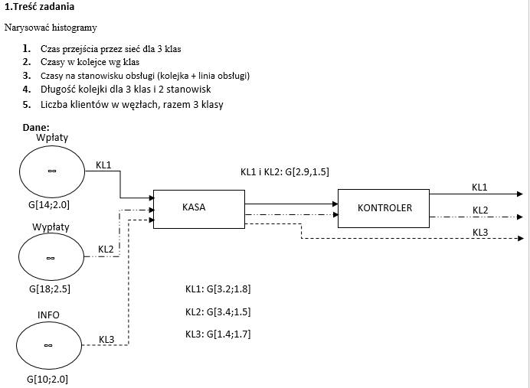

1. **Część teoretyczna**

**AMOK –**jest pakietem programowym, umożliwiającym praktyczne stosowanie modeli teorii masowej obsługi, a w szczególności modelowania systemów komputerowych. Został on stworzony do opisu i oceny efektywności takich systemów, lecz może znaleźć zastosowanie wszędzie tam, gdzie stosuje się teorie masowej obsługi i model w postaci sieci stanowisk obsługi, między którymi krążą klienci ustawieni w razie potrzeby w kolejki, może odnosić się do wieku sytuacji i obiektów.

1. **Rozwiązanie**

|  |
| --- |
| SOUR POCZTA  *DECLARATION*  /SOURCE/ NAME = WPLATY  /CLASS/ NAME = KLASA1[0]  /SOURCE/ NAME = WYPLATY  /CLASS/ NAME = KLASA2[0]  /SOURCE/ NAME = INFO  /CLASS/ NAME = KLASA3[0]  /STATION/ NAME = KASA  /STATION/ NAME = KONTROLER  /OUT/ NAME = OUT  *END*  *DESCRIPTION*  /SOURCE/ NAME = WPLATY  SERVICE = G[14,2.0]  TRANSIT = KASA:KLASA1;  /SOURCE/ NAME = WYPLATY  SERVICE = G[18,2.5]  TRANSIT = KASA:KLASA2;  /SOURCE/ NAME = INFO  SERVICE = G[10,2.0]  TRANSIT = KASA:KLASA3;  /STATION/ NAME = KASA  SERVICE (:KLASA1) = G[3.2, 1.8]  SERVICE (:KLASA2) = G[3.4, 1.5]  SERVICE (:KLASA3) = G[1.4, 1.7]  TRANSIT (:KLASA1, KLASA2) = KONTROLER;  TRANSIT (:KLASA3) = OUT;  /STATION/ NAME = KONTROLER  SERVICE = G[2.9, 1.5]  TRANSIT = OUT;  *END* |

|  |  |  |  |  |  |  |  |  |  |  |  |  |  |  |  |  |  |  |  |  |  |  |  |  |  |  |  |  |  |  |  |  |  |  |  |  |  |  |  |  |  |  |  |  |  |  |  |  |  |  |  |  |  |  |  |  |  |  |  |  |  |  |  |  |  |  |  |  |  |  |  |  |  |  |  |  |  |  |  |  |  |  |  |  |  |  |  |  |  |  |  |  |  |  |  |  |  |  |  |  |  |  |  |  |  |  |  |  |  |  |  |  |  |  |  |  |  |  |  |  |  |  |  |  |  |  |  |  |  |  |  |  |  |  |  |  |  |  |  |  |  |  |  |  |  |  |  |  |  |  |  |  |  |  |  |  |  |  |  |  |  |  |  |  |  |  |  |  |  |  |  |  |  |  |  |  |  |  |  |  |  |  |  |  |  |  |  |  |  |  |  |  |  |  |  |  |  |  |  |  |  |  |  |  |  |  |  |  |  |  |  |  |  |  |  |  |  |  |  |  |  |  |  |  |  |  |  |  |  |  |  |
| --- | --- | --- | --- | --- | --- | --- | --- | --- | --- | --- | --- | --- | --- | --- | --- | --- | --- | --- | --- | --- | --- | --- | --- | --- | --- | --- | --- | --- | --- | --- | --- | --- | --- | --- | --- | --- | --- | --- | --- | --- | --- | --- | --- | --- | --- | --- | --- | --- | --- | --- | --- | --- | --- | --- | --- | --- | --- | --- | --- | --- | --- | --- | --- | --- | --- | --- | --- | --- | --- | --- | --- | --- | --- | --- | --- | --- | --- | --- | --- | --- | --- | --- | --- | --- | --- | --- | --- | --- | --- | --- | --- | --- | --- | --- | --- | --- | --- | --- | --- | --- | --- | --- | --- | --- | --- | --- | --- | --- | --- | --- | --- | --- | --- | --- | --- | --- | --- | --- | --- | --- | --- | --- | --- | --- | --- | --- | --- | --- | --- | --- | --- | --- | --- | --- | --- | --- | --- | --- | --- | --- | --- | --- | --- | --- | --- | --- | --- | --- | --- | --- | --- | --- | --- | --- | --- | --- | --- | --- | --- | --- | --- | --- | --- | --- | --- | --- | --- | --- | --- | --- | --- | --- | --- | --- | --- | --- | --- | --- | --- | --- | --- | --- | --- | --- | --- | --- | --- | --- | --- | --- | --- | --- | --- | --- | --- | --- | --- | --- | --- | --- | --- | --- | --- | --- | --- | --- | --- | --- | --- | --- | --- | --- | --- | --- | --- | --- | --- | --- | --- | --- | --- | --- | --- | --- | --- | --- | --- | --- | --- | --- | --- |
| **C:\winamok>amok-32 spr9.amk DIFF**  **Wyniki.txt**   |  |  |  |  |  |  |  | | --- | --- | --- | --- | --- | --- | --- | |  |  | WYNIKI | (prosty wydruk ASCII) |  | : |  | | "Bez podz | iaｳu na klasy" |  |  |  |  |  | |  |  |  | CZAS OBS｣. | LICZBA KL. | WYKORZYST. | PRZEPUST. | | 1.Stan. | KASJERKA |  | 17.553551 | 3.9843776 | 0.5574603 | 0.2269841 | |  |  | QUEUE | 15.097607 | 3.4269172 | 0.4796017 | 0.2269841 | |  |  | SERVER | 2.4559440 | 0.5574603 | 0.0778586 |  | | 2.Stan. | KONTROLER |  | 8.5473160 | 1.0853734 | 0.3682539 | 0.1269841 | |  |  | QUEUE | 5.6473160 | 0.7171195 | 0.2447329 | 0.1269841 | |  |  | SERVER | 2.9000000 | 0.3682539 | 0.1235210 |  | |  |  | WYNIKI | (prosty wy | druk ASCII) | : |  | | Dla klasy | "KLASA1" |  |  |  |  |  | |  |  |  | CZAS OBS｣. | LICZBA KL. | WYKORZYST. | PRZEPUST. | | 1.Stan. | KASJERKA |  | 18.297607 | 1.3069719 | 0.2285714 | 0.0714285 | |  |  | QUEUE | 15.097607 | 1.0784005 |  | 0.0714285 | |  |  | SERVER | 3.2000000 | 0.2285714 | 0.2285714 |  | | 2.Stan. | KONTROLER |  | 8.5473160 | 0.6105225 | 0.2071428 | 0.0714285 | |  |  | QUEUE | 5.6473160 | 0.4033797 |  | 0.0714285 | |  |  | SERVER | 2.9000000 | 0.2071428 | 0.2071428 |  | |  |  | WYNIKI | (prosty wy | druk ASCII) | : |  | | Dla klasy | "KLASA2" |  |  |  |  |  | |  |  |  | CZAS OBS｣. | LICZBA KL. | WYKORZYST. | PRZEPUST. | | 1.Stan. | KASJERKA |  | 18.497607 | 1.0276448 | 0.1888888 | 0.0555555 | |  |  | QUEUE | 15.097607 | 0.8387559 |  | 0.0555555 | |  |  | SERVER | 3.4000000 | 0.1888888 | 0.1888888 |  | | 2.Stan. | KONTROLER |  | 8.5473160 | 0.4748508 | 0.1611111 | 0.0555555 | |  |  | QUEUE | 5.6473160 | 0.3137397 |  | 0.0555555 | |  |  | SERVER | 2.9000000 | 0.1611111 | 0.1611111 |  | |  |  | WYNIKI | (prosty wy | druk ASCII) | : |  | | Dla klasy | "KLASA3" |  |  |  |  |  | |  |  |  | CZAS OBS｣. | LICZBA KL. | WYKORZYST. | PRZEPUST. | | 1.Stan. | KASJERKA |  | 16.497607 | 1.6497607 | 0.1400000 | 0.1000000 | |  |  | QUEUE | 15.097607 | 1.5097607 |  | 0.1000000 | |  |  | SERVER | 1.4000000 | 0.1400000 | 0.1400000 |  | |

1)

2)

3)

4)

5)

**Podsumowanie:**  
Niestety pod systemem Windows 8.1 nie udało mi się uruchomić poprawnie programu winamok, jednakże program amok-32 po wywołaniu z odpowiednimi parametrami uruchomił się z poziomu wiersza poleceń.

Najkrótszy czas przejścia posiada klasa 3, ponieważ nie musi przechodzić przez kontroler, jednkaże posiada ona również najdłuższą kolejkę. Kolejka do kady jest dłuższa niż do kontrolera. Średni czas w kolejce jest tak samo wysoki dla wszystkich kas.