# Cs2520 p1 report

**University of Pittsburgh**

**Professor: Dr. Babay**

**Team member: Zhiyong Cheng, Shixiang Long**

10/01/2021

**1. Local area test:**

**1.1 t_ncp and t_rcv**

|  |  |  |  |
| --- | --- | --- | --- |
| Loss_rate\ metric | Data_size | Time | rate |
| 0 | 100 MB | 8S | 96 Mbps |

**1.1 ncp and rcv**

We tried tune the window size from 100~200, the rate is same

TIMEOUT 1S.

We find that Data_size are totally same, so it doesn’t resend the data. Therefore, reduce time out time

|  |  |  |  |
| --- | --- | --- | --- |
| Loss_rate\ metric | Data_size(include junk data) | Time | Rate(100MB) |
| 0 | 143.423 M | 52.72 s | 15.17 Mbps |
| 1% | 144.74 M | 53.75 s | 14.88 Mbps |
| 5% | 145.83 M | 52.44 s | 15.25 Mbps |
| 10% | 148.44 M | 51.53 s | 15.52 Mbps |
| 20% | 154.58 M | 49.11 s | 16.28 Mbps |
| 30% | 161.10 M | 48.99 s | 16.32 Mbps |

**Graph:**

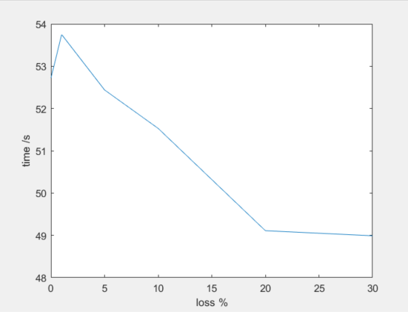

**1.2 ncp/rcv and t_ncp/t_rcv at the same time**

|  |  |  |  |
| --- | --- | --- | --- |
| program | Data_size(include junk data) | Time | Rate(100MB) |
| **ncp/rcv** | 136 MB | 42.30 s | 18.91 Mbps |
| **t_ncp/t_rcv** | 100 MB | 37s | 21.62 Mbps |

our program will preempt TCP’s bandwidth.

**2. wide area test**

There exists 40 ms between two nodes.

**2.1 t_ncp and t_rcv**

|  |  |  |  |
| --- | --- | --- | --- |
| Loss_rate\ metric | Data_size | Time | rate |
| 0 | 100M | 9S | 99 M/s |

**1.2 ncp and rcv**

|  |  |  |  |
| --- | --- | --- | --- |
| Loss_rate\ metric | Data_size | Time | rate |
| 0 | 146.792 M | 84.56 s | 9.46 Mbps |
| 1% | 146.41 M | 84.35 s | 9.48 Mbps |
| 5% | 150.00 M | 81.86 s | 9.77 Mbps |
| 10% | 151.69 M | 77.62 s | 10.30 Mbps |
| 20% | 158.00 M | 77.20 s | 10.36 Mbps |
| 30% | 164.26 M | 73.51 s | 10.88 Mbps |

**Graph:**

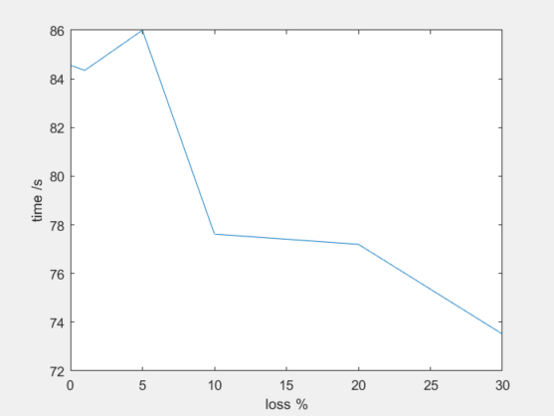

**1.2 ncp/rcv and t_ncp/t_rcv at the same time**

|  |  |  |  |
| --- | --- | --- | --- |
| program | Data_size | Time | Rate(include junk) |
| **ncp/rcv** | 150.50MB | 85.328 s | 1.17 Mbps |
| **t_ncp/t_rcv** | 100 MB | 91s | 1.6 Mbps |

our program will preempt TCP’s bandwidth.

**The way to tune the parameters:**

For timeout, we set timeout = 200. Since RTT = 40, I think 120 is a appropriate timeout on the sender side. Actually, later, I choose 1s to test the program, the result is same, which is weird. For the window size, I tried different window size from 50 to 200. The best window size is 100. Actually, 200 and 100 have the same performance. I think 100 is the maximum size.

Besides, there is another timeout on the receiver side. The problem we faced was that when the sender sends 1,2,3….60 packages, the order is different. Maybe the receiver would receive 60 first, so it immediately send NACK 1 2 3…5 to the sender. However, the packages are just in flight, which are not lost. In this case, the sender receives the NACK, and resend the 1 2 3…5, it wastes the bandwidth but not have any contribution of the transmitting. So we regulate that if the receiver timeout, it send the ack and NACK to the sender. This timeout is 60, which is 1.5*RTT(40ms). Besides, we tried 70 120, the results are same.

**The result:**

The result is interesting. You could see the data_size increase along with the loss increasing. It is understandable, since the sender should resend more packages. However, the funny thing is that the transmitting rate increase and the time decrease, which is totally different from my understanding. We spend many hours but can’t understand why.

Besides, from the contrast between TCP and our program running at the same time, we find that our program would preempt TCP’s bandwidth.