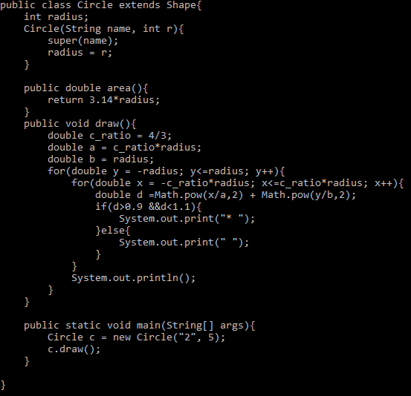

One of the sub class under Shape Class. It has its own area function, draw function

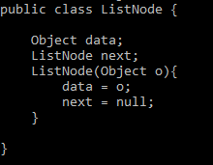

Node class for linkedlist. Taking 2 objects, one is data and the other one is the next node

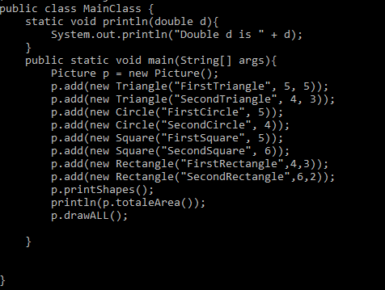

MainClass for writing a main

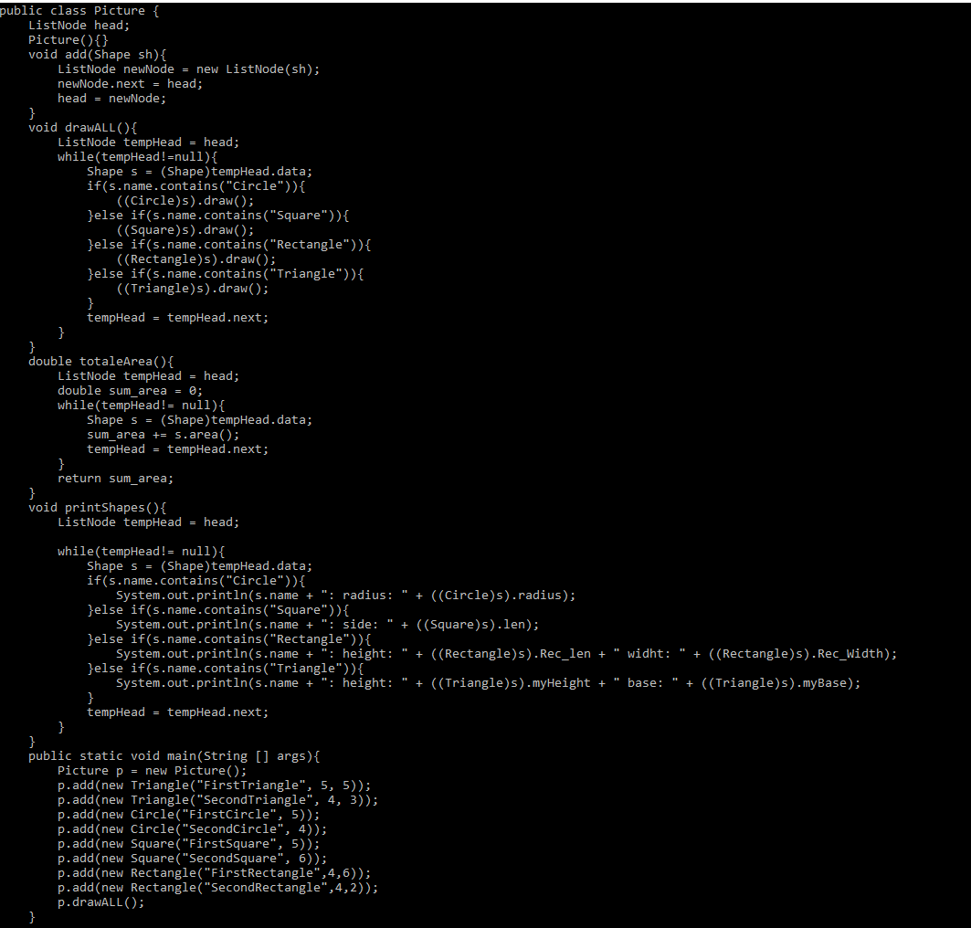

Picture class is to sum up all of areas in the linkedlist and draw all pictures

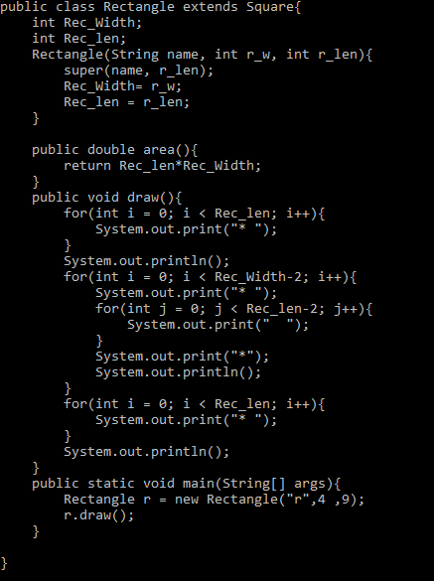

Rectangle class is a sub class under Square class which also have its own area, and draw function.

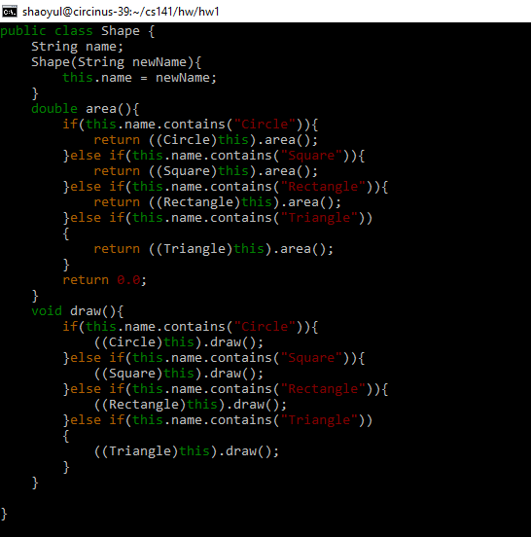

A shape class to know what kind of shapes in the linkedlist

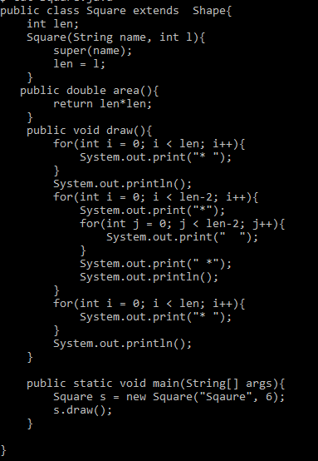

One of the sub class under shape class. It has its own area, draw function

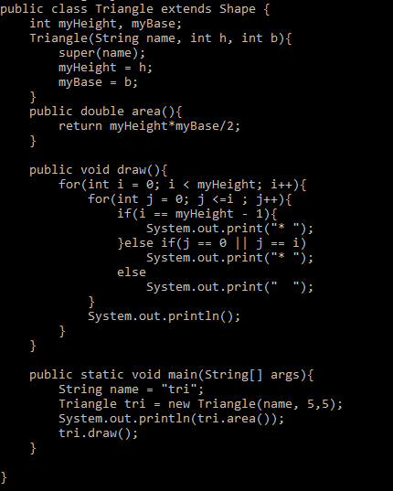

One of the sub class under shape class. It has its own area, draw function

Compilation:



Output

